What Kinds of Restaurants are Feasible in Manhattan/Brooklyn?

Introduction:

Right now, New York City is perhaps the world's most diverse city. One of the key examples of its variety is in restaurants; you can find restaurants from every country, culture, and cuisine in the world in NYC. If someone desired to open a new restaurant, the immediate question is what kind and where. That is what my project aims to find. My project is geared to help prospective restaurant owners understand the types of restaurants that NYC needs, and those that have a chance of becoming major hits. This project could also appeal to anyone who is looking to analyze the psychological dynamic of various areas of the city, and what foods they like in relation to one another.

Data:

The data I used was collected from the Foursquare Developer API. It included the name and type of restaurant for each restaurant within a kilometer of the two locations that I chose, Manhattan and Brooklyn. I ended up with 50 results per neighborhood.

Methodology:

Methods used:

* Collecting data from Foursquare API
* Filtering the data to include only necessary information
* Transferring the data into a Pandas dataframe
* Sorting the dataframe by restaurant style
* Finding the count of each type of restaurant

Results:

**Manhattan:**

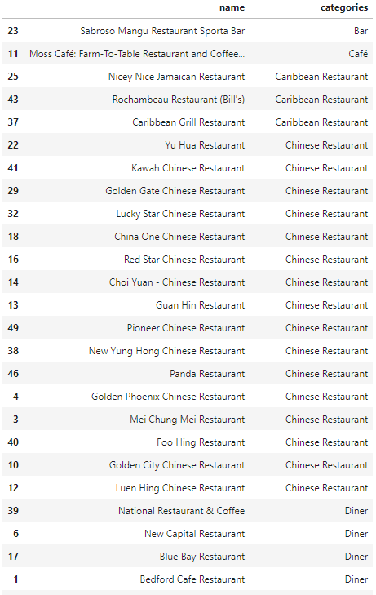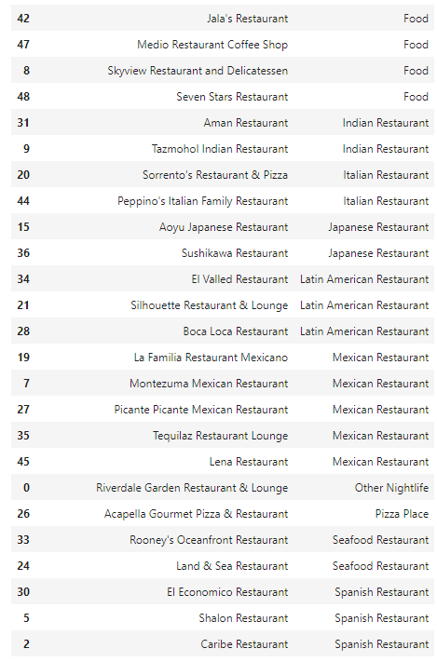

**Brooklyn:**

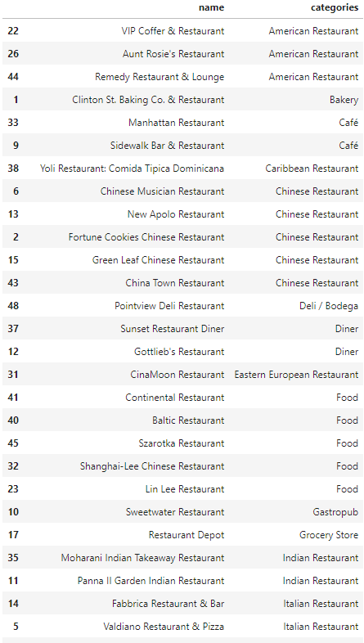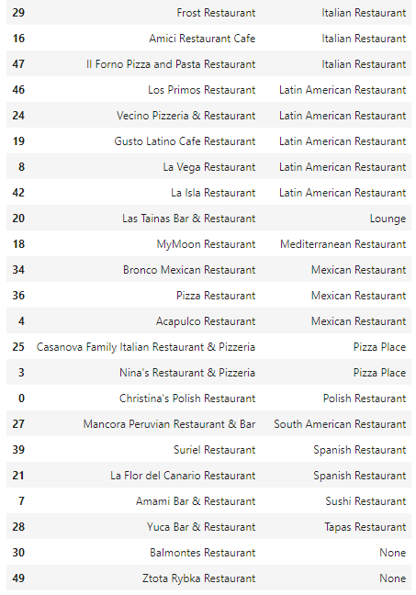

Discussion:

We see above that Manhattan and Brooklyn both have a diverse range of restaurants, but with slightly different demographics. Manhattan has a huge selection of Chinese restaurants, of which there are 16, and Latin American restaurants (including Spanish and Mexican), of which there are 11. This shows that another Chinese or Latin American restaurant would most likely fail, since are already so many in the area. Suggestions for possible restaurants in the area include American, Italian, and European.

On the other hand, Brooklyn has different restaurants. It has far fewer Chinese restaurants, and has around the same amount of Latin American (including Mexican and Spanish) restaurants. It also has a larger selection of Italian restaurants (5) as well as a few American restaurants. Opening a restaurant in Brooklyn may be more of a challenge, since it has restaurants of many categories and is not lacking in any generally area of cuisine.

Conclusion:

From my project, I have a couple of conclusions to make. To start with, I faced a couple problems. My original desire was for my survey to cover all of New York City, but I was held back by the venue display limit of 50 when searching in Foursquare. I realized that there are thousands of restaurants in all of NYC, and opening a new one has a lot to do with the local population, existing restaurants, and the exact location of the new restaurant. All in all, this project was a good experience as the culmination of all of the skills I learned in this course, and could be a good stepping stone for anyone looking to open a restaurant in New York City.