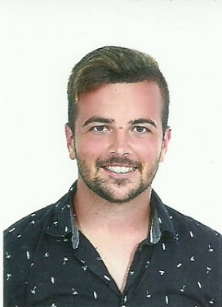

**Factory Worker**

Horta Pronta – Hortas do Oeste, S.A.

Summer of 2018

**Profile**

Specialized and passionate in the field of computer science, specifically programming. I consider myself to have a good level of adaptability, and I enjoy learning new skills across different areas. I have been working since the age of 14 and have dealt with various people in many different situations, which has given me versatility.

**Farmer**

RDV, Lda, Atouguia da Baleia

Summers of 2014, 2015, 2016, 2017, 2019, 2020, 2021



**Education and Training**

**Bachelor’s Degree (2019 - 2024)**

**Computer Engineering**

ESTG - IPL

**Technician in Management and Programming of Computer Systems, Level IV (2016 – 2019)**

Rafael Bordalo Pinheiro High School – Caldas da Rainha

**Shop Assistent**

Bershka LeiriaShopping

Jun. 2022 - Present

**Professional Experience**



**Cooking**

**Traveling**

**Movies/ TV Series**

**Socializing**

**Hobbies**

**English**

**Portuguese**

**Spanish**

**Languages**

**Rodrigo Reis**

**Personal Information**

**Travessa João Fernandes Peres, nº6 R/CH Direito 2410-381, Guimarota, Leiria**

**Email:**

**rodrigosousareis@hotmail.com**

**Phone:**

**+351 914 163 285**