**ICT3214-MOBILE APPLICATION DEVELOPMENT**

Individual Assignment 02 – Notepad App with Firebase



Name: R. Risfath Ahamed

Registration Number: ICT/19/20/093

Index Number: 5030

Table of Contents

AndroidManifest 3

1. AndroidManifest.xml 3

Java Files 4

1. CreateAccountActivity.java 4

2. LoginActivity.java 6

3. MainActivity.java 8

4. Note.java 9

5. NoteAdapter.java 10

6. NoteDetailsActivity.java 11

7. SplashActivity.java 13

9. Utility.java 14

XML Files 15

1. activity_create_account.xml 15

2. activity_login.xml 17

3. activity_main.xml 19

4. activity_note_details.xml 20

5. Activity_splash.xml 22

7. Recycler_note_item.xml 22

8. strings.xml 23

Screenshots 23

How it Works 24

GitHub Link 24

APK Link 24

# AndroidManifest

## AndroidManifest.xml

<?xml version="1.0" encoding="utf-8"?>  
<manifest xmlns:android="http://schemas.android.com/apk/res/android"  
 package="easy.tuto.notespro">  
  
 <uses-permission android:name="android.permission.INTERNET" />  
  
 <application  
 android:allowBackup="true"  
 android:icon="@mipmap/ic_launcher"  
 android:label="@string/app_name"  
 android:roundIcon="@mipmap/ic_launcher_round"  
 android:supportsRtl="true"  
 android:theme="@style/Theme.NotesPro">  
 <activity  
 android:name=".NoteDetailsActivity"  
 android:exported="false" />  
 <activity  
 android:name=".LoginActivity"  
 android:exported="false" />  
 <activity  
 android:name=".CreateAccountActivity"  
 android:exported="false" />  
 <activity  
 android:name=".MainActivity"  
 android:exported="false" />  
 <activity  
 android:name=".SplashActivity"  
 android:exported="true">  
 <intent-filter>  
 <action android:name="android.intent.action.MAIN" />  
  
 <category android:name="android.intent.category.LAUNCHER" />  
 </intent-filter>  
 </activity>  
 </application>  
  
</manifest>

# Java Files

## CreateAccountActivity.java

package easy.tuto.notespro;  
  
import androidx.annotation.NonNull;  
import androidx.appcompat.app.AppCompatActivity;  
  
import android.os.Bundle;  
import android.util.Log;  
import android.util.Patterns;  
import android.view.View;  
import android.widget.Button;  
import android.widget.EditText;  
import android.widget.ProgressBar;  
import android.widget.TextView;  
import android.widget.Toast;  
  
import com.google.android.gms.tasks.OnCompleteListener;  
import com.google.android.gms.tasks.Task;  
import com.google.firebase.auth.AuthResult;  
import com.google.firebase.auth.FirebaseAuth;  
  
public class CreateAccountActivity extends AppCompatActivity {  
  
 EditText emailEditText,passwordEditText,confirmPasswordEditText;  
 Button createAccountBtn;  
 ProgressBar progressBar;  
 TextView loginBtnTextView;  
  
 @Override  
 protected void onCreate(Bundle savedInstanceState) {  
 super.onCreate(savedInstanceState);  
 setContentView(R.layout.*activity_create_account*);  
  
 emailEditText = findViewById(R.id.*email_edit_text*);  
 passwordEditText = findViewById(R.id.*password_edit_text*);  
 confirmPasswordEditText = findViewById(R.id.*confirm_password_edit_text*);  
 createAccountBtn = findViewById(R.id.*create_account_btn*);  
 progressBar = findViewById(R.id.*progress_bar*);  
 loginBtnTextView = findViewById(R.id.*login_text_view_btn*);  
  
 createAccountBtn.setOnClickListener(v-> createAccount());  
 loginBtnTextView.setOnClickListener(v-> finish());  
  
  
 }  
  
 void createAccount(){  
 String email = emailEditText.getText().toString();  
 String password = passwordEditText.getText().toString();  
 String confirmPassword = confirmPasswordEditText.getText().toString();  
  
 boolean isValidated = validateData(email,password,confirmPassword);  
 if(!isValidated){  
 return;  
 }  
  
 createAccountInFirebase(email,password);  
  
  
 }  
  
 void createAccountInFirebase(String email,String password){  
 changeInProgress(true);  
  
 FirebaseAuth firebaseAuth = FirebaseAuth.*getInstance*();  
 firebaseAuth.createUserWithEmailAndPassword(email,password).addOnCompleteListener(CreateAccountActivity.this,  
 new OnCompleteListener<AuthResult>() {  
 @Override  
 public void onComplete(@NonNull Task<AuthResult> task) {  
 changeInProgress(false);  
 if(task.isSuccessful()){  
 //creating acc is done  
 Utility.*showToast*(CreateAccountActivity.this,"Successfully create account,Check email to verify");  
 firebaseAuth.getCurrentUser().sendEmailVerification();  
 firebaseAuth.signOut();  
 finish();  
 }else{  
 //failure  
 Utility.*showToast*(CreateAccountActivity.this,task.getException().getLocalizedMessage());  
 }  
 }  
 }  
 );  
  
  
  
 }  
  
 void changeInProgress(boolean inProgress){  
 if(inProgress){  
 progressBar.setVisibility(View.*VISIBLE*);  
 createAccountBtn.setVisibility(View.*GONE*);  
 }else{  
 progressBar.setVisibility(View.*GONE*);  
 createAccountBtn.setVisibility(View.*VISIBLE*);  
 }  
 }  
  
 boolean validateData(String email,String password,String confirmPassword){  
 //validate the data that are input by user.  
  
 if(!Patterns.*EMAIL_ADDRESS*.matcher(email).matches()){  
 emailEditText.setError("Email is invalid");  
 return false;  
 }  
 if(password.length()<6){  
 passwordEditText.setError("Password length is invalid");  
 return false;  
 }  
 if(!password.equals(confirmPassword)){  
 confirmPasswordEditText.setError("Password not matched");  
 return false;  
 }  
 return true;  
 }  
  
}

## LoginActivity.java

package easy.tuto.notespro;  
  
import androidx.annotation.NonNull;  
import androidx.appcompat.app.AppCompatActivity;  
  
import android.content.Intent;  
import android.os.Bundle;  
import android.util.Patterns;  
import android.view.View;  
import android.widget.Button;  
import android.widget.EditText;  
import android.widget.ProgressBar;  
import android.widget.TextView;  
  
import com.google.android.gms.tasks.OnCompleteListener;  
import com.google.android.gms.tasks.Task;  
import com.google.firebase.auth.AuthResult;  
import com.google.firebase.auth.FirebaseAuth;  
  
public class LoginActivity extends AppCompatActivity {  
  
 EditText emailEditText,passwordEditText;  
 Button loginBtn;  
 ProgressBar progressBar;  
 TextView createAccountBtnTextView;  
  
 @Override  
 protected void onCreate(Bundle savedInstanceState) {  
 super.onCreate(savedInstanceState);  
 setContentView(R.layout.*activity_login*);  
  
 emailEditText = findViewById(R.id.*email_edit_text*);  
 passwordEditText = findViewById(R.id.*password_edit_text*);  
 loginBtn = findViewById(R.id.*login_btn*);  
 progressBar = findViewById(R.id.*progress_bar*);  
 createAccountBtnTextView = findViewById(R.id.*create_account_text_view_btn*);  
  
 loginBtn.setOnClickListener((v)-> loginUser() );  
 createAccountBtnTextView.setOnClickListener((v)->startActivity(new Intent(LoginActivity.this,CreateAccountActivity.class)) );  
  
 }  
  
 void loginUser(){  
 String email = emailEditText.getText().toString();  
 String password = passwordEditText.getText().toString();  
  
  
 boolean isValidated = validateData(email,password);  
 if(!isValidated){  
 return;  
 }  
  
 loginAccountInFirebase(email,password);  
  
 }  
  
 void loginAccountInFirebase(String email,String password){  
 FirebaseAuth firebaseAuth = FirebaseAuth.*getInstance*();  
 changeInProgress(true);  
 firebaseAuth.signInWithEmailAndPassword(email,password).addOnCompleteListener(new OnCompleteListener<AuthResult>() {  
 @Override  
 public void onComplete(@NonNull Task<AuthResult> task) {  
 changeInProgress(false);  
 if(task.isSuccessful()){  
 //login is success  
 if(firebaseAuth.getCurrentUser().isEmailVerified()){  
 //go to mainactivity  
 startActivity(new Intent(LoginActivity.this,MainActivity.class));  
 finish();  
 }else{  
 Utility.*showToast*(LoginActivity.this,"Email not verified, Please verify your email.");  
 }  
  
 }else{  
 //login failed  
 Utility.*showToast*(LoginActivity.this,task.getException().getLocalizedMessage());  
 }  
 }  
 });  
 }  
  
 void changeInProgress(boolean inProgress){  
 if(inProgress){  
 progressBar.setVisibility(View.*VISIBLE*);  
 loginBtn.setVisibility(View.*GONE*);  
 }else{  
 progressBar.setVisibility(View.*GONE*);  
 loginBtn.setVisibility(View.*VISIBLE*);  
 }  
 }  
  
 boolean validateData(String email,String password){  
 //validate the data that are input by user.  
  
 if(!Patterns.*EMAIL_ADDRESS*.matcher(email).matches()){  
 emailEditText.setError("Email is invalid");  
 return false;  
 }  
 if(password.length()<6){  
 passwordEditText.setError("Password length is invalid");  
 return false;  
 }  
 return true;  
 }  
  
}

## MainActivity.java

package easy.tuto.notespro;  
  
import androidx.appcompat.app.AppCompatActivity;  
import androidx.recyclerview.widget.LinearLayoutManager;  
import androidx.recyclerview.widget.RecyclerView;  
  
import android.content.Intent;  
import android.os.Bundle;  
import android.view.MenuItem;  
import android.widget.ImageButton;  
import android.widget.PopupMenu;  
  
import com.firebase.ui.firestore.FirestoreRecyclerOptions;  
import com.google.android.material.floatingactionbutton.FloatingActionButton;  
import com.google.firebase.auth.FirebaseAuth;  
import com.google.firebase.firestore.Query;  
  
public class MainActivity extends AppCompatActivity {  
  
 FloatingActionButton addNoteBtn;  
 RecyclerView recyclerView;  
 ImageButton menuBtn;  
 NoteAdapter noteAdapter;  
  
 @Override  
 protected void onCreate(Bundle savedInstanceState) {  
 super.onCreate(savedInstanceState);  
 setContentView(R.layout.*activity_main*);  
  
 addNoteBtn = findViewById(R.id.*add_note_btn*);  
 recyclerView = findViewById(R.id.*recyler_view*);  
 menuBtn = findViewById(R.id.*menu_btn*);  
  
 addNoteBtn.setOnClickListener((v)-> startActivity(new Intent(MainActivity.this,NoteDetailsActivity.class)) );  
 menuBtn.setOnClickListener((v)->showMenu() );  
 setupRecyclerView();  
 }  
  
 void showMenu(){  
 PopupMenu popupMenu = new PopupMenu(MainActivity.this,menuBtn);  
 popupMenu.getMenu().add("Logout");  
 popupMenu.show();  
 popupMenu.setOnMenuItemClickListener(new PopupMenu.OnMenuItemClickListener() {  
 @Override  
 public boolean onMenuItemClick(MenuItem menuItem) {  
 if(menuItem.getTitle()=="Logout"){  
 FirebaseAuth.*getInstance*().signOut();  
 startActivity(new Intent(MainActivity.this,LoginActivity.class));  
 finish();  
 return true;  
 }  
 return false;  
 }  
 });  
  
 }  
  
 void setupRecyclerView(){  
 Query query = Utility.*getCollectionReferenceForNotes*().orderBy("timestamp",Query.Direction.*DESCENDING*);  
 FirestoreRecyclerOptions<Note> options = new FirestoreRecyclerOptions.Builder<Note>()  
 .setQuery(query,Note.class).build();  
 recyclerView.setLayoutManager(new LinearLayoutManager(this));  
 noteAdapter = new NoteAdapter(options,this);  
 recyclerView.setAdapter(noteAdapter);  
 }  
  
 @Override  
 protected void onStart() {  
 super.onStart();  
 noteAdapter.startListening();  
 }  
  
 @Override  
 protected void onStop() {  
 super.onStop();  
 noteAdapter.stopListening();  
 }  
  
 @Override  
 protected void onResume() {  
 super.onResume();  
 noteAdapter.notifyDataSetChanged();  
 }  
}

}

## Note.java

package easy.tuto.notespro;  
  
import com.google.firebase.Timestamp;  
  
public class Note {  
 String title;  
 String content;  
 Timestamp timestamp;  
  
 public Note() {  
 }  
  
 public String getTitle() {  
 return title;  
 }  
  
 public void setTitle(String title) {  
 this.title = title;  
 }  
  
 public String getContent() {  
 return content;  
 }  
  
 public void setContent(String content) {  
 this.content = content;  
 }  
  
 public Timestamp getTimestamp() {  
 return timestamp;  
 }  
  
 public void setTimestamp(Timestamp timestamp) {  
 this.timestamp = timestamp;  
 }  
}

## NoteAdapter.java

package easy.tuto.notespro;  
  
import android.content.Context;  
import android.content.Intent;  
import android.text.Layout;  
import android.view.LayoutInflater;  
import android.view.View;  
import android.view.ViewGroup;  
import android.widget.TextView;  
  
import com.firebase.ui.firestore.FirestoreRecyclerAdapter;  
import com.firebase.ui.firestore.FirestoreRecyclerOptions;  
  
import androidx.annotation.NonNull;  
import androidx.recyclerview.widget.RecyclerView;  
import io.grpc.okhttp.internal.Util;  
  
public class NoteAdapter extends FirestoreRecyclerAdapter<Note, NoteAdapter.NoteViewHolder> {  
 Context context;  
  
 public NoteAdapter(@NonNull FirestoreRecyclerOptions<Note> options, Context context) {  
 super(options);  
 this.context = context;  
 }  
  
 @Override  
 protected void onBindViewHolder(@NonNull NoteViewHolder holder, int position, @NonNull Note note) {  
 holder.titleTextView.setText(note.title);  
 holder.contentTextView.setText(note.content);  
 holder.timestampTextView.setText(Utility.*timestampToString*(note.timestamp));  
  
 holder.itemView.setOnClickListener((v)->{  
 Intent intent = new Intent(context,NoteDetailsActivity.class);  
 intent.putExtra("title",note.title);  
 intent.putExtra("content",note.content);  
 String docId = this.getSnapshots().getSnapshot(position).getId();  
 intent.putExtra("docId",docId);  
 context.startActivity(intent);  
 });  
  
 }  
  
 @NonNull  
 @Override  
 public NoteViewHolder onCreateViewHolder(@NonNull ViewGroup parent, int viewType) {  
 View view = LayoutInflater.*from*(parent.getContext()).inflate(R.layout.*recycler_note_item*,parent,false);  
 return new NoteViewHolder(view);  
 }  
  
 class NoteViewHolder extends RecyclerView.ViewHolder{  
 TextView titleTextView,contentTextView,timestampTextView;  
  
 public NoteViewHolder(@NonNull View itemView) {  
 super(itemView);  
 titleTextView = itemView.findViewById(R.id.*note_title_text_view*);  
 contentTextView = itemView.findViewById(R.id.*note_content_text_view*);  
 timestampTextView = itemView.findViewById(R.id.*note_timestamp_text_view*);  
 }  
 }  
}

## NoteDetailsActivity.java

package easy.tuto.notespro;  
  
import androidx.annotation.NonNull;  
import androidx.appcompat.app.AppCompatActivity;  
  
import android.os.Bundle;  
import android.view.View;  
import android.widget.EditText;  
import android.widget.ImageButton;  
import android.widget.TextView;  
  
import com.google.android.gms.tasks.OnCompleteListener;  
import com.google.android.gms.tasks.Task;  
import com.google.firebase.Timestamp;  
import com.google.firebase.firestore.DocumentReference;  
  
public class NoteDetailsActivity extends AppCompatActivity {  
  
 EditText titleEditText,contentEditText;  
 ImageButton saveNoteBtn;  
 TextView pageTitleTextView;  
 String title,content,docId;  
 boolean isEditMode = false;  
 TextView deleteNoteTextViewBtn;  
  
 @Override  
 protected void onCreate(Bundle savedInstanceState) {  
 super.onCreate(savedInstanceState);  
 setContentView(R.layout.*activity_note_details*);  
  
 titleEditText = findViewById(R.id.*notes_title_text*);  
 contentEditText = findViewById(R.id.*notes_content_text*);  
 saveNoteBtn = findViewById(R.id.*save_note_btn*);  
 pageTitleTextView = findViewById(R.id.*page_title*);  
 deleteNoteTextViewBtn = findViewById(R.id.*delete_note_text_view_btn*);  
  
 //receive data  
 title = getIntent().getStringExtra("title");  
 content= getIntent().getStringExtra("content");  
 docId = getIntent().getStringExtra("docId");  
  
 if(docId!=null && !docId.isEmpty()){  
 isEditMode = true;  
 }  
  
 titleEditText.setText(title);  
 contentEditText.setText(content);  
 if(isEditMode){  
 pageTitleTextView.setText("Edit your note");  
 deleteNoteTextViewBtn.setVisibility(View.*VISIBLE*);  
 }  
  
 saveNoteBtn.setOnClickListener( (v)-> saveNote());  
  
 deleteNoteTextViewBtn.setOnClickListener((v)-> deleteNoteFromFirebase() );  
  
 }  
  
 void saveNote(){  
 String noteTitle = titleEditText.getText().toString();  
 String noteContent = contentEditText.getText().toString();  
 if(noteTitle==null || noteTitle.isEmpty() ){  
 titleEditText.setError("Title is required");  
 return;  
 }  
 Note note = new Note();  
 note.setTitle(noteTitle);  
 note.setContent(noteContent);  
 note.setTimestamp(Timestamp.*now*());  
  
 saveNoteToFirebase(note);  
  
 }  
  
 void saveNoteToFirebase(Note note){  
 DocumentReference documentReference;  
 if(isEditMode){  
 //update the note  
 documentReference = Utility.*getCollectionReferenceForNotes*().document(docId);  
 }else{  
 //create new note  
 documentReference = Utility.*getCollectionReferenceForNotes*().document();  
 }  
  
  
  
 documentReference.set(note).addOnCompleteListener(new OnCompleteListener<Void>() {  
 @Override  
 public void onComplete(@NonNull Task<Void> task) {  
 if(task.isSuccessful()){  
 //note is added  
 Utility.*showToast*(NoteDetailsActivity.this,"Note added successfully");  
 finish();  
 }else{  
 Utility.*showToast*(NoteDetailsActivity.this,"Failed while adding note");  
 }  
 }  
 });  
  
 }  
  
 void deleteNoteFromFirebase(){  
 DocumentReference documentReference;  
 documentReference = Utility.*getCollectionReferenceForNotes*().document(docId);  
 documentReference.delete().addOnCompleteListener(new OnCompleteListener<Void>() {  
 @Override  
 public void onComplete(@NonNull Task<Void> task) {  
 if(task.isSuccessful()){  
 //note is deleted  
 Utility.*showToast*(NoteDetailsActivity.this,"Note deleted successfully");  
 finish();  
 }else{  
 Utility.*showToast*(NoteDetailsActivity.this,"Failed while deleting note");  
 }  
 }  
 });  
 }  
  
  
}

## SplashActivity.java

1. package easy.tuto.notespro;  
     
   import androidx.appcompat.app.AppCompatActivity;  
     
   import android.content.Intent;  
   import android.os.Bundle;  
   import android.os.Handler;  
     
   import com.google.firebase.auth.FirebaseAuth;  
   import com.google.firebase.auth.FirebaseUser;  
     
   public class SplashActivity extends AppCompatActivity {  
     
    @Override  
    protected void onCreate(Bundle savedInstanceState) {  
    super.onCreate(savedInstanceState);  
    setContentView(R.layout.*activity_splash*);  
     
    new Handler().postDelayed(new Runnable() {  
    @Override  
    public void run() {  
    FirebaseUser currentUser = FirebaseAuth.*getInstance*().getCurrentUser();  
    if(currentUser==null){  
    startActivity(new Intent(SplashActivity.this,LoginActivity.class));  
    }else{  
    startActivity(new Intent(SplashActivity.this,MainActivity.class));  
    }  
    finish();  
    }  
    },1000);  
     
    }  
   }

## Utility.java

package easy.tuto.notespro;  
  
import android.content.Context;  
import android.widget.Toast;  
  
import com.google.firebase.Timestamp;  
import com.google.firebase.auth.FirebaseAuth;  
import com.google.firebase.auth.FirebaseUser;  
import com.google.firebase.firestore.CollectionReference;  
import com.google.firebase.firestore.FirebaseFirestore;  
  
import java.text.SimpleDateFormat;  
  
public class Utility {  
  
 static void showToast(Context context,String message){  
 Toast.*makeText*(context,message,Toast.*LENGTH_SHORT*).show();  
 }  
  
 static CollectionReference getCollectionReferenceForNotes(){  
 FirebaseUser currentUser = FirebaseAuth.*getInstance*().getCurrentUser();  
 return FirebaseFirestore.*getInstance*().collection("notes")  
 .document(currentUser.getUid()).collection("my_notes");  
 }  
  
 static String timestampToString(Timestamp timestamp){  
 return new SimpleDateFormat("MM/dd/yyyy").format(timestamp.toDate());  
 }  
  
}

# XML Files

## activity_create_account.xml

<?xml version="1.0" encoding="utf-8"?>  
<RelativeLayout xmlns:android="http://schemas.android.com/apk/res/android"  
 xmlns:app="http://schemas.android.com/apk/res-auto"  
 xmlns:tools="http://schemas.android.com/tools"  
 android:layout_width="match_parent"  
 android:layout_height="match_parent"  
 android:layout_marginVertical="16dp"  
 android:layout_marginHorizontal="32dp"  
 tools:context=".CreateAccountActivity">  
  
 <ImageView  
 android:layout_width="128dp"  
 android:layout_height="128dp"  
 android:layout_centerHorizontal="true"  
 android:layout_marginVertical="32dp"  
 android:id="@+id/sign_up_icon"  
 android:src="@drawable/logo11"/>  
  
 <LinearLayout  
 android:layout_width="match_parent"  
 android:layout_height="wrap_content"  
 android:layout_below="@id/sign_up_icon"  
 android:id="@+id/hello_text"  
 android:orientation="vertical">  
  
 <TextView  
 android:layout_width="match_parent"  
 android:layout_height="wrap_content"  
 android:text="Hello."  
 android:textStyle="bold"  
 android:textSize="32sp"  
 android:textColor="@color/black"/>  
  
 <TextView  
 android:layout_width="match_parent"  
 android:layout_height="wrap_content"  
 android:text="Let's get started"  
 android:textStyle="bold"  
 android:textSize="36sp"  
 android:textColor="@color/black"/>  
  
 </LinearLayout>  
  
 <LinearLayout  
 android:layout_width="match_parent"  
 android:layout_height="wrap_content"  
 android:id="@+id/form_layout"  
 android:layout_below="@id/hello_text"  
 android:layout_marginVertical="32dp"  
 android:orientation="vertical">  
  
 <EditText  
 android:layout_width="match_parent"  
 android:layout_height="wrap_content"  
 android:id="@+id/email_edit_text"  
 android:inputType="textEmailAddress"  
 android:hint="Email Id"  
 android:textSize="20sp"  
 android:background="@drawable/rounded_corner"  
 android:padding="16dp"  
 android:layout_marginTop="12dp"  
 />  
 <EditText  
 android:layout_width="match_parent"  
 android:layout_height="wrap_content"  
 android:id="@+id/password_edit_text"  
 android:inputType="textPassword"  
 android:hint="Password"  
 android:textSize="20sp"  
 android:background="@drawable/rounded_corner"  
 android:padding="16dp"  
 android:layout_marginTop="12dp"  
 />  
  
 <EditText  
 android:layout_width="match_parent"  
 android:layout_height="wrap_content"  
 android:id="@+id/confirm_password_edit_text"  
 android:inputType="textPassword"  
 android:hint="Confirm Password"  
 android:textSize="20sp"  
 android:background="@drawable/rounded_corner"  
 android:padding="16dp"  
 android:layout_marginTop="12dp"  
 />  
  
 <com.google.android.material.button.MaterialButton  
 android:layout_width="match_parent"  
 android:id="@+id/create_account_btn"  
 android:layout_height="64dp"  
 android:text="Create Account"  
 android:layout_marginTop="12dp"  
 android:textSize="16sp"  
 />  
  
 <ProgressBar  
 android:layout_width="24dp"  
 android:layout_height="64dp"  
 android:id="@+id/progress_bar"  
 android:layout_gravity="center"  
 android:visibility="gone"  
 android:layout_marginTop="12dp"/>  
  
 </LinearLayout>  
  
 <LinearLayout  
 android:layout_width="match_parent"  
 android:layout_height="wrap_content"  
 android:layout_below="@id/form_layout"  
 android:orientation="horizontal"  
 android:gravity="center">  
  
 <TextView  
 android:layout_width="wrap_content"  
 android:layout_height="wrap_content"  
 android:text="Already have an account? "/>  
 <TextView  
 android:layout_width="wrap_content"  
 android:layout_height="wrap_content"  
 android:textStyle="bold"  
 android:id="@+id/login_text_view_btn"  
 android:text="Login"/>  
  
 </LinearLayout>  
  
</RelativeLayout>

## activity_login.xml

<?xml version="1.0" encoding="utf-8"?>  
<RelativeLayout xmlns:android="http://schemas.android.com/apk/res/android"  
 xmlns:app="http://schemas.android.com/apk/res-auto"  
 xmlns:tools="http://schemas.android.com/tools"  
 android:layout_width="match_parent"  
 android:layout_height="match_parent"  
 android:layout_marginVertical="16dp"  
 android:layout_marginHorizontal="32dp"  
 tools:context=".CreateAccountActivity">  
  
 <ImageView  
 android:layout_width="128dp"  
 android:layout_height="128dp"  
 android:layout_centerHorizontal="true"  
 android:layout_marginVertical="32dp"  
 android:id="@+id/sign_up_icon"  
 android:src="@drawable/logo11"/>  
  
 <LinearLayout  
 android:layout_width="match_parent"  
 android:layout_height="wrap_content"  
 android:layout_below="@id/sign_up_icon"  
 android:id="@+id/hello_text"  
 android:orientation="vertical">  
  
 <TextView  
 android:layout_width="match_parent"  
 android:layout_height="wrap_content"  
 android:text="Hello."  
 android:textStyle="bold"  
 android:textSize="32sp"  
 android:textColor="@color/black"/>  
  
 <TextView  
 android:layout_width="match_parent"  
 android:layout_height="wrap_content"  
 android:text="Let's get started"  
 android:textStyle="bold"  
 android:textSize="36sp"  
 android:textColor="@color/black"/>  
  
 </LinearLayout>  
  
 <LinearLayout  
 android:layout_width="match_parent"  
 android:layout_height="wrap_content"  
 android:id="@+id/form_layout"  
 android:layout_below="@id/hello_text"  
 android:layout_marginVertical="32dp"  
 android:orientation="vertical">  
  
 <EditText  
 android:layout_width="match_parent"  
 android:layout_height="wrap_content"  
 android:id="@+id/email_edit_text"  
 android:inputType="textEmailAddress"  
 android:hint="Email Id"  
 android:textSize="20sp"  
 android:background="@drawable/rounded_corner"  
 android:padding="16dp"  
 android:layout_marginTop="12dp"  
 />  
 <EditText  
 android:layout_width="match_parent"  
 android:layout_height="wrap_content"  
 android:id="@+id/password_edit_text"  
 android:inputType="textPassword"  
 android:hint="Password"  
 android:textSize="20sp"  
 android:background="@drawable/rounded_corner"  
 android:padding="16dp"  
 android:layout_marginTop="12dp"  
 />  
  
 <EditText  
 android:layout_width="match_parent"  
 android:layout_height="wrap_content"  
 android:id="@+id/confirm_password_edit_text"  
 android:inputType="textPassword"  
 android:hint="Confirm Password"  
 android:textSize="20sp"  
 android:background="@drawable/rounded_corner"  
 android:padding="16dp"  
 android:layout_marginTop="12dp"  
 />  
  
 <com.google.android.material.button.MaterialButton  
 android:layout_width="match_parent"  
 android:id="@+id/create_account_btn"  
 android:layout_height="64dp"  
 android:text="Create Account"  
 android:layout_marginTop="12dp"  
 android:textSize="16sp"  
 />  
  
 <ProgressBar  
 android:layout_width="24dp"  
 android:layout_height="64dp"  
 android:id="@+id/progress_bar"  
 android:layout_gravity="center"  
 android:visibility="gone"  
 android:layout_marginTop="12dp"/>  
  
 </LinearLayout>  
  
 <LinearLayout  
 android:layout_width="match_parent"  
 android:layout_height="wrap_content"  
 android:layout_below="@id/form_layout"  
 android:orientation="horizontal"  
 android:gravity="center">  
  
 <TextView  
 android:layout_width="wrap_content"  
 android:layout_height="wrap_content"  
 android:text="Already have an account? "/>  
 <TextView  
 android:layout_width="wrap_content"  
 android:layout_height="wrap_content"  
 android:textStyle="bold"  
 android:id="@+id/login_text_view_btn"  
 android:text="Login"/>  
  
 </LinearLayout>  
  
</RelativeLayout>

## activity_main.xml

<?xml version="1.0" encoding="utf-8"?>  
<RelativeLayout xmlns:android="http://schemas.android.com/apk/res/android"  
 xmlns:app="http://schemas.android.com/apk/res-auto"  
 xmlns:tools="http://schemas.android.com/tools"  
 android:layout_width="match_parent"  
 android:layout_height="match_parent"  
 android:background="#f6dbd5"  
 android:padding="16dp"  
 tools:context=".MainActivity">  
 <RelativeLayout  
 android:layout_width="match_parent"  
 android:layout_height="wrap_content"  
 android:id="@+id/title_bar_layout">  
 <TextView  
 android:layout_width="wrap_content"  
 android:layout_height="wrap_content"  
 android:id="@+id/page_title"  
 android:text="Notes"  
 android:textSize="32sp"  
 android:textColor="@color/black"  
 android:textStyle="bold"/>  
  
 <ImageButton  
 android:layout_width="36dp"  
 android:layout_height="36dp"  
 android:id="@+id/menu_btn"  
 android:src="@drawable/ic_baseline_menu_24"  
 android:layout_alignParentEnd="true"  
 android:layout_centerVertical="true"  
 app:tint="@color/white"  
 android:background="?attr/selectableItemBackgroundBorderless"  
 />  
  
 </RelativeLayout>  
  
 <androidx.recyclerview.widget.RecyclerView  
 android:layout_width="match_parent"  
 android:layout_height="match_parent"  
 android:layout_below="@id/title_bar_layout"  
 android:id="@+id/recyler_view"/>  
  
  
 <com.google.android.material.floatingactionbutton.FloatingActionButton  
 android:layout_width="wrap_content"  
 android:layout_height="wrap_content"  
 android:id="@+id/add_note_btn"  
 android:backgroundTint="@color/white"  
 android:layout_alignParentEnd="true"  
 android:layout_alignParentBottom="true"  
 android:src="@drawable/ic_baseline_add_24"  
 />  
  
  
</RelativeLayout>

## activity_note_details.xml

<?xml version="1.0" encoding="utf-8"?>  
<RelativeLayout xmlns:android="http://schemas.android.com/apk/res/android"  
 xmlns:app="http://schemas.android.com/apk/res-auto"  
 xmlns:tools="http://schemas.android.com/tools"  
 android:layout_width="match_parent"  
 android:layout_height="match_parent"  
 android:background="#f6dbd5"  
 android:padding="16dp"  
 tools:context=".NoteDetailsActivity">  
  
 <RelativeLayout  
 android:layout_width="match_parent"  
 android:layout_height="wrap_content"  
 android:id="@+id/title_bar_layout">  
  
 <TextView  
 android:id="@+id/page_title"  
 android:layout_width="wrap_content"  
 android:layout_height="wrap_content"  
 android:text="Add New Note"  
 android:textColor="@color/black"  
 android:textSize="32sp"  
 android:textStyle="bold" />  
  
 <ImageButton  
 android:layout_width="36dp"  
 android:layout_height="36dp"  
 android:id="@+id/save_note_btn"  
 android:src="@drawable/ic_baseline_done_24"  
 android:layout_alignParentEnd="true"  
 android:layout_centerVertical="true"  
 app:tint="@color/white"  
 android:background="?attr/selectableItemBackgroundBorderless"  
  
 />  
  
 </RelativeLayout>  
  
 <LinearLayout  
 android:layout_width="395dp"  
 android:layout_height="383dp"  
 android:layout_below="@id/title_bar_layout"  
 android:layout_marginVertical="26dp"  
 android:background="@drawable/rounded_corner"  
 android:backgroundTint="@color/white"  
 android:orientation="vertical"  
 android:padding="16dp">  
  
 <EditText  
 android:id="@+id/notes_title_text"  
 android:layout_width="match_parent"  
 android:layout_height="wrap_content"  
 android:layout_marginVertical="8dp"  
 android:hint="Title"  
 android:padding="12dp"  
 android:textColor="@color/black"  
 android:textSize="20sp"  
 android:textStyle="bold" />  
  
 <EditText  
 android:id="@+id/notes_content_text"  
 android:layout_width="match_parent"  
 android:layout_height="wrap_content"  
 android:layout_marginVertical="8dp"  
 android:gravity="top"  
 android:hint="Content"  
 android:minLines="15"  
 android:padding="12dp"  
 android:textColor="@color/black"  
 android:textSize="20sp" />  
  
  
 </LinearLayout>  
  
 <TextView  
 android:layout_width="match_parent"  
 android:layout_height="wrap_content"  
 android:id="@+id/delete_note_text_view_btn"  
 android:text="Delete note"  
 android:layout_alignParentBottom="true"  
 android:gravity="center"  
 android:textSize="18sp"  
 android:visibility="gone"  
 android:textColor="#FF0000"/>  
  
  
</RelativeLayout>

## Activity_splash.xml

1. <?xml version="1.0" encoding="utf-8"?>  
   <LinearLayout xmlns:android="http://schemas.android.com/apk/res/android"  
    xmlns:app="http://schemas.android.com/apk/res-auto"  
    xmlns:tools="http://schemas.android.com/tools"  
    android:layout_width="match_parent"  
    android:layout_height="match_parent"  
    android:background="#f6dbd5"  
    android:orientation="vertical"  
    android:gravity="center"  
    tools:context=".SplashActivity">  
     
    <ImageView  
    android:layout_width="176dp"  
    android:layout_height="205dp"  
    android:layout_gravity="center"  
    android:background="@drawable/logo11"  
    android:gravity="center"  
    android:textStyle="bold" />  
     
    <ProgressBar  
    android:layout_width="24dp"  
    android:layout_height="24dp"  
    android:indeterminateTint="@color/white"  
    android:layout_margin="0dp"  
    />  
     
   </LinearLayout>

## Recycler_note_item.xml

<?xml version="1.0" encoding="utf-8"?>  
<?xml version="1.0" encoding="utf-8"?>  
<LinearLayout xmlns:android="http://schemas.android.com/apk/res/android"  
 android:orientation="vertical"  
 android:layout_width="match_parent"  
 android:layout_height="wrap_content"  
 android:padding="12dp"  
 android:layout_marginVertical="8dp"  
 android:backgroundTint="@color/white"  
 android:background="@drawable/rounded_corner"  
 >  
  
 <TextView  
 android:layout_width="match_parent"  
 android:layout_height="wrap_content"  
 android:id="@+id/note_title_text_view"  
 android:text="note title"  
 android:textColor="@color/black"  
 android:textSize="18sp"  
 android:layout_marginVertical="4dp"/>  
 <TextView  
 android:layout_width="match_parent"  
 android:layout_height="wrap_content"  
 android:id="@+id/note_content_text_view"  
 android:text="this can be note content that can be long"  
 android:maxLines="2"  
 android:ellipsize="end"  
 android:textSize="17sp"  
 android:layout_marginVertical="4dp"/>  
  
 <TextView  
 android:layout_width="match_parent"  
 android:layout_height="wrap_content"  
 android:id="@+id/note_timestamp_text_view"  
 android:text="note title"  
 android:textSize="12sp"  
 android:gravity="right"  
 android:layout_marginVertical="4dp"/>  
  
</LinearLayout>

## strings.xml

<resources>  
 <string name="app_name">Library App</string>  
 <string name="add_new_books">Add New Books</string>  
 <string name="book_id">Book ID</string>  
 <string name="title">Title</string>  
 <string name="publisher_name">Publisher Name</string>  
</resources>

# Screenshots

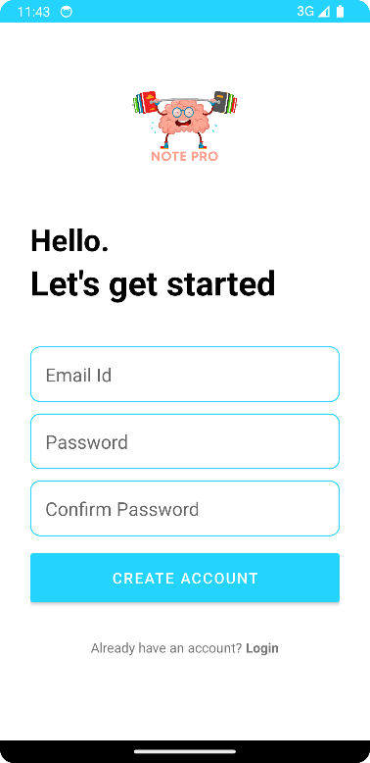

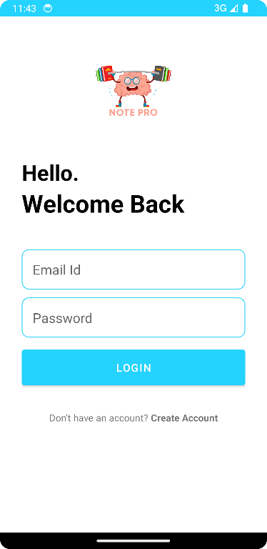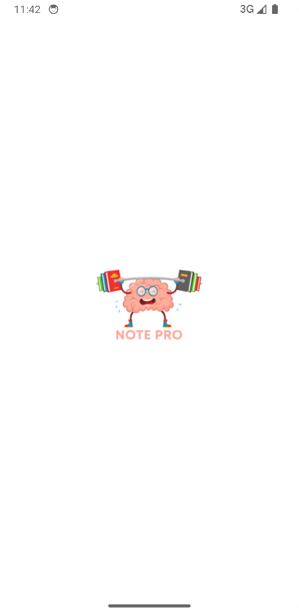

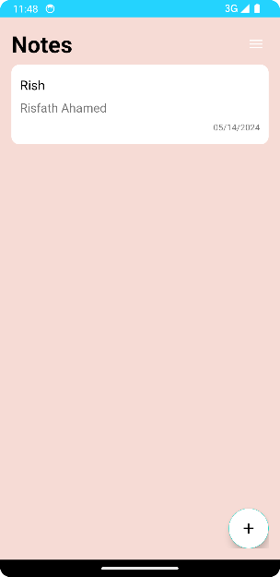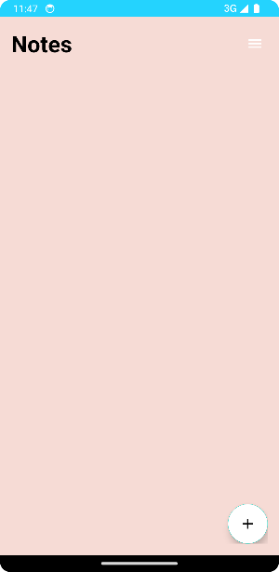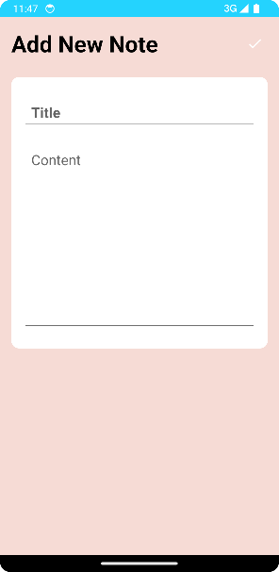

# How it Works

1. Open the app.
2. If you don’t have an account, click "Create Account" using your email and password, and confirm the password. Please provide a valid email because the app only works after your email is verified. A verification email will be sent to the address you provided.
3. After successful verification, you will be directed to the login page.
4. Enter your email and password. (An Internet connection is required.)
5. Press the floating icon to create notes, and press the three bars at the top to log out.
6. After adding a note, press the right icon and go back. You can now see what you added.

# GitHub Link

<https://github.com/RRisfathAhamed/Notes_App.git>

# APK Link

<https://drive.google.com/drive/folders/11mPO44bI-yunVlXG6vm-LPweR_8PMPFJ?usp=sharing>