**Week 5 (Mechanical Engineer):**

This week five tasks were given; each task consists of rotation of a joint for the robot arm.

THE UPPER BODY:

The body length was 40 cm, the thickness and width of it matches the hips thickness which is 9cm and the hips width which is 32cm.

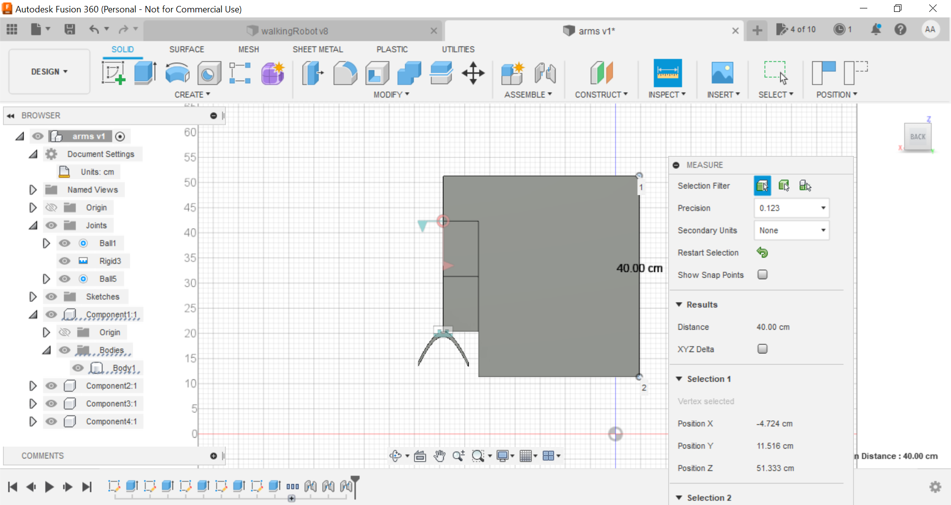

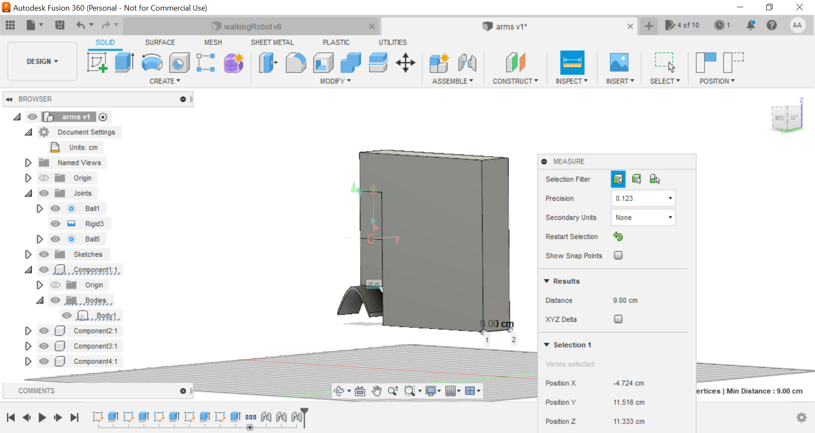

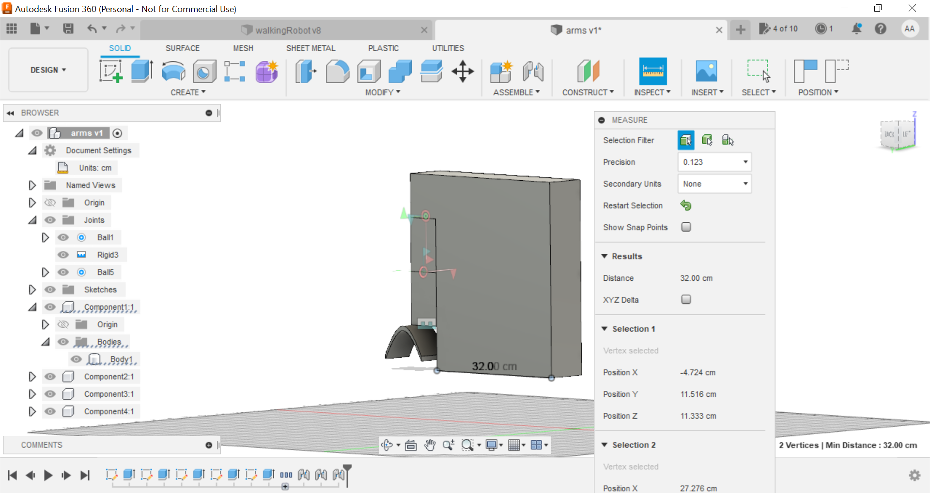

THE ARM JOINTS:

The robot arm has three joints, joint1 and joint2 moves around two axes, joint3 moves only around one.

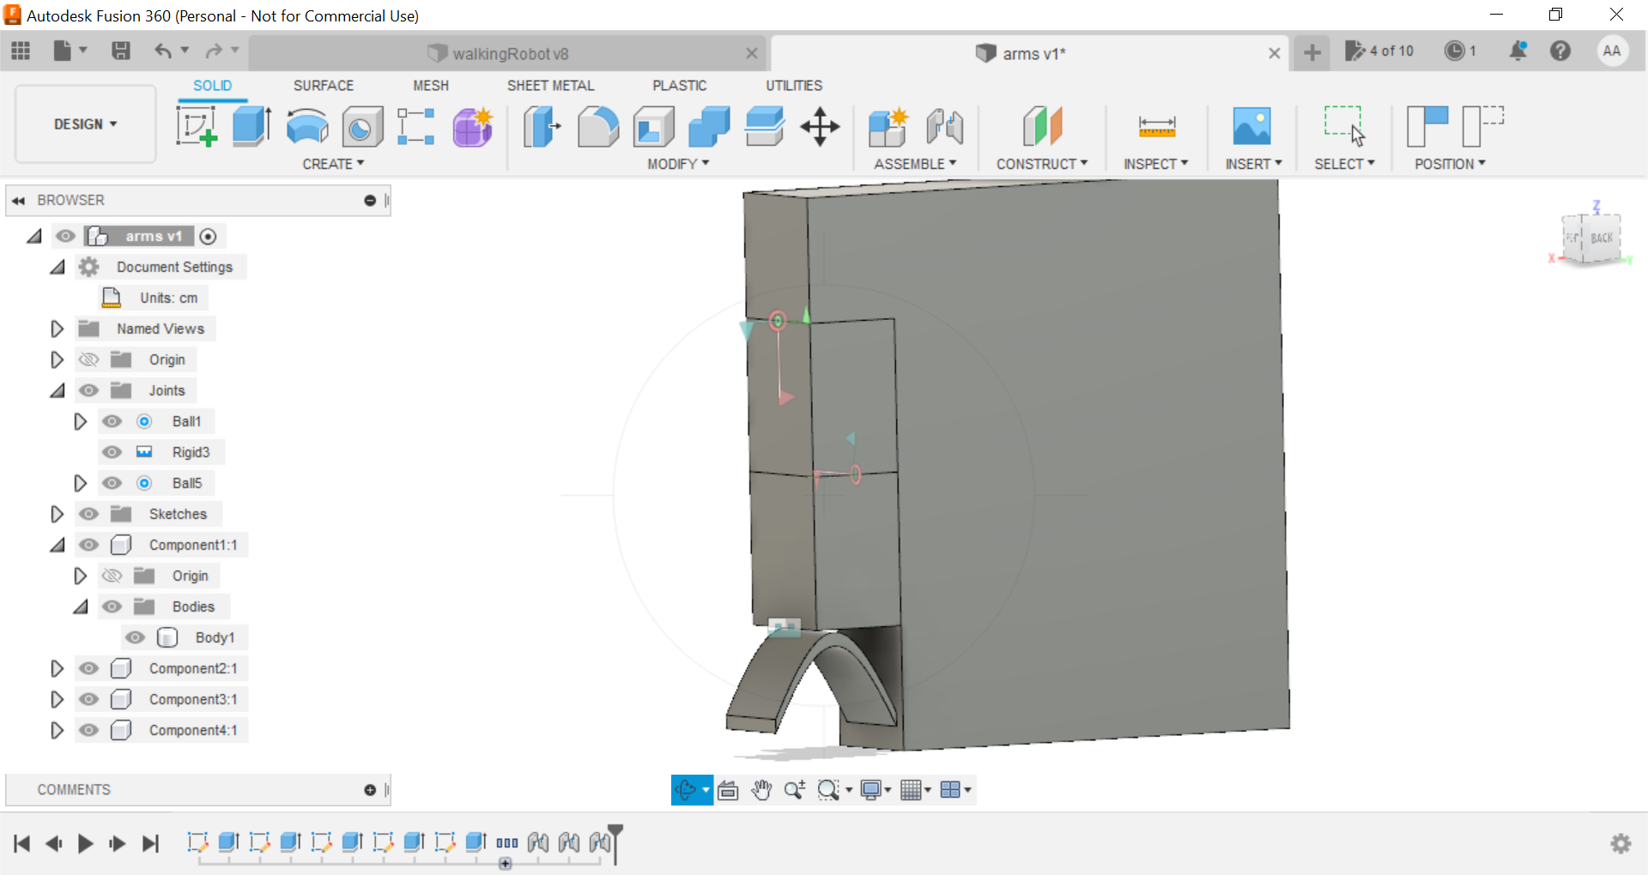

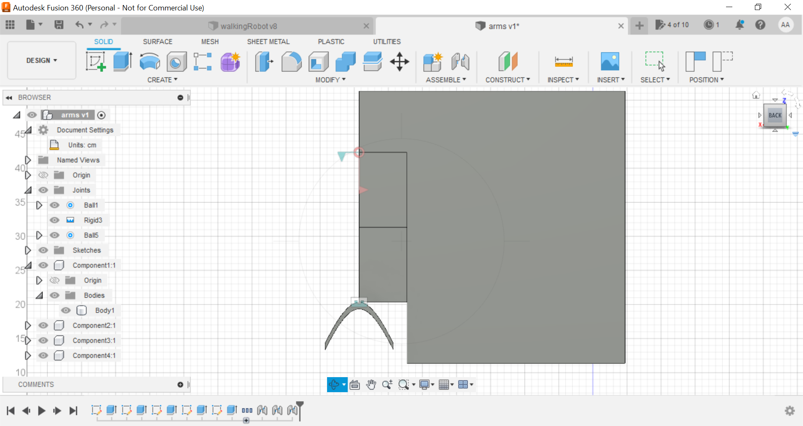

JOINT.1:

1-Around the Y axis:

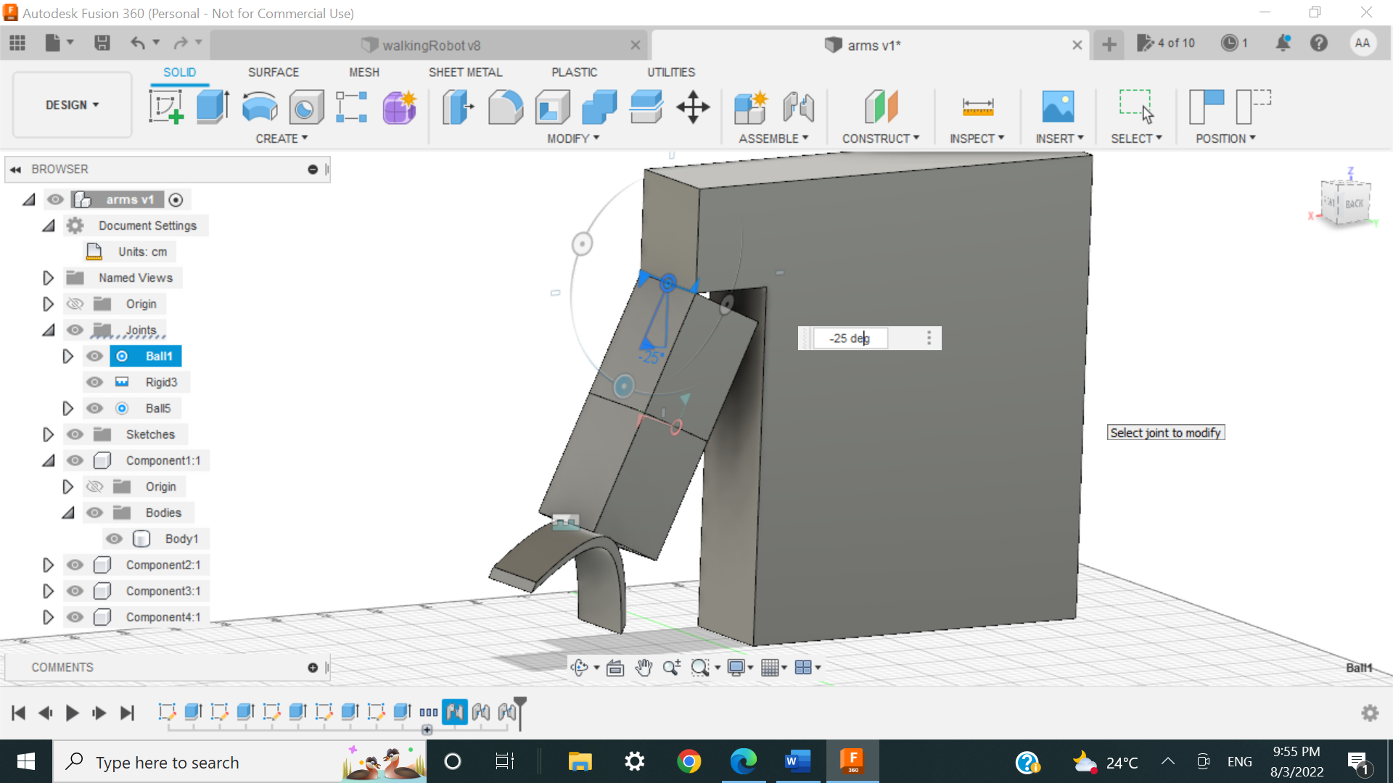

2-Around the X axis:

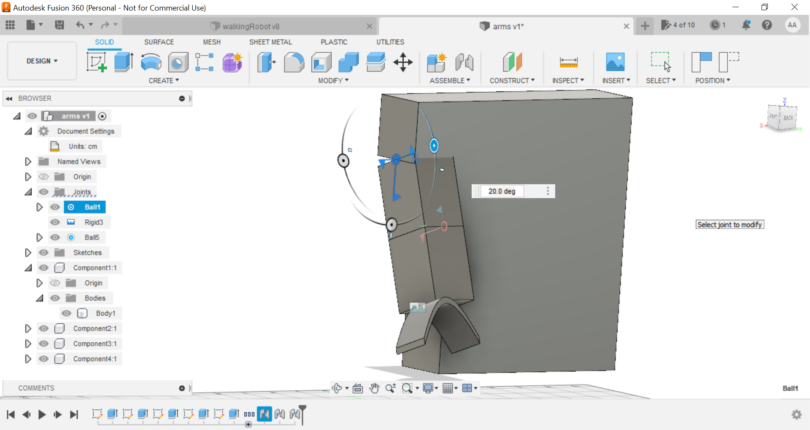

JOINT2:

1-Around the X axis

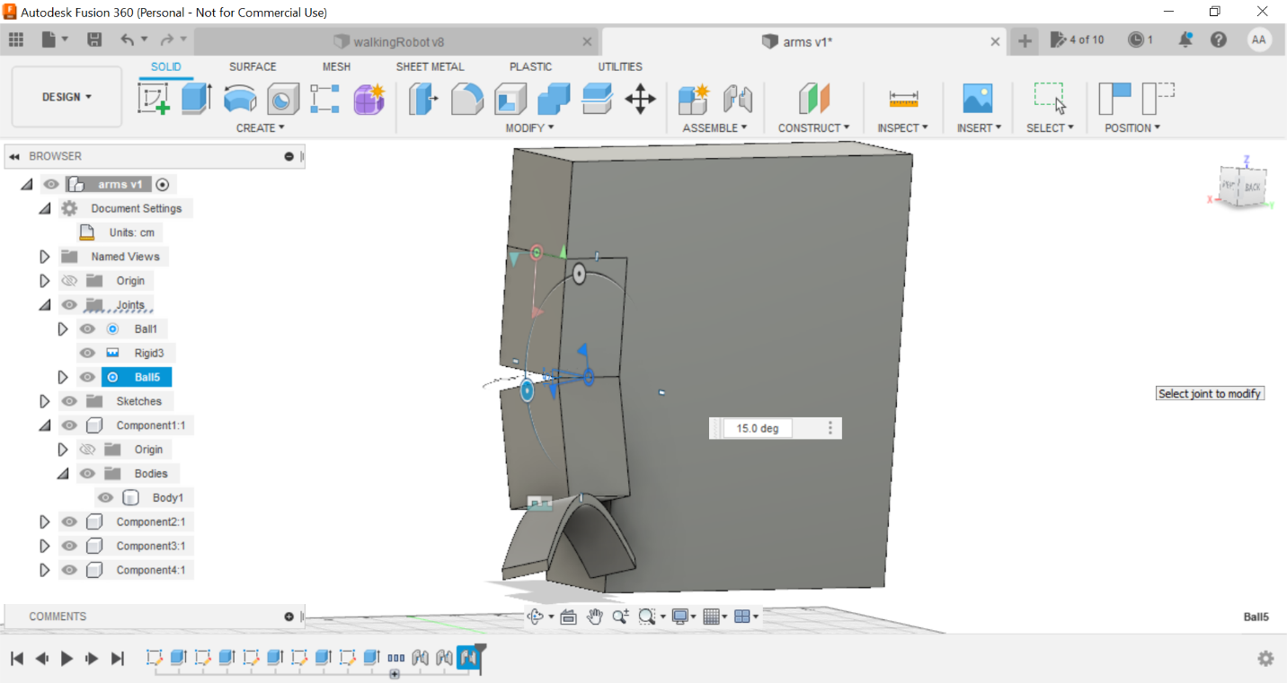

2-Around the Z axis

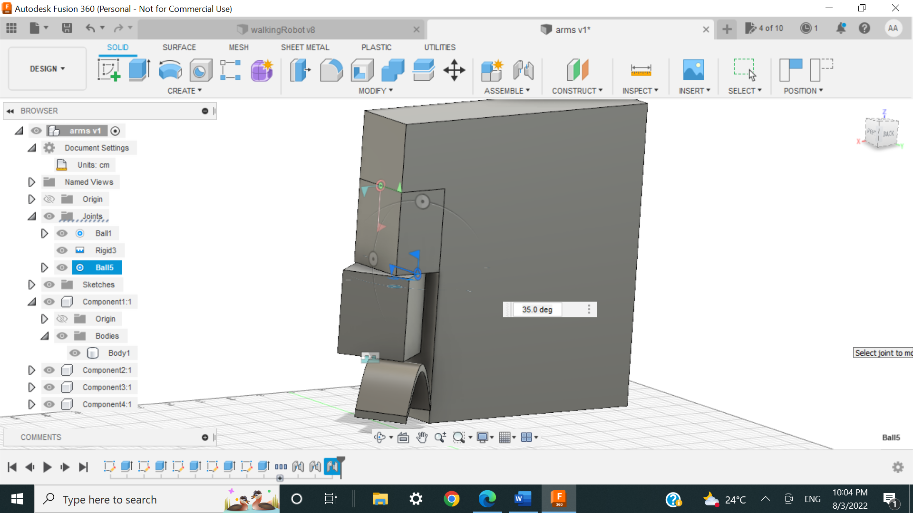

JOINT3: The robot hand rotates around the Z axis

