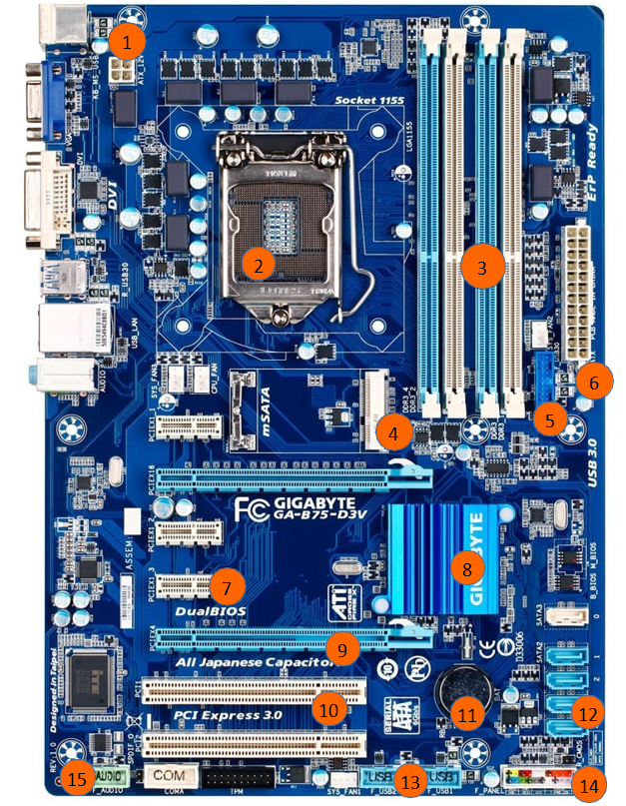

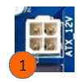

|  |  |  |
| --- | --- | --- |
| **1** | **NOM** | **FONCTION** |
| Port ATX / connecteur alim CPU |  |

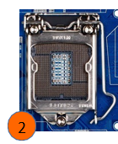

|  |  |  |
| --- | --- | --- |
| **2** | **NOM** | **FONCTION** |
| Slot processeur / socket | Accueillir le processeur |

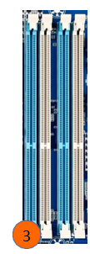

|  |  |  |
| --- | --- | --- |
| **3** | **NOM** | **FONCTION** |
| Slot mémoire | Accueillir barrette de ram |

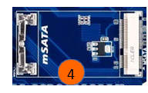

|  |  |  |
| --- | --- | --- |
| **4** | **NOM** | **FONCTION** |
| Slot ssd |  |

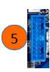

|  |  |  |
| --- | --- | --- |
| **5** | **NOM** | **FONCTION** |
| USB 3.2 |  |

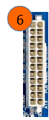

|  |  |  |
| --- | --- | --- |
| **6** | **NOM** | **FONCTION** |
| Connecteur d’alimentation |  |

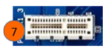

|  |  |  |
| --- | --- | --- |
| **7** | **NOM** | **FONCTION** |
| PCI Express |  |

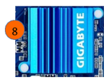

|  |  |  |
| --- | --- | --- |
| **8** | **NOM** | **FONCTION** |
| Chipset |  |



|  |  |  |
| --- | --- | --- |
| **9** | **NOM** | **FONCTION** |
| GPU | Connecteur carte graphique |



|  |  |  |
| --- | --- | --- |
| **10** | **NOM** | **FONCTION** |
| PCI express |  |

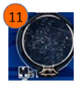

|  |  |  |
| --- | --- | --- |
| **11** | **NOM** | **FONCTION** |
| RTC Battery |  |

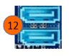

|  |  |  |
| --- | --- | --- |
| **12** | **NOM** | **FONCTION** |
| Slot Sata |  |

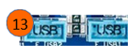

|  |  |  |
| --- | --- | --- |
| **13** | **NOM** | **FONCTION** |
| Slot USB2 |  |

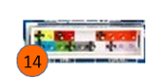

|  |  |  |
| --- | --- | --- |
| **14** | **NOM** | **FONCTION** |
| Connectique du boitier / AFP |  |



|  |  |  |
| --- | --- | --- |
| **15** | **NOM** | **FONCTION** |
| Port Audio |  |