TEMT: Design and Implementation
This project helps sustainability and supply-chain teams explore freight emissions, compare transport choices and inspect the records behind each estimate. The implementation connects an interactive landing page to a working shipment workspace, analysis API and downloadable reports.
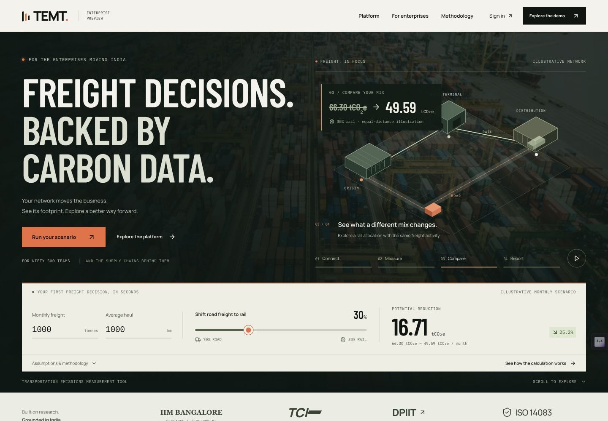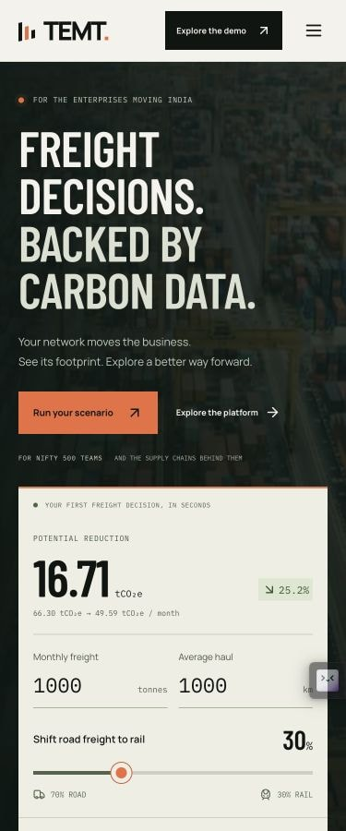
Figure 1. Desktop and mobile views of the interactive estimator. The desktop view supports scenario comparison; the mobile view presents inputs before the illustrative scene.

Implemented scope
The delivery comprises a responsive landing page, immediate emissions estimator, NIFTY 500 company lookup, editable shipment workspace, road/rail/ocean/air calculations, mode and monthly analytics, a validation demonstration, and a stateless analysis API. The workspace exports CSV, PDF and a Power BI import pack.
Audience and data. The principal audience is sustainability and supply-chain teams at India-focused listed enterprises. The official NIFTY 500 source snapshot contains 501 records, retrieved on 14 September 2026. Company names are real; shipment activity and resulting emissions are synthetic examples, not customer data.
Institutional and certification references concern the original product. The SGS statement for TEMT v1.3 covers the original TEMT v1.3 methodology against ISO 14083:2023. This preview uses a separate calculation engine and produces illustrative estimates.
Deployed application | Source repository

1. Calculation method and data
The browser and server import the same shared TypeScript calculator. Each accepted transport leg is evaluated using a published well-to-wheel (WTW) default factor. This includes fuel or energy supply and vehicle operation within the stated factor boundary.
Emissions (kg CO2e) = tonnes × kilometres × factor (kg CO2e / tonne-km)
Profile | Factor | Published scope and reference
Road: India diesel HCV | 0.0663 | 30–50 t gross vehicle weight; GLEC v3.2, p. 106
Rail: India | 0.0106 | Mixed national traction; p. 97
Ocean: dry container | 0.01145 | Middle East/India; converted from 114.5 g/TEU-km at 10 t/TEU; p. 112
Air: short haul | 1.363 | Distance ≤1,500 km; p. 94
Air: long haul | 0.788 | Distance >1,500 km; p. 94
All factors are kg CO2e per tonne-km. Source: Smart Freight Centre, GLEC Framework v3.2 (October 2025). Source URLs and assumptions are retained with the factor records.

Default estimator arithmetic
For 1,000 tonnes travelling 1,000 km by road, the baseline is 1,000 × 1,000 × 0.0663 = 66,300 kg CO2e. Moving 30% of the same activity to rail gives (700 × 1,000 × 0.0663) + (300 × 1,000 × 0.0106) = 49,590 kg CO2e. The estimated difference is 16,710 kg (16.71 t), or 25.2036%.
This compares equal transport activity and distance. It does not assess route availability, terminal movements, first/last-mile distances, capacity, cost or an operationally feasible rail substitution.

Factor and record assumptions
Published defaults already include their stated adjustments: road uses a 5% distance adjustment, 68.3% load and 14.4% empty running; ocean uses 70% fleet loading and 15% distance adjustment. Air uses a 55% belly/45% freighter mix and the published 95 km adjustment. These adjustments are not applied again. No additional aviation radiative-forcing multiplier is added. India road and rail defaults are preliminary estimates.
Each row requires shipmentId, legIndex, date, subsidiary, mode, profile, tonnes and kilometres. Dates use YYYY-MM-DD. Optional origin and destination labels describe the leg. Accepted legs aggregate by mode, month and subsidiary; filters act after validation. Compensated summation and unrounded intermediate values limit avoidable numerical error. Display rounding does not alter exported calculation inputs.

2. Data validation and API controls
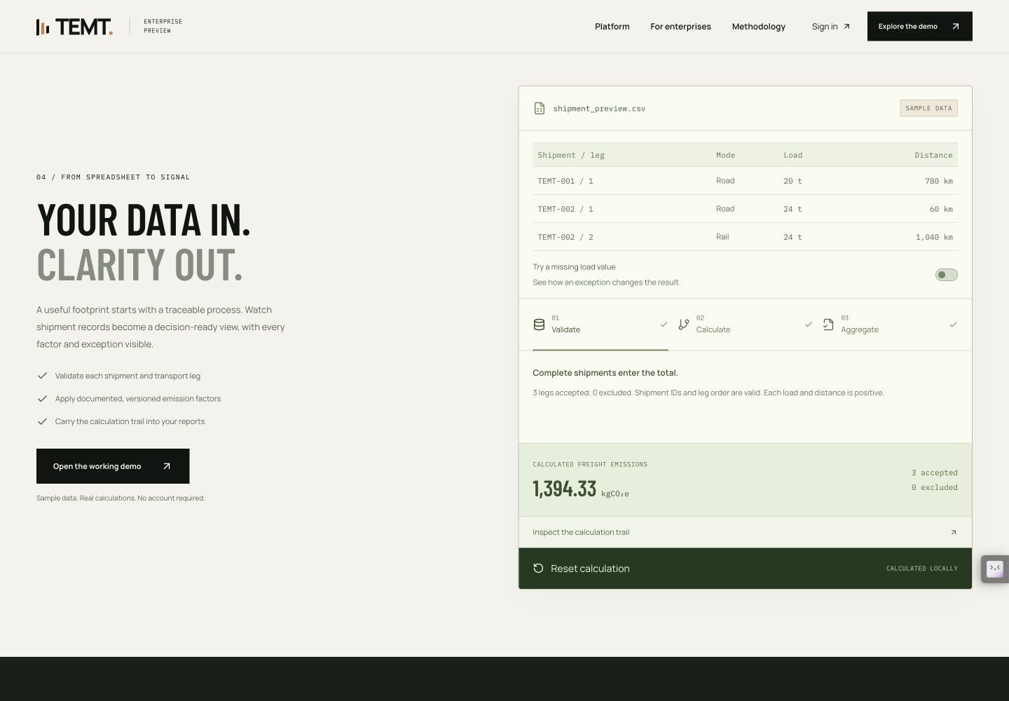
Figure 2. Validation example: three accepted legs across two shipments produce 1,394.33 kg CO2e. The missing-load control is visible but inactive.
Validation rules. Required identifiers must be non-empty and bounded in length. Leg indices must be positive integers, dates must be real calendar dates, and tonnes and kilometres must be finite and positive. Mode and profile must agree; air profiles must match the distance threshold. Numerical-range and maximum-row checks apply.
Shipment integrity. An invalid leg, duplicate leg index or missing index in a shipment excludes that entire identifiable shipment. Invalid rows without an identifiable shipment are rejected individually. Introducing the missing load in the example excludes both TEMT-002 legs; the remaining TEMT-001 leg produces 1,034.28 kg CO2e.
CSV import. Imports require a .csv file, all required headers and an explicit profile for every row, with limits of 2 MiB and 1,000 legs. Import is all-or-nothing: any parse or validation failure leaves the existing dataset unchanged. Imported rows remain in the browser until the user requests server analysis.
Endpoint | Contract
GET /api/health | Status, engine version and persistence: none; /health is an alias.
GET /api/factors | Versioned factors, methodology boundary and maximum leg count.
POST /api/analyze | application/json; body {"rows": [...]}; returns analysis and validation results.
The API uses Helmet headers, no-store responses, a 2 MiB JSON limit and a default 60-request/minute/IP limit on factors and analysis. Health and CORS preflight requests are outside that limit. Exact allowed origins govern browser access; requests without an Origin header remain possible. CORS is not authentication. Controlled error responses omit internal details. Shipment bodies are processed in memory without persistence or request-body logging.

3. Architecture and interface decisions
Deployment. Next.js, React and Tailwind produce a static frontend served from Render's CDN. A separate free Express service in Singapore performs requested analyses. Both use the same calculator package; no database is required for this demonstration. CSS animation, SVG scenes, Recharts and Lucide support the interface.
Availability behaviour. The landing estimator works locally without waiting for the API. During server analysis, the interface offers a manual ‘Process in browser’ action after eight seconds. The request times out after 90 seconds; errors or timeout use the local engine. Dataset edits invalidate stale responses, and the interface identifies the result's processing origin. The free API may suspend when idle.
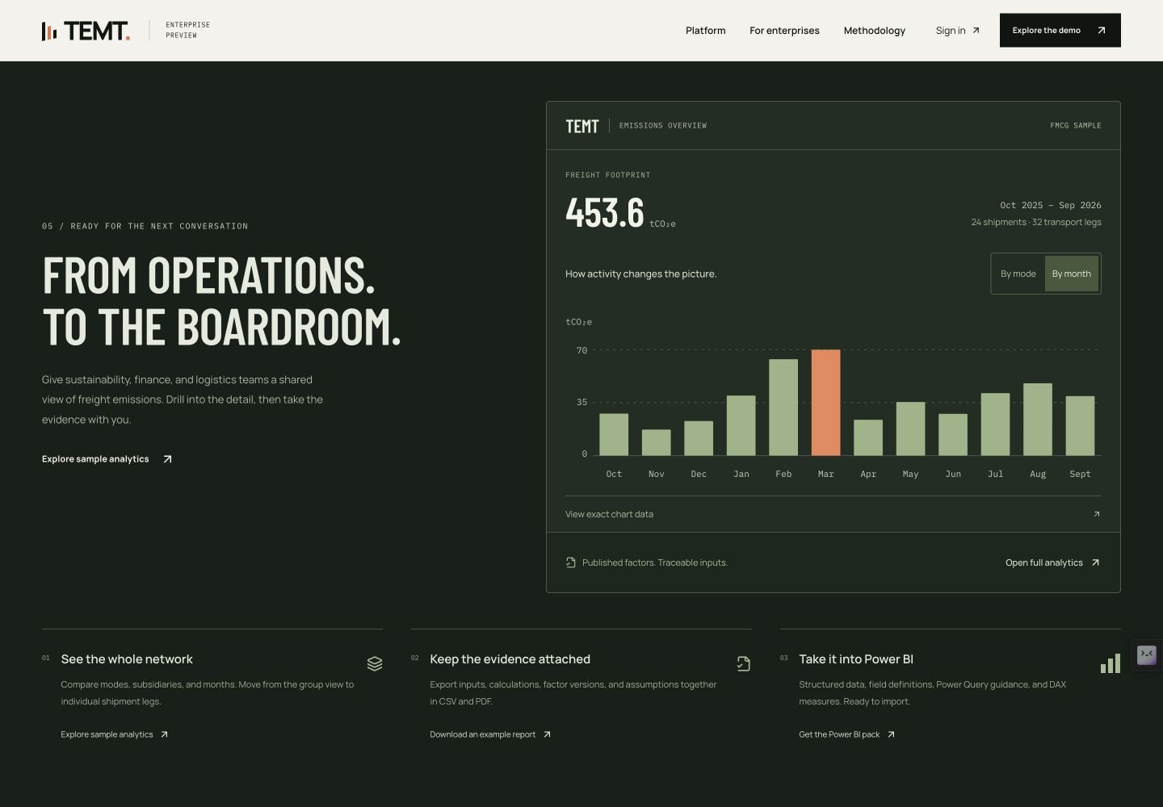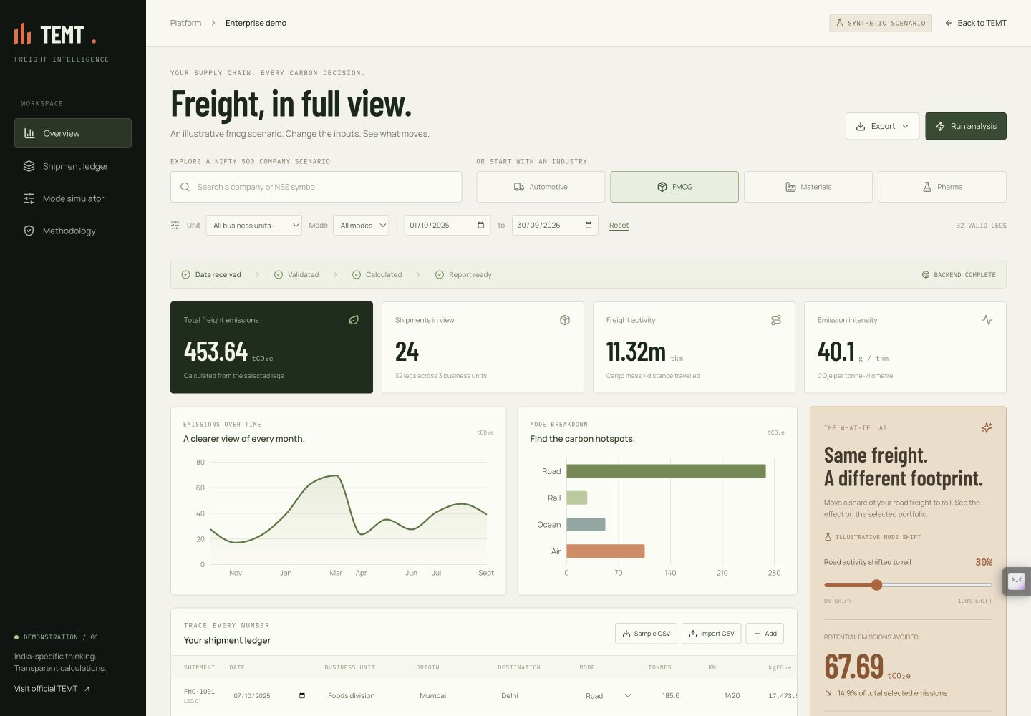
Figure 3. Landing analytics and the shipment workspace show the same FMCG sample: 24 shipments, 32 legs and 453.64 t CO2e.
Evaluation sequence. A visitor first changes freight weight, distance and rail share, then opens the workspace with those three inputs preserved in the URL. Sector and transport-mode examples expose calculated activity. The reporting preview switches between mode and month views and provides exact chart data. This sequence connects the initial estimate to inspectable records.
Interaction and accessibility. Connect, Measure, Compare and Report chapters provide context without blocking the estimator. Playback has pause and manual controls, pauses off-screen or in a hidden tab, and uses manual playback for reduced-motion or supported data-saving preferences. Mobile layouts prioritise the result and native input controls.
Reporting. The current filtered view can be exported as CSV, a PDF report or a Power BI import pack. Outputs preserve factor/version context, relevant inputs and validation information. CSV formula-injection protection is tested. The Power BI pack supports importing files; it does not establish a live Power BI connection.

4. Verification and further development
All 112 automated tests passed, alongside TypeScript checks, source-integrity checks and production builds. Tests cover calculator validation, imports and exports, API controls, filter consistency and estimator-to-workspace parity.
Public-site Lighthouse 13.4.1 | Desktop | Mobile
Performance score | 100 | 91
Accessibility / best practices / SEO | 100 / 100 / 100 | 100 / 100 / 100
First contentful paint | 0.3 s | 2.0 s
Largest contentful paint | 0.6 s | 2.9 s
Total blocking time | 0 ms | 50 ms (54 ms raw)
Cumulative layout shift | 0 | 0
Public audits ran on 14 September 2026 at 03:08 IST. Mobile used simulated 4× CPU slowdown and 150 ms RTT; desktop used 1× and 40 ms RTT. Performance floors of 95 desktop and 90 mobile were met. These are laboratory observations on a shared machine, not field Core Web Vitals or an accessibility certification.
API observation. The one-leg default scenario returned 66,300 kg CO2e with exact browser/server parity. The observed engine duration was 1.82 ms and HTTP duration, including response transfer, was 112.83 ms. An initial health request took 23.25 s with unknown prior idle time. These individual observations do not establish latency guarantees or controlled cold-start performance.

Project resources
Live application | Analysis workspace | Source repository
Sample shipment CSV | Sample PDF report | Power BI import pack
The repository includes setup instructions, deployment configuration, source references, design rationale, test records and raw performance measurements. The screenshots show the implemented interface and sample data.

Further development
Before enterprise use, proposed work includes SSO and role-based access, tenant isolation, governed factor updates, persistent audit trails, reviewed data retention, approved logistics integrations, monitored paid capacity and repeatable load testing. The current preview is stateless and requires no customer credentials.
Default-factor scenarios are not carrier measurements, a complete corporate inventory, or assured reporting. Production decisions require verified activity data and reviewed methodological boundaries.
IIMB: DPIIT adoption and ULIP | NSE: NIFTY 500 source snapshot

