AUTHORIZED PRODUCT PREVIEW / 14 SEPTEMBER 2026

FREIGHT DECISIONS.
BACKED BY CARBON DATA.
A working enterprise experience for India's sustainability and supply-chain teams.
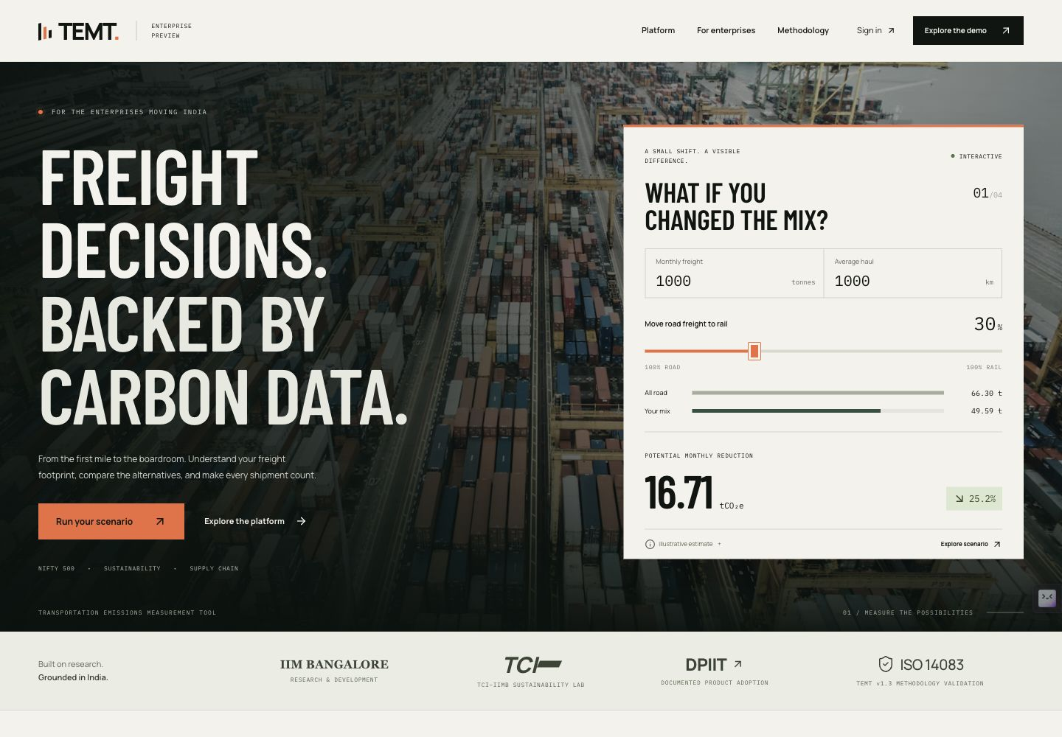
FIG. 01 The opening connects a clear product proposition to an immediate, adjustable freight scenario.
4 transport modes / 501 company records / 1 shared engine
I designed and built a responsive landing page, a shipment-analysis workspace and a real API. The journey moves from a quick carbon estimate to editable shipment data, traceable calculations and useful reporting files.
Company names come from the official NIFTY 500 snapshot. Scenario activity is synthetic; company selection does not imply a customer relationship or actual company emissions.

02 / DESIGN & ENGINEERING

MAKE THE FIRST TEN SECONDS USEFUL.
The opening is designed to create a meaningful action before asking a visitor for a sales conversation.
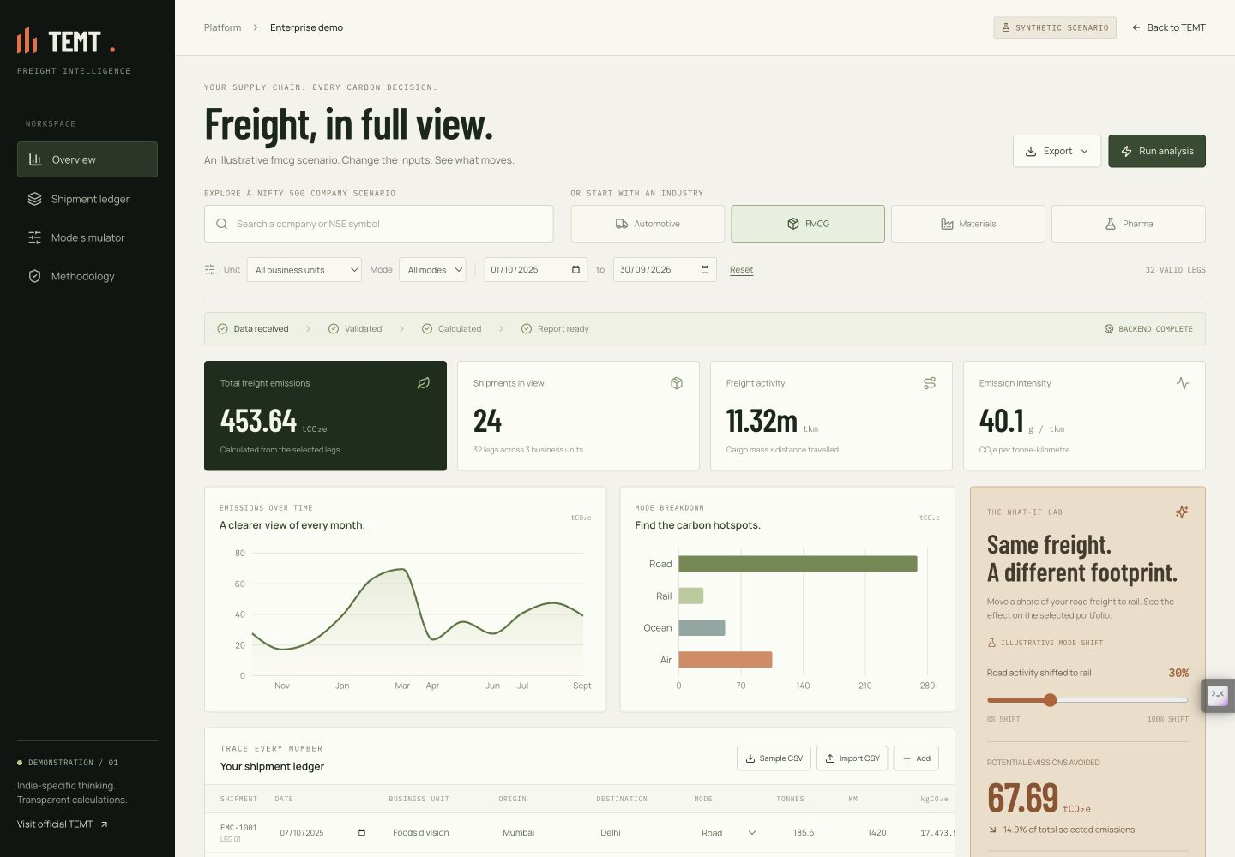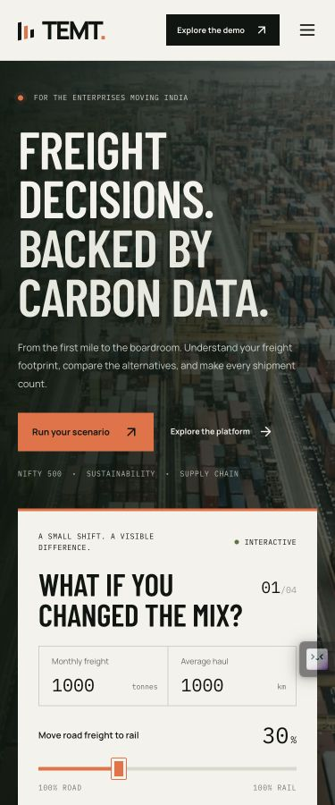
FIG. 02 Desktop workspace and mobile layout. The same product journey adapts to available space, with readable inputs and direct actions.
Recognize the problem. Condensed headlines, freight photography and an orange action color create hierarchy. The primary CTA opens a working scenario; the secondary CTA explains the platform.
Try a decision. The road-to-rail slider recalculates immediately. Four mode tabs expose their assumptions, and sector presets give enterprise teams a relevant starting point.
Stay in context. Search real company names or choose an industry. Edit shipment legs and compare the resulting analytics without losing the scenario context.
Design decision: motion signals interaction and progress. Reduced-motion preferences, keyboard operation and clear focus states support practical access.

03 / DESIGN & ENGINEERING

FROM SHIPMENT ROWS TO EVIDENCE.
The demonstration does real calculation work, with explicit validation and a reporting trail.
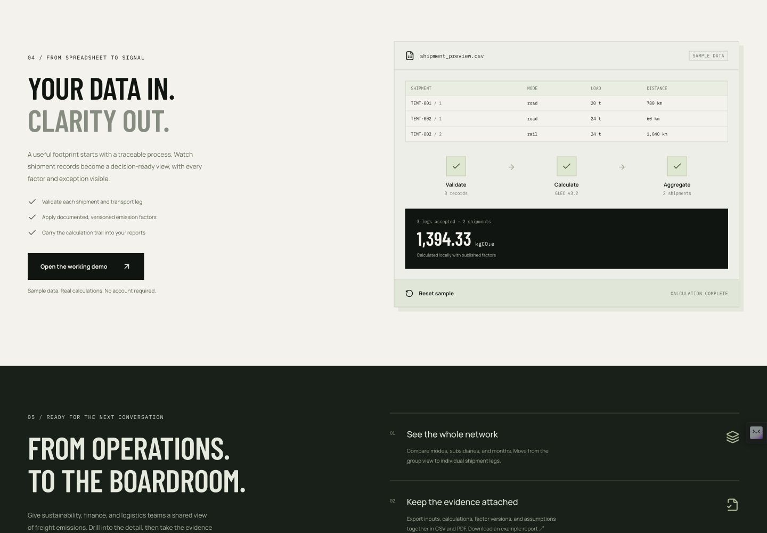
FIG. 03 The working pipeline makes inputs, processing and outcomes inspectable. Invalid shipment data is surfaced before it enters totals.
Validate. CSV import and an editable ledger support multi-leg shipments. Invalid, duplicate or missing legs exclude the identifiable shipment until corrected; exceptions remain visible.
Calculate. Each accepted leg uses tonnes × kilometres × a published WTW factor. Browser and API share the same unrounded TypeScript calculation, then aggregate by mode, month and subsidiary.
Export. Filtered results become CSV, a PDF report and a Power BI import pack. The files preserve factor context and active filters. The pack is an import workflow, not a live Power BI connection.
Methodology boundary: GLEC v3.2 defaults support scenario estimates. This separate demo engine is not the certified TEMT product, a carrier measurement system or a complete corporate inventory.

04 / DESIGN & ENGINEERING

BUILT TO BE INSPECTED.
A small, transparent architecture keeps the landing immediate and makes the server-side work demonstrable.
01 / Static frontend. Next.js, React and Tailwind export to Render's CDN. Locally hosted assets, Motion, Recharts and Lucide shape the responsive experience.
02 / Stateless API. Express processes requested analyses in memory, with request limits, validation and CORS. It does not persist shipments or log request bodies.
03 / Shared calculator. One versioned package serves the browser and API. If the free backend is waking, local processing remains available and its origin is shown.
Verification | Observed result
Automated tests | 89 passed
TypeScript and source integrity | Passed
Production frontend and API builds | Passed
Live server analysis | 32-leg parity; 4.925 ms engine
Lighthouse performance | 97 desktop / 87 mobile
Lighthouse accessibility | 100 desktop / 100 mobile
Largest contentful paint | 1.1 s desktop / 2.7 s mobile
Total blocking time | 0 ms desktop / 350 ms mobile
Cumulative layout shift | 0 desktop / 0 mobile
Results describe the tested build and conditions. They are not an uptime SLA, a latency guarantee or evidence of customer emissions reductions.
Lighthouse 13.4.1 against the public site, 14 September 2026. Mobile: 4× CPU slowdown, 150 ms RTT; shared-machine load can affect these lab results. Latest mobile performance: 87/100; the 90 target was not met. These are not field measurements.
Warm API observation: 32 legs, 24 shipments; 146.06 ms including connection and transfer. Browser/server output matched exactly. This is not a cold-start measurement.
Release engineering: locked dependencies, a retained NSE source snapshot, pinned CI actions and separate Render services keep the implementation reproducible.
View the successful CI run for the validated release

05 / DESIGN & ENGINEERING

A PRODUCT CONVERSATION, READY TO OPEN.
The handoff includes the live experience, editable source and concrete examples of the reporting workflow.
Live product: temt-iimb-sample.onrender.com
Explore the working scenario
Download the sample PDF report
Download the Power BI import pack
Download the sample shipment CSV
Review the source repository
THE DECISIONS THAT MATTER
Personalization with clear boundaries. Real company names make the demonstration relevant. Synthetic labels prevent example activity from looking like confidential company data.
A traceable commercial story. Institutional references open the original evidence. Product verification is scoped to its published version, while demonstration factors and assumptions remain inspectable.
Fast first interaction. A CDN serves the landing page independently of the API. The stateless server demonstrates backend processing; enterprise connectors and persistent workflows remain future integrations.
SELECTED REFERENCES
IIMB: DPIIT adoption and ULIP
TEMT v1.3: SGS validation statement
Smart Freight Centre: GLEC v3.2
NSE: constituent snapshot
Full source register: docs/SOURCES.md in the repository. Photography: CHUTTERSNAP / Unsplash. Fonts: Barlow Condensed, Manrope and IBM Plex Mono under their included licenses.
Validated release 63bcf04 / 14 September 2026

