**1. Illiterate of the future would not be one who does not know to read, but people who does not know how to learn.**

Learning is a streamlined process (*means with fewer errors and delays*) of strengthening thoughts by rigorous (*extremely thorough and careful*) input pulled towards knowledge development whereas reading is specific to be familiar with the written text. In the present competitive era, only commendable (*deserving*) learners can reach to vertex (*the highest point*).

It is a technological era where every single day is engulfed (*completely surrounded*) with new aspects which can only be absorbed (*engage*) and explored by brilliant learners. Reading is ability whereas learning is an adroit (*clever or skilful*) task to ameliorate (*make (something bad or unsatisfactory) better.*). Learning is a process of filtering gold dust from every possible channel.

Only a bright spark with one's adroit (*clever or skilful*) knowledge can explore the avenue (*direction or route*) to apex (peak, pinnacle). Skill of taking decision for foreseeable (*able to predict*) future is an intrinsic (*natural, innate or inborn, essential*) part of the globalization and can only be obtained by learning ability. Learning does not only imply to knowledge of specific subject but also experience acquired by our day to day activity in various spectrum of life.

Ample (*more than enough*) of examples can be taken across the globe that achieved the acme (*best*) and targeted the triumph (*victory*) with their learning ability. Mr. Bill Gates, CEO of Microsoft failed numerous times during his study but with his exemplary (*very good, perfect*) ability to learn helped him to reach on cloud nine.

To conclude, shrewd (intelligent, clever) learning acumen (*awareness, cleverness*, *the ability to make good judgements and take quick decisions*) of the person can take him a long way in reaching its zenith (*pinnacle, peak*).

**1. Illiterate of the future would not be one who does not know to read, but people who does not know how to learn.**

Learning is a streamlined process (*means with fewer errors and delays*) of strengthening thoughts by rigorous (*extremely thorough and careful*) input pulled towards knowledge development whereas reading is specific to be familiar with the written text. In the present competitive era, only commendable (*deserving*) learners can reach to vertex (*the highest point*).

First of all, there is no doubt the competition to get the job and secure business deals have surged (*move suddenly and powerfully forward or upward.*) massively. Nowadays, the companies prefer specialists than generalists, as the former possess (*own*) numerous skills in a particular area. A case in point, a hedge (limit, restrict) fund manager should not only master in fundamental analysis, but also excellent in technical analysis. Such skills will help him or her to secure the job in top companies.

Secondly, the innovation in various areas has urged lazy people to move ahead in life than their counterparts. For example, a decade back, an accountant used to put journal entries and finalizing balance sheet, while nowadays he should be computer literate with thorough knowledge of accountancy standards and principles.

Finally, the computer, communication devices, and various services have grown to such an extent that people need to be excel in all these applications. If they did not take any amount of interest or initiative to learn the information or hone (refine) the skills, then Sir Alvin Toffler statement will certainly be true.

To conclude, the people all over the world should follow Sir Alvin Toffler statement and continuously learn new information and skills in order to move ahead in their professional life or else it will become very difficult to sustain their job in this era.

**2. Some people believe law changes human behavior. Do you agree/disagree?**

Every citizen is subjected to abide by the country's law. Laws are meant to be implemented for social security, peace and order, systematic governance and so on. Besides these, there is another common school of thought on law; it can be used as an effective tool to control human behavior.

People's nature and thoughts are highly affected by national rules and regulations. People are unlikely to break law and get penalized for the same. For instance, Singapore has imposed punishment against throwing chewing gums in public places. Thus, Singaporeans are trained to that habit, and they are likely to follow it wherever they go. On the contrary, People from countries where public smoking is not banned tend to break law against smoking in foreign country.

The government, bearing social responsibility, should formulate creative laws that restrict people to indulge in bad habits. But the problem with most of the countries is that they are so much overwhelmed in their major problems that this kind of responsibility becomes a trivial matter (*unimportant*). Nevertheless, an educated society always expects behavior-changing policies from law-makers. Some examples of such rules can be on issues like public smoking, alcoholism, cleanliness, bullying and fights, racism so on.

In a nutshell, People are guided by the laws, and they do not want to break rules. The behavior and characters of law abiding citizens can be molded by country's law.

**2. Some people believe law changes human behavior. Do you agree/disagree?**

Everyone knows that laws are the rules laid by the government on the citizens of their respective country. It helps in smooth functioning of the nation by governing the behavior of people. It is disagreed that laws can change behavior of a person. It can only assist in creating a disciplined environment for the society and controlling the crime to some extent but not eliminating it.

Firstly, imposing laws has created a sense of fear among people of getting punished. For instance, damaging the historical monuments, books, paintings, sculptures or other form of art is considered a crime and is punishable under vandalism (*action involve in public and private property*) law. This example shows that a person with moral responsibility will take care of other’s assets but a person who is not worried about the consequences will deface (*ruin*) them. Thus, we can say that human’s action can be regulated by laws but cannot be changed completely.

In addition, in our day to day life, we follow rules without even realizing them. Traffic law is an example of this. Today, most of us follow the traffic signals out of habit. We stop at a red light, start an indicator before a turn and wear seat belt when we are on road. Thus, we can say that laws embed some changes in human behavior to some extent. However, we are still facing road-accidents which clearly show that rules and regulations have controlled the behavior of mankind without altering them completely.

In conclusion, we can say that rules and regulations can help in controlling the behavior that is dangerous. Laws not only help in checking the reckless (careless) nature of people but are necessary for the development of society.

**3. Many people think that regions affect successful person. What is your opinion about native region and accomplished person’s influence on the region he belongs to.**

Today the world is enrich (*improve*) with development and quality ideas. People have contributed the world to make rapid progress. There are multiple factors behind their success, people usually identify due to the regions. Whether one's success is very much dependent on his or her native regions is a moot (*debatable*) question. This essay will express complete disagreement with this statement and will offer reasons for this viewpoint.

To begin with, a variety of reasons can be offered to explain why I am not in favor of this. Foremost among these, I believe that achieving success in life depends on many factors such as determination, discipline, clear visions of your goals and ambitions, motivation and most importantly hard work. Moreover, support from friends and family around you would also play an important part in your journey to success. Although there is no doubt that being in a good and cohesive (*causing unity*) environment is beneficial, a person who is disciplined and determined to achieve his goals will find ways to his success no matter where they are.

Secondly, to accomplish anything in life required immense hard work and commitment. Success means earning respectable position, monetary gains and secured future. Industrious (*hard working*) as a key has a lion's share in achieving success and remarkable position in the society. Moreover, people those who have marked themselves as examples for others have burnt the midnight oil (*To stay awake late at night to work or study*) for reaching at desired positions. To illustrate, people like, Bill Gates, Ratan Tata, APJ Abdul Kalam and list goes other eminent personalities are the perfect cases of successful leaders in their respective fields.

To wrap up, the connection between people belong to native regions and accomplished folks have a very small or trivial effect in overall success stories of any person. Basic fundamentals will remain static and identical to earn respectable position in this universe.

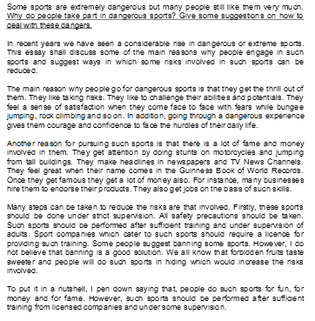

**4. Some sports are extremely dangerous but many people still like them very much. Why do people take part in dangerous sports? Give some suggestions on how to deal with these dangers.**

**5. Age discrimination occurs when a decision is made on the basis of a person’s age. In the workplace, these are most often decisions about being employed in the first place, winning promotions or being unfairly dismissed. Should discrimination against older workers be made illegal?**

Discrimination against older workers is one of the most dangerous problems facing lesser developed nations today. However, the issue is being tackled by various agencies to provide equal rights to the employees. I would like to accord with the given notion.

To begin with, every human being has the right to live equally in this egalitarian society without any fear most importantly older workers in the work place. Elderly workers should be given more respect and dignity because of their age and working experience. If this is done on workplace, the productivity will be surged up and the company may gain more profit. For instance, there is a less chance of making an error by older workers than younger because the older comprehend the protocol well and act being very careful with due consideration.

Further emphasizing my point of view, older can be a mentor to the young starter and the young workers can be an efficient worker in future. In this way, the organisation may not have to hire a trainer and spend money on training. However, if you think that older workers are not physically as strong as younger, then they still should be allocated to the lighter jobs and if older are not as smart as younger in terms of following latest technology, they should be provided training to command over the latest Information Technology innovation.

To conclude, I believe there should be a strict law and order on discrimination against older to protect the individual rights of the freedom. Government should focus on implementing policies on workplace that can protect elder abuse and discrimination so that senior workers nave feels any torture either mentally or physically.

**6. Nowadays, the mass media including TV, radio and newspaper have become the essential part of our lives. What is your opinion? OR The mass media including TV, Radio and newspaper influence our society and shape our opinions and characters. What is your opinion?**

The mass media has a very high influence in showering the light over the avenue (*direction*) of our future. It plays a vital role in deciding the way to reach to pinnacle. The media enacts (*put into practice (an idea or suggestion).*) as a common platform where people from different region stand together.

Nowadays, media is a predominant (*main, primary*) and integral part of our society. Communication from various regions can be achieved by different synonyms of mass media like television, radio and internet. It is a vast sea of knowledge. For example, social media is a mode of communication which brings people across the world together by minimum effort.

The media is also influential in developing adroit (*clever or skilful*) knowledge. Television is an exemplary (ideal) example which helps us to be familiar with the different cultural behavior, latest news, wildlife and fashions. It is a source of information which can change opinion of a person and led him to be a deciding factor in case of polling.

The effect of globalization is majorly seen due to mass media. Mass media is an impetus (*boost, inspiration, motivation*) source for business to feed into euphoria (*happiness, joy*) to perpetuate (*sustain, maintain, prolong*) the virtuous cycle (*complex chains of events which reinforce themselves through a feedback loop*). It demonstrates the object that builds a perspective (*position, view*) of an individual. The mass media works as a springboard for major brands like Walmart that are established by spreading the words across the globe using mass media.

To conclude, mass media has become a prominent (*important*) part of our society and is having tremendous impact on people’s mind and perspective (*view*). With shrewd (intelligent, clever) learning acumen (*awareness, cleverness*, *the ability to make good judgements and take quick decisions*) and power of mass media, an individual can reach to the apex.

**6. Nowadays, the mass media including TV, radio and newspaper have become the essential part of our lives. What is your opinion? OR The mass media including TV, Radio and newspaper influence our society and shape our opinions and characters. What is your opinion?**

It is apparent that the mass media has become essential part of everyone's life. Almost every family has TV set or radio. There are a lot of people who spend too much time of their days watching or reading the media. Therefore, I strongly believe that it has a great impact on people's ideas and actions. In this essay I am going to describe a positive and negative influence of media on people.

There are some good effects of media on shaping people's ideas. For instance, Television is a very convenient and cheap type of entertainment. People can relax after their work by watching favorite shows or games. They also have the opportunity to learn more about histories or lifestyles and cultures of different countries by watching films about them. In addition, people are aware of current world news from media resources.

On the other hand, it is obvious that the media has bad influence on people’s views as well. As an example, there are too many advertisements on TV or radio. They do not simply interrupt programs; some of them give false and misleading hope that happiness can be achieved by buying things. Sometimes, people go into debts in order to purchase products that they probably don’t need .Furthermore, statistics say that children mostly enjoy watching TV and video among such activities as: bike riding, art or craft, skateboarding. It is known that many of them are cruel and horror films or videos. Consequently, children harm themselves not only physically but also psychologically. They become more aggressive and more violent to people surround them.

To conclude, the media can influence on people’s views and behaviors both helpful as well as harmful. Therefore, we should know our limits and use it only to educate ourselves about what is going on around us. In this case, the mass media will be, certainly, beneficial for us.

**6. Mass media including the Internet, the television, and newspaper influences our society and shapes our opinions and characters. What is your opinion?**

Adult and children are frequently confronted (face and deal with problem) with statements regarding whether mass media influences public perception. In my view their ability to shape everything we read, hear and watch is undeniable.

Most people have access to a computer these days, and many of us have moved to a much more digital existence. We’ve gained millions of bloggers and literally billions of Web pages. The information we received can be biased, manipulated or distorted. If our opinions are developed by reading that information, surely we are vulnerable to such influences.

Televisions, a luxury possessed by few in any given neighborhood just a few decades ago are now in nearly every household. Through the television, people are able to receive a wide variety of information, ranging from international news to the latest movies. As a result opinions of people are heavily swayed (influenced) by the contents of the information delivered by televisions, hundreds of cable TV channels and satellite radio stations. Also, newspapers are still readily accessible by a majority of people. In essence (reality) they could convey false information to readers so that people cannot make independent or neutral decisions.

In short, people’s point of views and character comes from the information they have access to. Thus, mediums that deliver information to the masses such as the Internet, television, and newspapers have significant control over their opinions. (224 words)

**7. The space travel is fantastic these day and they are very fascinated towards its but there are many environmental problems in our planet we should resolve the problems or travel space and spend a lot of money. (Look Down Page for same essay)**

In my opinion, government should spend money for our fundamental needs on earth and preserve our earth as possible as they can. There are three crucial reasons that support my opinion, such as outer space is an uncertainty and we could not estimate how much money we need to spend for it, our earth is the place we live in now so that we should preserve it rather than seeking for the outer space, and our money is finite so that we should spend it on the appropriate way.

First, outer space is an uncertainty and we could not estimate how much money we need to spend for it. Whereas, we could estimate how much money we should spend for the fundamental needs in terms of our resource, population and basic spending. Furthermore, we should pursue the goal that we could achieve rather than pursue the goal that we could not know if we will achieve it.

Second, our earth is the place we live in now so that we should preserve it rather than seeking for the outer space. It's a simple logic, we should live in here and now rather than seek for something that might exist in the future. Moreover, if we regard our earth as the only precious place, we do not need to seek for the our place. In other words, we do not need another outer space if we preserve our earth entirely. Consequently, we could get what we need from our earth if we focus on preserving it.

Third, our money is finite so that we should spend it appropriately. In other words, the money that will be spend for the outer space is absolutely much more than our fundamental needs on earth. Furthermore, we should value our money then spend it for what we need. Consequently, we do not need to invest our money for the outer space if we spend it appropriately, because we could regard our earth a comfortable space and we would never want to seek for the outer space.

To sum up, according to the reasons that I mentioned above, I urge that our governments should spend money for our fundamental needs on earth.

**7. The space travel is fantastic these day and they are very fascinated towards its but there are many environmental problems in our planet we should resolve the problems or travel space and spend a lot of money.**

In recent years the space travel has become an interesting tourist destination for affluent tourists, however opponents view that there are plenty of environmental   
problems and instead use this money to eradicate the negative effects of the environment. Indeed, my view is the wealthy tourists should travel to space in order to satisfy their wants, but simultaneously   
they should also take active part to reduce the effects of environment problems.

There are various reasons of going to space travel. Broadly speaking there are two reasons. First of all, space travel is a very unique concept, where tourists can have a beautiful and breathtaking view of planets and satellites. The people have read the space information in books and watching vidoes on television which is an artifical source of information, but when they travel to space the feeling and excitement is totally different. In addition, there are few wealthy tourists who are very passionate and live to like the luxury life. There is no doubt that it is very expensive, but still they want to fulfill their wants and add a bunch of excitement in their life. A case in point, in 2013-14, a Russian and a United States billionaires travelled to Mars which costed them around USD10 million and their experiences said they just watched Neil armstrong landing on moon on television, but today they reallly saw a very different and spectacular view of planets.

While these tourists should explore their passion and satisfy their happiness, simultaneously there are various environmental problems that has erratically hampered the ecosystem. One major merits will be as these tourists are either millionaires or billionaries and they have influence with political leaders, bureaurcrats and to a some extent have a major weapon so called "power", so they should use some portion of their income to maintain environment system in a positive way. To illustrate, Prime Minister of India Narendra Modi mission of Swacch Abhiyaan encouraged not only common people, but also entrepreneurs, wealthy businessman and many more and, as a result, the city is getting cleaner gradually and recycling industry got a major boost. Another major benefit is the wealthy people income around the world hold a significant portion of a country's GDP, so it is their duty as a citizen to solve and reduce the environmental problems, for instance, global warming, climate change, pollution and many more.

To conclude, space travel is slowly surging and wealthy tourists will get attract in order to pursue their passion and satisfy their wants. In my view, they should surely go to space travel, but as a citizen they should also make sure that they are contributing some form of help to solve the environmental problems.

**8. Globalization, advantage and disadvantage.**

Globalization is such a commonly used term in the twentieth century. It simply means that the world has become integrated economically, socially, politically and culturally through the advances of technology, transportation and communication. It is undeniable that globalization has resulted in both positive and negative effects which must be addressed accordingly.

Globalization has a beneficial influence on our lives. Globalization develops local economies. So, it helps nations to decline an unemployment rate and raise economic growth. Furthermore, globalized economy advances technology. For example, when a multinational company establishes a factory in a developing country, the new equipment, the new management skills and job vacancies are all in the best interest of the local society. Moreover, globalization has transformed world into global village. As a result, people all over the world can communicate together easier than the past by internet and satellite TV.

On the other hand, nobody can deny the devastating (*damaging*) consequences of globalization. One of crucial side is cultural shock. Worldwide networks and televisions have severely affected young people. These facilities have escalated (*increase rapidly*) cultural differences and generation gaps. For instance, when young aged persons watch popular superstars like singers, actors, actresses etc., on satellite channels. They imitate their behaviors, clothes, etc., that it leads to misbehaviors among adolescents (*teenager*). In addition, another critical impact of globalizing is the danger of epidemic (*widespread*) diseases which can easily spread because of faster transportation and increasing in number of tourists. This statement is proved in the recent bird's flu disease which has infected most Asian countries over a short period of time.

In conclusion, although globalization has sparked a heated debate in recent decades whether it is a blessing or a curse (*phrase used to express anger*), I believe that globalization is playing an increasingly useful role in today's communities but we should not ignore destructive side effects of globalization as the unhealthy dependence among countries is another concern in relation to globalization.

**9. Company’s top level authorities should get their employees in decision making process. Discuss.**

Organizations are designed and run by the group of people. Top management and the employees club together to make a successful and profitable company. The contribution of management and its employees are very crucial in making the company prominent among others in the industry. Therefore while making decisions and policies the top management should also consider the employees who are giving adroit and remarkable efforts.

The employees who are part of the running business and are playing active role in achieving company’s goals and objectives should be considered while make important decisions. The employees who are immense experienced can give more innovative ideas for bright future of the organization. In most of the business the employees are facing business clients and therefore they can make better decisions to improve business productivity. Employee empowerment will bless (praise) more innovate ideas to grow and improve business cycle.

In contrary, few people are not convinced with the employee empowerment because the plausibility (believable) of an employee will be difficult. They believe that if decision and policies right will be given to employees then they may misuse and may take decisions for their personal favor. It will deteriorate company goals and objectives and may diminish (decline) the business growth and profits.

In conclusion, the employee empowerment will appreciate and accelerate the business productivity if decisions are made in right directions but in contrast if it goes in wrong way then the organizations future will be in danger.

**10. Parents should be held legally responsible for their children’s acts. What is your opinion? Support it with personal examples.**

No, parents are not held responsible for their children's acts.

Most parents raise their children the best that they can. You can teach a child right and wrong, and you can give punishments where you see fit. However, when a child grows up and starts to spread his/her wings, their choices are no longer entirely in control of a parent. You can do the best you can do as a parent, but when the time comes to let go, a parent loses some control.

Parents should not have to take the punishment for their children. Most parents love their children and always try to keep them on the right track and show them right from wrong. If a child should suddenly act out and start hanging out with the wrong crowd the parents most definitely would want their child to stop. Most likely the child will not listen and go get into trouble then end up calling the parent and expecting the parent to bail them out. No parent should have to take the blame for their children's mistakes, but instead let the child get there consequence.

Parents are not the one sending their kids out there to kill and to rob people house. Parents try their best to keep their kids under control but their kids just won't listen because they are not leaders they are followers. I have experience days that when kids are in school they are disrespectful to their teachers and when they go home they are like little angles and they have the most respect in the world understand that some parents don't do anything to their kids for being disrespectful but it is not their fault that their child don't want to listen to them.

yes, parents are not held responsible for their children's acts.

Parents, not teachers, are the primary educator, therefore they should be morally and legally responsible for the actions of their children; but up to a certain limit. The child is taught how to act in public situations by their parents. But I think there is a certain point where the influence of peers is greater than a parent's influence.

A child is basically the reflection of their parents. Moreover, Parents are a role model to their child. They set an example of how they should act and show they what is right or wrong. I feel if a child is taught discipline and moral values than a child is less likely to create problems. Those children who do not receive those lessons early in life will less likely follow the rules.

Children are not born with a bundle of cash in their pocket. Thus, making it impossible for them to support themselves and buy the essential things they need to live. Parents should be morally held because they're the ones who are setting examples for their child. Parents should also be held legally responsible because they're supposed to tell their child the rules and regulations of schools, houses, public places, and the world and if the child doesn't know any of these rules it is the parents fault and should have taught them better. Some say that when your child gets to a certain age they're allowed to make their own decision and parents shouldn't be held responsible but by the court of law a person with a family or parent will have to be responsible for the person. So even at a certain age that their child is able to make their decisions a parent or family member is still responsible for them.

**11. Television**

1.Television is now playing a very important role in our lives.

2. Television is not only a convenient source of entertainment, but also a comparative cheap one.

3. Television keeps you informed about current events. It allows you to follow the latest developments in science and politics.

4. Many television programs introduce people to things they never thought of before and have never heard of before.

5. Television has been good company to those who do not work, like housewives, lonely old people, etc.

6. People all around the world are no longer distant and isolated from each other.

7.It brings most distant countries and the strangest customs right into your living room.

8. Compared with radio, everything on television is more lifelike, vivid (*producing powerful feelings or strong, clear images in the mind.*), and real.

9. Television may be a vital factor in holding a family together.

10. Television keeps people informed of the news and weather. disasters like floods, winds, etc.

**Disadvantages**

1.Television is a great time waster.

2. Television takes up too much of our time.

3.We no longer have enough time for hobbies, entertaining activities.

4.Other outside amusements like theaters, movies, sports, etc get ignored.

5. People have grown addicted to television, often neglecting the necessary and more important things like meals, sleep, and even work.

6. The more the viewer watches television, the lazier they become. The TV glues them to the set instead of allowing them to go out.

7. Television prevents people from communicating with each other.

8.It has done much harm to the relationship between family members.

9. Families sit and watch television at dinner instead of talking with each other

**12. Causes and Effects of Global Warming**

Global warming is not a scary myth that scientists have made up, but a very real natural condition that is affecting the world more and more each day. Global warming is the warming near the earth's surface that results when the earth's atmosphere traps the sun's heat. The changes are small, so far, but they are expected to grow and speed up.

One major cause of global warming is the use of fossil fuels like coal, oil and natural gas. The worldwide consumption of fossil fuel has increased dramatically. As the carbon dioxide from burning fossil fuels enters the atmosphere, some of it is taken up by photosynthesizing plants, and the oceans absorb some. But because we are burning so much fossil fuel at such a rapid rate, we are putting carbon dioxide into the atmosphere much faster than these natural processes are taking it out. There is no longer a balance between the amount of carbon dioxide being added to the air and the amount of carbon dioxide being removed. As a result, the concentration of carbon dioxide in the air is steadily increasing.

Deforestation is another major cause of global warming which makes the problem of the greenhouse effect worse in two ways. When trees are burned, carbon dioxide is released into the air. To also eliminates countless numbers of carbon dioxide-absorbing trees from the environment.

There are solutions to global warming, thankfully. Scientists and governments are working together to create ‘greener’ alternatives to daily life. People don’t have to give up their vehicles, but they may decide to choose hybrid cars instead of fossil fuels. Wind turbines and other sources of renewable energy can prevent the burning of coal, which is a major contributor to CO2. Planting more and more trees is another solution to this problem.

**12. Causes and Effects of Global Warming**

Since last few decades climate change is afflicting our planet severely. What really is the proper role for individuals and institutions in addressing climate change? An immediate and natural response may be that everyone should do their part. Yes it's is the duty of the government, companies, and individuals to reduce carbon emission to save the planet. This essay will outline the role of each party in combating climate change.

First as individual, we must significantly reduce the amount of heat-trapping emission we are putting into the atmosphere. For example use of public transport instead of car or bike to commute to office regularly by which we can save our own money and reduction in carbon dioxide emission.

Second the institutions or the company decisions affecting carbon dioxide (CO2) emissions, for example, decisions by companies about how to produce electricity, as well as thousands of other goods and services with less carbon emission.

Third and last to fully address the threat of global warming, we must demand action from our elected leaders to support and implement a comprehensive set of climate solutions: such as

Expand the use of renewable energy and transform our energy system to a cleaner one. Place limits on the amount of carbon that polluters are allowed to emit. Build a clean energy economy by investing in efficient energy technologies, industries, and approaches. For example, increasing in solar energy plants and decrease in thermal power generation. Reduce tropical deforestation and its associated global warming emissions.

Finally to conclude it is everybody responsibility to control the global warming to give better future to our next generation.

**13. In a war of ideas, it is people who get killed”. Does a common man suffer from a group’s ideology? Express your opinion, and support the same with reasons and examples.**

Throughout history, the thinking of a group of people is impacting the lives of thousands of civilians. Whether it is considered on a political or social level, a set of decisions of a group explains how a society should work.  It is completely agreed that in the conflict of interest between different countries or different groups within same country, it is the innocent people who sacrifice their lives. It can be seen from the incidents of World War II and September 11 attacks in United States of America.

                 First of all, during World War II, a group of countries namely US, UK and China united and attacked Japan with explosive atomic bombs destroying the cities of Hiroshima and Nagasaki, killing more than one million civilians. This is a clear example of the decision laid by a few countries against Japan to surrender to its Allies. Though, these countries achieved victory in their mission but Japanese people are still suffering from the radioactive radiation effect which resulted in blindness and mental disorders. Thus, we can say that political ideologies of a group can drastically harm society.

                In addition, September 11 attacks on US by a group of 19 militants, associated with Islamic extremist group, hijacked four airplanes and killed around 3,000 people by colliding airplanes into symbolic US landmark. This example clearly shows how the decision and planning of these terrorist activists took lives of thousands of innocent people.

                Looking at the above examples, we can say that it is common man who is suffering from the social, economic and political interests of a few people.  It is hoped that in future, the major decisions concerning every citizen or the civilians of another country, would be taken considering its consequences.

**14. Value added by travel in Education. Is travel a necessary component of education or not? Will scholar sitting at home have more knowledge?**

**Or**

**Travel to study is over rated; we have brilliant scholars who studied locally. Is travel really required for higher studies?**

In today's globalized scenario, numerous doors of opportunities have opened and people can now move to another place without any hurdle. In this Modern contemporary world, it is now trending to travel another place for achieving studies. However, some people argue that for attaining knowledge it is not necessary to move other places and our world got brilliant scholars who completed their study in their native place. According to me, international education widens student perspective and gives them tremendous and better career opportunities.

There are ample of reasons for supporting international higher studies, First of all, it is an opportunity to learn different culture and to adapt that which also enhance tolerance quality within us. In addition to, Travel alone to another country for education develops responsible behavior in young students and give them an opportunity to focus more on their study.

Moreover, acquiring globally recognized qualification opens many job opportunities for the student in almost every corner of the world. For instance, a person who holds international MBA degree gets priority for a job as compared to other domestic management students. However, travel to study has its own drawbacks such as higher cost, living alone develop homesickness in students and sometimes students also do part time job along their study to bear cost which increases burden on them.

To recapitulate, although travelling for higher education has some disadvantage, but its advantage outweighs drawbacks. Hence, travelling to another country for higher education is a key to success in this globalized planet.

**14 Travelling to study is discussed to be overrated; there are many brilliant scholars who study locally. Is travel really necessary for higher achievement?**

In recent years, there is an ongoing debate about whether travelling is an indispensable (essential) part of a qualified education. It is believed that especially in developing countries, students who travel abroad will acquire a far greater likelihood of gaining higher achievements.

Firstly, by travelling students may access to better academic resources. For the developing world, less qualified universities exist, leading to greater competitions among high school students and insufficient learning opportunities. If students travel to countries, such as Australia, qualified teaching resources are more easily accessible due the abundant supply of educational facilities and knowledgeable teaching staff. Thus travelling can increase a student’s chance of receiving higher education.

Furthermore, be exposed to exotic culture promote the likelihood of achieving a rosy career (successful) success. Whist they may already be brilliant scholars, travelling provides students with the tremendous opportunities to gain further knowledge and experiences. For instance, intelligent African student often choose to study Agriculture in Australia, so they can bring valuable farming skills to their home country.

However, travel is overrated for unmotivated students as they are likely to squander (waste) learning opportunities yet for the hand-working students, travelling is a doorway to career success.

To conclude, for most students in developing world, travelling for study is more beneficial than studying in the hometown as travel provides the diligent (hard working) students with a wealth of educational and cultural experience vastly increasing their likelihood of being success. (234 words)

**15. Education is the biggest barrier in my learning - Einstein. What do you mean by this? And do you think Einstein was correct in saying that.**

            Education is an effort of the senior people to transfer their knowledge to the younger members of society. In traditional education system, the educational system was too small and the content of education was related to religion, philosophy, metaphysics and scriptural subjects. This is the reason why Einstein considered education to be the biggest barrier in his learning. This essay will analyze both sides of the argument.  
            According to Einstein, students learn through a formally designed education pattern restricting their thought process. Also, there are some rigid (fixed) rules like age of admission, content and duration of course, procedures of examination, selection of elective (*optional*) subject, which are designed by government or designated agency such as school. The students are taught and given the answers to the questions and these questions come in the examination to test their retention power. Thus, students are not encouraged to think out of the box and search for solution themselves. They all are expected to provide the same answer which is in books. This example shows why Einstein believed that formal education hinders the process of learning.  
             However, in my opinion, education in schools is important for children as it provides disciplined environment, proper guidance from teacher, extracurricular activities to develop basic skills like reading and writing. In addition, modern day education is aided with a variety of technology, computers, projectors, internet, and many more. There is much to learn and more to assimilate (*understand*). For instance, internet provides vast knowledge and students should be allowed to search the answers to their problems themselves. This will help them in coming up with different solutions and succeeding in life. Thus, we can say that education plays a vital role in the initial learning phase of children.  
             Looking at both sides of the argument, we conclude that the current education system is the building block of learning through proper teacher’s guidance and using new technology such as internet.

**16. What is the best invention of last 100 years, computer, antibiotics, airplane, and explain why.**

**OR**

**In the past 100 years, there are many inventions such as antibiotics, airplanes and computers. What do you think is the most important invent for the past 100 years? Why?**

It is evident that science and modern inventions have revolutionized the world and is a blessing to mankind. With the advent (*arrival*) of computers, antibiotics and airplane, humans have progressed in all spheres (*area*) of life.  In my opinion, computers seem to be the greatest inventions of all times. This could be clearly seen by looking at its multitasking capabilities, ability to store information and utility in almost all fields.

                First of all, computers can do numerous mathematical calculations with incredible speed and pin point accuracy. For example, a computer can simultaneously execute more than one task, thereby increasing the productivity and reducing the human errors. This makes it clear how the human involvement is minimized by just supplying data to the computer for evaluations and getting results in fraction of seconds. Thus, I can say that computer is one of the most outstanding innovations of the last century.

                Secondly, computers can store large amounts of information and a user can retrieve it later for further processing. For instance, trend analysis and forecasting in a company are done by referring to historical data. These examples illustrate the usefulness of computers for measuring the success of a company.  It is obvious from this that the computers  have contributed significantly to the world’s economy.

                Finally, there are many uses of computer in different fields of work. Engineers, architects, jewels, and film-makers all use computers to design things. Teachers, writers, and most office workers use computers for research, word processing and emailing. Small businesses can use computers as a point of sale and for general record keeping.

                In conclusion, we can say that computers are the top innovations of all times considering high speed processing at a time, high storage facility and presence in almost every field. It is hoped that new software’s and hardware’s will keep on making the computer better as life without computer seems to be like a rose without petal.

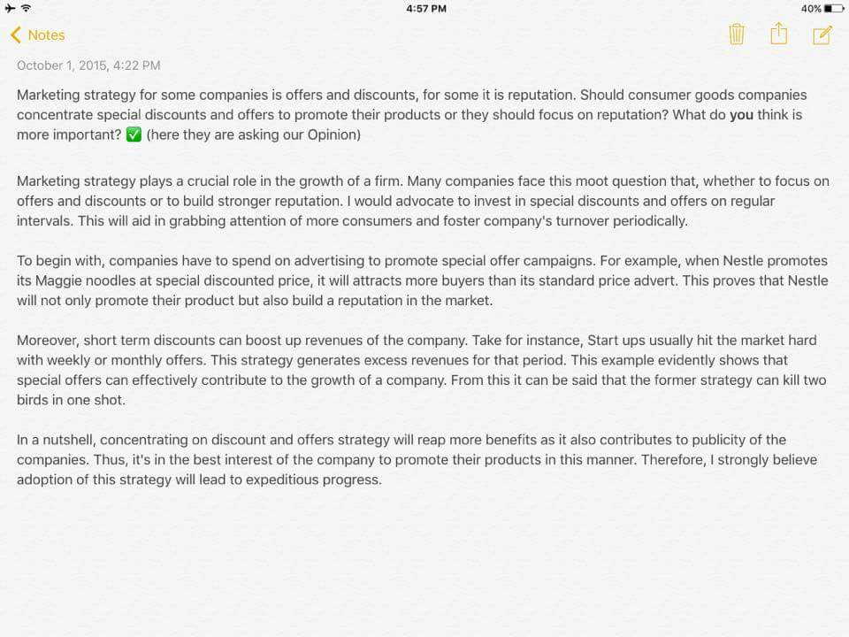

Vocab for Marketing strategies - **Moot** - debatable, **advocate** - support, **foster** - encourage the development of, **expeditious** - speedy, rapid, **reap** - get, **advert** - an advertisement.

**17. Marketing Strategies for some companies are offers and discounts, for some it is reputation. Should consumers goods companies concentrate special discounts and offers to promote their products or they should focus on reputation? What do you think is more important?**

**17.** **Marketing strategy for big companies should be placed on offer and discounts, and in what ways this can impact on their reputation.**

With globalization and rise of industries, the competition to be the best and on the top of the market has also increased. Companies use various methods and strategies to compete with each other. One of these measures is placing offers and discounts on their products. This essay will discuss the influence of this strategy on its reputation.

To begin with, discounts and offers placed on the products increase its sales. Many times people buy products which are not required only because there is a discount on it. This helps the company to make the consumers aware of their product in the market. When a product is newly introduced in the market, a low price is quoted, so that the buyers give it a preference over the other known items. Once, the buyers are familiar with the product and the sales increase, the discounts are taken off. This is a very lucrative method used by the companies today.

Nevertheless, sometimes these strategies fail. Many times people doubt the quality of the products with offers. They think that the materials used to make those items are cheap and low quality and hence do not buy it although they are available at a very low cost than the other similar products. Furthermore, people buy these items only till the offers exist and once the actual price is quoted, they think it is highly priced and hence avoid buying it. Some consumers have a liking towards a particular company product and do not buy items from other companies. This results in loss to those industries which are selling their products with offers and discounts.

To conclude, although offers and discounts increase the sales of the products, companies should also think of its reputation. They should also develop other strategies to attract consumers.

**18. In education system, assessment through formal written examination still valid? What is your opinion.**

Formal written examinations are conventional ways of gauging (*calculate*) skills of students. Not all ,but there are many who advocate (*support*) that few hours testing system cannot truly reflect the actual talent and skill of students ,and argue that it should be removed from our education system. Personally, I do not concur (*agree*) with them; however, I firmly believe that written tests should get higher weight in assessing students though, other new methods of assessment can be incorporated.

Writing is an effective way of expressing thoughts and ideas. That is why, it has been used as primary tool in our examinations till now. Such regular written tests conducted throughout the academic year creates competitive feeling among students, and they work harder to achieve good grades. Moreover, written tests are supposed to be more fair than any other forms.

On the other hand, one cannot overlook the fact that student's whole year performance cannot be measured in few-hours final written exam. For instance, student gets failed if he does not appear on exam day due to illness or other reasons; this is totally unfair. To make the examination system more effective, nowadays most of the schools have already started taking multiple unit tests throughout the year, and each tests carry certain weight on final mark-sheet. Furthermore, some other form of tests such as computer-based, oral and presentation skill tests should be included in exams.

In conclusion, our education system should continue formal written examination; yet incorporating (*include*) other new methods of skill tests can improve it.

**18. In education system, assessment through formal written examination still valid? What is your opinion.**

The evaluation examination system for students for their knowledge and skills assessment is been under discussion for long time. Formal examination system is the first system assessment of students for their course work and abilities. The system of continuous assessment for students introduced to ameliorate (*make better*) in the examination system for better results of assessment. One group people are convinced with formal examination system and the other group of people argues that continual examination system is better because the formal examination system only test the memory of student not skills and expertise.

The formal examination system is under practice since a very long time. It is effect to test students’ memory that how he has gained knowledge and his interest during the studies throughout the year or semester. The exam which is given under invigilator under strict environment that a student cannot take help from anyone or others resources of knowledge will give optimum level of assessment. Since the formal assessment system is taken once. It does not consider one’s student health and other personal problems which can affect the examination result. In what condition students are giving his exam, how the student arrive the examination center, during his travel he may face some unlikely conditions which can affect the evaluation result.

In contrast, there is another system of examination which is a continuous examination system throughout the education. It involves assignment, project and practical tasks. It evaluates different levels of skills and abilities of a student which he learns during the studies. It also keep student busy and do not give stress to the student to have a cumulative exam at once. Student is unfairly to be affected with nonacademic factors through the education. Therefore, it will be useful to evaluate the rights skills and knowledge in the student. This system may not evaluate the memory of a student which is also an indispensable (*essential*).

In conclusion, the formal examination system evaluates the memory of a student and the continuous system evaluates the skills require to work on the ground. Therefore, the combined education approach will lead to avail both the benefits and can club together and lead an optimum result.

**18. In education system, assessment through formal written examination still valid? What is your opinion.**

In recent years, we have all been exposed to media reports concerning whether written examinations are essential in or education system. In this essay, it will draw conclusions based on both sides of the arguments.

Firstly, written examination is an objective (fair) approach to assess students capability .All students are exposed to same exam settings with unambiguous (clear) marking criteria, which aim to avoid subjective (unfair) marking that occurs in other types of tests. The objectivity of written exams can be illustrated by the rising importance of a highly standardized college entrance test in China. Every year, the sheer number of students takes the test and hundreds of universities acknowledge its validity. By excluding human factors, the test is deemed (judge) impartial so that students academic performance can be fairly assessed.

However, written examinations may bring about some detrimental (negative) side effects that undermine (reduce) its objectivity. Due to the significance of some written exams, students may under enormous pressure so that they are unable to excel their full potential resulting in an unsatisfied test result. For example, my brother was a gifted high school student who devoted to painting most of his time. Unfortunately, drawing is not one of the testing subjects in the college entrance exam and this talent was not access by such form of examination. The low school performance did not give him an opportunity to attend the university he wished. Hence, the written test cannot said to be a true reflection of student’s ability.

In conclusion, there are both merits, such as being objective, and dements, such as being partial in some situation associated with formal written examination. Overall, it is argued that advantages outweigh the drawbacks. .(262 words)

**19. In some countries around the world, voting is compulsory.  
Do you agree with the notion of compulsory voting?  
If Voting is compulsory in democratic society, what conclusions can we draw about ‘Nature of democracy?**

In a democratic country, making voting compulsory will break the rules of democracy. Some people believe compulsory voting takes away the freedom of people whether they should or not. However, it is argued that voting is one of the civic duties, just like paying taxes.

When voting is made unavoidable, inevitably people tend to pay more attention to political issues, which is happening in the country. On the other hand, if voting is optional, people pay less attention towards the problems in the country. In addition, compulsory voting makes people more responsible and helps them to work towards the welfare of the country.

Furthermore, compulsory registration and voting enhances the critical evaluation of the representatives. If people fails to vote, there could be chances for the candidates to win with much fewer votes than a majority of eligible voters. For instance, in countries like United States, regardless of turnouts, candidates can still win with fewer votes.

To put it in a nutshell, a voter is compelled to vote not for the benefits for others, but for his own welfare. Voting is one of the mandatory duties of a citizen like paying taxes and education. It is the duty of every citizen to select a trustworthy leader.

**20. Some people think that manmade zoos should not exist in 21st century. Do you agree or disagree?**

Zoo- a place where animals, pets, insects breed and have their life. To many kids around the world, in the very early days of school life Zoo trip had always been fun filled and exiting trip. Most of kids without even realizing that the whole trip has imparted (*convey*) and exemplified (*illustrate*) the knowledge of the young brains enjoy the trip and so is with the parents who guide them.

In present era, 21st century, with deteriorating environmental conditions, most of the species, animals are facing extinction of their life cycle. For instance, today most of us learn about dinosaurs that they used to live once upon a time on earth , however barely we can find them. Many scientists with the aid of government and social organizations have come forward to preserve the rare species of animals and insects and show them alive to the next generations. I believe this is one of the great initiative to provide better home and food for animals. On the other side, these manmade zoo’s help in knowledge sharing and pleasant environment to the visitors , prominently young kids.

One can opine (suggest) that this is a very artificial way of creating a life to the animals, they should be let free in forests to lead their life. But in the present scenario, where mankind is not taking the responsibility for creating a friendly safe environment, I believe the manmade zoo can at least help in finding home and food.

**21. Some types of employment are more suitable for men and other types of employment are more appropriate for women.  
To what extent do you agree with the statement? Support your point of view with reasons and examples from your own experience.**

Among various kinds of jobs available in the market, some are more appropriate for men and some are more fit for women; However, most of the jobs do not require specific gender. It fully depends on the nature of job. Here, I present some employments that favor particular gender.

In case of jobs demanding heavy physical power, men have higher chance to get recruitment. Employer presumably expects male applicants for such vacancies. By birth, male are stronger compared to female. However, there can be some exceptions.

On the other hand, for jobs dealing with customer relation, reception , baby-sitting etc female candidates are more likely to get position. In those skills, women are considered better than men as nature of these jobs are close enough to the tasks that women do in their home daily.

Nevertheless, most of the professions like doctors, engineers, pilots, managers, accountants, police officers etc are fit for both gender. Though number of women working in any profession may be less ,the women are being empowered more on present world and they are participating in every jobs. There should not be any discrimination and prejudice in any job on the basis of gender.

In a nutshell, nature of the job sometimes can be a determinant factor to choose candidate on the basis of gender. However, most of the jobs do not favor any gender. Nowadays, women are also considered equally capable as their male counterpart.

**22. In under developed countries, tourism has disadvantages and can be said the opposite as well.**

In recent decades, low cost airfare has made international travel easier and many countries have, therefore, developed their tourism industries into key sectors of their economies. While it is clear tourism brings obvious benefits to the countries that host tourists, it is also true to say it may bring disadvantages as well.   
  
Undoubtedly, there are significant benefits that tourism brings to a country. First, a thriving (*growing*) tourist industry implies an increasing need for a variety of services such as hotels, transport, restaurants and entertainment. This results in a considerable number of jobs being created for people who lack a college education and also the development of the infrastructure needed to accommodate visitors. Moreover, tourism is a "green" industry that, unlike factories, generates a low level of pollution. In fact, because beautiful natural landscapes are often places that tourists come to see, a country will often be sure to maintain the landscape in order to keep it attractive for tourists.   
  
Despite the benefits, there are aspects of tourism that may prove harmful to a country. For instance, a country may suffer from the loss of their traditional culture. This is caused by people in a country changing their lifestyle, customs, and language in order to more effectively serve visitors or because they become influenced by foreign countries. This can cause stress in a traditional society and could even lead to animosity (strong hostility) towards tourists. In addition, because tourists often carry expensive objects like cameras and are unaware of their surroundings, they make good targets for theft. Crime also increases as a result of the increases in drugs and prostitution that caters to some vacationers.   
  
In summary, global tourism is greatly beneficial to an economy and environment of a country. However, it can be detrimental (harmful) in several ways. To my way of thinking, a country should seek to develop its tourism industry because it can bring steady jobs to many people without their need for higher education and without the risk of environmental damages.

**23. The environment, we are living in, is dangerous due to various problems. So who do you think is responsible? Is it government, organizations or individuals?**

The perilous (*dangerous*) environment is alarming as well as jeopardizing (*endanger*) issue which has encompassed (*surround*) the entire globe. However, point of taking responsibility has always heated a never ending debate. This essay will shed light on the responsible bodies.

Firstly, the governments of different countries are contributing highly by encouraging the manufacturing of lethal weapons like nuclear bombs to make their countries most powerful across the globe. Moreover, government boosts the installation of factories, biggest source of pollution, without taking environment into consideration. Apart from this, dearth (*lack*) of stringent (strict) rules is another factor making government responsible.

Considering the organizations, the esteemed (*respected and admired*) ones like NASA and ISRO launch rockets and satellites which emit considerably harmful gases that are directly proportionate to air pollution and greenhouse effect. As well as, fertilizer companies are also aggravating (*make worse*) the surroundings.

Even, the individuals are equally worsening the environment with their irresponsible behavior like littering, smoking and excessive use of private vehicles, not only this, the desire of individuals to have bigger houses leads to paucity (*the presence of something in only small or insufficient quantities or amounts.*) of land resulting into deforestation, the most significant factor spoiling the ambiance.

Conclusively, all three bodies play their part in environmental issues and it is imperative (crucial) to step forward and take required action instead of seeking condolence (*sympathy*) by blaming one another.

**24. When computers first appeared on the scene, it was thought they would make us more productive in providing goods and services, smarter and possibly happier. Skeptics claim that the opposite is true as computers have proved disappointing in terms of productivity, and have made us less happy and more stupid because information is not knowledge.**

**Which of these points of view do you agree with most? Support your argument with reasons and or examples from your own experience and observations.**

It is a known fact now that there is no survival without computer and other electronic gadgets. All of these have deeply penetrated into our lives and made humans extremely dependent. I believe that it entirely depends upon the use of the technology to decide whether it’s beneficial for us or causing more harm than good.

Without a doubt, computers, related intricate techniques and softwares have changed the business dynamics drastically. For example, use of retailing software at supermarkets and warehouses have made it much easier to manage business operations, efficiently and effectively, reducing the associated costs tremendously. Moreover, tasks such as inventory counting, stock recording, sales summary and much more which were previously considered as a daunting task lacking accuracy can now be carried out with ease and efficiency. Furthermore, all other industry and service sectors such as banking, manufacturing, medicine, science and others have progressed impressively with the introduction of computers and now it is difficult to keep the two separable.

On the other hand, excessive use of computers by students is stifling their cognitive abilities and brain development. It has been observed that even for simple calculations, the pupil tend to use softwares such as excel sheets rather than using their mental abilities. In addition to this, less efforts are made to verify the authenticity of information gathered for research and assignments from the internet. Plagiarism is a new trend now which is hampering the creativity of young minds. Here, the use of computers should be limited to encourage more creativity, invention and innovation.

Overall, the use of computers has its own merits and demerits. However, the advantages outweighs the disadvantages in this era. Furthermore, the negative impact can be controlled by taking appropriate measures suitable to the circumstance.

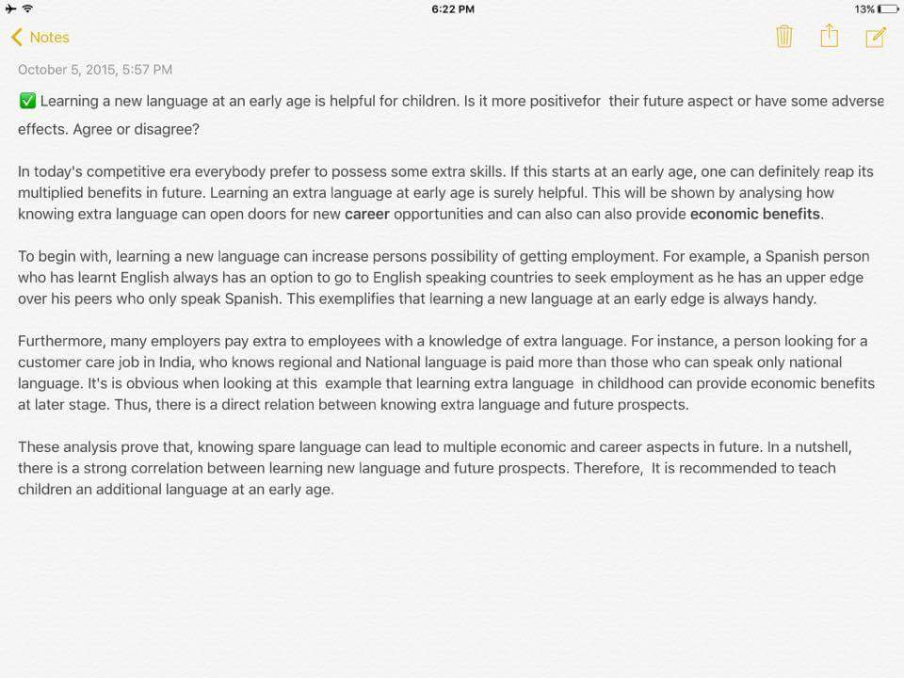

**possess -** own, **reap** - gain, obtain, gather, **exemplifies** - illustrate, **correlation** - link.

**25. Learning a new language at any age is helpful for children. Is it more positive for their future aspects or have some adverse effects. Agree or disagree?**

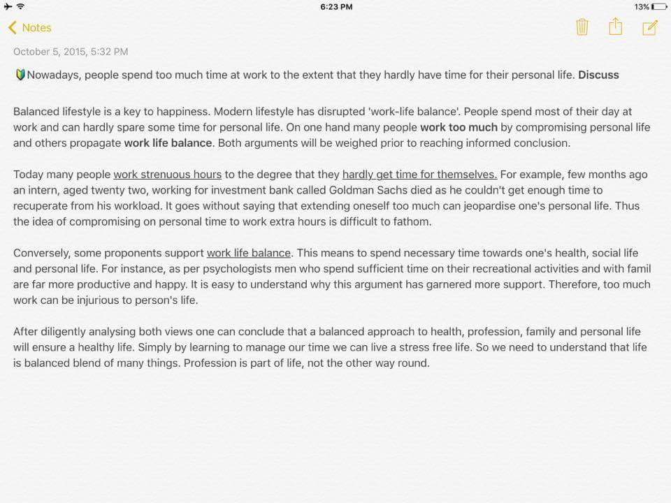

**disrupted** - interrupt, damage . **Prior** - existing or coming before in time, order, or importance. **Strenuous** - difficult, arduous. **intern** - a student or trainee at work. **recuperate** - recover from illness or exertion. **jeopardize -** put (someone or something) into a situation in which there is a danger of loss, harm, or failure**. fathom -** understand**. proponent -** a person who supports a theory**. recreational -** relating to or denoting activity done for enjoyment when one is not working**. diligently -** thoroughly**. Garnered -** gather , collect**.**

**26. Nowadays, people spend too much time at work to the extent that they hardly have time for their personal life.**

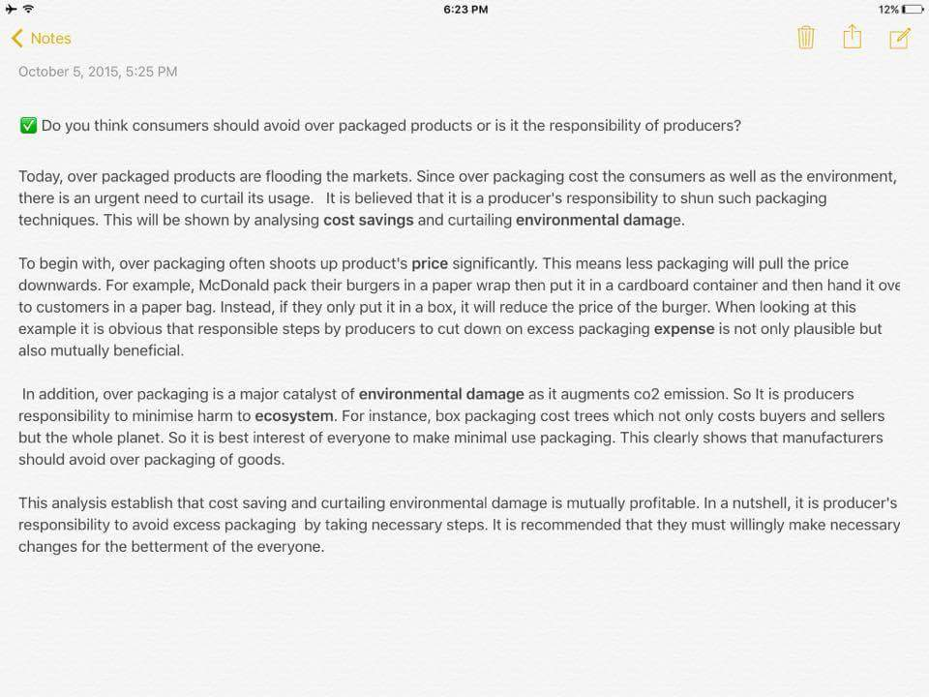

**curtail** - reduce, **shun** - avoid, **plausible** -  seeming reasonable, **catalyst** - a substance that increases the rate of a chemical reaction without itself undergoing any permanent chemical change, **augments** - increase, **willingly** - of one's own free will.

**27. Do you think consumers should avoid over packaged products or is it the responsibility of producers?**

**27. Do you think consumers should avoid over packaged products or is it the responsibility of producers?**

Over packaging of products has become a trend in today's competitive world. Producers are trying to attract consumers with attractive packaging of their products, not bothered about its negative impact not only on our environment but the users as well. It should be the responsibility of the producers to limit the wastage of the resources in the form of un-necessary packaging.

The cost of over packaging is actually added to the product sold. In fact, at times it is seen the packing cost and durability is more that the product itself. The type of packaging found in pharmaceutical industries can be taken as an example here. Pills and tablets are found to be packed in much bigger and colorful strips than needed. Such packaging is of no concern to the consumers. But, the cost of medicine would have definitely been lesser if sold in a simple outlook.

Further, the material used is mostly non-disposable which adds to the environmental pollution to a great extent. Snacks and other food items packaged in eye-catchy shimmering (glitter) colored packets are consumed in a large scale by everybody. These packets are really difficult to dispose as they emit poisonous gas if burnt and if not can be seen to contaminate water somewhere. Producers should realize the importance of using materials like paper and stick to simple packaging.

Packaging as seen increases the cost of the product and also makes our environment unhealthy. So, this packaging boom should be checked on a serious note by the producers. Moreover, the producers should be restricted with predefined rules and parameters set by the government. It is also recommended that an awareness among the users that quality of the product is important rather than the attractive packaging.

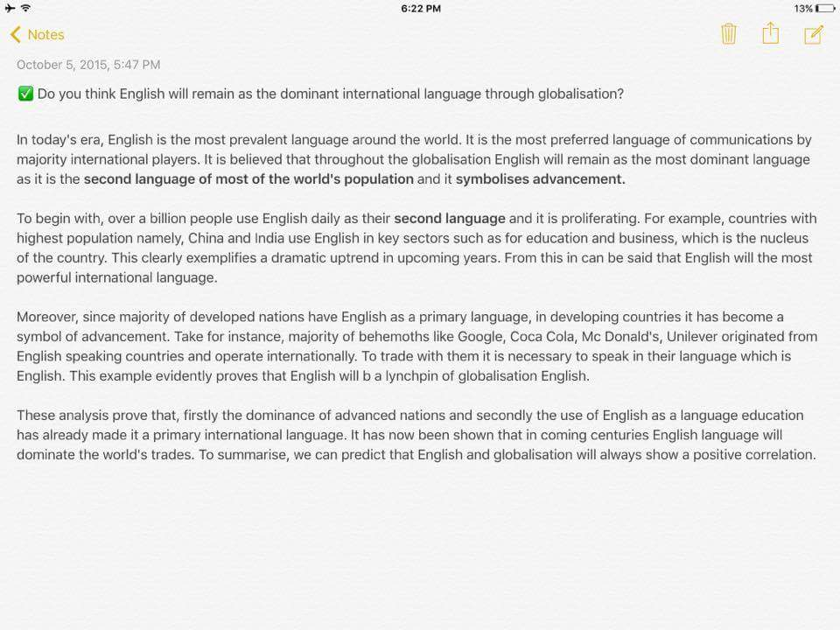

**prevalent** - widespread, **proliferate** - inc. rapidly in number, **nucleus** - core, **behemoths** - a large and powerful organization, **linchpin -** a person or thing vital to an enterprise or organization.

**28. Do you think English will remain as the dominant international language through globalization?**

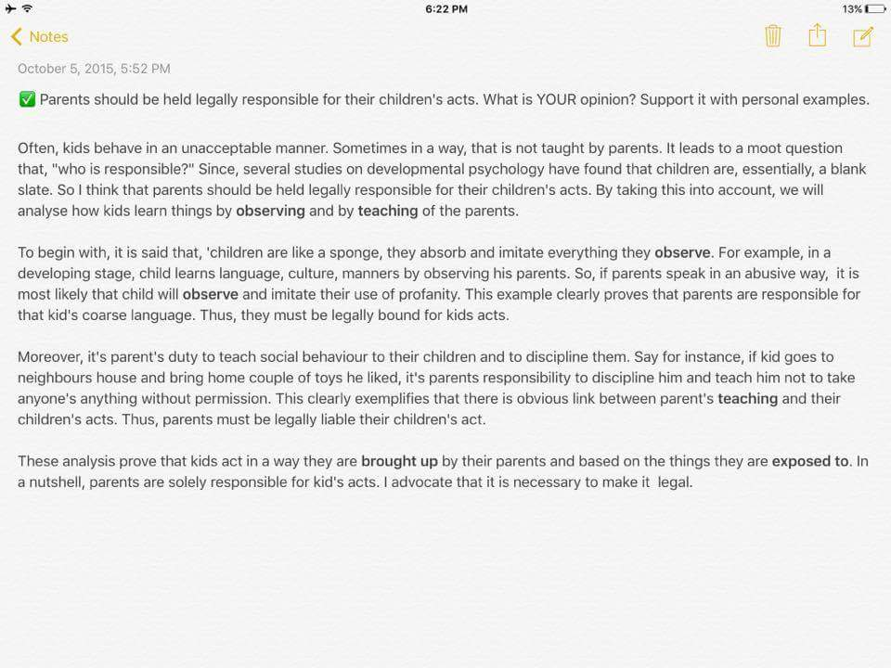

**moot -** debatable**, coarse -** harsh /rough**, profanity -** obscene language.

**29. Parents should be held legally responsible for their children's acts. What is your opinion? Support it with personal example.**

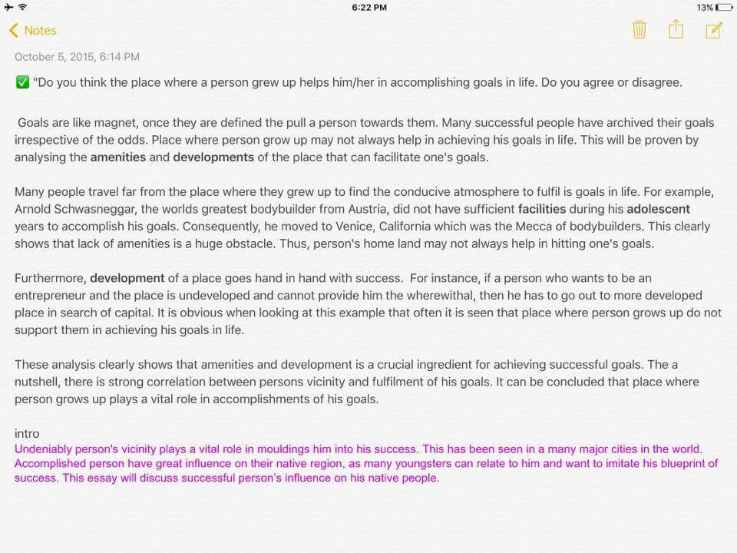

**30. Do you think the place where person grew up helps in accomplishing goals in life. Do you agree or disagree.**

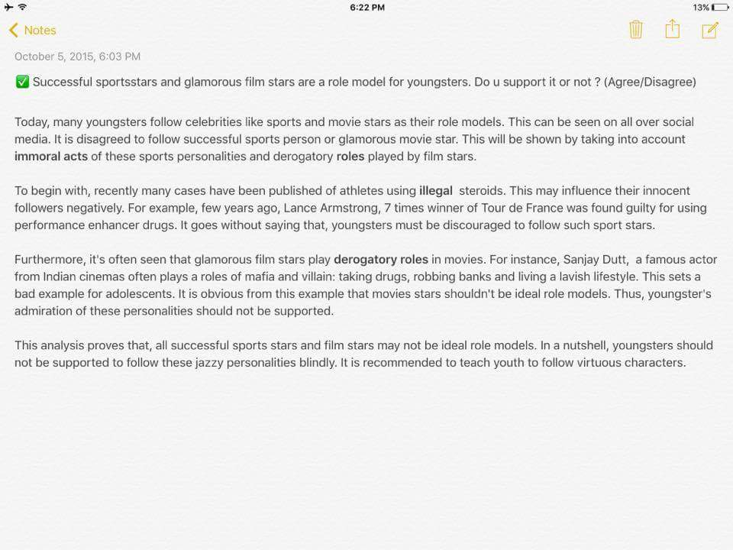

**immoral -** bad, **derogatory** - showing a disrespectful attitude, **steroids** - drug, **adolescents** - teenager, **Jazzy** - bright, colourful, and showy, **virtuous** - good.

**31. Successful sports stars and glamorous film stars are a role model for youngsters. Do you support it or not?**

**32. Scientists are constantly exploring other planets rather than solving problems of their own planet. Do you think they should explore or try to evade (avoid) the problems of earth .**

Evidently (*clearly*), human species have always demonstrated an insatiable (i*mpossible to satisfy.*) quest (*search*) to discover something new. Space exploration is perfect selection to epitomize (*be a perfect example of*) this quest. However, army of people entirely condemn (criticize) the idea of spending heaps (*in large amount of*) of amounts on such endeavor (*attempt*). This essay would discuss this issue in detail.

Vividly (*lively, producing a strong and clear impression*), commencement (*beginning*) of space exploration, since 1960's, have brought countless advantages to humanity, wireless communications through mobile, radio, internet are outcome of space exploration only by using satellites. It is irrefutable (*impossible to deny*) that the planet earth , already teeming (*be full of*) with humanity, will be overcrowded and the dearth (*lack of* *something*) of space on this planet is imminent (*about to happen*). Therefore, billions of dollars are being spent to search life-like signs on other planets of Galaxy. Already the efforts have started paying off as scientists have found life sustaining elements , water and breathable air, on Mars. Some of the predictions  are even made to make leisure trips for people  to other planets.

On the contrary, a group totally opposes such kind of spending as they reckon (*calculate*) that planet earth needs attention to make it secure and worth-living. Firstly, some people are facing problems like malnourishment and have died due to insufficient food and health care services. Moreover, significant chunk of population is deprived (*lack of basic material*) of education due to lack of funds to support. Thus, wasting money on making trips to other planets just to collect few pebbles (*a small stone*) from there makes no sense. The money spent on such ventures (*travel*) has no direct outcome as it takes a number of decades to make any discovery, whereas, money spent on education and health gives direct result of improved wellbeing.

After pondering (*think about carefully*) over a great deal of thought of both sides, I opine (suggest) that a right balance needs to be sought (*past particle of seek*) as both the aspects are of paramount (*more important than anything else*) value and need attention and funding.

**33. It is usually foolish to get married before completing your studies and getting established in a good job? Do you agree or disagree". Or It's good to be married once you have finished your study and you in the jobs- agree or disagree**

Getting married before finishing studies and getting employed can be arduous at times. Although some people may believe in getting married prior to settle their career, I would still advocate that getting married later is much better as one can focus on his career.

There are numerous disadvantages to getting married while still a student. “Getting married in college can create a greater problem when you are dependent on parents to support you. There is the probability of more tension on the part of both sets of parents.” Expecting your parents to continue paying your tuition as though you were still a child once you have chosen to take on the very adult responsibility of marriage can also create tension.

Another reason to wait is the time constraint on enrolled newlyweds. Balancing time at home, adjusting to a new life and spending time on academics is a daunting task, regardless of how organized you are. Married college students are often left with not enough time to do housework, study or have couple time. Little time is left for each other so there’s less time to work on personal growth and the marriage.

The college marriage often results in restriction of college experiences, participation in college functions and of relationships of college friends.

Not only that, but she also finds that marriage affects academics. “There is often a drop in grades due to added responsibilities or having to take on a full time job. The distractions that marriage brings are endless and normal, but if your current schedule and goals make marriage too much to handle on top of your college life, then the smartest decision may be taking care of your college career before saying your vows.

Sometimes the engaged couple isn’t actually ready to decide what they want out of life (or marriage) yet. College is a time of growth and maturing. Getting married too soon can cut growth and maturation short. “Most students need some time to be self-supporting, living on your own and making decisions as you mature. An early marriage can prevent students from ever getting that time to mature.

**34. Large shopping malls are replacing small shops. What is your opinion, good or bad?**

In today's epoch (*era*), shopping malls have turned to be a revolution (*change* ) in the space of shopping trends. However, two type of models that exist majorly in this world, single shop and another one is eye-catching shopping centers with huge space. Undoubtedly, shopping arcades (*gallery*) provides unexpected experiences by their well-planned and automated system on numerous elements. Therefore, this essay will analyze the benefits of shopping gallerias over the conventional shops.

To begin with, presence of shopping malls in any location has a great edge on various prospects. People in urban areas don't prefer to visit numerous shops due to time constraints (*limitation*). Hence, to save on time, shopping malls outrages (*outnumber / anger*) traditional outlets in endless ways, To illustrate, huge complexes genuinely proves as one stop center experience by offering products under the same roof, like, grocery items, clothes, electronics, food courts, banking service and so on. As a result, it will be justified to represent that convenience and economic ease pushes the shopping center's fashion to a great extent.

Moreover, several shopping centers have been knocking the doors to make lives extremely comfortable under social and economic benefits. To illustrate, astonishing shopping malls requires hands on expertise in architecture, design, construction and other significant fields. As a result, by providing jobs, malls upgrades the economic growth as well. For smooth running, it requires huge man power and extensive experience, hence, shopping malls altogether makes a great place for fun, ease and earning.

**Hammering on the last nail**, shopping malls with endless benefits for economic and social zone wins a league over traditional shops. Unbeatable services and products provide encyclopedic (*thorough*) benefits and help's country to grow rapidly.

**Hammering on the last nail -** an event which causes the failure of something that had already started to fail ------ also known as final nail in the coffin of our friendship.

**Disadvantages of Malls**

These include excessive crowding, especially on weekends and holidays. Crowded aisles (walkway) and stores make shopping very difficult; people often end up forgetting items they needed to buy. Parking can also be a problem when the mall is very crowded.

The temptation to browse is always present, and browsing often leads to buying things that are not needed. Keeping to a monthly budget becomes increasingly difficult every time you visit the mall. With all the sales and special offers intended to tempt buyers, saying "no" becomes very hard.

**34. Large shopping malls are replacing small shops. What is your opinion, good or bad?**

Today we are living in a modern world which has made our lives very fast. The pivotal need of a person is comfort, safety and time so he would be able to joy his life. In mega cities, people are making money but are having short of time for their lives. The mega shopping malls trend in the recent years has become very famous which is leading to diminishing the trend of buying from small shops.

The big shopping malls are very popular among consumer for buying goods. They can find from needle to car in one shopping, they do not need to bother to move from one physical location to other to buy another thing by throwing themselves in traffic jam and hassle of driving on the traffic jam roads. Shopping malls usually buy goods in big lots therefore they can offer cheaper price for the customers. Everything available in a single building will make possible for the mall owner to provide security, proper ventilation and other management. Consumers can get enormous facilities in a single building such as cafe to have a cup of coffee and have some rest. Parents can leave their children in play land inside a mall will enable them to mind free shopping without worrying about their children. Huge place for vehicle car parking available to enable them comfort about parking, as in big cities to find a car parking place is also very difficult.

In contrast, small shops usually buy goods in small quantity for a consumer which leads the availability of fresh items. Small shops do not require large system of cooling because they have to manage small area for cooling and additional space will not likely to cover. It will save energy consumption for the government. People are living far from middle of city; they can buy items from the nearest shop. Small shops are usually around residential areas will lead to ensure the availability of goods and mitigating the need to driving a car and move to the shopping mall when some person is tired after working hours.

In conclusion, the shopping malls are making contribution to the country economic growth but usually big malls involve foreign investment which is taking profits outside the state. The small shops are also providing the benefits to the citizens and which have their own benefits. The government should make some regulation which should prevent the small shops from being diminishing and keep the mega shopping malls trends together.

**35. Information revolution has changed the way of mass communications and had some negative and positive effects on individual lives as well as on society. To what extent do you agree or disagree?**

**Communication has changed significantly in the last 10 years. Discuss pros and cons impacts.**

IT has not only brought the world closer together. Therefore, we can not only share information quickly and efficiently, but we can also bring down barriers of linguistic and geographic boundaries. The world has developed into a global village due to the help of information technology allowing to shares ideas and information with each other.

Communication has also become cheaper, quicker, and more efficient. We can now communicate with anyone around the globe by simply text messaging them or sending them an email for an almost instantaneous response. The internet has also opened up face to face direct communication from different parts of the world thanks to the helps of video conferencing.

**Bridging the cultural gap -** Information technology has helped to bridge the cultural gap by helping people from different cultures to communicate with one another, and allow for the exchange of views and ideas, thus increasing awareness and reducing prejudice (bias).

However, While information technology may have streamlined (smooth - running) the business process it has also created job redundancies (no longer useful), downsizing and outsourcing. This means that a lot of lower and middle level jobs have been done away with causing more people to become unemployed.

**Privacy** - Though information technology may have made communication quicker, easier and more convenient, it has also bought along privacy issues. Due to website and email hacking, people are now worried about their once private information becoming public knowledge.

**Lack of job security** - Industry experts believe that the internet has made job security a big issue as since technology keeps on changing with each day. This means that one has to be in a constant learning mode, if he or she wishes for their job to be secure.

**Dominant culture** - While information technology may have made the world a global village, it has also contributed to one culture dominating another weaker one. For example it is now argued that how US influences most young teenagers all over the world now act, dress and behave. Languages too have become overshadowed, with English becoming the primary mode of communication for ,business and everything else.

**35. Information revolution has changed the way of mass communications and had some negative and positive effects on individual lives as well as on society. To what extent do you agree or disagree? Or Communication has changed significantly in the last 10 years. Discuss pros and cons impacts.**

We are living in the age of 21 century and technology is shaping our lives. The human has made rapid development and progress in achieving the goals and objectives towards information dissemination (*act of spreading something*). In the last decade, the mass communication flourished tremendously in the society as people are eager to get recent and actual information.

The mass communication has been accelerated in the last few years. It has made easier access to the information from different regions of the world. The computer Internet technology boosts the speed of mass communication. Earlier the newspapers were the only source of mass communication media, but now the mass communication is equipped with the latest technology and innovations of computer Internet. The mass communication media is playing a pivotal role in the society. The politicians are using mass communication media for their election campaigns and make the people in their favour to caste vote. Products advertisements are being done for business promotions to attract consumers toward their product. The indispensable (essential) role of mass media in our society become highly effect to help and organize the needful people towards the charity promotions to help someone for medical treatment and support for the basic necessities of life.

Every coin has two sides, so the information can also be abused (misuse). It can mislead people and can cause damage to society. Moreover, people misuse information and that can leads to rumours and even create violence. For instance, information or posts on social media like Face book and Twitter are unsafe as it can create problems in the on the name on religion or anything. Furthermore, wrong elements of society can use information in an inappropriate way like making bombs, guns.

In conclusion, the mass media has highly influenced our live and is affecting that a person can change opinion towards the thing around. It is giving benefits to people it is taken in correct direction, but if the mass media is controlled and use for someone’s interest than it is highly deterioration for the society.

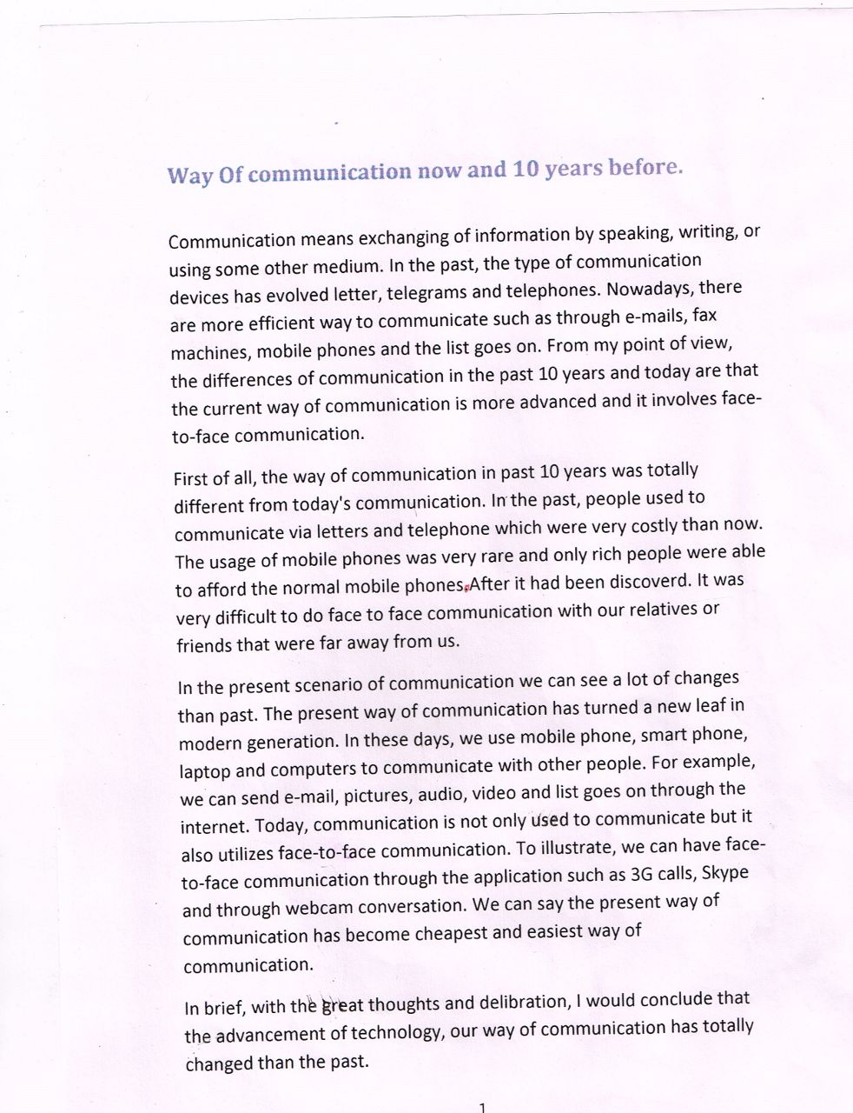

36. Ways of communication then and now.

**37. Imagine if you assign a study of climate change on which area you will select and why give example?**

Climate change can be described as abnormal changes in the temperature and in various seasons. In recent years, climate change is a serious worrying concern in a number of countries around the world. In this essay, I am going to analyze the causes, its negative effects and solutions of climate change as early detections could help not only our country, but also it will improve the life of society considerably.

There is no doubt that climate change and global warming has a inter-relationship with drastic effects and clearly one of the major causes is cutting down of trees. The MNC companies, particularly, manufacturers and suppliers of wood are actively engaged in cutting down of large trees to manufacture wooden furniture, and, as a result there is a less amount of rainfall. Another major cause is   
massive consumption of non-renewable sources of energy by power generation companies. This leads to emitting large amounts of carbon dioxide and carbon monoxide, which ultimately affect weather patterns and climates. A case in point, Weather Bureau Organization predicted less amount of rainfall and high humidity levels in North India and in some parts of Asia due to climate change.

Looking, however, at the above negative effects there are various solutions that can be adapted by governments and individuals. Political leaders across the globe need to co-operate so that research into renewable forms of energy, such as, solar power and biomass energy can be properly funded. Thus, there will be a reduction in levels of carbon dioxide and to a certain extent the weather patterns will be steady and normal. They should also ensure that regulations against illegal logging (cutting of trees) are properly enforced. Finally, individuals can also play an important role to reduce climate change. They need to install renewable energy appliances at their homes so that less energy is consumed and wasted. Moreover, they need to plant trees and samplings in order to reduce not only air pollution, but also climate change negative effects will contract substantially.

To conclude, climate change is a serious issue, but its drastic effects can be reduced, if governments and individuals play an important part to save the nation as well as to improve the community life.

**37. Imagine if you assign a study of climate change on which area you will select and why give example?**

In recent decades, there has been a colossal (*extremely large*) upsurge (*an increase*) in the amount of environmental degradation that stems from climate change across the globe. Out of many issues related to climate change, I would like to base my study on industrialization, an integral factor contributing to the deterioration of the ecosystem.

The arguments in favor of my stance (*attitude*) are manifold (*many and various*). Although, industrialization is an inevitable (*unavoidable*) phenomenon (*event*) that stemmed (*caused by*) from the requirements to meet the demands of growing population, the adverse (*negative*) impacts associated with this cannot be warranted. Industries and factories pollute the environment by dumping hazardous (*risky, dangerous*) chemicals that pollute water, air and what not. Besides, the number of species that have disappeared or are on the brink of extinction is alarming indeed.

Studying such a vital factor responsible for global climate change will enhance one's cognizance (*knowledge and awareness*) regarding the ways to deals with this situation. This is because only when more research and studies are devoted to this end, can we expect some breakthrough in this regard. In other words, the likelihood that the result of these cumulative research projects will have a considerable impact in dealing with this concern cannot be overlooked at all.

To conclude, climate change is a serious issue, but its drastic effects can be reduced, if governments and individuals play an important part to save the nation as well as to improve the community life.

**37. Imagine if you assign a study of climate change on which area you will select and why give example? Or what is the most important problem of this planet around the globe. OR The most pressing problem being faced by governments of the world.**

Over the last few years, climate change has become a serious worrying concern across the globe. Well, the unseasonal weather patterns and an abnormal change in temperatures have drastically affected our environment. If there is one area that I would like to highlight on climate, then it is the greenhouse effect.

There are various reason that why I gave preference on the greenhouse effect. First of all, nowadays, the power generation companies emit the massive amount of harmful chemicals such as carbon dioxide and carbon monoxide and as a result, it leads to the greenhouse effect. In addition to this, we should not forget the dangerous fumes emitted by trucks and private vehicles. The over dependency on vehicles by various groups of consumers have caused voracious effects not only on people health but also hampered the quality of air, and lives of human beings.

Likewise, there are also other crucial factors that lead to the greenhouse effect. One of the most serious factors is the excessive usage of the air conditioners in the corporate offices and surprisingly, due to the increase in the disposable income, the people have installed this product in their homes too. While their massive usage means the chlorofluorocarbon gases are released into the atmosphere, which imbalances the levels of the ozone layer. As a consequence, it not only leads to the greenhouse effect but also leads to the global warming.

To sum up, it can be seen how the various factors of climate change have provided perilous (*dangerous*) effects on the environment and the human beings. I wish that the governments and politicians need to cooperate in order to see our environment as a safe and healthy.

**38. Talk about the pros/cons of this era as is full of daily invention. (Look down for new essay)**

In this modern era many things have been invented in various areas that have given numerous benefits to the human beings and society. Let us discuss the merits and demerits of invention that is used for daily purposes of this era.

There is no doubt that in this modern era the invented innovative products has offered considerable benefits to people. Broadly speaking there are two benefits. First of all, due to escalating inflation rates and changes in demographic structure of education paradigm (a typical example) between men and women, they both are working in MNC and Corporate in order to live a lavish lifestyle. They do not have sufficient amount of time to complete their daily task. To illustrate, they will use washing machine to wash clothes, grinders to prepare spices, etc. As a result, these inventions have helped their life very easier, quicker and much more   
convenient. Another major benefit is the communication devices that has really transformed the level of communication and working activities amongst people. People are using Whatsapp and e-mail to communicate with subordinates, peers and office colleagues. Thus, it has really helped them to complete their work much more faster and easier.

In sharp contrast to this, there are also negative effects of this technological invention. One is people have become over-dependent on communication devices which has made them less active and increase of mental stress. Furthermore, they pose a major threat on people health as well as made them less sociable. Another major worrying concern is it is believed that the widespread use of e-mail and internet chatting is destroying traditional forms of communication, such as, letter-writing and face-to-face conversation. As a consequence, their habit of making friends and communicating in real life is hampering the relations considerably and making them more dependent on internet.

To conclude, the invention in various areas in 21st century has revolutionized the people life in a day-to-day basis with numerous benefits, however there are also drastic effects of this technology. I hope that inventions will continue in future and cannot be refrained (stop oneself from doing something.), but we should see that we are using these innovative invention products in moderate amounts.

**38. Talk about the pros/cons of this era as is full of daily invention.**

In this modern era, the numerous technological advances have been taken place in various areas for daily use that have given countless benefits to the people around the world. In my view, however, there are plenty of significant drawbacks that have hampered their lives.

There is no doubt that different innovations have provided considerable advantages to the people. First of all, due to escalating (*increase rapidly*) inflation rates and the changes in demographic structure (*a study of population*) between men and women; they both are working in the corporates to live the lavish lifestyle. They do not have the sufficient time to perform their daily tasks. As a result, they are using the washing machine, grinders and refrigerators which have fortified (*protect*) their lifestyle.

Secondly, the communication devices have transformed the level of communication. For instance, the smartphones to send the mail, the laptop to deliver the marketing presentation, have made their daily lives easier and quicker than earlier.

On the flip side, there are adverse effects of this technology. One of the drastic consequences is people have become over dependent on the mobile phone, palmtops and Ipad. They are using these devices in large amount that have made them less active and sociable. Another effect is the widespread use of e-mail and internet chatting acted as a catalyst (*anything that inc. the rate of something without itself undergoing any change*) for destroying the traditional forms of communication, for example, letter-writing, face-to-face and telephone conversation.

To conclude, I reckon (*believe*), the prolific (*productive*) technological inventions have provided an orbit of benefits to the people in their daily lives, but there are also detrimental (*harmful*) consequences that have disturbed their lifestyle.

**39.** **Nowadays TV has become an essential part of life. Medium to spread news & awareness and for some it acts like a companion. What is your opinion about this?**Over the last decades, the various technological innovations such as smartphones, computers, and televisions serve various purposes to all groups of people. Indeed, my view is that Televison has become an integral part in everyone's life which represents information and entertainment, but at the same time it has also hampered people life significantly.

Undoubtedly the invention of Television has provided numerous benefits in daily life. One of the most important merits is it acts as a source of information in the form of news, reality programmes and educational based series. The news around the world provides various information which in reality is not possible by going or visiting to the foreign countries. For example, a woman from Nigeria can sit at home or at her office and swtich on the TV to see the news of India, Russia, and many more. In addition to this, there are some people, particularly, young children and old-aged who are alone at home and feel boredom, but if they watch TV, it acts as an mode of entertainment. A case in point, they can watch music, movies, cartoons and other channels. Thus, it is notably evident that how TV has played a significant role in our lives and made our life very easier and convenient.

On the other hand, people have also encountered negative effects of TV which has become an serious issue. The clearest demerits is young children have become addicted and, as a result, they have become less active and less sociable. They are spending huge amount of time on watching amusement programmes, which have given them an artificial source of entertainment. Another serious concrn is people have invited to serious mental and physical illness. The excessive usage of TV means they are sitting at one place and has significantly reduce the physical activity. As a consequence, they have become obese, exposed to hyperactivity and hypertension.

To conclude, my view is that TV plays an important role in our life for entertainment and information, however at the same time its negative effects are hampering our personal growth. I wish that young children should be protected and their parents should see that they watch it for a limited amount of time.

**39.** **Nowadays TV has become an essential part of life. Medium to spread news & awareness and for some it acts like a companion. What is your opinion about this?   
OR   
Television has many useful functions to play in everyone’s life, for some its relaxation, for some it is companion. Discuss your viewpoint and support your answer with examples and discussion point.**

Gone are those days

When people got entertained

With conventional ways

like playing cards or cock and bulls fight

Today 21st Century

Modern Era

Tecnhnology - given

Many gadgets

T.V. is one of them

**2nd  In my point of view**

T.V. modern styled

Wonderful way

To rejuvenate man

Fabolous Style of Time pass

And called stess buster

Life is full of hurry and worry

TV – way to end mind’s stress

By watching daily soaps and reality shows

Movies, Discovery

Full of entertainment and knowledge

News channels add flavour in rising information

**3rd Furthermore**

Tv Called a real companion

Today Nuclear families

People sepnd spare time with this.

As people take meal everyday,

They nevermiss to utilize their few hours on TV

Many Queries of people are solved

TV never leaves the company of man 24X7

**Last In a nutshell**

Tv – both qualities

As a bosom friend

Even relax mind and body

Still it is electonic device

People should watch in limit and not become couch potato

**40.** **Pros and Cons of Reservation.**

Reservation is an arrangement in which a specific class in the society is given privileges over others on various grounds. Reservation started in India many years ago to protect lower tribes from undue exploitation, and to raise their living standard. Although, it was a temporary system to bring lower tribes at par with others casts in the society. Greedy politicians continued to use this as instrument to garner votes from the weaker section of the society. Ever since its inception, it has been a matter of debate with no clear consensus on whether it should be eradicated or continue to stay in the society. Scholars have varied views among themselves while there are others who say it should be evicted from the system, there are others who justify its existence. Let’s delve deeper and evaluate both the views.

A fraternity of scholars are of the opinion that reservation is an indispensible part of the system citing current caste system, unemployment and poverty in the country. As per them, reservation gives an opportunity to the weaker section of people to participate in the education system, government jobs & food security program. Hence, it guarantees social security to the needy and help them come at par with the established group in the society. Furthermore, it extends right to education and other public services to those who cannot afford to pay hefty charges for basic education.

While facts provided to support reservation are true, there is distinct section of intellectuals who think contrary. As per them, reservation is stigma to the society and its roots should be eradicated from the society for prosperity and harmony in a country. They argue that jobs and higher education must be based on individual capacity and not on the basis of specific caste or society. To exemplify, a surgeon scoring less mark than his peers in the entrance exam and still making into a premier institute may cause many lives into jeopardy. In addition, people with no or less individual capacity getting more rewards due to reservation may bring the morale of a deserving student to the ground. Therefore, I opine that reservation must be fully removed from the society and everyone should be given equal opportunity.

To sum up, while reservation has its own pros for many in the society, its cons are equally dreadful to those who deserve to be at the right place due to their capability. Therefore, non-reservation is far more suitable solution to keep up with the global pace of economy and advancements around the world.

**41**. **Some people think placing advertisements in schools is a great resource for public schools that need additional funding, but others think it exploits children by treating them as a captive audience for corporate sponsors. Choose which position you most agree with and discuss why you chose that position. Support your point of view with details from your own experiences, observations or reading.**

Advertisements have been an inseparable part of any corporate businesses to attract potential customers to expand their businesses. On the contrary, in my opinion placing advertisements inside public schools in order to lure juvenile mind is certainly not a good idea to promote commercial business.

To begin with, schools are the home for immature children where they come to learn academic as well as moral lessons. These children can be tempted to do any activities easily therefore putting advertisements inside schools may impact pejoratively on such students. For example, a child might break his hands and legs by imitating and reproducing the action pose shown on the violent blockbuster movie advertisements. Moreover, many advertisements nowadays displays sexually motivated explicit materials and other adult themes which would captivate young mind to delineate juvenile delinquency indulging into an anti-social behaviour such as raping, smoking, vandalism and other heinous crimes. Further, these children might tempt to spend hefty sum of money to buy the mendaciously advertised unfruitful products which not only hampers their academic activities but also largely effects on their brain development and ethical behaviour.

On the contrary, advertisements are good source of funding for the public schools who always find themselves hard to manage their financial cash flow. Corporate houses often pay a huge sum of money when they place advertisements inside schools as young school children can easily be motivated to go after their products. Besides, many advertisements targeted to kids such as Toothpaste, Shower gel and Detol are espousing to bring awareness on children to wash their hands before eating foods and after using toilets or brushing teeth early in the morning and before going to bed.

Therefore, to recapitulate, advertisements are efficient and effortless source of money for the public schools however schools management must act prudently to monitor continuously students’ behaviour and choose suitable advertisements to put inside schools so that children do not go astray.

**41. Essay on advantage and disadvantages of study abroad.**

Mushrooming of Study-abroad agents and English learning institutes in streets depict that the number of students flying abroad to pursue further education is trending. Most of the students opt this path in search of state-of-the-art better education system and eventually, to have brighter professional career. Though there are many advantages of foreign education, we can not ignore the fact that life of international student is equally challenging.  
In developing countries ,including Nepal, the university education lags far behind to that of developed countries.Students ,who can afford financially , mainly go to USA, Australia or the UK though it costs more than ten times as compared to Nepal. They experience state-of-the-art learning processes supported by elite professors and sophisticated laboratories.They get opportunities to interact with students from different countries and understand life more widely. With degree of such renowned universities, they also have better chance of landing high-paid international jobs.  
However, they have to struggle real hard to complete their degree. They face home-sickness,cultural shock ,and also it takes time to adapt themselves in totally new environment. Since living standards are higher, they may have to do part-time jobs to support their education and living at the same time. This may cause distraction and they may not be as efficient as they really are. On the other hand, student who studies in his native country enjoys privilege of living with family and relatives.  
In a nutshell, foreign degrees are often sought as a matter of pride and excellence;however, the hardships that a student has to go through cannot be overlooked.

**42.** **Advantage and disadvantage of performing old theatre play in high school**

Theatre is an immediate way of experiencing what it means to be human’ since it is a form of art ‘that engages human beings to tell stories about other human beings’ in which the expressions are done in ‘human form’. It is also a form of live entertainment, however, dissimilar with concerts, mass media programs, sports, and dances in a way that ‘theatrical entertainment presents us with the actor’s body, voice, mind and soul enacting stories that challenge us to enjoy human inventiveness, or to think about uncomfortable truth, or to come to higher understandings of human affairs.

Advantage:

1. It increases students’ motivation, participation, confidence and fluency in the spoken English as well as communication through the body language.
2. It extends the emotional range of expressions.
3. It develops creativity and spontaneity.
4. It provides opportunities for group and self-expression.
5. It promotes confidence, trust, cooperation and group cohesion (*unity*).
6. It develops the students’ performance skills.
7. It fosters (*encourage*) verbal and non-verbal communication.
8. It feeds the speakers’ need to exchange ideas and make decisions.
9. It maximizes students’ use of English.
10. It ensures students’ involvement and decision-making.
11. It stimulates (*encourage interest in*) authentic conversations that aim at developing conversational competence among foreign language learners.
12. It creates sensitivity and a sense of awareness.
13. It prepares students for real life and unpredictability.

Disadvantage:

1. Activities are artificial. The situations are sometimes and irrelevant to the learner’s need.
2. Activities are difficult to monitor both physically and verbally.
3. There is a fear among teachers that drama use may cause sort of uncontrolled fun among learners.
4. It causes embarrassment and awkwardness, in some situations, especially among adult learners.
5. It encourages incorrect forms of language as long as the teacher is not encouraged to correct mistakes immediately so as not to discourage students.
6. Activities may not be suitable to all the class. The activities that succeeded with a group of students may fail with another.

However, these problems could be solved if careful thought and planning are used in the classroom. Teachers themselves must be convinced of the effective use of such activities if they want to encourage their students to have a positives attitude towards language learning in general and above all they must be willing to bring about some change in the way they are working.

**43.** **Can Internet replace classroom teaching?**

In today’s high-tech classrooms, teachers have to be equal parts educator and I.T. specialist. They not only have to know their content, but also how to integrate, operate, and troubleshoot advanced equipment and computer programs. Teachers are constantly adapting to stay current, but will technology eventually take over the entire classroom?

Advantage:

There are many reasons why schools would opt for technology over teachers. First and foremost, buying and implementing technology is more cost-effective than hiring classroom teachers. Computer programs and Internet services do not require healthcare, retirement benefits, professional development, or pay raises.

Furthermore, technology can save educational institutions from legal headaches such as teacher unions and lawsuits. Even though schools perform extensive background checks, they still face the stigma (*disgrace or shame*) and media attention brought on by teachers who commit crimes and engage in inappropriate behavior. By getting rid of teachers, schools could spend more time and money on education and less on litigation.

Technology is also tempting because it can help cut down on the expense of traditional brick-and-mortar buildings. By offering online learning experiences, schools can educate students off campus—thus saving money on facilities and maintenance. Additionally, online coursework can provide greater curriculum choices to students in rural or remote areas.

Another incentive for schools to use technology is the ability to offer students a flexible education experience. Online universities already allow students to “attend” courses at night and on the weekends. It’s hard to find teachers that will do the same.

Disadvantage:

Technology is a great way to offer educational services to students, but it still has its limitations. No matter how “smart” a product or computer program is, it can’t compare to the knowledge and life experience that a teacher brings into the classroom. A teacher can use this background to help the student make real-world connections and see a subject from a different perspective.

Educational technology usually takes a one-size-fits-all approach to learning that doesn’t account for learning differences or students with special needs. By contrast, a teacher can present material in a variety of ways and modify curriculum to meet the needs of each student.

When using technology, students’ knowledge is usually evaluated through standardized tests. However, classroom teachers use both formal (tests, quizzes, essays, etc.) and informal (observation, discussions, student questions, etc.) assessments to determine if a student has mastered a concept.

Finally, there are usually no alternatives when electronic products break down or Internet connections are lost, and they can be expensive to fix and replace. Technology only educates students if they can use it, but a teacher can adapt a lesson and continue teaching even if her projector is broken or the Internet is down.

While the role of technology in education is steadily increasing, it is more likely that it will continue to be used as a supplement to teaching rather than an alternative to teachers. In fact, currently available online universities and virtual academies still employ educators to create lessons, mediate discussions, and evaluate student progress. These interactions between students and teachers are an important part of the learning process and help students become productive members of society. Even the best learning products and services can’t replace the invaluable life lessons taught by a dedicated teacher.

**44. Cultural Shock is a new worrying concern for few immigrants. What are the few possible options to eradicate this?**

Cultural setback is causing a panic in the minds of migrants when they reach the new country. Newcomers faces a lot of teasing problems when they arrive in the foreign country in form of adjusting to new language, food habits, diverse laws, unfamiliar customs and religion. These hurdles can be overcome in different ways. In my opinion flexibility and adaptability with proper preparation and respecting the laws and customs of the land will help the immigrants to settle down fast in the new land.

Firstly, prior to leaving your native country one should get oneself acquainted (familiar) with the new laws and customs of the foreign country. Moreover, learning the language of the visitor’s country would be an added advantage. It is commonly said that “When in Rome be like a Roman”. Adjusting to the new culture, climate and food habits will help the migrants to develop liking and enjoying the foreign culture. To illustrate this many immigrants from the Asian countries migrates to developed countries like Canada, U.S. They focus on their purpose and are not perturbed (*upset*) by anything else.

Secondly, the newcomers should immediately understand and follow the law of the land in order to keep themselves away from any trouble. Migrants can mix up with their own community people in the foreign country to ease down the initial stress. Another sensitive issue is of “racism”, which the migrants can face in the foreign country. In that case the best solution is to face the situation with patience and then take the issue through a proper channel to the concerned authorities. For instance, in Australia few years back there were few incidents of racism, which were resolved peacefully with the intervention of authorities.

Finally, I would say that it is up to the attitude of the immigrants, how they would react to and imbibe (*learn*) the new customs and regulations. In any case, one can enjoy with a new lifestyle and live happily.

**45. Polygamy has led to massive divorce rates around the globe. Give the possible option for this issue and various solutions to reduce the rates?**

Polygamy means a man can have multiple wives. Multiple marriages by individuals have enhanced the divorce rate in many places around the world. Polygamy gives rise to many crises. In my opinion the possible solutions to these issues are in the introduction of strict laws, motivating for women empowerment and compulsory education or all.

In polygamous society, man seeks wife among woman of younger ages. As he continues to have multiple partners, the earlier wives get dejected and the man loses interest in them. This leads to clash of thoughts, domestic violence, and conflict of interests, jealousy and discord. Repeated incidents, further breaks the relationship, and finally ends up with a divorce. In addition to it the children of polygamous wives also suffers emotionally and for economic resources.

According to me the solution for these issues lie in a monogamous relationship. On the other hand government should impose stricter laws so that the women are not exploited by men. Also women should be made aware about their rights and be provided with equal rights in the society. Women empowerment should be encouraged, to reduce the dependency of women on men. An educated man and woman can take wise decisions, so government should encourage the citizens to provide compulsory education to all children. Alternatively, in case of divorce a heavy amount of alimony (maintenance) should be imposed in order to discourage it.

Lastly, spreading awareness and campaigns about the ill effects of polygamy can also be an effective way to tackle the issues. It is a well-known fact that “unity is strength” and a united family will always bring prosperity.

**45. Some effective people like repetitive routine, such as eating the same food, do you like this way? (Modified one below)**

Our society has been witnessing a tremendous upsurge in the number of efficient people follow the same behavior pattern. It is under heated debate that whether people should repeat themselves or not. This essay will examine both sides followed by my own perspective.

There are multifarious (*many*) reasons for people to repeat their behaviors. The predominant one lies in the fact that it reduces the time of searching for a solution, thereby saving the time to do something of higher importance. For instance, if one can have the same lunch every day in the same restaurant, he or she can save a significant amount of time, which could be used in the academic or professional field. Furthermore, have the same option decreased the probability of suffering from bad choices, hence those who have difficulties in decision making can have the sense of security.

However, the upsides of repetitive behaviors are not without concern. First of all, the excitement of experiencing, exploring and adventure is omitted from the life. Therefore, people can easily get bored, which can have a detrimental (harmful) impact on people physically and mentally. Secondly, trying something new can inspire people to be more motivated, more relaxed, and more creative because their concentration is diverted from the conventional way of thinking.

As the views outlined above, one can conclude that repeating behaviors are like a double-edged sword (*if two sides of the same blade are sharp, it cuts both ways*). Although they can have an adverse effect on some people, they can increase efficiency substantially (significantly).

**45. Some effective people like repetitive routine, such as eating the same food, do you like this way?**

With age of person, it is obvious that the change occurs in thinking and habits. People who resist themselves from such expansion can be sufferer in life.

**Second Paragraph:**

In my point of view

Nature itself brings certain changes

in a single day, month and year.

It is equally important for an individual to adopt new things in routine.

Repetitive things make life monotonous (*boring*) and lethargic.

To bring productivity and attain financial success, new routine must be accepted.

For growth in life people should break barriers.

Bringing changes in life make person multilingual and multicultural.

Even his rigid and orthodox attitude gets changed.

Such a person reaches at pinnacle of success.

**Third Paragraph:**

Furthermore,

Sedentary lifestyle has no success

It makes a person sick and lazy.

The journey of man from caves to moon is the proof that if man invites new things then he can reach at the top.

New factors bring.

innovation and satisfaction.

Many underdeveloped nations brought development.

by adopting changes. Dubai, Singapore, Malaysia is the right examples.

Even in companies to raise productivity.

Certain new learning programs are given to employees.

A person who runs with world, he always lives relaxed life.

**Last Paragraph:**

In a nutshell, I personally believe.

A person must be adaptable personality.

if one wants to be adept (expert) in skills then

he must be open for changes and make his life beautiful.

**46. Number of cars owned by a family need to be limited to one. How far do you agree with the statement? Give your opinion? Or should we limit one car to one family or any other alternative should be there to solve the environment issue?**

Gone are those days when people covered their journeys by foot or horses. Today is 21st century which is a modern era. Science and technology has given a lot of transport services. Both public and private modes have contributes in it. But still people have inclination towards own cars, which leads to ample of problems globally.

In my point of view, the idea of having one car in an individual family is really wonderful.

1. Help to control traffic and pollution.
2. Save fossil fuels.
3. Reduce accidents.
4. Inclination towards public transport can generate revenue for a country.
5. Reduce expenditure of family on different cars.
6. Parking problems vanish.

On the other hand, the other ways to control environment are

1. Car pooling
2. CNG
3. Hybrid Cars
4. Idea of Singapore Policy
5. School Buses.
6. Special transportation for employees in office.

In a nutshell, I personally believe that idea of having one car in a family is worthwhile. Ample of problems can be solved. No doubt, it is a herculean task (very hard to perform). Still countries can collaborate and make stern laws (strict) on buying cars.

**46. Number of cars owned by a family need to be limited to one. How far do you agree with the statement? Give your opinion? Or should we limit one car to one family or any other alternative should be there to solve the environment issue?**

I believe, limiting one car to one family is possibly not the best solution to solve environmental issues. Following reasons support my opinion.

First of all, environmental issue consist of number of factors and is a wider term then what is referred to here. Air pollution is just one aspect of overall environmental issue, our world is facing today. Though, air pollution in itself is a huge concern that should be taken in account and ways to reduce air pollution should be worked on. Adding to the point, pollution caused by vehicles is one big issue but it accounts to a percentage of air pollution and there are other factors like industrial gases, coal combustion in factories that also add up to the amount of air pollution. So, limiting the use of vehicles may reduce air pollution to an extent but, it is not an ultimate solution to fix problems in context of air pollution and in overall context of solving environmental issues.

Secondly, limiting one car to one family will limit the overall personal vehicle usage among people is a hypothesis to begin with and there is no strong proof to support this assumption. Limiting one car to one family may even backfire to an increased overall use of vehicle where people end up taking longer routes to transit to work in order to cover the route of their entire family who need a vehicle.

It’s said that a country is not considered to be developed if each person owns a car, but it is considered to be developed if people who own a car also wish to use public transport. So I firmly suggest that in order to reduce the air pollution caused by vehicles, it is not advisable to limit the resources people own but it is highly crucial to provide them with better facilities in public transport so that they would willingly transit using public transport and not a private vehicle. If this change is achieved in the facilities it will definitely change people’s mind-sets to take a step towards a world that contains healthy air to breathe

So, as mentioned before, I suggest, limiting a car to a family may sound as a logical solution at a first glance but it’s definitely not one of the best solutions at a longer run and might worsen the state of air pollution in a country.

**47. The newspaper is no longer a need in the modern society. What is your opinion?**

The number of news websites and the number of internet users are swelling at a rocket speed these days. There are innumerable people who get most of their daily news from websites and this community is increasing in number every minute. However, I believe that this development will never be able to diminish the existence of newspapers and magazines.

There are many reasons why news websites cannot replace newspapers. First, newspapers are cheap, easy to handle and carry. We can take them anywhere with us and read. Secondly, many people in this world are not familiar with the computers and the internet. This proportion will never be zero in the coming century because millions of people today hardly earn their everyday living. For them, computer use is simply out of question.

Moreover, newspaper still remains a reliable and credible source of information. It is because, newspapers are often written by renowned journalists, usually after an intensive process of confirming and crosschecking the credibility of the events or incidents. Furthermore, newspapers and magazines are more readers friendly as one can glance through a variety of items with a flip of pages as compared to the internet where one would have to open several windows.

However, users who depend on the news offered by the net are rising every day because there beneficial in numerous ways. People can get quick news updates on the internet. Moreover, many websites also offer videos and images of the incident. In addition to, a feature of downloading the news videos is also available these days.

To sum up, news websites have immense benefits for the users. However, they cannot cater to each and every person in the world, which implies that print media will survive on this earth.

**48. Competition in schools, advantage and disadvantage.**

Learning is inevitable in life. It starts from childhood. At the age of 4, child gets admission in school. He learns multifarious (*many*) things which help him to grow. To give the shape of child’s learning certain competitions are held at school period.

**Advantage**

Competition make

Child’s confidence

Shape to his talent

Ends discrimination

Gives responsibility

Help to do more hard work

Even competition gives responsibility to teachers

Such competitive environment opens many paths for failure

Today, players, singers, dancers and professionals, doctors, engineers

Make career and choose stream once they get success in school competition

**Disadvantage**

No need

Only tension

Spoil charm of childhood

Competition leads to depression

Sometimes students commit suicide

Such competition’s defeat decreases passion of learning

Feeling of jealousy and enmity (rivalry) arises in children

Event their victory make them egoistic

And change their nature which effect whole life

Nutshell:- competition in schools

Not ended

First platform to grow

But over-expectation should not be from children

**49. Some people believe that animals should be treated in the same way humans are and have similar rights, whereas others think that it is more important to use them as we desire for food and medical research.**

Since prehistoric era animals have been widely used by humans and in different ways to fulfill several needs. They have provided the main sources of food, clothes, transportation and other tools largely used for the well-being of humankind. Yet in the modern world, animals, still offer an efficient and indispensable mean for scientists to develop killing edge vaccinations. Whether to ban the exploitation of animals in general or to continue profiting from them for the betterment of people's lives still a matter of dispute. I personally believe that the animals' use in our lives should be strictly controlled.

In favor of securing the same rights as humans, some claim that animals should be treated in a moral and ethical way. They consequently require stop killing of sheep and cows for instance, simply to provision eatable meat. They additionally argue that though the animals are driven by instinct rather by brain like humans, they still are living creatures and should enjoy their lives in peace.

On the other side, supporters of exploiting animals for the good of mankind evaluate their use in our lives as essential in different aspects. Firstly, it is suspicious that humans may survive by merely rely on vegetable sources of food, even though this is not impossible. Secondly, it would be quite impossible to keep the pace of development in medicine, especially to counter epidemic diseases, if we deprive scientists from experiencing on animals. However, testing each and every new drug on humans is unethical and inhumane.

To conclude, it would not be easy for humans to evolve without utilizing animals; however humans should control this utilization and regulate it firmly. Misusing animals like in circuses, zoos or illegal competitions should be completely prohibited since those activities are solely aiming fun and mere financial benefits and disregarding the animals' suffering.

**50. There are many different types of music in the world history. Why do we need music? Is the traditional music of a country more important than the international music that is heard everywhere nowadays?**

Music is food of soul. It is part and parcel (*important*) in man’s life. With the new evolutions, a drastic change is equally seen in music in today’s period.

**Second Paragraph:**

According to my notion

Music is called stress buster

It rejuvenates (*refresh*) mind and body

It equally works as career

Singer, musicians

Run livelihood on music

Not only common man but

Bollywood, Hollywood industries depends on music

For human, music has an immense role to impress God

**Third Paragraph:**

Furthermore, I would like to say that

Traditional music is already at last legs

There is really a need to develop more and more interest in traditional music

Such music – reflection of rites and rituals

Native language of one country highlight in music

Cultural Music – raises fun and energy to dance

On events – people are thrilled with their ritual music

**Last Paragraph:**

I personally believe

Music has an inevitable role in man’s life

It is high time to improve the quality of music

**51. World history suggests that violence and conflict were more evident under male leadership than under female leadership. So, for peace to prevail, female leadership can be considered as a better option than male leadership.**

**To what extent do you agree or disagree?**

Peace and prosperity (success) are not bound to gender and in fact, they are connected to the qualities that leaders possess. Therefore, I contradict with the given idea that females are better to lead the world than males.

History tells us that males have been better leaders in term of their ruling style and devotion. To judge the state of peace, discrimination between genders is unjust as world’s history is flooded with examples where men leadership lessened chaos around the globe for example in the time of empire system. The given opinion totally has a conflict to what we have today. Countries with least rate of brutality, cruelty and violence such as Sweden and Switzerland are ruled by male governors. The United Kingdom is run by Queen which also has maintained a good prosperity within the state. Again, we have noticed considerable violence and corruptions under the female government in India, Pakistan and Bangladesh!

World’s peace is most injured by the negative use of nuclear technology, differences in religion, poverty and crime rates. If a leader gets good control of such conflicting issues, then regardless of gender, peace would prevail (*win*) worldwide. Maintenance of peace is influenced by making effective foreign relation policies, eliminating poverty, strengthening funding for needy nations and avoiding war. These are real duties of a leader which men women both can do.

Hence, I totally disagree with the idea of relating peace to the gender of a leader. Both men and women should be given equal chances to lead the world. It is just a general rule to be followed that those who desire peace, deserve to be seated in authoritative positions.

**50. Some people think that human needs for farmland, housing and industries are more important than saving land for endangered animals. Do you agree or disagree with this point of view? Why or Why not?**

Today either in democratic or kingdoms likes UAE the needs of pubic are a priority. Still the civic body of nations has duty to look after flora and fauna. As both living being are equally important.

**Second Paragraph:**

According to my notion

No doubt public pays tax and look forward for basic amenities

But value of endangered species cannot be ignored

As the division of land for food grains to end drought,

Famine is considered at the top

But to maintain food chain breeds of animals are prior.

**Third Paragraph:**

Furthermore, I would like to say

As the authority makes budget and gives preferences to shelter to public.

Even the demand of zoo and sanctuaries for animals for their safety

and security is equally required.

Even such places uplift tourism and generate revenue

Making commercial area and produce employment are goals to achieve for the govt.

Many breeds have extinct and some are in danger.

It is mandatory to save them.

Otherwise national animals of nation will vanish.

**Last Paragraph:**

In a nutshell, I personally believe the authority should work intelligently.

Legislators must be educated in making budgets.

Either animals or human, both are important for a nation.

Man himself should come forward and try to facilitate animals.

**51. The traffic congestion has increased massively across the globe. The government has proposed a solution to raise the taxes to reduce the traffic jam. What is your view on this?**

Traffic Jams are becoming one of the most severe urban problems for the authorities of most cities around the world leading to many other difficulties such as road rage, increased stress level, air pollution and so on. To address this issue, some short-sighted people suggested imposing taxes on the drives which can be a solution in this regard.

Levying taxes cannot be an appropriate answer to the problem of traffic jams for numerous reasons. First, the majority of owners of private vehicles belong from the rich class. People from middle or lower class usually travel through the public transport. Rich people cannot affect the high rate of taxes as they can afford it. Ergo (therefore), car usage shall not see a decline.

Second, higher tax puts a great burden on the economy of the countries. This can increase the gap between rich and poor in the society. Finally, higher tax means the higher expense for the driver and he will bear this expense by increase the price of his services, which will contribute to inflation level in the country.

In nutshell, the tax is not the solution to traffic congestion and there are other methods to fight against this problem such as inspiring people for using public transport, development of infrastructure, introducing better traffic management and so on. Hence, imposing hefty (heavy) taxes is inappropriate to stop the traffic problem.

**52. Right amount of motivation and practice can teach one better than the training given to him in classrooms by teachers.**

Motivation is a dose which required by everyone. A daily dose of motivation in a right amount is an essential for the success and abundance in a life. Hence, it is justified to say that inspiration and efforts can shape us to achieve our desired goals in life, which may not be possible only by education in school.

In my point of view, there are ample of examples of the famous people, who accomplish their goals by regular practice and even after frequent failures. To exemplify this, Steve Jobs, former CEO of apple Inc. who didn't complete his graduation but still he attained success by his dedication, perseverance (*persistence*) and by staying positive in every phase of his life. Other glorious names are Albert Einstein, Bill Gates, Mark Zuckerberg and the list goes on.

Furthermore I would like to say, today's educational system is mainly focused on academic intelligence rather than creativity and sports area. Hence, apart from education there are abundant talents which require frequent motivation and arduous practice to reach on the top.

Finally, though the educational universities are prominent to provide the base to lead diverse fields, but a passion of using those skills in an outer world matters the most. An education or intelligence without the ambition is like a bird without wings. Thus, it is rightly said that mere theoretical knowledge will not provide everything.

To recapitulate, educational institutes play an indispensable (absolute necessary) role in molding (shape) children future, but somehow, it is meaningless without, the right amount of motivation and ambition (goal, aim) in mind. Hence, efforts to learn things and having a passion about to achieve goals is more outweigh than academic intelligence.

**53. What are the advantages and disadvantages of studying the plays and theatrical arts which were written centuries ago?**

There has still been a fascination (*interest*) about the iconic ‘Romeo and Juliet’ play when we flip pages back to history and theaters. Theses famous plays are so well descriptive (*illustrative*) that it leaves people spell bound (*when your attention is caught by something*) today even. The merits and demerits associated with studying them are explained here under.

These works of art opens to different spheres (*region*) of country’s dimension to people who are actually unaware about it. It enlightens (*greater knowledge*) them with immense knowledge and moreover, the sheer (*perfect*) perseverance (*determination*) and efforts put by the authors in writing them. Students explore them as a source of entertainment and fun while reading them in forms of their favorite novels. Furthermore, it transcends (*surpass*) all the political boundaries which are there in different cultures. Introducing to a wide reservoir (*pool*) of cultures and customs gives a new dimension to the minds of people.

On the other hand, studying the plays and theaters of ancient times sounds more boring and uninteresting to many of us. They hardly find any interest in the long lived histories of wars and romance. In addition to this, it does not serve any purpose in their potential careers nowadays nor do the resumes of people have a place for them. In today’s busy life, where everyone is sweating out to have a good lifestyle people actually don’t have time to stand these kinds of play rather they would like to take out time to be with their friends and family.

To sum it up, let bygones be bygones (*forget about unpleasant things that have happened in the past*) and moreover it is a subjective choice. For some it can be a refreshing experience to take the real feel of it through plays and for some it can be a mere wastage of time.

Bygones: a thing dating from earlier times.

**54. Benefits and problems of studying and work related to old theatre play in high schools give your opinion with examples?**

There are certain benefits and drawbacks of learning old theater play in schools. On one side we can learn old culture through these plays while on opposite side these plays can prevent us from learning modern plays and culture. This essay will discuss about positive and negative side of this approach with relevant example.

On positive side, old theater plays are the main entity (*organization*) that still preserved ancient culture and heritage. So, by learning these plays in high schools, we can get vital information about our ancestors and their life style. Such information is critical in case if we want to pass our heritage to next generation. For instance, in India, ancient plays today maintained important place in high school subjects which help students to learn their culture and traditions. Hence, these old plays are vital to preserve our ancient history.

On negative side, even though these plays are full of information about our culture and traditions, they often misguide students as our ancestors lived in the superstitious world. Therefore, students try to copy some of the wrong traditions into the life and can destroy their career. For instance, there are many old plays in India in which women got less important than men. Hence, students can follow such message and they can also behave this way throughout their life.

In conclusion, old theater plays show negative and positive side of our history and it is up to students and their parents to choose which side they want to follow.

**55.** **Any recent invention that you think proved beneficial or detrimental to society.**

Science has revolutionized each and every field. In Today's scenario, the world is accelerating and each day there is a new invention coming in front of us. Hence, we are dependent on the fast pacing technologies. However, the daily new inventions have positive and negative side.

Every field nowadays has something to show to the world. One of the recent inventions is a smartphone. The said small box has made people's life more comfortable. There are enormous benefits of this technology. First and foremost, it is a key of information. You can find information of any field only by putting fingers in a keypad.

Moreover, smartphones provide a feature of installing various applications which help us in our day-to-day life. For instance, there are numerous applications relating to enhance vocabulary, regular health check-ups, business and finance related and so on. It is a massive source of entertainment, watching movies with 2D and 3D effects and capture memories is not an arduous task with the invention of a smartphone.

However, the flip side of a coin represents adverse impacts of this feature. Emission of radiations from phones is menacing (*danger*) for the health of the human being. Furthermore, people are these days getting addicted by this new invention and they are moving in the condition where serious prescription of doctors is needed by them.

In nutshell, albeit (though), smartphones have numerous problems but its benefits outweigh its disadvantages. Ergo (therefore), It is beneficial to use this fascinating gadget with the extra care for avoiding adverse impact on the health.

**56.** **Xenophobia has accelerated rapidly in the Western countries. According to you what solutions can be proposed by the government and individuals?**

Xenophobia is the fear and stigmatization (*dishonor*) of foreigners. People who look different, speak a different language, or have different customs can appear threatening to those who are used to only one particular ethnic group, lifestyle or set of behaviors. In the western countries xenophobic incidents has gained momentum. The main reason for this is the large scale immigration of the people across the globe to western countries for a better life. In my opinion, both government and individuals should take the responsibility to curb (*control*) this menace (*risk*).

Xenophobia results in discrimination, racism, and nationalism, which in turn inspire violence, hostility (*unfriendliness*), and exploitation (*misuse*). It is the sheer will power of the government, how strictly it deals with it. It should prosecute (*conduct legal proceeding*) hate crimes and hate speech. Furthermore, punishing the perpetrators (*criminal*) sends a clear message that xenophobia is unacceptable. Getting assistance and support of law enforcement is crucial. Police are often untrained in how to address hate crimes or, worse, among the chief exploiters of refugees, migrants, and foreigners. Government should talk with its citizens and educate them about these historical facts will help prevent future outbursts (*a sudden release of emotions*) of xenophobia.

On the other hand, individuals can also handle xenophobia at their level. They should get organized and united and put up their issues with the concerned authorities. Secondly, in this era of globalization, one should be ready to embrace (*accept*) diversity. Many people even go for intercultural marriages. Furthermore, if the individuals are not satisfied with the government, they can vote and elect a progressive leader. Lastly, people can take the help of media and social networking sites to spread awareness about the harmful effects of xenophobia.

In a nutshell, the complications that arises because of xenophobia can be dealt, when both government and individuals works jointly to eradicate it.

**57. Euthanasia is no longer acceptable in the modern society. Discuss the solutions to accept this fact?**

Euthanasia is the process of painlessly helping a terminally ill person to die. The legalization of euthanasia is not common; it still causes intense debate among people. A few years ago, in some countries, it is legal of killing a person who is suffering from an incurable and painful disease or in an irreversible coma. Recently law as passed that Euthanasia should not acceptable anymore in the society. This essay will discuss the solutions to accept this fact.

To begin with, Euthanasia is not a correct approach to rescue the person from severe pain because there might be a few chances to cure the disease. For instance, my neighbor was met with an accident at age of 24 years old, his complete body was paralyzed from the bottom of the neck and later he went to a coma. After consulting the second opinion, someone suggested Ayurveda treatment which had cured him completely.

Secondly, there are types of Euthanasia which include voluntary (*open to choice*) or involuntary (*done against someone’s will*) whereas both are illegal to end someone or their own life. Few ethics (*moral value*) should follow by the people before involving into sensitive decisions. For instance, people who don’t want to provide for their aged parents may make use of Euthanasia to end their parents’ life which is illegal and unethical. Every person has right to live on the earth it should not be done by forcibly to kill anyone.

To sum up, discontinue of Euthanasia legalization is a good decision for the patients who have chances to survive few more years. The government should educate the people on preventing the Euthanasia.

**58. Success has different meaning for different people. Some relates success with money and other thinks success is to have a leisure time?**

Attaining success is a dream of each individual. Still meaning of success varies from person to person. Some consider success means to have monetary benefit. Others criticize it and believe that to have leisure in life is a real success.

Some people believe that money is a real happiness. It gives contentment. Money gives status and brings self-confidence of achievement. Success means financially strong. Life becomes smooth and easy with money. Success is not for fun or leisure. If a person has money then he can do fun. Money maintains relation and brings the feeling of successful person. Many years are spent to achieve sometimes, it is shown with luxury items. Only money can make it possible.

Others believe leisure is part of life. It makes health and refreshes a person. There is no benefit of earning money if there is no time for leisure. At least leisure helps to spend time with family. Leisure makes person healthy and stress free. Its importance cannot be ignored.

In my point of view, both leisure and money have predominant role. As idle mind is devil’s workshop. In the same way priority to money makes life and relation bitter. Person should maintain balance in both free time and to earn money.

To sum up, leisure and money both are two sides of a coin. Synchronization can make life beautiful and enjoyable.

**59. Global Transportation has escalated the cost of country. Describe it’s advantage and disadvantage.**

Travel from one place to another is possible with global transport. The world has become integrated with it and such transportation has advantages for the whole world.

**Advantages:**

* Employment
* Saves time
* Commercial development
* Bind the countries, shipping, aircraft
* Rise tourism
* Sign of development
* Country’s revenue generation

**Disadvantages:**

* Air traffic/ Pollution
* Hi-jacking--- common
* Expensive
* Country’s extra expenditure on maintenance

To sum up--- Global transports

New development

Nation gets benefit

Need to have more security measures

To make safe and sound

**60. Do you agree or disagree with this statement? "Actions speak louder than words".**

Words and actions are two kinds of emotional behaviour. It is **ironic** (*unexpected*) that some people are always talking. But they are doing nothing. As a consequence, I completely agree with the statement:" Actions speak louder than words" because of the reasons presented below.

Diligence (*persistence work*) is better than laziness, intelligence than foolishness, honesty than dishonesty, anybody acknowledges that fact. But in this life, many people know the good without following it, the evil without avoiding it. For instance, they still smoke, even though they know it is bad. Nobody can rival them in speaking, yet their behaviours’ are undeserving. Therefore, it is easy to speak but difficult to act.

Moreover, if you, just talk without your specific actions, you will become a boastful (*arrogant*) person to people. People could possibly look down on you. Then, what should you do? You must act. If you act without words, you can become an astute (*sharp*) and intelligent person. People will not compare you to those talkative, and useless. That is the best way to behave in community.

In conclusion, words are nothing but words. Action is the way to make people admire you. Do not talk much, just act, because actions speak louder than words.

**60. Do you agree or disagree with this statement? "Actions speak louder than words".**

Words usually express our opinions and emotions but actions mostly show our reactions toward different issues. We might make many promises in word but in action we might break them easily and we might not be a man of promise. Therefore I deeply and genuinely agree that “actions speak louder than words.”

Firstly, as I've experienced in many cases, people usually don’t act as they say. Absolutely it’s really easy to say everything and claim about different issues but it’s not that that easy to do what we say. We usually have many ideal and acceptable opinions in our mind but when it comes to action, we don’t act as we've claimed before or as we've been expected. For instance I've experienced that many of my friends claim that I can always count on them if I have a problem but when there’s a problem, only some of them are really beside me, the ones who spare no effort to help me.

If someone wants to prove something, then he has to take actions to prove it; he can’t do it only by expressing. For example if you want to show people that you love them you have to prove it by caring for them and paying attention to them and prove it in different ways.

Moreover, I truly believe that people are evaluated by their actions rather their words. However it’s important for us to pay attention to our words because words also show our etiquette (good behaviour) and propriety, but I think that our behaviours’ and actions are more demonstrators of our personality and character.

To put it in a nutshell, my final verdict is that our actions are more representative of our personality and we’re judged by our action and behaviour rather than our words.

**61 Global warming is one of the most serious issues that the world is facing today. What are the causes of global warming and who measures can governments and individual take to tackle this issue?**

In recent years, we have all been exposed to dire (terrible) media reports concerning the catastrophic effects of global warming. The aim of this essay is to examine its causes and provide some solutions.

To begin with the predominant (main) factors resulting in the warming of the earth are the excessive emissions of carbon dioxide. The carbon dioxide emissions come from the massive burning of fossil fuels and are a result of tropical deforestation.

In terms of potential solutions, both governments and individuals could play a part. Firstly, governments could enact (pass) legislation to reduce our dependence on fossil fuels and promote the use of alternative energy resources. For example, governments could raise tax on conventional energy producers to compensate industries which utilize low- carbon energy resources. In addition, governments may set a maximum carbon dioxide emission allowance for companies and any excess of these amounts shall be penalized.

For individuals, the change of lifestyle will have profound (very great) effects on containing global warming. Reducing the use of wooden products, paper products, for instance, enables us to reserve tropical forests which play a vital role in mitigating the greenhouse effect.

To conclude, excessive emissions of carbon dioxide are a leading contributor to global warming and various measures could be taken by governments and individuals to tackle this problem effectively. (211 words)

**62. Government and international organizations have to confront (*face*) the people, about the problems faced by inhabitants.**

Country known for development and certain issues faced by citizens. To sort it out both government and international organizations should collaborate to overcome it.

Citizens are backbone of country’s success, if their issues are solved, definitely the country will grow. For instance, problem like terrorism can be sort, if government come to know as Kashmir is prone area to terrorist attack then centre government can take help from international borders to solve it.

Furthermore, security will rise with effort of government and international organisations. Problems like corruption, bribery will never touch. Recently, India had deal with Paris, making India technical sound. Such steps surely bring solution of any problem of citizen.

Moreover, people can solve their personal problem themselves. However, country’s trouble is in the hand of government as it has authority, it makes law and order, it has tie-up with neighbouring countries. Many international organisations have started business set up around the world so masses can fulfil their livelihood and problem of poverty can be ended.

Lastly, Government is made by the people, of the people and for the people, so country’s trouble can be nipped in the bud (*Halt something at an early stage*) and citizens can feel contented (satisfied) by living there.

**63. With the advancement in technology, the number of computers being used in the field of education has increased. Some people believe that there will be no role of teachers in the classroom. To what extent do you agree or disagree?**

Advancements in technology are infinite.

Computers have brought significant change in education.

But role of teacher is eternal (*endless*) and it can never be overcome by gadget.

**Second paragraph**:

According to my notion,

Teacher – pupil relation is since ages,

Equipment comes in learning programs in this modern world.

Still teacher’s lectures will always be alive.

Child usually gets admission at age 4 and start interacting with teachers.

With skills of teaching, child learns multifarious things,

So, Device like computers cannot replace a teacher.

**Third paragraph**:

On the other hand,

People have view that, it is period of gizmos.

Teachers have limited knowledge, with computer –

Children become more innovative.

From past to present computer can give any kind of information related to any subject.

**Forth paragraph**:

In 1998, Google came into existence which makes search much easier than ever before.

After that, concept of Online classes commence

which started in first decade of 21st century.

But teachers are called real role model of child since ages,

A teacher teaches with different level and in flexible way

For instance, a teacher can be multilingual to make student understand

The concepts in their native language.

Teachers are required in every field like

Doctors, engineer or any other professional level

**Last paragraph:** To sum up

Empowerment of teachers can never end

His role is inevitable

No gadget can overcome a teacher.

**64. Universities should penalize the students for the late submission of their work. Do you agree or disagree and represent your viewpoints in this regard?**

From our childhood days, it has been *carved into our minds* (*very difficult to forget*) to complete the work on time. This requires an extreme level of hard work, determination, and dedication. In addition, it helps us to remain focused in our lives in the *persuasiveness* (*making you want to do a thing*) to achieve our objectives and we all know that there is no shortcut to success. Should the universities penalize students for their late submission of work is the moot question, this essay will completely agree with this statement and will present views in this regard.

Firstly, in the modern era, most of the universities are often expensive and they intake a large amount of investment. As during the university period, most of the students are not earning so they rely heavily on their parent's pockets for their very survival. They should recognize that their parents are *burning the midnight oil* to meet their expenses so they should always keep the intention of making the best out of it.

Secondly, the penalty imposed in submitting the late assignments, tasks, and works will highlight the poor students in the class and will encourage them to work harder to gain them the required respect they want in front of other students. Also, this penalty can be in the form of a certain amount of fee which will bring the students in front of their parents and they will eventually be forced to put harder work in order to come back on the track.

To wrap up and in the view of the above-presented points, it is highly recommended that the universities should impose a plenty in late submissions of the work where the common objective is the achievement of ultimate success at the end.

**65. Advantage and disadvantage of cashless society?**

A cashless society is the one in which people use more Credit and Debit Cards instead of carrying Cash in their wallets. I believe that a community which is cashless has lots of benefits to offer. I will discuss both benefits and drawbacks of the cashless society in the upcoming paragraphs.

To begin with the demerits, first of all, if the society goes cashless altogether, it can become more *spend-thrift (when we spend in irresponsible way)*. If people carry cards all the time and every shop and vendor has a swiping machine available, people can become *impulse* (*a strong desire*) buyers and end up purchasing things which they do not even require. Next, as the cards are tiny, they can easily drop from the pockets, and people can lose a lot of money if they do not notice it promptly.

On the contrary, there are plenty of benefits of going cashless. The most significant advantage is that people need not carry bulky wallets all the time. These days, there are Smartphone cases available, which have a card pocket made in them. People can keep all their cards in them and save their pocket space. Furthermore, carrying cards is safer because even if people lose them, they can promptly intimate their Bank to cancel their card on the spot. But, if they have cash in their wallet, and they lose it, they can never get the money back.

Moreover, paying by card saves money in long run. For example, if we purchase an item for $24.48 and we pay in cash, it gets rounded off, and we are supposed to pay $24.50. But if we tap the card instead, we spend the exact amount. It might not appear to be a significant saving, but when we always use the card to pay for everything, we can save a lot of money.

In conclusion, becoming cashless brings in just a few disadvantages, but if people stay more conscious, they can avail a plethora of its advantages. Every country should go cashless and lead a secure life.

**66. What are the benefits of living in big cities, as opposed to rural areas? What are the problems of rural areas and how can they be solved?**

Residing in urban or rural areas is entirely the decision of an individual. But, I believe that living in cities is more beneficial. Life in villages is restricted as the people have a backward thought process. However, this problem can be solved by educating the people. This essay will discuss merits of city life, drawbacks of rural areas and the solutions for the same.

To begin with the advantages of living in urban areas, cities provide better life facilities to the citizens. People can *avail* (*use*) medical, education and leisure facilities within the same city and do not need to travel to faraway places to purchase the things that they want. Furthermore, people have better life opportunities in cities. They can get jobs ranging from labor to a Multinational Company post within the same area.

On the other hand, there are lots of problems that emerge when we reside in a village area. First of all, the thinking of rural citizens is very conservative. They not only restrict their lives but also do not allow other people to live their life with full freedom. Next, there is a scarcity of necessary facilities such as the hospital, schools, colleges, jobs in countryside areas.

*Apparently (it seems that)*, the problems of rural areas can be solved if younger generation educates the elderly. They should tell them about the recent advancements, ways of living and thinking of people. Slowly and gradually, it will change the mentality of the older generation. Other than this, the government can introduce more advancement in the villages, so the people do not have to look up to the cities for fulfilling their necessities.

In conclusion, rural as well as urban life comes up with its own set of benefits and drawbacks; however, the problems can be curbed with a little bit of *optimism* (*hope*). People should reside in the area which they like the most.

**67. Effective learning requires time, comfort and peace, so it is impossible to combine study and employment. Study and employment distract one from another. To what extent do you think the statements are realistic? Support your opinion with examples.**

Comfort, time and internal peace are required to make learning efficient. Hence, it is not possible to do job and study side by side. Occupation and education disturb one another. I strongly oppose this statement because handling both these together is easily possible with strong willpower. I will elaborate points to support my opinion in the further paragraphs.

Firstly, there are a lot of people in western countries, who do a part-time study and work full-time or vice-versa. It all depends on the preference of the individuals. If they want to bear some hassle and become more productive in their life, they can manage both things side by side. This not only makes them knowledgeable but increases their potential as well.

Secondly, there are a few parents who cannot bear the expenses of their child’s education. Resultantly, they put their children into some labor so that they can earn money for the family. But it does not mean that the child has to abandon his dream of acquiring education. With firm determination, they can continue their education and work to feed their family as well.

Finally, sometimes people think they have completed their education, but when they get a full-time job, they realize that diploma or degree can increase their chances of promotion. Moreover, some employers select the potential employee from colleges while they are studying and pay for their Masters or Advanced Diplomas because they see their profit in that investment. Hence, studying and working side by side helps candidates to grow professionally.

In conclusion, working and studying is very much possible. It just depends on the dedication and determination of the person. People should do both study and work side by side to make themselves more skilled and capable.

**68. Some people believe that academic subjects such as chemistry, physics, and history should be taught in schools, while others believe that students will derive more benefit from studying practical subjects, such as motor mechanics and cooking.**

Some individuals are of the opinion that subjects such as physics and history should be taught at secondary education level. However, others disagree and state that more emphasis should be given to practical skills such as cooking and mechanical. I will analyze both these views, before coming up with my opinion in the following paragraphs.

To begin with the first school of thoughts, this is to teach academic subjects in school. Children should be taught these primary subjects so that they understand the basic science principles applicable in their day to day life rather than becoming superstitious. For example, if people will know that eyelid flickers due to tension in the vein, they will not consider it to be a sign of good or bad luck. Next, it is pointless to teach practical skills in schools itself as not everybody wants to do a job in the future. There are only a few students who acquire only secondary level education.

Another school of thought thinks practical subjects are more beneficial for the individuals. Firstly, by studying these subjects, students can become ready to acquire job just after completion of their primary education. Apparently, they can then work simultaneously, to ease off the financial stress of their parents, and gain tertiary education. Secondly, studying such subjects is advantageous for children who study only until secondary school. Even if they are unable to study afterward, they can still get a job and survive comfortably.

In conclusion, both academic and practical subjects have their benefits for the children, but I believe that more emphasis should be given to the topics which will be truly worthwhile in real life. Schools should not stuff children will only theoretical knowledge.

**69. Recently the freedom to work and live anywhere has become the main trend due to the development of communication technology and transportation. Do the advantages of these developments outweigh the disadvantages? Discuss. (#Work from Home)**

Currently, people have the liberty to reside and work anywhere due to the recent advancements in the modes of commuting and communication. This freedom has allowed people to spend more time with their family as they can work from home. However, excess use of transportation has led to increase in pollution. I will discuss merits and demerits of progressions in communication and traveling mediums.

There are some reasons why development in telecommunication and transportation is advantageous. First of all, people now require just a laptop and internet connection to work from home. Using the internet, they can *converse* (*communicate*) with their colleagues and bosses and finish their work by sitting at their home. Resultantly, they can spend more time with their family members. Next, easy availability of public transportation has made it possible for people to travel to the remote area. They can also commute to and from work quickly and be back home by the end of the day.

On the other hand, such progressions have many disadvantages. Firstly, people have become lazy. They rely on vehicles, even to travel to nearby places. Due to this, they not only become inactive but invite many diseases as well. Secondly, by working from home, people have no social life. They sit inside their house, do their work and spend time with their family. Other than that, they do not have any social life, which affects their personality in the longer run.

Furthermore, advancements in modes of transportation have elevated the level of pollution globally. These days, families have a number of vehicles than the number of family members, just to show off their status in the society. As a result, pollution has increased manifolds.

In conclusion, I believe that there are more demerits than merits of progressions in communication and transportation mediums. People should use these services in limit and focus more on healthy living.

**70. What are the advantages and disadvantages of living in an era in which new things are constantly being invented?**

Over the years, there have been a lot of advancements in every walk of life. Living in the era where new inventions are made continuously, comes with both benefits and drawbacks. In the further paragraphs, I will explore some of the merits and demerits of residing in a technological age.

To begin with the advantages, first of all, the advancements in the workplace have reduced the human effort. Earlier, the same work which required human workforce can now be done in a fraction of seconds using machines. Undoubtedly, it requires investment, but with the fast rate of productivity, the sales and profits can be increased rapidly. Next, medical advances have become a boon for human life. For instance, earlier, people used to die because of diseases such as Dengue, but now, the cure for even the biggest illnesses like Cancer is also available. Lastly, with innovations, people can easily converse with their near and dear ones living in faraway countries. Without advancements, human life could not have become easier.

On the contrary, if we have a look at the disadvantages of living in a technologically advanced era, it can be said that the over-*reliance (dependency)* on machinery has made people lethargic. Also, as the employers can easily replace a hundred workers with a single machine, it has resulted in unemployment among the youth. Apart from these, it has undoubtedly brought advancements in the medical field, but the nuclear weapons have also been invented, which can eradicate the entire human race in minutes. Finally, advances in technology have made people unhealthy and obese as they prefer robots and appliances to do their home *chores* (*task*).

In conclusion, the advantages of residing in technologically sound era are many, but the disadvantages cannot be ignored as well. It all depends on humankind that how they make use of these progressions.

**71. Some people believe that the sole aim of higher education is to make people ready for employment. To what extent do you agree or disagree? Discuss.**

Few individuals are of the view that the primary goal of tertiary education is to prepare people for work. To a large extent, I agree with this statement because if the youth of the country will be educated, only then they will be able to get better jobs. This essay will discuss points to support my opinion.

On the one hand, many people believe that university studies give more extensive benefits to their students besides the career purpose. Firstly education is required for character development. Even if the person has a degree, it will not ensure him or her safe profession unless he or she has developed their character. If a person is adequately groomed, only then they will be able to place themselves in a professional setting. For instance, if a candidate appears in an interview, the interviewees not only check their academic qualification but also check if the person is capable enough to adapt himself to a new setting.

On the other hand, there are numerous reasons which support the ideology that university education is only aimed at making graduates ready for jobs. Firstly, if the university students will be well-qualified, they will get much better jobs in Multinational Companies – entrance to which is tough. Secondly, having a degree does not guarantee a job, but one of the prerequisites that are essential to apply for a job is having some or the other kind of professional degree.

Furthermore, attaining university education provides a broad spectrum of selection for the students. If they have only school qualification, they have fewer job opportunities. Whereas, if they have a tertiary education, the possibilities for various professions open up and they can choose the field in which they want to pursue their career.

In conclusion, although higher education provides added benefits to the graduates, its major purpose is to make the youth ready for attaining job occupations. Students should acquire education so that they can have an independent and well-settled life in their future.

**71. The government should invest more money in teaching science than in other subjects for a country’s development and progress. To what extent do you agree or disagree?**

People hold different views about whether the government should only prioritize science subjects in order to develop and progress. While it is true that focusing on science subjects are *conducive* (*beneficial*) to the country, I would argue that other subjects share an equal importance.

On the one hand, there are several reasons to believe that concentrating on teaching science subjects contributes considerably to the advancement of a nation. Firstly, it is evident that various scientific breakthroughs around the world are attributable to knowledge on science subjects such as mathematics, physics and chemistry. Specifically, in the field of medicine, *profound* (*very great*) knowledge on chemistry enables scientists and researchers to conduct multiple experiments and thus *coin (invent)* new drugs that cure and save thousands lives. Secondly, with the aid of scientific knowledge, students are capable of solving a spectrum of real world problems, which in return, cultivates their imagination and creativity. Such capabilities would stimulate innovations that gain the country progress.

On the other hand, it appears to me that a sufficient amount of money should be dedicated to other subjects as well. Obviously, science is not the only factor contributing to the progress of a nation. In the era of globalization, diplomacy and international trading between countries play an indispensable role in fostering economic growth. Such activities cannot be engaged if there exists language barriers, which emphasizes the need for investing in language teaching. To illustrate, Vietnamese students nowadays are able communicate in English confidently and fluently owing to the fact that their school curriculums focus heavily this language. Such abilities enable them to work with abroad people, which give rise to foreign investments from around the world.

In conclusion, science subjects, though being vital and conducive to certain extent, should not be the only focal priority. Rather, substantial focuses on other subjects such as language would gain the country development and progress.

**72. Some people feel that boarding schools (where students or pupils live at school during the term) are an excellent option for children, while other people disagree for a number of reasons. Consider both sides of this debate and reach a conclusion.**

Sending children to boarding schools is becoming a debated issue. Some believe that this is proper decision for children, while others disagree for some reasons. There are valid arguments on both sides that I will explain in this essay.

On the one hand, those who support that boarding school treatment is appropriate option for students said that children may become independence figures. This means that staying far away from family is an ideal preparation for challenges and responsibilities in their adult life. This is because they tend to face and tackle problems by themselves. It can be seen in little cases such as washing their clothes or tidying up their bed. Furthermore, it is often said also that boarding school life has effective and intensive learning system focusing pupils to spend their time on studying. If children lived in educational environment in longer period, they would obtain many lessons and could ask for subjects to their teacher whenever they need.

On the other hand, people opposing to this argue that boarding school choice seems like an illogical decision for students. It would make them get stressful and homesickness if they had to separate from their parents in their younger age, and this is a first-happened situation for them. It can be seen that not a few students leave their boarding schools and move to general schools because of those problems. In addition, this decision also leads to gain mental disorder among boarding children. Living with their peers in one crowded place lets them to get bullying from their friends. Hence, they can lose confidence and create excessive fear themselves.

In conclusion, although boarding school choice seems dangerous for children mentality because of bullying and stressful condition, however it can be an appropriate option for pupils considering the effectiveness of studying and their independence development.

**73. Should governments spend more money on improving roads and highways, or should governments spend more money on improving public transportation (buses, trains, subways)? Why? Use specific reasons and details to develop your essay.**

Governments always try to seek the best for their countries; they are usually in a situation where they have priorities to be achieved. If governments are to choose between spending money on improving roads and highways or on public transportation, I think that the former option would be better. The basis of my view is based on several reasons.

First of all, traffic congestion which is a major problem in many countries would be solved. All of us know that traffic could be *implicitly* (*completely*) *furious* (*angry*) in all aspects. It could delay people's commitments to significant issues. For example, if an on call doctor is having an emergency, whereby he needs to be at the hospital for an urgent surgical operation, on which a person's life is completely dependent. In this case, stuck at traffic is definitely critical. Therefore, overcoming traffic problems could sometimes save people's life.

Secondly, maintaining a good road's infrastructure could also prohibit road accidents. So many accidents could occur due to the existence of an awful roads and highways. For example, my neighbor's daughter have had a tragic car accident last month, as a result she is suffering today from permanent disability, as she is no longer able to walk. Investigations have shown that her accident was due to an inappropriate design of a road intersection. Hence, fixing the roads and highways could always prevent such terrific accidents from happening.

Finally, it is more convenient to initially improve the roads and highways than improving public transportation. Because even though Public transportation is new, they would definitely deteriorate more rapidly when driven on old roads and highways. For instance; driving a car on a well paved road would maintain endurance of the car for a longer time, when compared to driving it on a bumped street regularly. Thus, improving the roads and highways should be an initial step to improving public transportation.

In conclusion, by improving the roads and highways in a country, the country itself would overcome the problem of traffic congestion, would also prohibit the increasing chance of road accidents. Moreover, public transportation would maintain a good state for longer time.

**74. Some people think the government should pay for healthcare and education but other people claim that it is the individual’s responsibility. Discuss both views and give your opinion.**

As people have paid taxes to the government, it is believed that they should be provided with free healthcare and qualified education. However, others disagree with the statement, as they think that each individual should be responsible for his or her own health and education. The following essay will discuss both views in details.

On the one hand, many people believe that it is the government's responsibility to provide standard health care and decent education to their people. As people have paid income taxes, property taxes, value added taxes and other kinds of fees to the government, these funds should also be beneficial for the people as well. Some portions of the budget should be allocated to fund medical activities and educational programs. Having a lot of educated and healthy residents brings many benefits for the government, as there are a lot of skill and productive labors in the country who would develop the country's economic sector.

On the other hand, some people believe that health and education is a personal matter as it is the responsibility of each individual to maintain own their health and education. They disagree if education and healthcare should be funded from the taxes. They think that it is unfair because some people might be working hard and paid a large amount of taxes, but others might be indolent or jobless and get the same benefits from the government. Therefore they believe that healthcare and education should be standalone institutions, and each people should pay for getting a good education and maintaining their own health.

In conclusion, to a certain point, I would agree that it is the government's task to provide education and healthcare for their people, as some poor people might not be able to get a good education and decent healthcare.



**75. Medical technology has increased average life expectancy. Is it curse or blessing?**

**76. Nearly every new building is designed by an architect nowadays. Some people believe that is important for a building.**

With growing advancement and technologies, the architectural field has also been escalated nowadays. People are becoming much more advanced and want perfection and luxury. Today, many people get their houses designed by an architect. To some people, this seems needless, while others consider it the important thing for constructing a building. In my opinion, construction should involve a person with expertise to get the best result out of it. Several reasons for this are explained further.

Initially, buildings and houses were made of wood, bamboo sticks and stone to serve the purpose of just providing shelter. Whereas today apart from providing just a roof over our heads, it has many other purposes to serve. Firstly, safety and security are two important reasons to live in a house. Therefore, people today hire an expert to design a house that is safe and sound. High-quality materials are being used to make it durable and long lasting.

Moreover, as the population is growing rapidly, there is a need of space for the people to live. A structure designed by an architect can help solving the problem. Buildings using less land can be made to accommodate more people and saving a lot of space. For example, in Japan, people are working on a project to build underground complexes so that less land is consumed and is eco-friendly as well. Furthermore, today different shapes and styles of buildings have become a symbol of status and luxury.

To conclude, I believe that without an expertise help all the above-mentioned factors could not be achieved. Therefore, wise and conservative type of buildings can solely be designed by an architect.

**77. Which one you think has more influence on people- the knowledge gained from experience or the knowledge gained from books. In your opinion, which source is more important? Why?**

"Experience is the best teacher" is an old saying, and I agree with it since experiences enrich a person’s wisdom and teach invaluable lessons that can never be learned from elsewhere. We can learn a lot of important things from books, and books tell us about the past, present and future, but the most important lessons in life come from our own experiences.

As children in primary school, we learn facts and information from books, but that is not all we learn in school. On the playground, we learn how to make friends. In our class work, we learn how it feels to succeed and what we do when we fail. We start to learn about the things we like to do and the things we don't. We don't learn these things from books, but from our experiences with our friends and classmates.

In our university classes, we learn a lot of information and skills we will need for our future careers, but we also learn a lot that is not in our textbooks. In our daily lives both in the class and out of the class, we learn to make decisions for ourselves. We learn to take on responsibilities. We learn to get along with our classmates, our roommates, and our workmates. Our successes and failures help us develop skills we will need in our adult lives. They are skills that no book can teach us. Throughout our adulthood, the experience remains a constant teacher. We may continue to read or take classes for professional development. However, our experiences at work, at home, and with our friends teach us more.

Books teach us a lot, but there is a limit to what they teach. They can give us information or show us another person's experiences. These are valuable things, but the lessons we learn from our own experiences, from childhood through adulthood, are the most important ones we learn.

**78. Professional workers like doctors, nurses and teachers make a greater contribution to society and so should be paid more than sports and entertainment personalities. To what extent do you agree or disagree?**

Or

**Some people feel that entertainers are paid too much money. Do you agree or disagree? Which other types of jobs should be highly paid?**

Nowadays the most controversial topic is professionals such as doctors nurses, engineers and teachers should be paid more than the sportsman and entertainment characters. In world doctors and nurses treated as gods because they are the people who give another life to a patient. Furthermore entertainment personalities also act a great role for the society. However in further I will discuss both views before making a conclusion.

Firstly, in any emergency doctor and nurses are ready to serve their patient even in mid night nights also, they do not work in a fixed time frame. Furthermore their job is so risky than the other occupations because they are the people who directly dealing with the human life. If there is serious surgery, doctors and nurses should pay more attention towards the patient. Hence doctors and nurses should pay more salary because of their higher contribution to society.

In addition to that engineer, teachers also do greater contribution to society. A case in the point, teachers need to do lots of struggle to teach languages, disciplines and social behaviors to students. Furthermore the engineers also do greater effort to make better society. To cite an example, a civil engineer who currently works in a delayed construction project need to do more nightshifts in order to complete project. By considering all above factors professional workers should be paid more.

On the other hand sports and entertainment personalities like musicians also do a contribution to society. They are the people who support to reduce the stress of busy people.

Finally, after considering the all above mentioned points my point of view is the professionals who do more risky jobs should be paid more than the entertainment personalities. For those people all should pay money after considering their contribution to the society.

**79. More information available online so library's book are useless" or**

**79. As e-books are available online these days, the value of printed books has diminished. Agree or disagree.**

Advancement in technology and development in internet has provided people to get more information online rather than going to library was always a debatable topic. Many people claim that advantage of the information available on the internet is beneficial. Others reject this notion and argue that due to the online e-books availability libraries are getting closed. In my opinion, former **proposition** (*statement*) appears to be more **rational** (*logical*). The following essay would further elaborate both sides with examples and thus lead to a **plausible** *(reasonable)* conclusion.

To begin with, in the first growing world technology is developing with rapid speed in all fields. More and more e-books are getting released in the internet. People can get any type of book or information on the single click on the internet network. Can access any book without any delay and can sit at home and read the book. To cite an example, it is benefit for disabled people as they can't walk all the way to library to read books and newspapers.

In contrast, there are few concerns with the e-books. Firstly, spending excess time on laptops or computers can cause visual problems. Secondly, due to the e-books people are becoming lazier as they can sit hours at home spending excess time on reading. Thirdly, due to the development of e-books many employees working in library, many writers and many more people are losing their jobs.

According to the arguments **aforementioned** *(previously mentioned)*, one can reach out to conclusion that even though there are some disadvantages of e-books its benefits are very useful to present world. In a nutshell, the advantages of e-books has overweighs the disadvantages.

**80. Rich countries should help developing countries. Agree or disagree?**

Today’s world is divided into industrialized and developing countries, where the main difference between them is the amount of money they spend on the healthcare system, education and infrastructures. Most citizens in developing nations live under the poverty line and, in my opinion, rich countries have the ability and should take up the responsibility of supporting them.

It is true that governments of developing nations should take care of their citizens. However, since those countries are buried into debts as a result of unbalances finances, Rich countries are more equipped to help fewer fortune nations than their own governments. For example, industrialized countries can help poorer nations with some loans or grants that enable them paying off their debts. In addition, many poor countries live in subhuman conditions because of extreme poverty and epidemic diseases like AIDS and Cholera. They lack the knowledge and the sufficient medical resources to tackle such problems. However developed countries can donate them free medicines and send skilled doctors and nurses.

On the other hand, people from many developing countries migrate to wealthy nations to study or to work. Rich countries benefit out of those foreigners. For example, many immigrants to France and the UK have proved themselves in those countries by working hard. But on the other side, the economies of immigrants’ countries get worse because their countries lose them while they are needed to lead their nations to a better future. Therefore, it seems to be sensible that rich countries support the immigrants’ home countries.

In conclusion, I believe it would be difficult to see any progress in the economy of developing countries without the cooperation of rich nations.

**Handwriting vs Typing**

In the modern epoch, it is an irrefutable fact that handwriting plays an integral and indispensable role in the contemporary world. With some people consider it beneficial other negate this notion as they believe that typing has diminished the potential influence of handwriting. In my opinion, the former proposition seems to be rational. This essay will elucidate both the views in forthcoming paragraphs.

To set the ball rolling, there are myriads of prospects in the favor of handwriting but the most preponderant one stems from the fact that a child starts his writing skills from nursery class. From primary to tertiary education handwriting skills matter a lot. A child is encouraged to have legible handwriting. It is inevitable that not only languages but also technical subjects are expressed in personal handwriting before being typed.

Like every coin has flip side, in this modern epoch the new skill of writing mode typing is equally required. In schools, computer has become the compulsory subject; children are taught to type fast. In these days many computerized exams demand literacy as well as typing skills among children. In professional life this has become part and parcel as typing brings accurate results in lesser time.

To recapitulate, in my pragmatic cognizance after mulling over all the arguments aforementioned, it is immensely clear that handwriting is the prime requirement. There is a need to have colossal effort of parents and teachers to acquire it. Typing skills add another feather in the cap of a child.