Week 3 Monday Lab Solution:

Q1. Source – Where pipeline finds data
Ingestion – Extract data from source to workflow
Raw - Stores data as raw data
Staging – Apply cleaning
Transformation – Transform data in the required form according to business purpose etc
Analytics – Analyze data

Q2.
Area | ETL | ELT
When transformation happens | After ingestion of data | After loading data
Where transformation usually runs | After extracting in a script | Where database is
Suitable example | Python code to from a .csv file | A SQL code to transform it

Q3. Given Flow

Extract JSON files
↓
Clean and standardise with Python
↓
Load cleaned rows into the warehouse

Ans:
--- Original flow is ETL
----Extract JSON files
↓
Load data into the warehouse
↓
Clean and standardise with SQL
----- Transformation will happen in the warehouse

Q4
--ETL
--Before loading data can be cleaned for inconsistent date formats and invalid price
--Dates and price can be standardized also
-- Any transformation can be processed externally by outsourcing

Q5- What is the main purpose of a data pipeline?
B- Move and process data through defined stages
Q6 – Which statement best describes a raw layer?
B - It stores data close to its original form
Q7 – Which sequence represents ETL?
A - Extract → Transform → Load
Q8 – Where does transformation usually happen in ELT?
B - After loading into the target platform
Q9 - Which scenario most strongly supports ELT?
A - A modern warehouse can store raw data and run large SQL transformations

Q10:
Use case | Choice
Daily sales report | Batch, once in a day it can report batch wise
Payment-fraud alert | Streaming – It has to be done instantly
Hourly stock snapshot | Batch, it can runs hourly
Immediate delivery notification | Streaming- it has to be active real time

Q11. Simulate Batch and Streaming Events

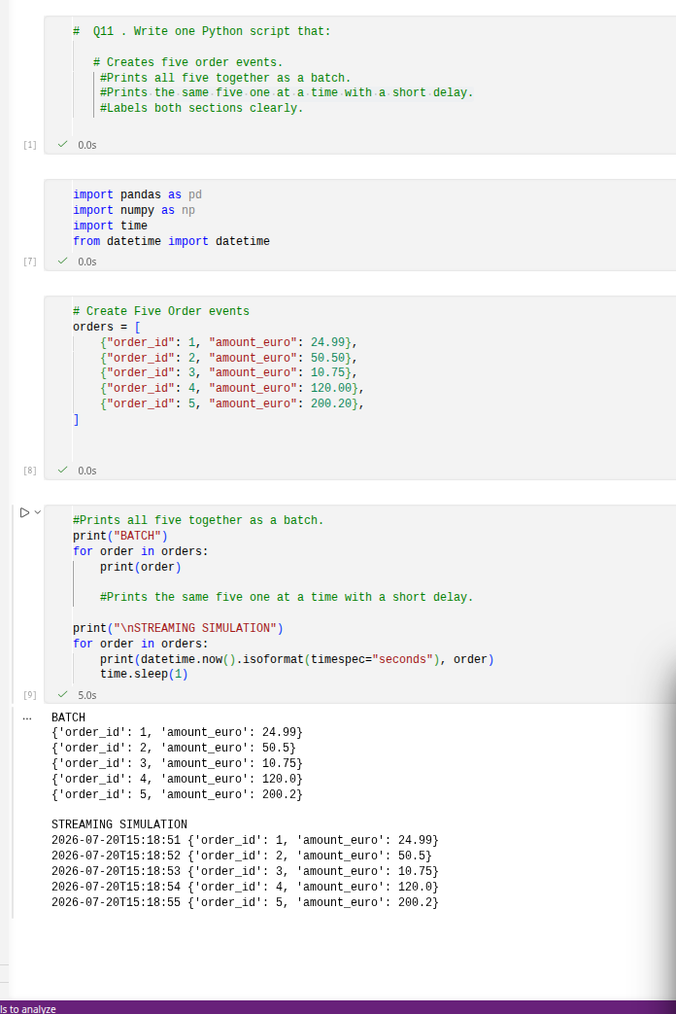
Q12: Ingest a Customer File into Raw Storage

customer_id,name,email,city
1, Amelia Clarke ,AMELIA@EXAMPLE.COM,Manchester
2,Oliver Bennett,oliver@example.com,Bristol

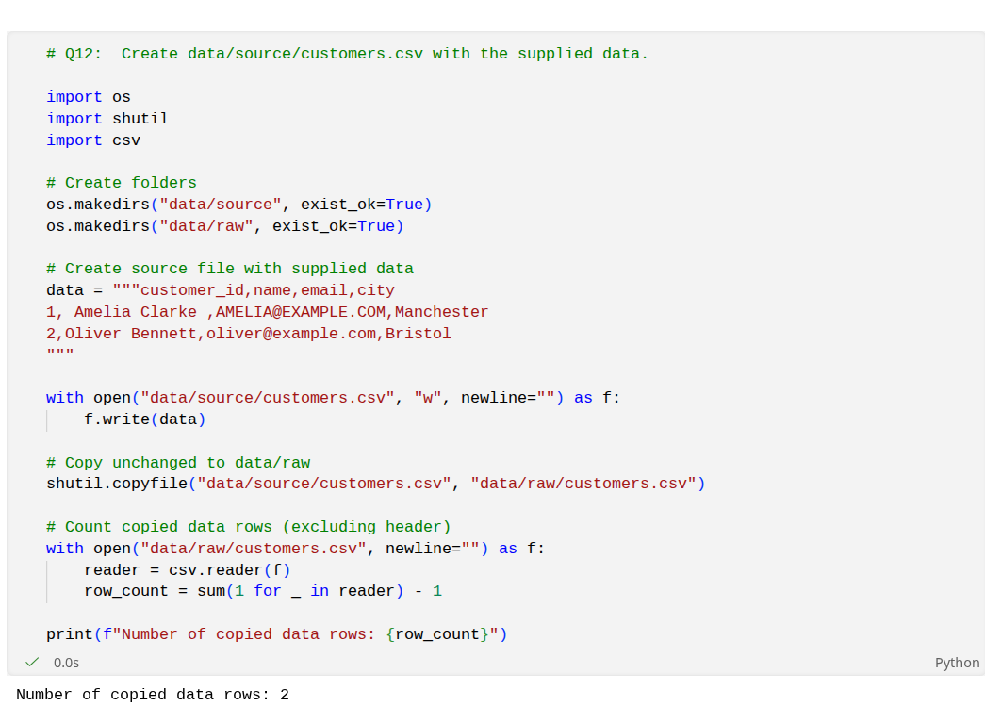
Q13: Clean Raw Customers into Staging

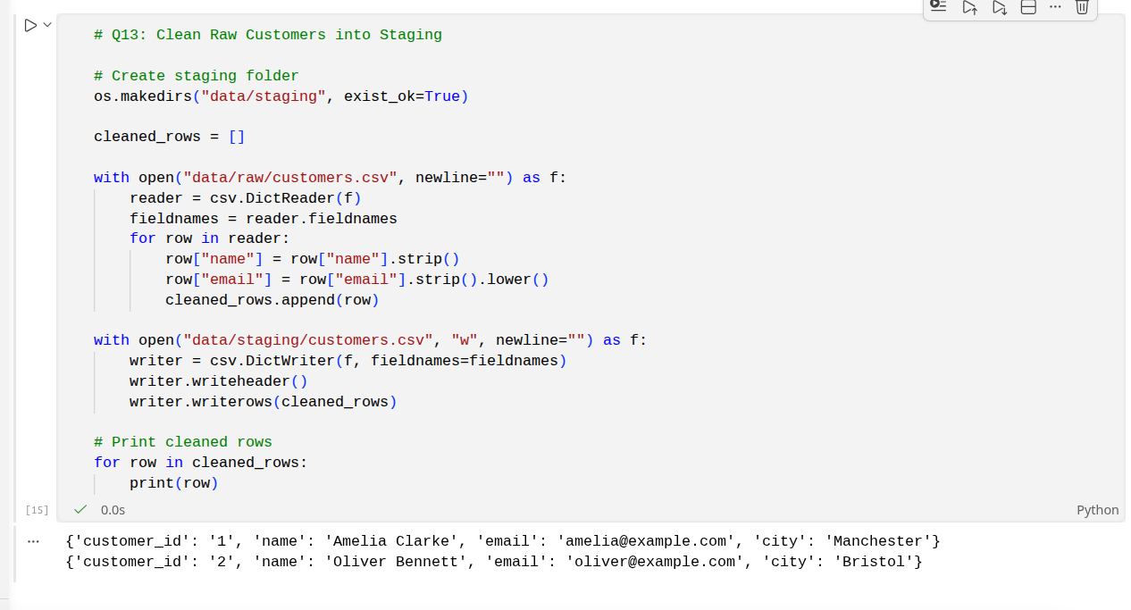
Q14. Which processing style best fits a report produced once every night?
A- Batch

Q15- Which processing style best fits an immediate fraud alert?
B- Streaming

Q16- What does an ingestion job normally do?
A. Moves data into a pipeline

Q17- Which task belongs most naturally in staging?
A. Trim names and validate required fields

Q18- Why keep raw and staging data separate?
A. To preserve the original input while creating a cleaned version

Q19:
--- ingest_customers
↓
clean_customers
↓
build_customer_summary
↓
publish_report

---- If clean_customer fails then the next step build_customer_summary will not be performed.
---- Because each step depends on the previous one.

Q20 :

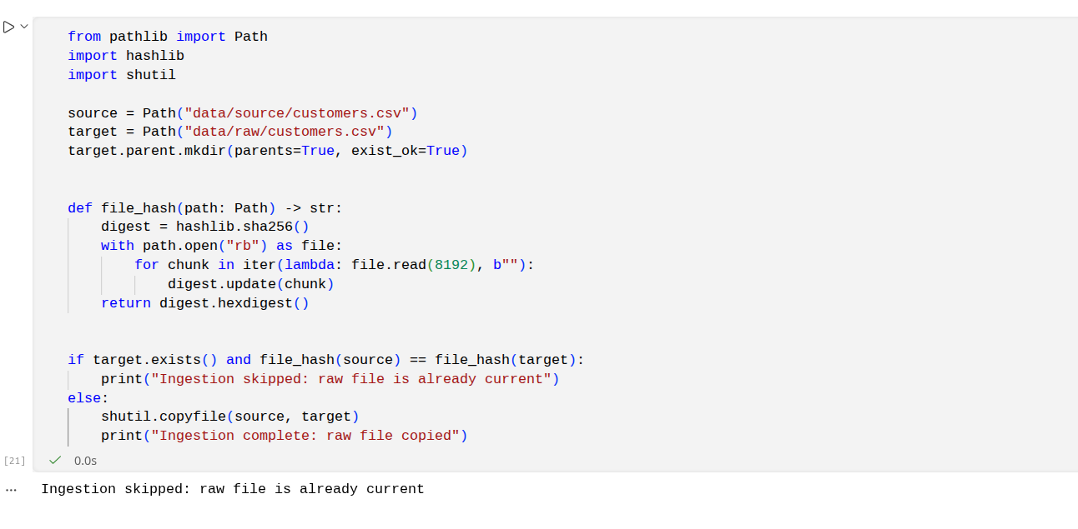
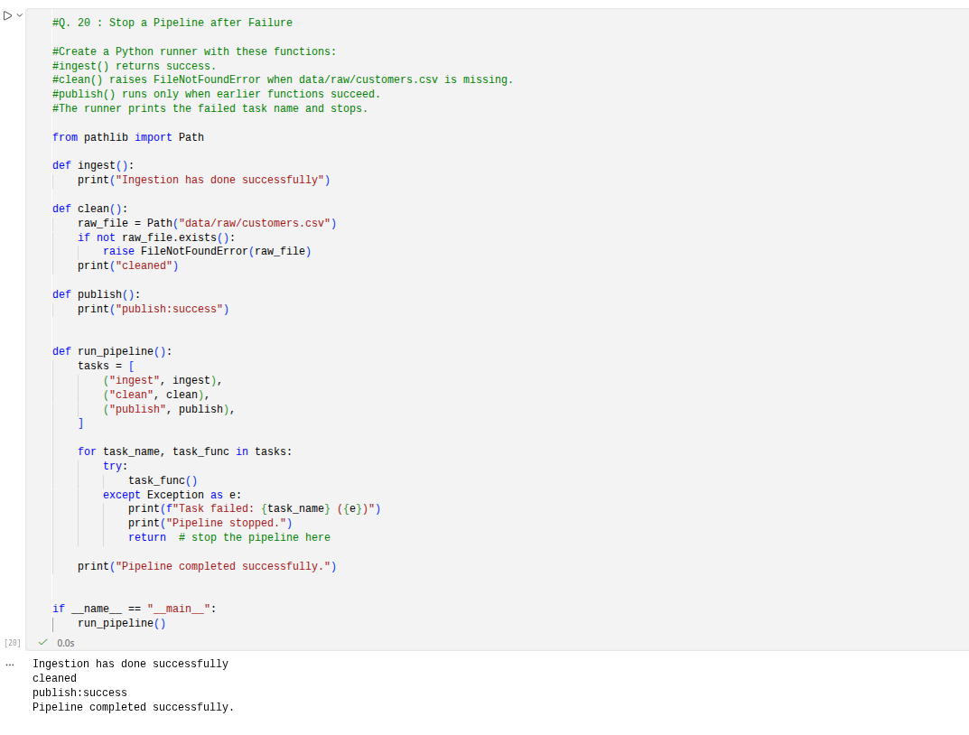
Q21:

