**PropHub**

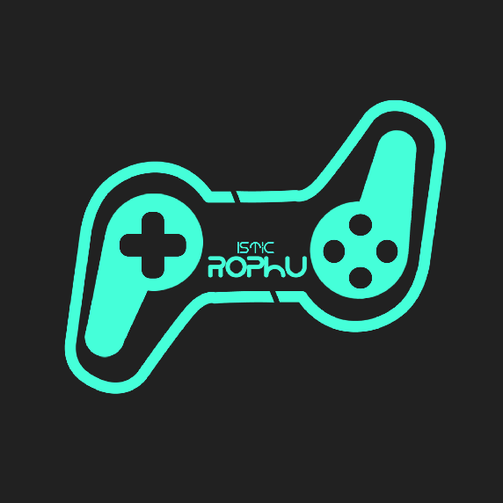

PropHub is an open marketplace for indie Games developers. It's a place for Game assets and video games designers that enables them to sell their content for the price they set. PropHub is also the home of compeletly unique assets that range widely from free to paid.

Made by :

Raed Saidi

Mariem Rjab

Tarak Msolli

