Predicting Cardiac Diseases in Children



Rui Santos: up202109728

CC4072: Foundations of Data Science
Profª. Inês Dutra,
2025-2026
Contents
Introduction 3
Problem Definition 4
Methodological approach 4
Data scope and Evaluation 4
Raw data 5
Variable description 5
Preliminary analysis 5
Summaries 5
Visualizations 6
List of main changes needed to be performed 7
Preprocessing 8
Basic description 9
Summaries 9
Visualizations 10
Analysis 11
Bivariate analysis 11
Multivariate analysis 12
Predictive Models 13
Discussion and Main Conclusions 14
Bibliography 15
Tables 16
Figures 19

Introduction
This report details the development of a predictive analysis framework for identifying cardiac diseases in children, utilizing a dataset provided by the Real Hospital Português (RHP), Brazil. The primary objective of this study is to apply feature importance methods to rank variables that are most predictive of cardiac pathologies.
The rest of the report is divided into 7 sections:
- Problem definition
- Raw data analysis
- Preprocessing
- Basic description
- Analysis
- Discussion and Main Conclusions
The notebook with all the material I used to create this report are present in this github repository and in the bibliography there is a link for the notebooks I used for each section in this report.

Problem Definition
The primary goal of this study is to apply feature importance methods to rank variables that are most predictive of cardiac pathologies in children. By identifying relevant and non-redundant variables, this research aims to build automated classifiers that assist medical professionals in distinguishing between healthy patients ("Normal") and those with cardiac pathologies ("Anormal").

Methodological approach
The project entails three distinct analytical tasks:
- Supervised Learning (Classification): The core task involves generating predictive models using Decision Trees, Support Vector Machines and Bayesian Networks.
- Feature Selection: Statistical analysis will be used to measure variable dependence and discard redundant features (e.g., handling strong correlations between height, weight, and BMI).
- Univariate & Multivariate Analysis: The study includes exploratory clustering to identify groups of similar patients and regression analysis to understand variable relationships.

Data scope and Evaluation
The dataset comprises anonymized records from the Real Hospital Português (Brazil) for children. The input features include demographic data (e.g., age, gender), physical measurements (e.g., weight, height, BMI), and clinical indicators (e.g., blood pressure, heart sounds, murmurs).
Model performance will be assessed using metrics suitable for the domain, some of the metrics used are:
- Confusion Matrix
- Sensitivity (Recall/True Positive Rate)
- Accuracy
- Receiver Operating Characteristic (ROC) and Precision-Recall Curve (PRC)

Raw data
The contents of this section are the following:
- Variable description according to their types (interval-scaled, binary, nominal, ordinal, ratio-scaled).
- Preliminary analysis on the raw data (summaries, histograms, boxplots, spread measures, density).
- List of main changes needed to be performed with the raw data.

Variable description
Table 1 categorizes the dataset variables by their respective types: Nominal, Ordinal, Interval, and Ratio-scaled.

Preliminary analysis
In this section I did a preliminary analysis on the raw data. This type of analysis allowed me to discover several things about the dataset itself (inconsistences, outliers, duplicates, missing values, etc..). The results of this analysis are presented in the subsections below, supported by relevant visualizations. To facilitate all the work done in the following subsections, some columns were renamed to a more ‘standard’ and uniform name.

Summaries
The raw dataset comprises 17,873 patient records, each described by 21 features detailed in Table 2. An initial inspection reveals that the majority of features were interpreted as object types, with only a few recognized as numeric. Notably, several variables were misclassified upon import due to a lack of standardization during data collection (for instance, FC (cardiac frequency) appears as an object despite being numeric, and Idade (age) is cast as a float rather than an integer).
The dataset also exhibits a significant volume of missing values. Certain features display missingness rates of approximately 43% (see Table 3 and Figure 1), requiring careful handling as these gaps may not hold inherent meaning.
Regarding the target variable (Normal vs. Anormal), the class distribution is unbalanced, with a predominant number of patients classified as "Normal." This skew aligns with real-world clinical prevalence, where pathology is less common than health. Furthermore, the target labels contain inconsistencies (e.g., 'Normais' instead of 'Normal', and 'anormal' instead of 'Anormal') which must be standardized. Figure 2 illustrates the distribution of cardiac pathology across the dataset."

Visualizations
Figure 3 displays the pair plot of the relation between numerical features. From that plot, we can conclude that the raw data is heavily affected by noise and data entry errors, which manifest as extreme outliers. These include physically impossible values such as heights of zero, negative weights, and BMI values reaching the 600–800 range. Consequently, aside from the relationship between height and weigh, which exhibits a visible trend despite the interference, it is not possible to establish clear linear relationships or discernible patterns among the features in the raw dataset.
Dues to the amount of features I decided not to include the histograms for all features are omitted for brevity, their analysis revealed significant noise, particularly within numeric features, which manifested as long tails or isolated spikes. This noise steams primarily from: missing, impossible or incorrect values that will be appropietaly handled in later sections of this report. Regarding categorical features, we observed high cardinality across several variables. Furthermore, the distribution analysis indicates that features such as Convenio, Atendimento, and DN provide to many different values with no predictive value and will therefore be excluded during the preprocessing stage.
With a boxplot of numerical features in regard to the target feature (present in Figure 4) I saw that inconsistencies in the target labels are clearly visible (e.g., 'anormal' vs. 'Anormal' and ‘Normais’ vs. ‘Normal’). Furthermore, the plots confirm the presence of physically impossible values, such as negative ages, negative weights, and extreme outliers in BMI and Systolic Blood Pressure (SBP) that far exceed biological limits. The only feature that doesn’t show outliers in this blox is the ‘Altura’ feature.
To evaluate data dispersion (how spreaded the data is), I utilized a visualization like Figure 5, on the numeric variables of the dataset. This plot illustrates key spread metrics, specifically the Range (Amplitude), Interquartile Range (IQR), Standard Deviation, and Coefficient of Variation. With the analysis of spread measures, I discovered a significant discrepancy between metrics sensitive to outliers and those that are robust. While the Interquartile Range (IQR) indicates that the central portion of the data falls within plausible clinical limits, the Range (Amplitude) and Standard Deviation are disproportionately inflated for features such as IMC, Peso, and Idade. This vast difference confirms that the dataset's high variability is largely artificial, driven by the specific errors and impossible values identified earlier (e.g., negative ages and extreme BMI) rather than true biological diversity. Consequently, relying on the mean or standard deviation for normalization would be misleading, reinforcing the need to use robust scaling or outlier handling techniques in the preprocessing stage.
Although density estimates were included in the spread visualization, I decided to include dedicated density plots for numeric variables to provide a more granular view of the data distribution than histograms allow. However, analysis reveals that these plots are heavily distorted by the extreme outliers identified previously. The artificial extension of the value range (e.g., caused by negative ages or IMC > 600) forces the 'true' patient population distribution into a compressed, narrow spike (see Figure 6). This visual compression obscures the meaningful variations between the 'Normal' and 'Anormal' classes. Consequently, these results reinforce the necessity of removing impossible values before attempting any reliable probabilistic analysis or standardization.
To determine the linear relationships between numerical features, I utilized a correlation matrix (Figure 7). This analysis revealed that the three most significant correlations occur between the feature pairs: ‘Peso’ and ‘Altura’, ‘SBP’ and ‘DBP’, and ‘Idade’ and ‘Peso’ (the correlation plot of the feature pairs can be seen in Figure 8). These strong associations in my opinion seem clinically consistent and indicate statistical dependence. Specifically, Peso and Altura increase in parallel as a direct result of pediatric growth and development, explaining their correlation with Idade. Furthermore, Systolic (SBP) and Diastolic (DBP) blood pressures are physiologically coupled components of the cardiac cycle, leading to their high linear correlation. It is also important to note that the correlation matrix was recomputed following the data cleaning and preprocessing stages. This subsequent analysis yielded more robust correlation coefficients, indicating that the removal of noise and outliers allowed for a more accurate representation of the feature dependencies.
To investigate the associations between non-numerical features and the target variable, I utilized stacked bar charts. From this analysis, I concluded that ‘Sopro’ and ‘B2’ are the most significant discriminators between the 'Normal' and 'Anormal' classes. Conversely, ‘Sexo’ appears to have a negligible impact on the diagnosis. Additionally, the visualization highlighted that ‘Motivo1’ and ‘Motivo2’ exhibit high cardinality, making it difficult to derive clear patterns from these variables without reducing the cardinality with further grouping.
Finally, boxplots were employed to examine the dependencies between categorical and numerical features. From these visualizations, we can conclude that there is significant overlap in the numerical distributions across the different categorical groups. This suggests that the categorical variables do not impose a clear separation or distinct linear relationship on the numerical data.

List of main changes needed to be performed
Based on the analysis of the raw data, the following changes are required to improve data quality:
- Irrelevant Feature Removal:
  - Eliminate non-predictive features such as patient IDs, names, dates of visit, and birth dates.
- Filter age group:
  - Eliminate records of patients that don’t enter in the interval of [2,19]
- Clinical Consistency:
  - Remove records that do not represent ‘valid’ clinical data (e.g. remove invalid impossible values of SBP and DBP, according to reference values provided by the teacher)
- Label Standardization:
  - Correct inconsistent categorical values (e.g., unifying "M" vs. "Masculine").
- Error Correction:
  - Remove instances containing incorrect or physically impossible values (e.g., Height = 0).
- Missing Value Handling:
  - Appropriately handle the missing values
- Outlier Management:
  - Apply the Interquartile Range (IQR) method to remove extreme outliers that would otherwise distort the analysis.
- Transformation:
  - Apply standardization to scale numerical features and generalize low-level features into higher-level categories.

Preprocessing
The data preprocessing phase was executed strictly adhering to the methodology outlined in the previous subsection. Upon completion, the resulting dataset was saved to serve as the foundation for the subsequent 'Basic Description' analysis and the advanced predictive modeling tasks in the 'Analysis' section.
To initiate the cleaning process, features deemed irrelevant to the predictive task (namely ID, Atendimento, DN and Convenio) were eliminated (ending up with 17 features). Subsequently, an age-based filter was applied to remove records of patients outside the [2, 19] year interval. This step was essential for standardization and reduced the dataset from 17,753 to 12,384 rows. Additionally, the Idade (Age) feature was cast to an integer type to reflect the discrete nature of the variable.
Following filtration, I addressed data inconsistencies by unifying values that represented the same concept but were recorded differently (e.g., standardized categorical labels). During this process, I also reduced the cardinality of high-dimensional features such as Motivo1 and HDA1, grouping rare occurrences to improve model suitability.
Next, I proceeded to remove incorrect, impossible, or irrelevant values based on the clinical reference tables provided in the assignment documentation and external verification. This step, which targeted physically impossible entries (e.g., negative weights or extreme outliers), further refined the dataset, resulting in a final count of 8,995 rows.
Missing values (NaN) were handled according to whether the absence of data carried inherent meaning. I categorized these instances into three distinct groups:
- Group 1: Imputation (Meaningful Missingness)
  - Sopro (Murmur): Missing entries were interpreted as the absence of a murmur and imputed with the value ‘Ausente’.
  - HDA1, HDA2 (History of Disease): Absence of data was treated as having no prior clinical history and replaced with ‘Assintomático’.
  - Motivo1, Motivo2 (Reason for Visit): Missing values were assumed to indicate no specific complaint or an unlisted reason and were recoded as ‘Outro’ (Other).
- Group 2: Row Removal (Non-Meaningful Missingness): For the following features, a missing value indicates that a critical measurement was not taken. To preserve the integrity of the diagnostic analysis, rows containing missing values in these columns were removed:
  - ‘Peso’ (Weight) & ‘Altura’ (Height): Fundamental measures essential for BMI calculation and growth assessment.
  - ‘Pulsos’ : Indicates an incomplete physical examination.
  - ‘SBP’ & ‘DBP’ (Blood Pressure): Critical physiological indicators required for cardiovascular assessment.
  - ‘Patologia’: Rows missing the target classification (Normal vs. Anormal) are unusable for supervised learning.
  - ‘B2’ & ‘FC’: Essential clinical observations.
  - ‘Sexo’: A fundamental demographic variable required for standardizing other metrics.
- Group 3: Recalculation
  - ‘Result SBP/DBP’ & IMC (BMI): Missing values in these columns were not removed or imputed directly.
  - Instead, these features were mathematically re-derived using the cleaned values of their parent variables (recalculating Result SBP/DBP from SBP/DBP and IMC from Peso/Altura).
After applying these ‘conditions’ in the removal of missing values in the dataset, I ended up with 6358 rows.
For duplicate entry removal, the number of rows dropped from 6358 to 6321.
Regarding outlier management, I made a strategic decision to preserve data points that, while statistical outliers, represent biologically plausible patient data. Conversely, values identified as physically impossible were treated as noise and removed. Figure 9 and Figure 10 illustrate these invalid outliers, specifically highlighting the impossible values detected in Altura (Height) and Peso (Weight) that fall outside the clinical reference limits provided. After handling outliers, I ended up with 6293 rows.
I performed feature construction by mathematically recalculating PPA ('Result SBP/DBP') and IMC (BMI) using the cleaned values of their parent variables (SBP/DBP and Peso/Altura, respectively). The distribution of the recalculated ‘Result SBP/DBP’ is shown in the histogram in Figure 11. Additionally, Figure 12 Figure 12 presents boxplots contrasting the ‘IMC’ distribution before and after the removal of impossible values, visually confirming the effectiveness of the outlier rejection process.
Upon the conclusion of the preprocessing pipeline, the refined dataset was exported to a CSV format to serve as the input for the subsequent analysis. Table 4 - Dataset info after completing preprocessing step provides a small summary of the characteristics and dimensions of this final preprocessed dataset.

Basic description
In this section, the visualizations initially generated for the raw data analysis were reproduced using the preprocessed dataset. This comparative approach allows for a clear assessment of the preprocessing stage's effectiveness in mitigating noise and improving overall data quality.

Summaries
The final preprocessed dataset consists of 6,293 records and 21 features, representing a substantial reduction from the original 17,873 entries. This decrease is a direct result of the preprocessing and cleaning applied to ensure data quality. All missing values have been successfully addressed through either imputation or removal, resulting in a complete dataset with zero null entries. Regarding the target variable, the class distribution remains unbalanced, comprising 4,193 'Normal' cases and 2,190 'Anormal' cases.

Visualizations
Figure 13 displays the pair plot of the relation between numerical features, and here we can clearly see the improvement compared to Figure 3. Namely, we can see that chaotic noise has been replaced by coherent physiological trends. Strong correlations are now clearly visible, such as the linear relationship between Systolic and Diastolic Blood Pressure, and the expected developmental trends where height and weight increase with age.
Due to the dimensionality of the dataset, individual histograms for every feature are omitted for brevity. However, a collective analysis of the post-preprocessing distributions reveals a significant improvement: the data appears 'smoother' and devoid of the artificial spikes caused by noise in the raw dataset. This enhancement is exemplified in Figure 14, which contrasts the distribution of the Altura (Height) feature before and after preprocessing, showing a natural well shaped curve. Regarding non-numerical features, the histograms also confirm the successful reduction of cardinality, resulting in cleaner and more interpretable categories.
Using the boxplots of the numerical features shown in Figure 15 (after preprocessing) and Figure 4 (before preprocessing), it can also be observed that the elimination of impossible outliers has restored the natural scale of the variables. Unlike the raw data, where extreme values compressed the distributions into flat lines, the processed plots reveal distinct Interquartile Ranges (IQR) and medians that fall within biologically plausible limits (e.g., ‘IMC’ and ‘Peso’ now span realistic clinical intervals).
For the data dispersion, I utilized the same type of figures I used in the Raw data sections, and conclude that the values of the spread measures, in general, have stabilized and reduced comparing to the one obtained on the raw data. In terms of visualization, in general, it can be seen that the 'squashing' effect caused by extreme outliers is gone. The bars representing Range and Standard Deviation are no longer artificially inflated, providing a realistic view of the data's actual variability.
In terms of the density plots of the preprocessed data, compared to the ones obtained from the raw data, it is easily established that the artificial compression of the distributions has been resolved. Unlike the raw plots, where extreme outliers forced the density into narrow, uninformative spikes, the preprocessed visualizations display smooth, continuous curves. This expansion along the x-axis allows for a proper analysis of the data's skewness and the subtle variances between the 'Normal' and 'Anormal' classes.
The correlation matrix of the preprocessed data (Figure 16) shows a marked improvement in the strength and clarity of the feature dependencies compared to the correlation matrix of the raw data (Figure 7). This enhancement is caused by the effective removal of noise and impossible outliers. In the raw data, extreme values (e.g., negative ages or invalid values like Altura=0) acted as leverage points that distorted the linear relationships. Removing them allowed the true physiological correlations, such as the strong link between ‘Altura’ and ’Peso’ ,to be accurately captured. This analysis revealed that some of the most significant correlations occur between the feature pairs: 'Peso' and 'Altura', 'Idade' and 'Peso', and 'Altura' and 'Idade' (visualized with pair plots in Figure 17). While some strong associations were already present and merely enhanced (e.g., 'Peso'/'Altura' and 'Idade'/'Peso'), others were effectively unmasked only after data cleaning (e.g., 'Altura'/'Idade'). This suggests that the relationship between ‘Altura’ and ‘Idade’ was previously obscured by the high volume of noise and impossible values.
Once again, to check the relation between non-numerical features and the target variable (Patologia), I utilized stacked bar charts. From this analysis, I concluded that ‘Sopro’ and ‘B2’ remain the strongest discriminators, with the presence of murmurs or abnormal sounds showing a near-perfect correlation with the 'Anormal' class. Additionally, the newly created categorical features provided valuable insights: 'Systolic/Diastolic Blood Pressure' categories show a clear trend where 'Hypertensive' patients are disproportionately represented in the 'Anormal' group. Conversely, Sexo (Gender) continues to display a balanced distribution, confirming it is not a primary discriminator for cardiac pathology.
Finally, with the help of boxplots, I examined the dependencies between categorical and numerical features. From these visualizations, I can conclude that the data seems to exhibit biological consistency. Specifically, the 'Intervalo de Idade' plots show a clear, stepwise increase in ‘Altura’ and ‘Peso’, confirming natural growth trends. Furthermore, when analyzing the target variable 'Patologia', we observe that the 'Anormal' class displays a wider dispersion and higher median values for physiological metrics like Systolic Blood Pressure, indicating that these numerical features are relevant discriminators for the diagnosis.

Analysis
This section is divided into three subsections:
- Bivariate analysis (correlations, regression)
- Multivariate analysis
- Predictive models

Bivariate analysis
Bivariate Analysis involves the simultaneous examination of two variables to determine if an empirical relationship exists between them. Unlike univariate analysis, which summarizes a single feature (e.g., calculating the mean age), bivariate analysis seeks to identify associations or causal links, for instance, determining if an increase in Age correlates with higher Systolic Blood Pressure (SBP), or if BMI varies significantly between sexes.
There are three primary types of bivariate analysis: Numerical vs. Numerical (e.g., Correlation), Numerical vs. Categorical (e.g., T-tests) and Categorical vs. Categorical (e.g., Chi-square). This section will focus on Numerical vs. Numerical relationships. In accordance with the assignment guidelines, I utilized Correlation and Linear Regression techniques to model these dependencies.
In terms of the correlation matrix in Figure 16, the analysis indicates that the three major positively correlated pairs are Altura/Idade, Peso/Altura, and Peso/Idade. This confirms that the primary source of variance in the numerical data is driven by the patient's growth stage.
For the regression analysis, I employed Simple Linear Regression to model the dependencies between key physiological variables. I selected specific Target (Y) and Predictor (X) pairs based on established biological causality: Height (Y) vs Age (X), Weight (Y) vs Height (X), Weight (Y) vs Age (X), and BMI (Y) vs Weight (X). These pairs were chosen because they exhibit a clear directional relationship, where the predictor is expected to determine the target (e.g. Age determines Height). To evaluate the strength of these models, I analyzed two primary metrics:
- R-squared (R²): Represents the percentage of the target's variance that is explained by the predictor.
- Coefficient: Quantifies the magnitude of the relationship, indicating how much the target variable is expected to increase (or decrease) for every one-unit increase in the predictor.
Conclusively, the regression analysis demonstrates strong linear dependencies among the key physiological features. The models for Height/Age and Weight/Height exhibited the highest predictive power (high R²), confirming that age is a robust predictor of physical development in this pediatric population. The positive coefficients across all tested pairs further validate that as patients age, their anthropometric measurements increase proportionally.

Multivariate analysis
To assess the independent influence of each feature on the target variable ('Patologia'), I utilized a Logistic Regression model. This method is specifically suited for binary classification tasks (Normal vs. Anormal). Also, to ensure a fair evaluation of feature importance, the dataset was preprocessed using standardization for numerical inputs and one-hot encoding for categorical ones. Figure 18 displays the resulting model coefficients. Based on these values, Table 5 and Table 6 summarize the top 5 predictors that significantly increase the likelihood of a 'Normal' or 'Anormal' diagnosis.
Continuing the multivariate analysis, I utilized Mutual Information as a complementary metric to the Logistic Regression coefficients. This step was performed using the same preprocessed data (standardized and one-hot encoded) to ensure consistency. Figure 19 displays the importance ranking for the full feature set, while Figure 20 isolates the numerical variables. The analysis reinforces the previous findings, as the features with the highest Mutual Information scores correspond to those with the most significant regression coefficients, providing robust evidence that these variables are the primary drivers of the target class.
To conclude the Multivariate Analysis, I applied K-Means clustering to the scaled numerical features to determine if the data naturally segregates into distinct groups corresponding to the target classes ('Normal' vs. 'Anormal'). The analysis revealed that the formed clusters do not perfectly align with the pathological categories. This discrepancy indicates that the disease does not manifest exclusively through alterations in numerical variables (such as blood pressure or BMI). Consequently, categorical variables containing specific clinical information (e.g., 'Sopro') are essential for accurate distinction, a conclusion that corroborates the feature importance findings from the Multiple Linear Regression analysis.

Predictive Models
To approach the classification task, I selected three distinct algorithms representing different learning paradigms: Decision Trees (for rule-based interpretability), Support Vector Machines (for finding optimal hyperplanes in high-dimensional space), and Bayesian Networks (for probabilistic reasoning).
Before training, the dataset underwent a specific preparation pipeline to ensure compatibility with these algorithms. As detailed in the associated notebook, this phase included:
- Standardization of numerical features to normalize scales.
- One-Hot Encoding and Mapping of categorical variables to convert symbolic data into machine-readable numerical formats.
The processed dataset was divided into training (80%) and testing (20%) subsets. As expected, the split maintained the inherent class imbalance, reflecting the higher frequency of 'Normal' diagnoses in the patient population. I opted not to apply balancing techniques like SMOTE or undersampling because the goal was to evaluate the models on the realistic distribution of the data. With artificial rebalancing I could add bias the model's probability estimates, potentially leading to a high false-positive rate (predicting sickness when the patient is healthy), which is undesirable in a screening context.
For every model, I tested two different hyperparameter configurations to compare performance under different tuning conditions. The evaluation process involved calculating Cross-Validation scores to verify stability. Subsequently, I analyzed the results using Confusion Matrices, ROC/PR Curves, and detailed Classification Reports. These reports provided granular metrics (specifically Precision, Recall, and F1-Score) for both the 'Normal' and 'Anormal' target classes. This model performance analysis was done using Figure 21, Figure 22, Figure 23, Figure 24 and Figure 25. The general conclusions from this model’s comparison are:
- Decision tree Models
  - Both Decision Tree models performed well, with Model 1 exhibiting a slight advantage over Model 2. The analysis indicates that Model 1's reduced depth prevented the algorithm from overfitting, ensuring that the model remained general enough to accurately classify new patient data.
  - Model 1 was the winner
- Support Vector Machine Models
  - Model 1 (utilizing a Polynomial kernel) demonstrated superior performance metrics compared to Model 2 (utilizing a Sigmoid kernel). This result suggests that the decision boundary separating 'Normal' from 'Anormal' pathologies is best approximated by a polynomial curve. While the Sigmoid kernel attempts to mimic the activation function of a neural network, it appears to have struggled with this specific feature space, whereas the Polynomial kernel seems to have successfully mapped the data into a higher-dimensional space where the classes were clearly separable.
  - Model 1 was the winner
- Bayesian Network Models
  - Model 1 and Model 2 achieved similar performance metrics. This stagnation suggests that the probabilistic assumptions (e.g., independence between features) might not fully hold for this dataset, or that the network structure (DAG) was similar for both configurations.
  - Model 1 was the winner

Regarding the overall ranking of the algorithms, the Bayesian Network demonstrated the lowest predictive performance. At the top tier, both the Support Vector Machine (SVM) and Decision Tree (DT) models achieved statistically similar results across key metrics (Accuracy, Recall, and F1-Score). Consequently, I cannot say which model is superior using only predictive scores as comparison. It is important to note that this comparative analysis was restricted to classification performance; factors such as computational cost and inference time, which might otherwise serve as tiebreakers, were outside the scope of this report.

Discussion and Main Conclusions
In conclusion, this project demonstrated that data quality is the single most significant determinant of model performance. The transition from raw to preprocessed data highlighted the necessity of removing noise to reveal true statistical dependencies. Moreover, this workflow confirmed that technical skills must be complemented by domain expertise (a contextual understanding of the physiological variables was the only way to effectively validate hypotheses and ensure the reliability of the final diagnostic models).

Bibliography
- Full repo : https://github.com/RS181/Data-Mining-I/tree/main/Assignment
- Raw data - Raw data analysis_notebook
- Prepocessing – Preprocessing_notebook
- Basic description – Basic_description_notebook
- Analysis – analysis_notebook

Tables

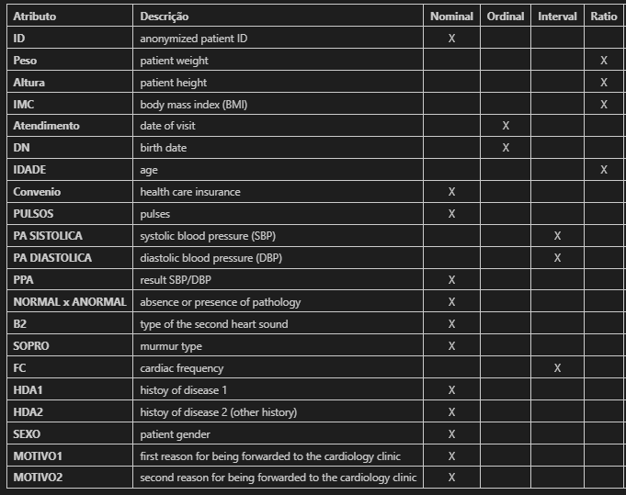
Table 1 - Feature types

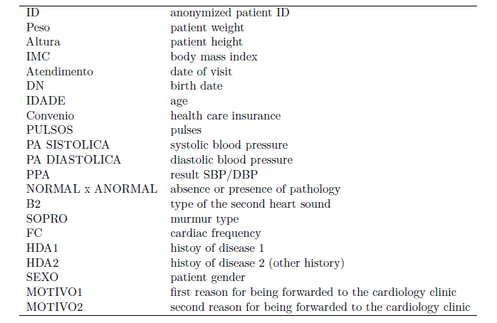
Table 2 - Columns (feature) descriptions

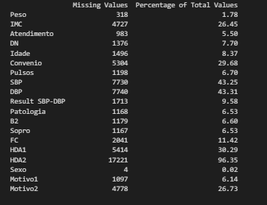
Table 3 - Missing values percentage on raw data
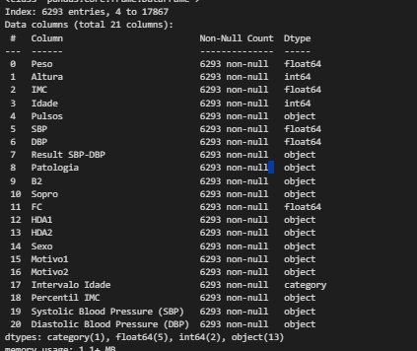
Table 4 - Dataset info after completing preprocessing step

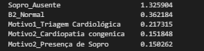
Table 5 - Logistic regression coefficients (for 'Normal' pathology class)
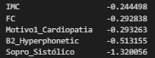
Table 6 - Logistic regression coefficients (for ‘Anormal’ pathology class)

Figures

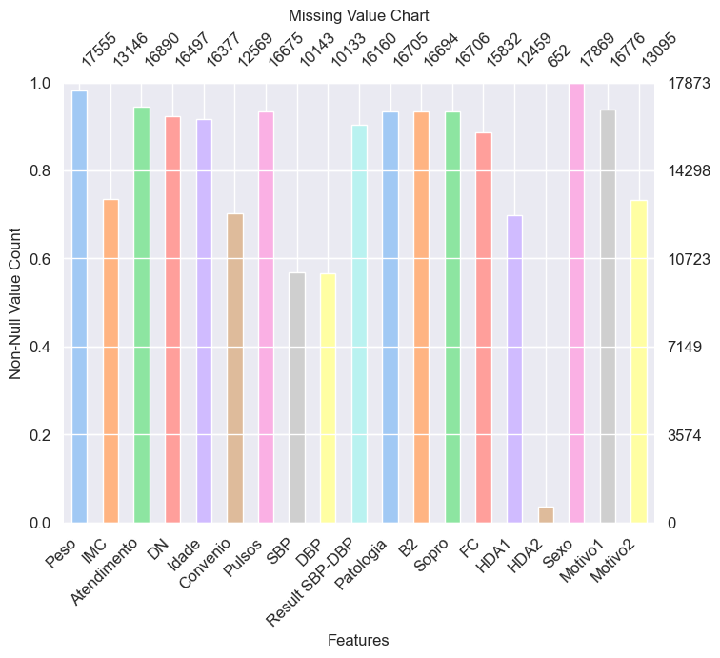
Figure 1 - Missing value chart (raw data)

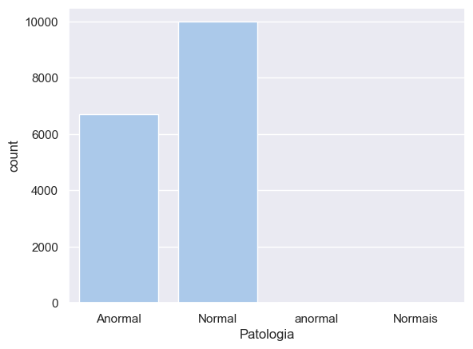
Figure 2 - Distribution of 'Patologia' (raw data)

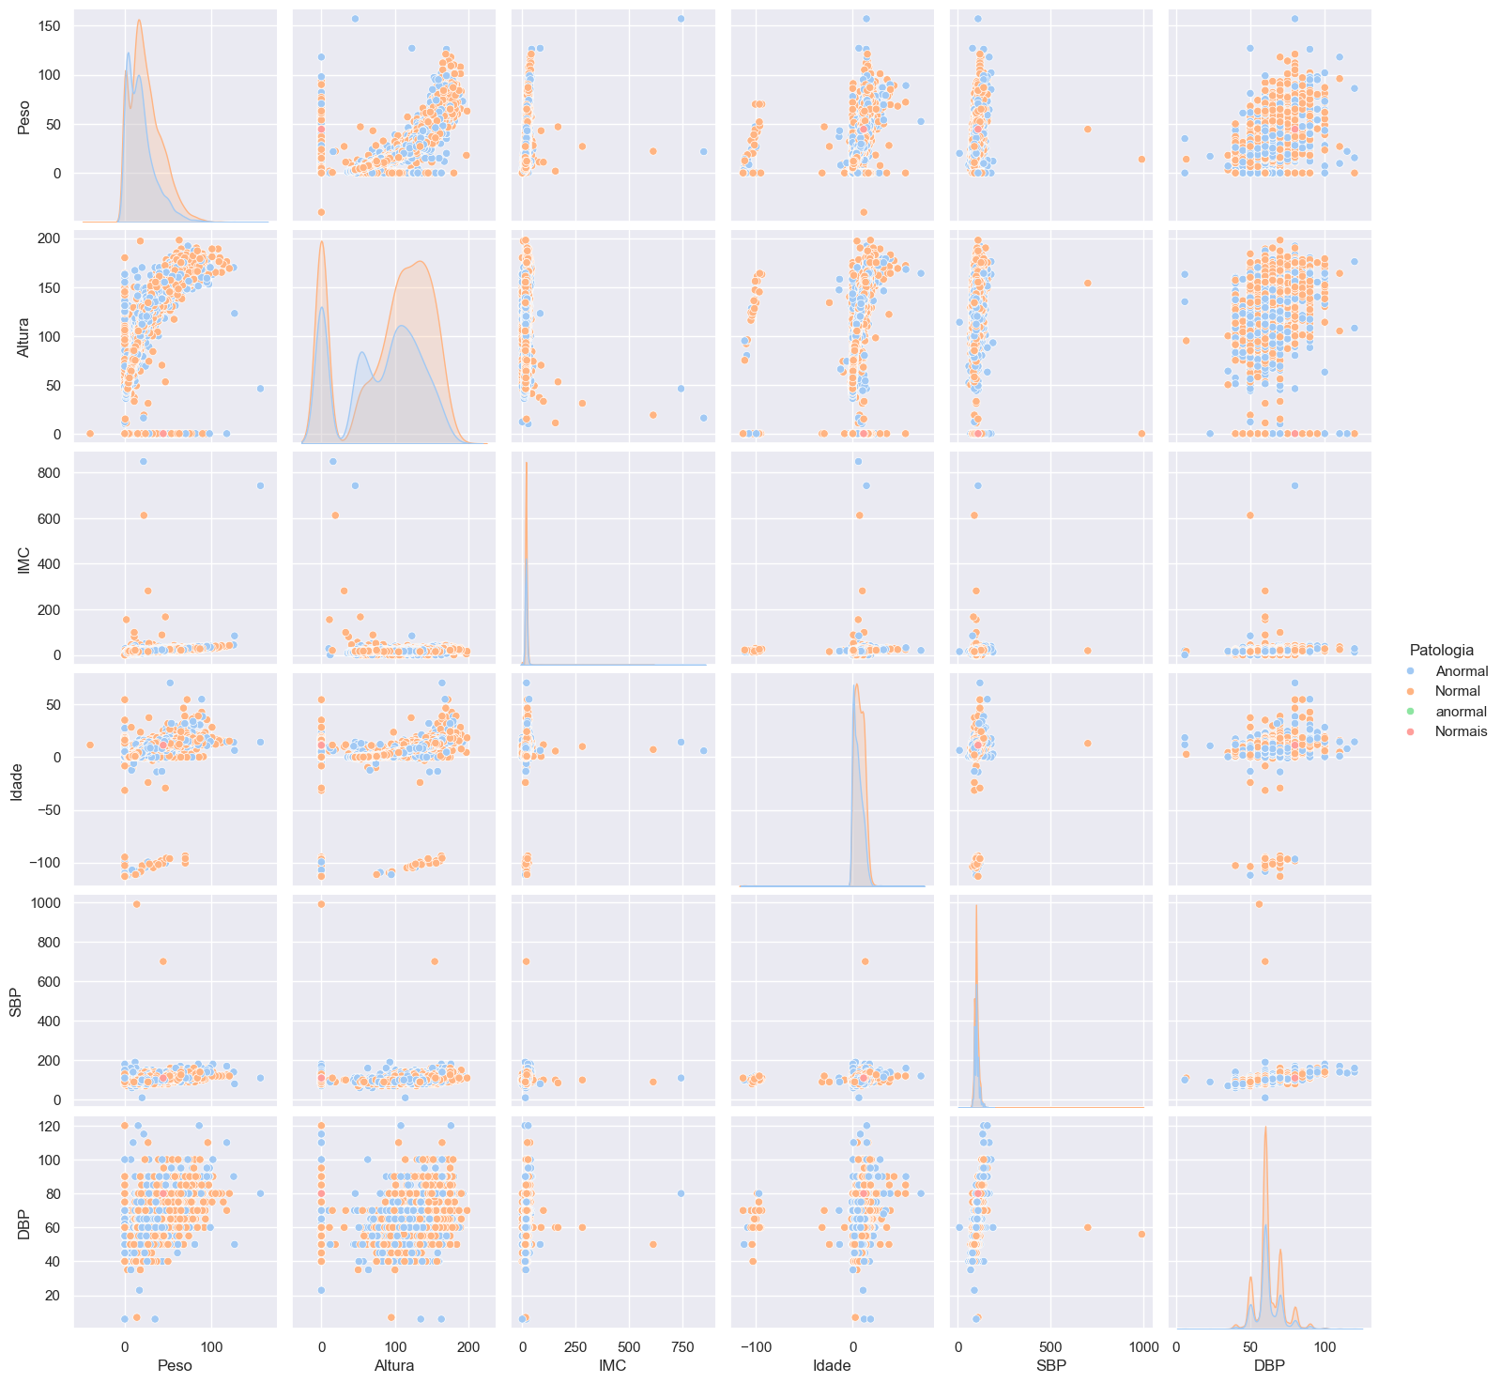
Figure 3 - Relation between numerical features (raw data)

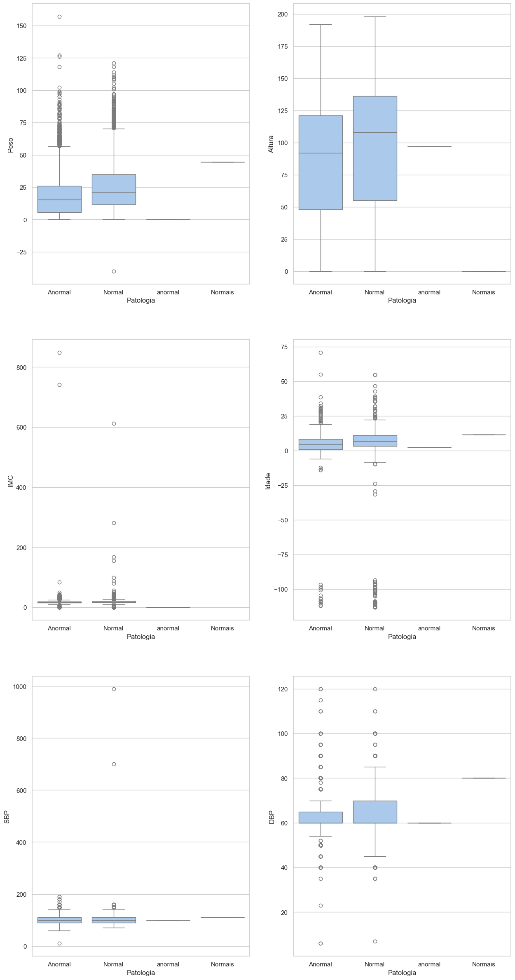
Figure 4 - Boxplot of numerical features in regards to tareget feature (raw data)
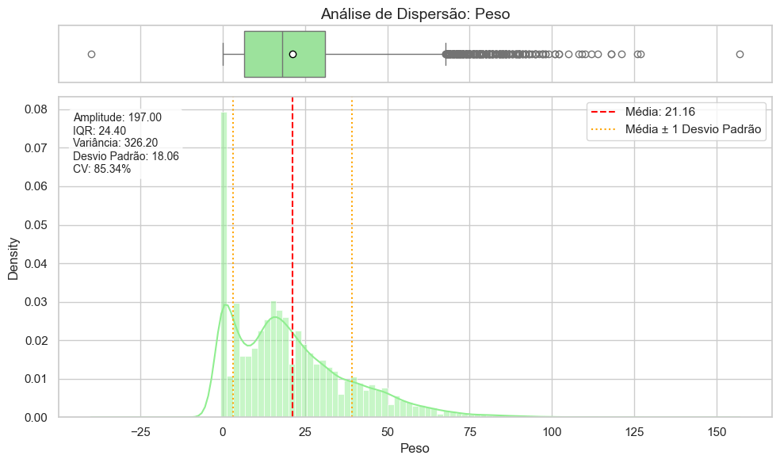
Figure 5 - Spread analysis on Peso feature (raw data)

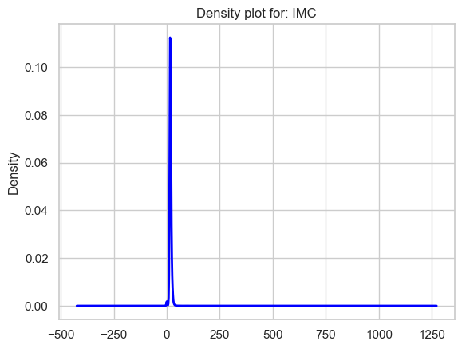
Figure 6 - Density plor for IMC (raw data)

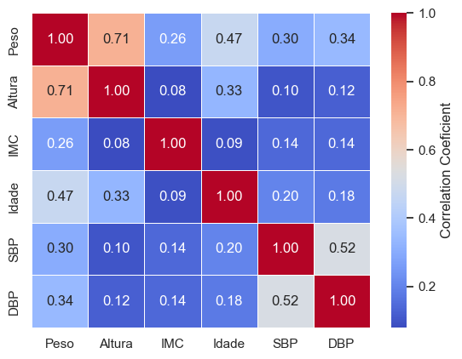
Figure 7 - Correlation of numerical features (raw data)

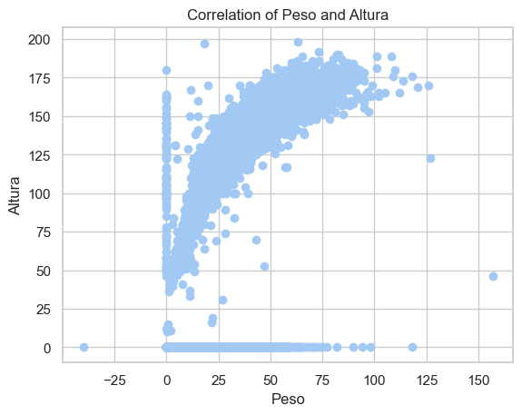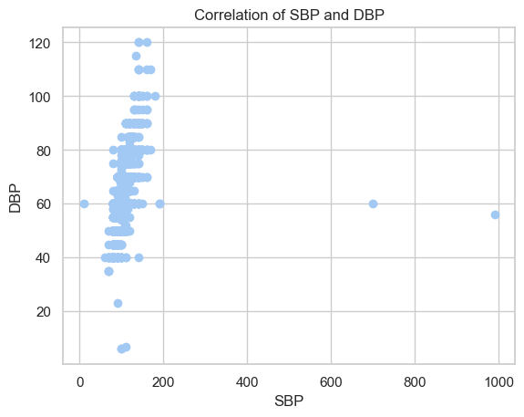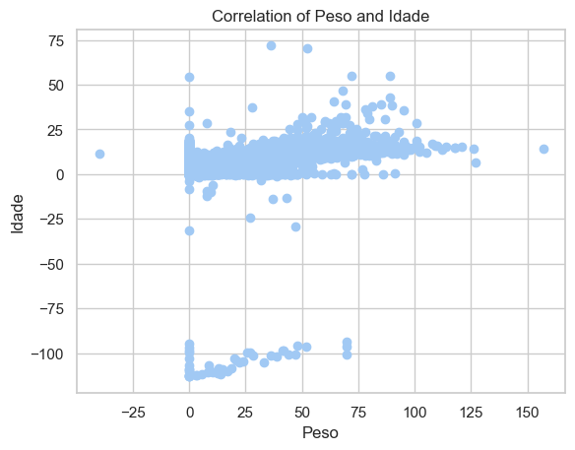
Figure 8 – Correlation of the top 3 positively correlated features (raw data)

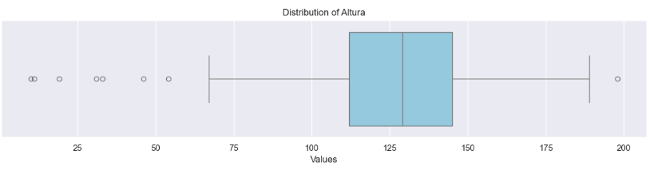
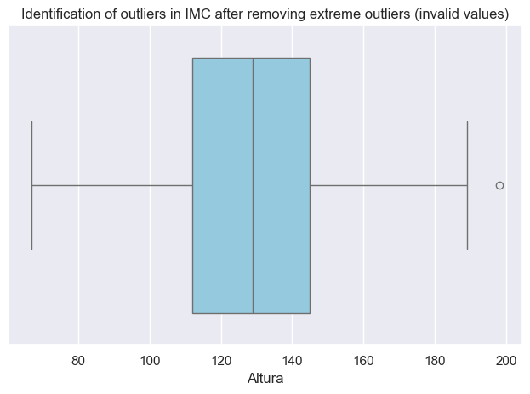
Figure 9 - Boxplot of 'Altura' feature before and after removing outliers

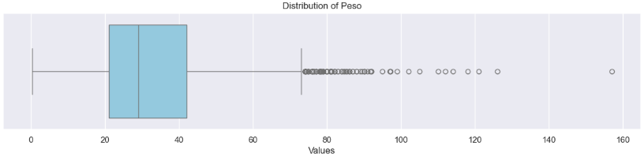
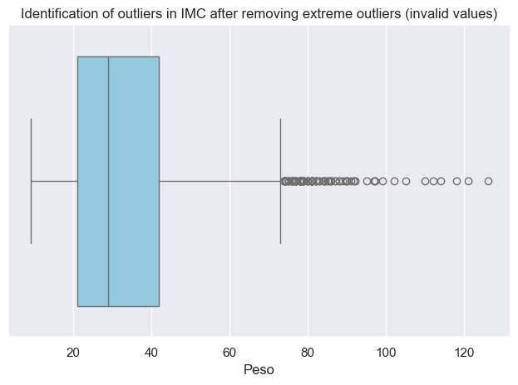
Figure 10 - Boxplot of 'Peso' feature before and after removing outliers

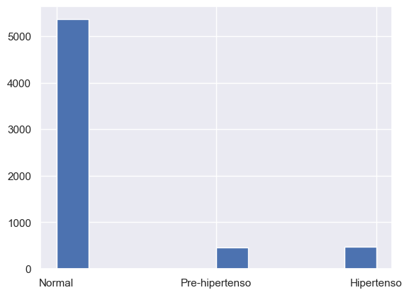
Figure 11 - Histogram of Result SBP-DBP’

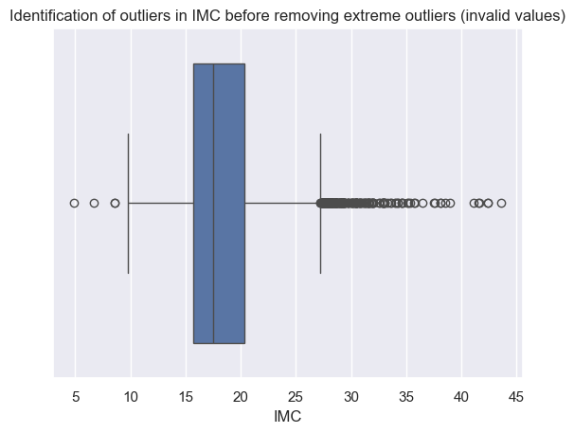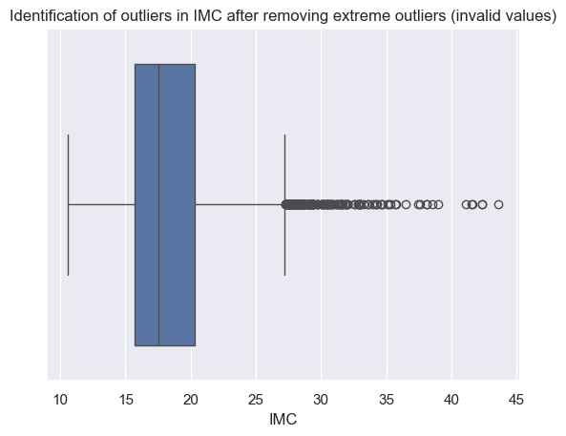
Figure 12 - Before and After boxplots of IMC
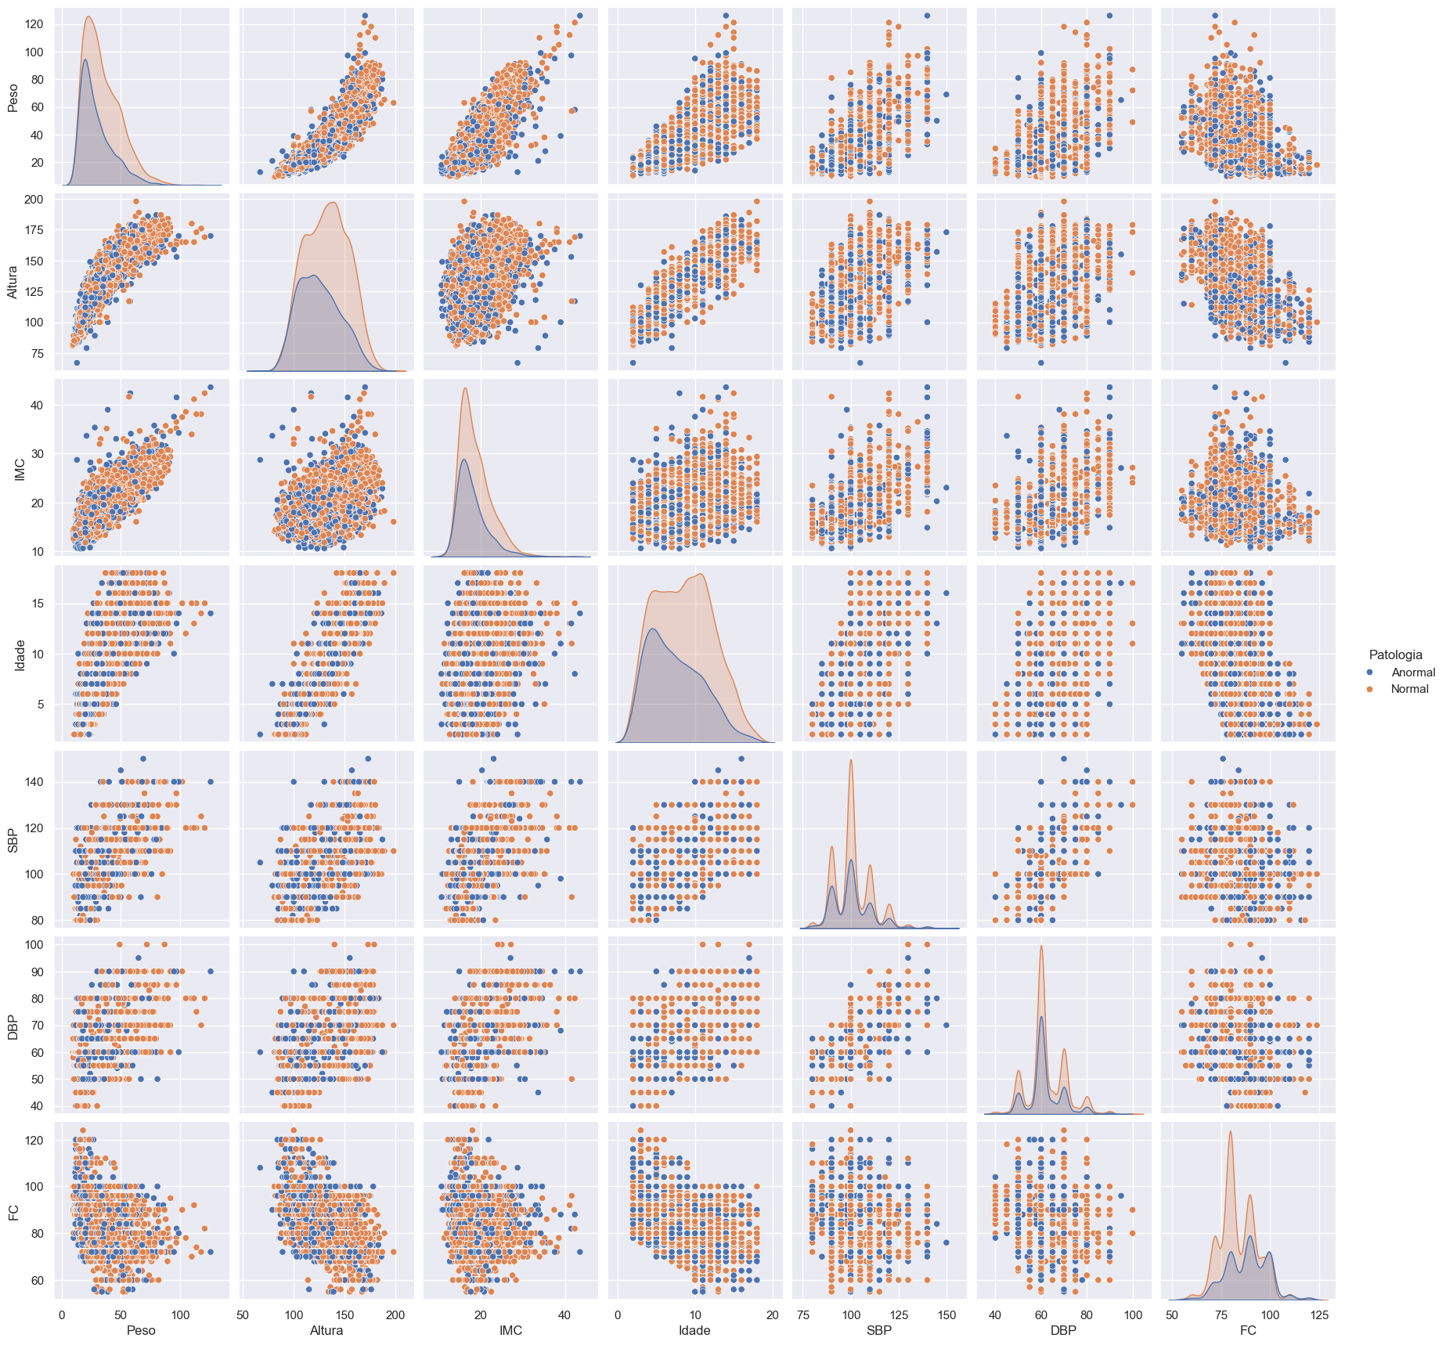
Figure 13 - Relation between numerical features (preprocessed data)

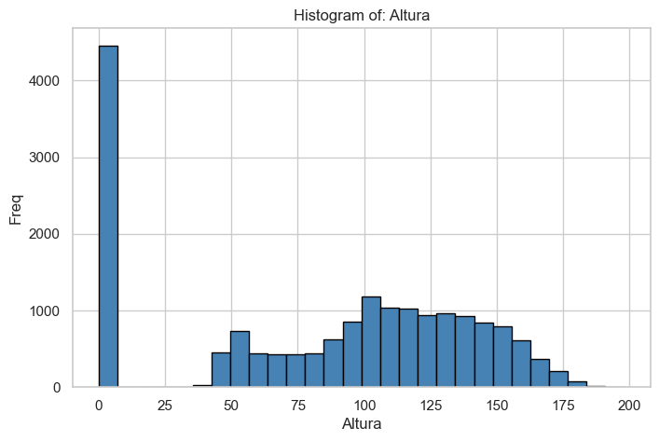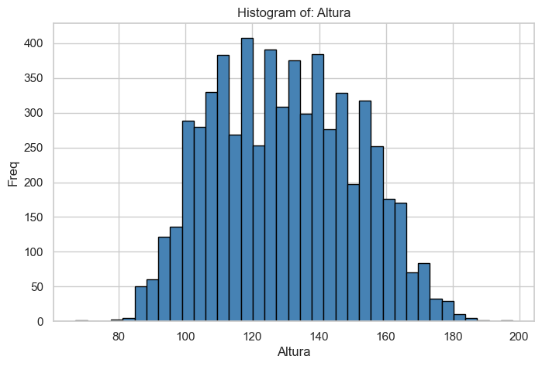
Figure 14 - Comparison od the Histogram of 'Altura' feature, before and after preprocessing

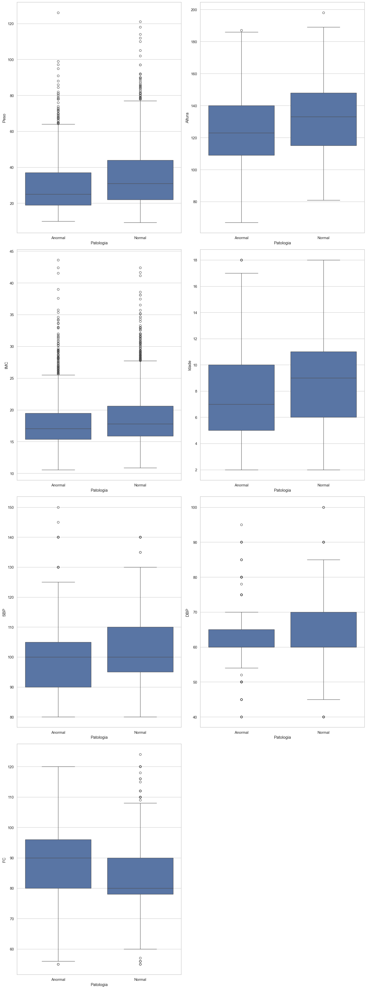
Figure 15 - Boxplot of numerical features in regards to target feature (preprocessed data)

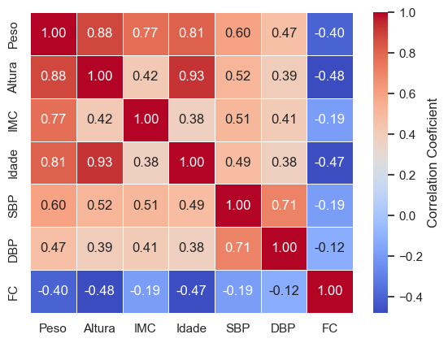
Figure 16 - Correlation of numerical features (preprocessed data)

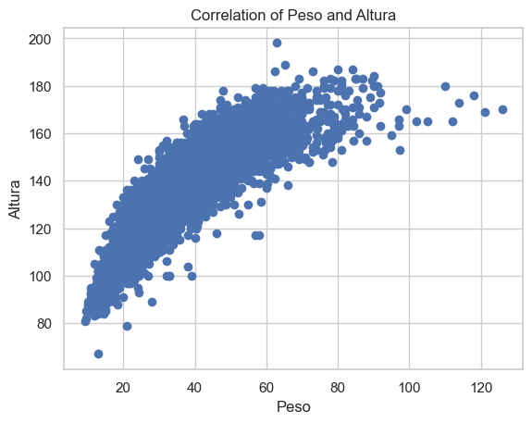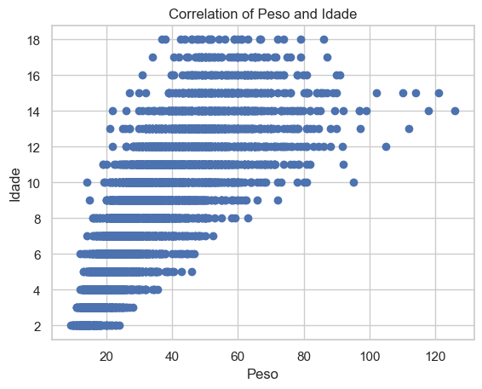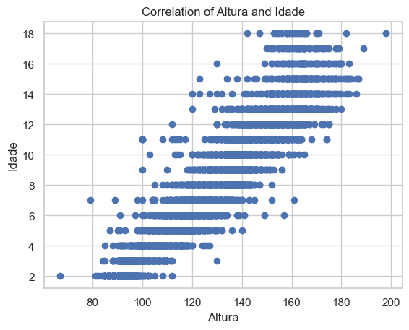
Figure 17 - Correlation of some of the positively correlated features (preprocessed data)
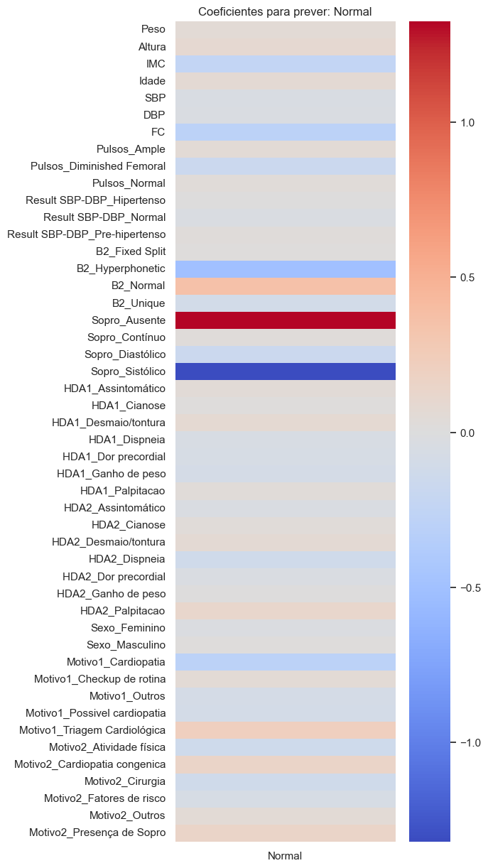
Figure 18 - Logictic regression coeficients for the ‘Normal’ Pathology class

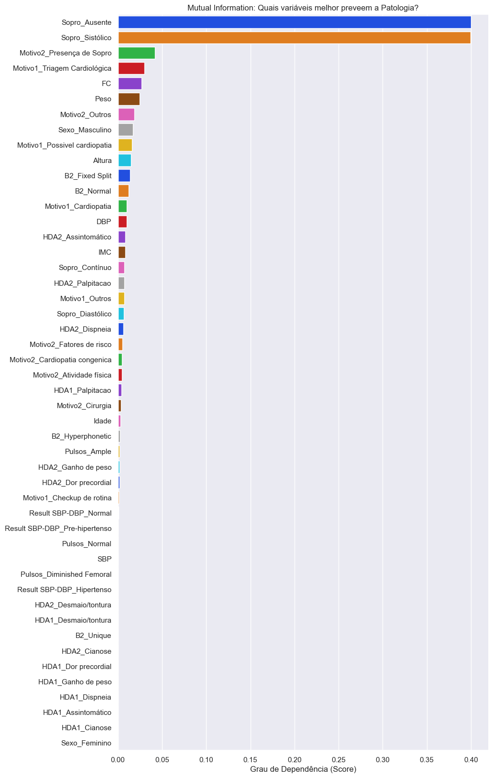
Figure 19 – Mutual information scores for all features

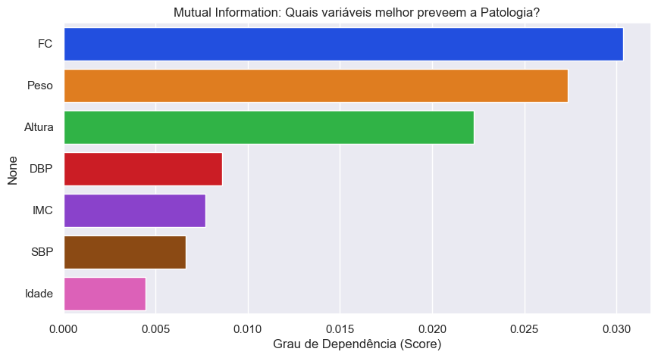
Figure 20 - Mutual information scores numeric features only

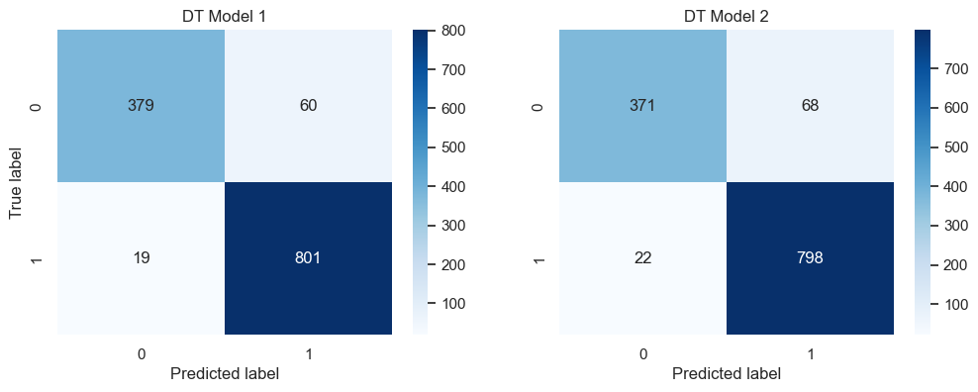
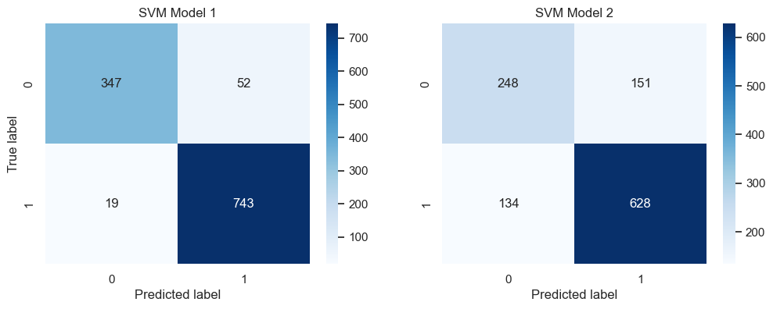
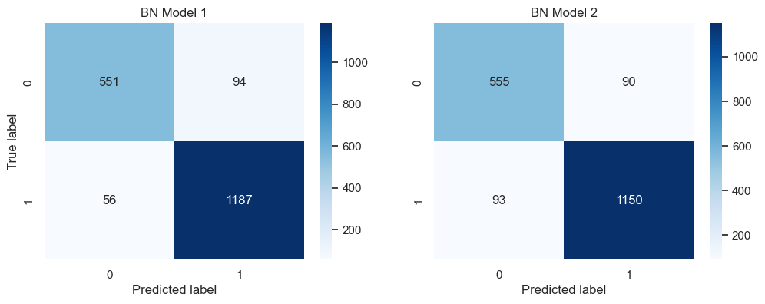
Figure 21 - Confusion matrix for Decision Tree, Support Vector Machine and Bayesian Network models, respectively

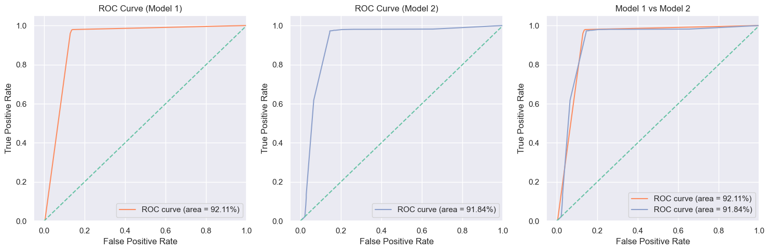
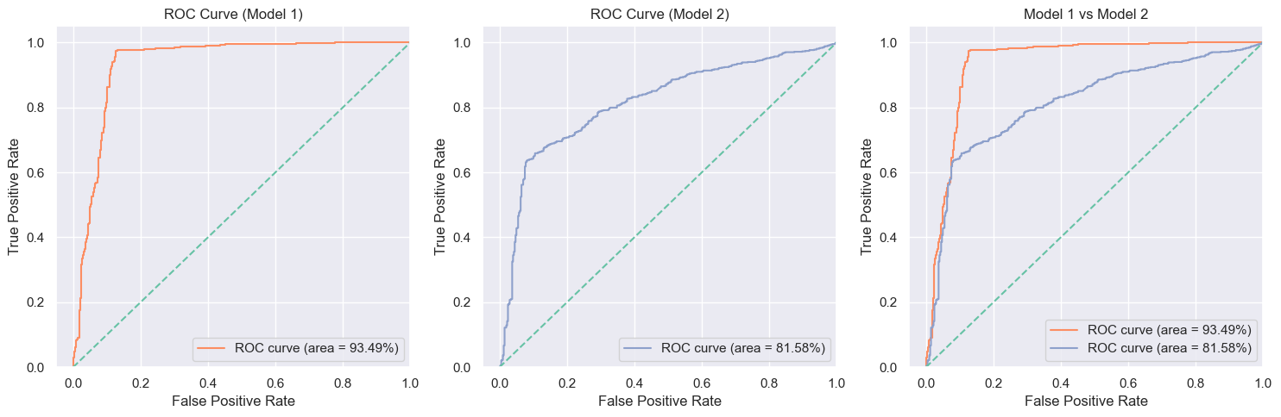
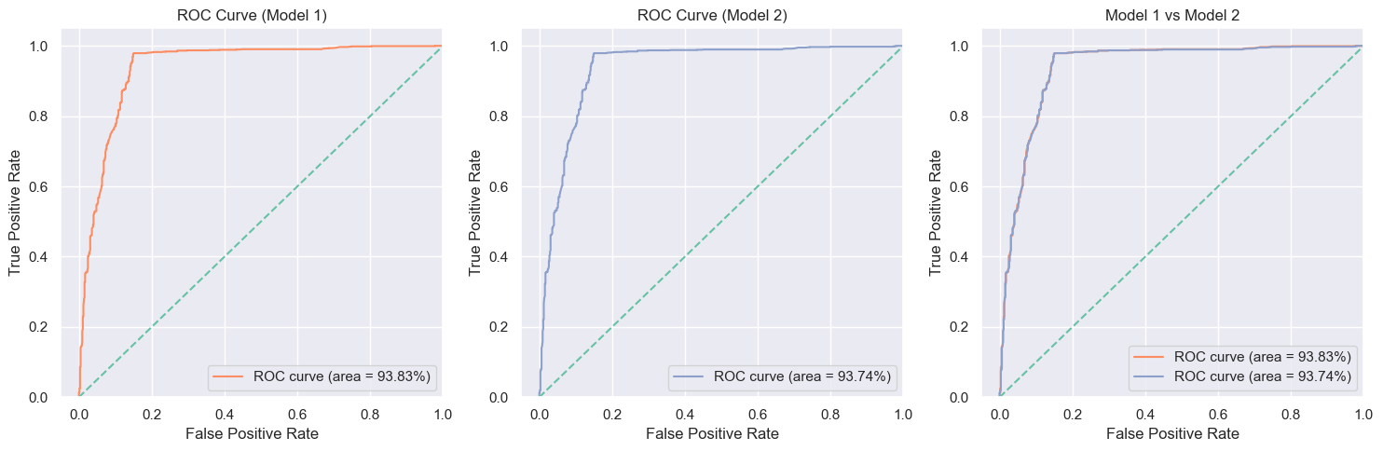
Figure 22 - ROC curves for Decision Tree, Support Vector Machine and Bayesian Network models, respectively

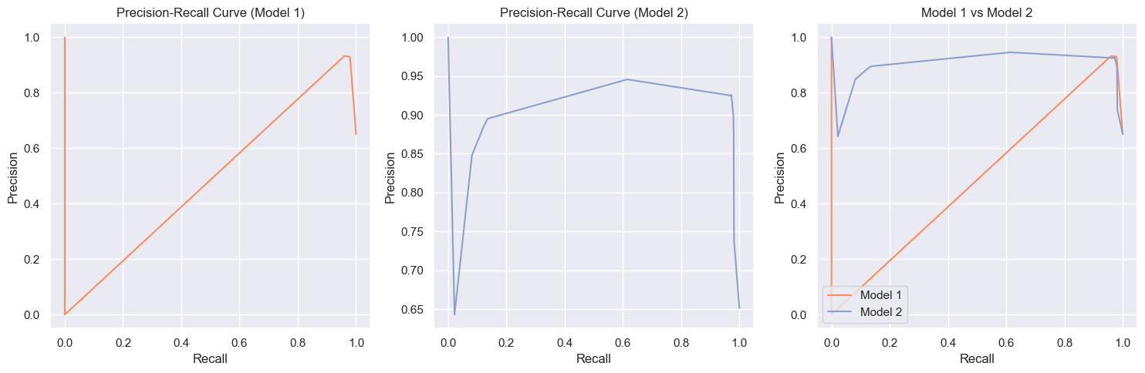
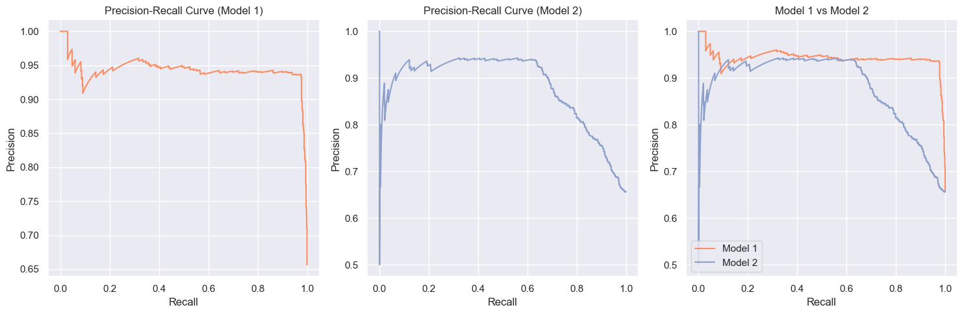
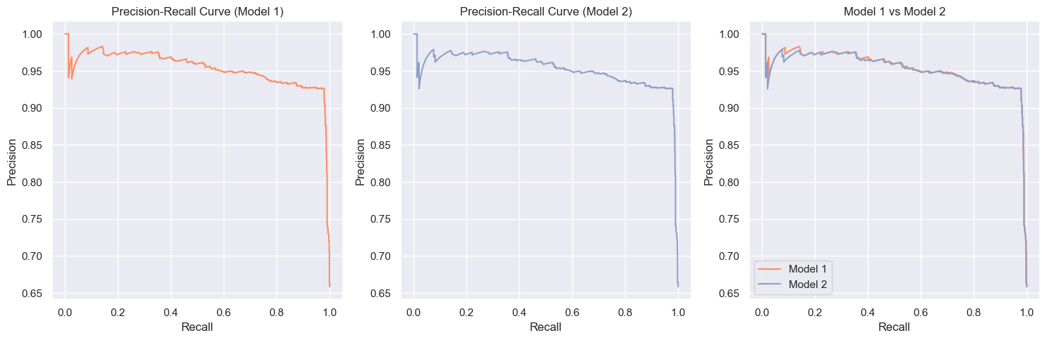
Figure 23 - PR curves for Decision Tree, Support Vector Machine and Bayesian Network models, respectively

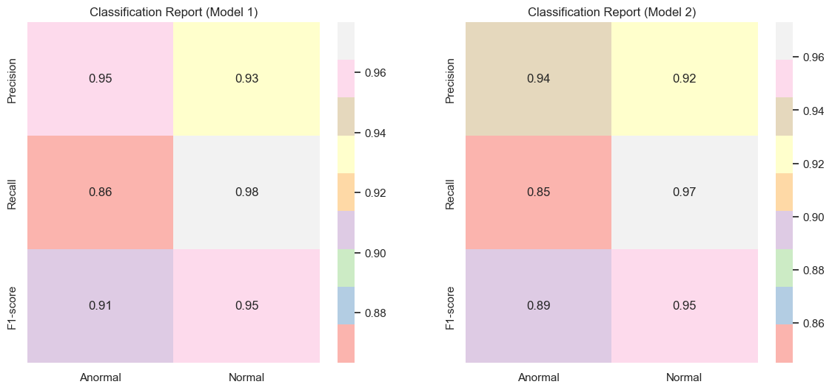
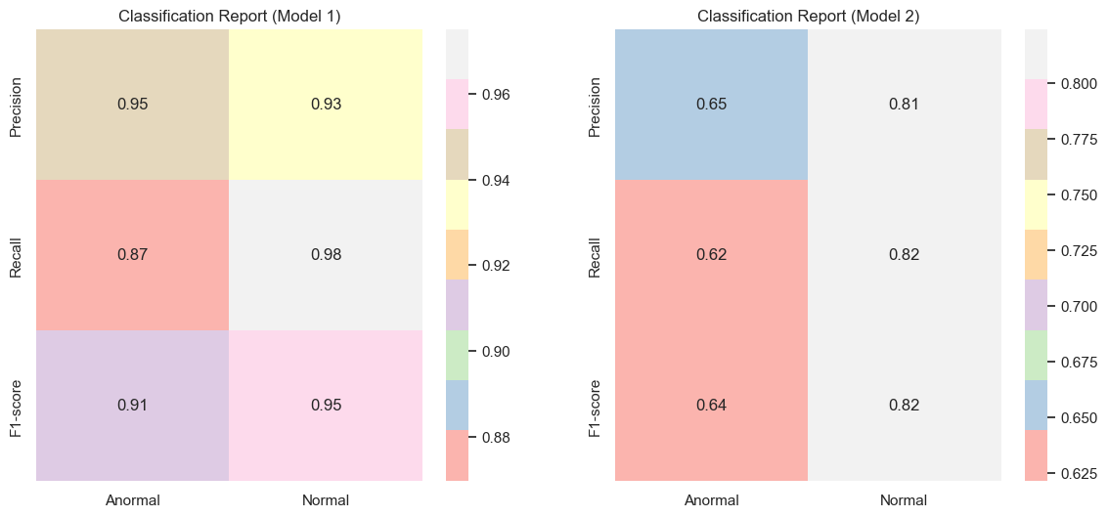
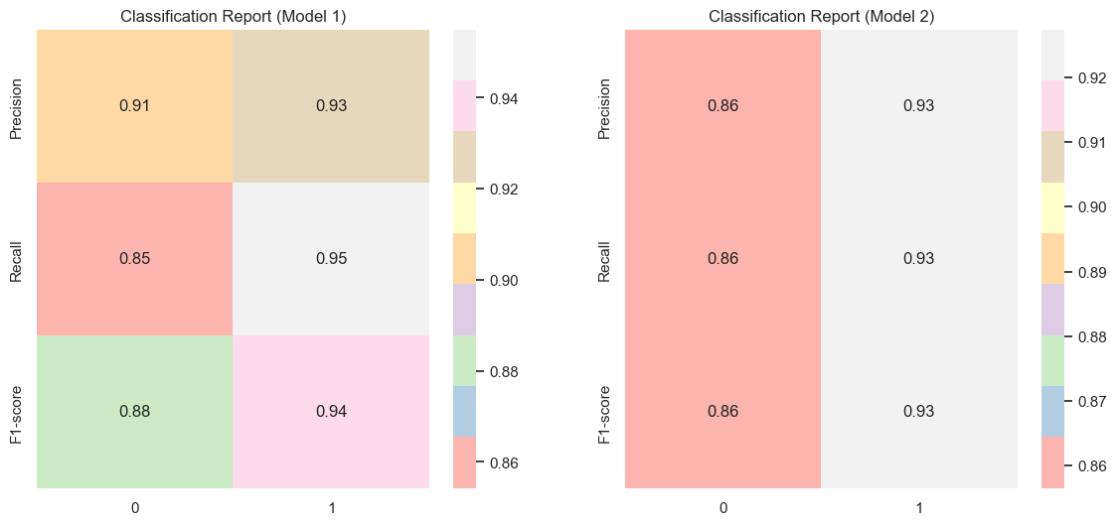
Figure 24 – Classification report for Decision Tree, Support Vector Machine and Bayesian Network models, respectively

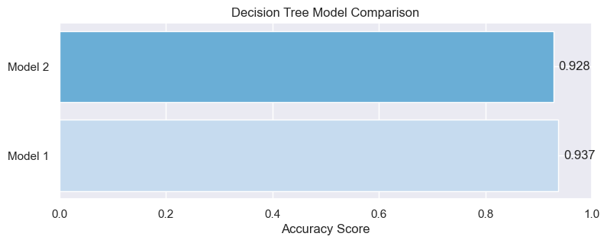
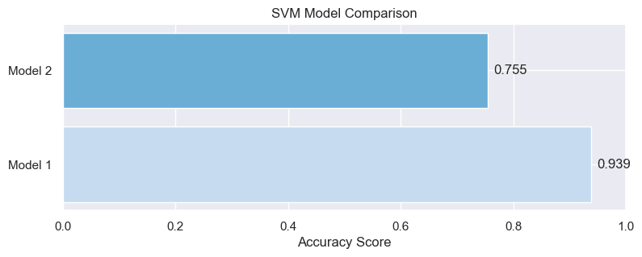
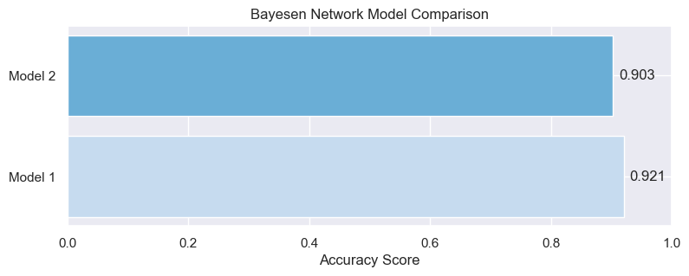
Figure 25 – Accuracy for Decision Tree, Support Vector Machine and Bayesian Network models, respectively

