**PES University, Bengaluru**

**Final Semester Assessment (FSA) – B.Tech. (CSE) – III Sem**

**Session: August – December, 2018**

**UE17CS206 – Digital Design & Computer Organization Laboratory**

Project Report

on

“16-Bit Booth’s Multiplier”

Submitted by

|  |  |
| --- | --- |
| **Aekansh Dixit** | **PES1201701808** |
|  |  |
|  |  |
|  |  |

**Name of the Examiners Signature with Date**

1.______________________ _____________________

2.______________________ ­­­­­ _____________________

3.______________________ _____________________

4.______________________ ­­­­­ _____________________

**Department of Computer Science & Engineering**

**PES University**

(Established under Karnataka Act No. 16 of 2013)

100 Feet Ring Road, Bengaluru – 560 085, Karnataka, India

16-Bit Booth’s Multiplier

# Problem Description

Booth's multiplication algorithm is a multiplication algorithm that multiplies two signed binary numbers in two's complement notation.

Booth's algorithm examines adjacent pairs of bits of the 'N'-bit multiplier Y in signed two's complement representation, including an implicit bit below the least significant bit, **y−1** = 0. For each bit **yi** for **i** running from 0 to N − 1, the bits **yi** and **yi−1** are considered.

Where these two bits are equal, the product accumulator P is left unchanged. Where **yi** = 0 and **yi−1** = 1, the multiplicand times **2i** is added to P; and where **yi** = 1 and **yi−1** = 0, the multiplicand times **2i** is subtracted from P. The final value of P is the signed product.

# Implementation

Booth's algorithm can be implemented by repeatedly adding (with ordinary unsigned binary addition) one of two predetermined values A and S to a product P, then performing a rightward arithmetic shift on P. Let m and r be the multiplicand and multiplier, respectively; and let x and y represent the number of bits in m and r.

1. Determine the values of A and S, and the initial value of P. All of these numbers should have a length equal to (x + y + 1).
   1. A: Fill the most significant (leftmost) bits with the value of m. Fill the remaining (y + 1) bits with zeros.
   2. S: Fill the most significant bits with the value of (−m) in two's complement notation. Fill the remaining (y + 1) bits with zeros.
   3. P: Fill the most significant x bits with zeros. To the right of this, append the value of r. Fill the least significant (rightmost) bit with a zero.
2. Determine the two least significant (rightmost) bits of P.
   1. If they are 01, find the value of P + A. Ignore any overflow.
   2. If they are 10, find the value of P + S. Ignore any overflow.
   3. If they are 00, do nothing. Use P directly in the next step.
   4. If they are 11, do nothing. Use P directly in the next step.
3. Arithmetically shift the value obtained in the 2nd step by a single place to the right. Let P now equal this new value.
4. Repeat steps 2 and 3 until they have been done y times.
5. Drop the least significant (rightmost) bit from P.   
   This is the product of m and r.

# Flowchart Diagram

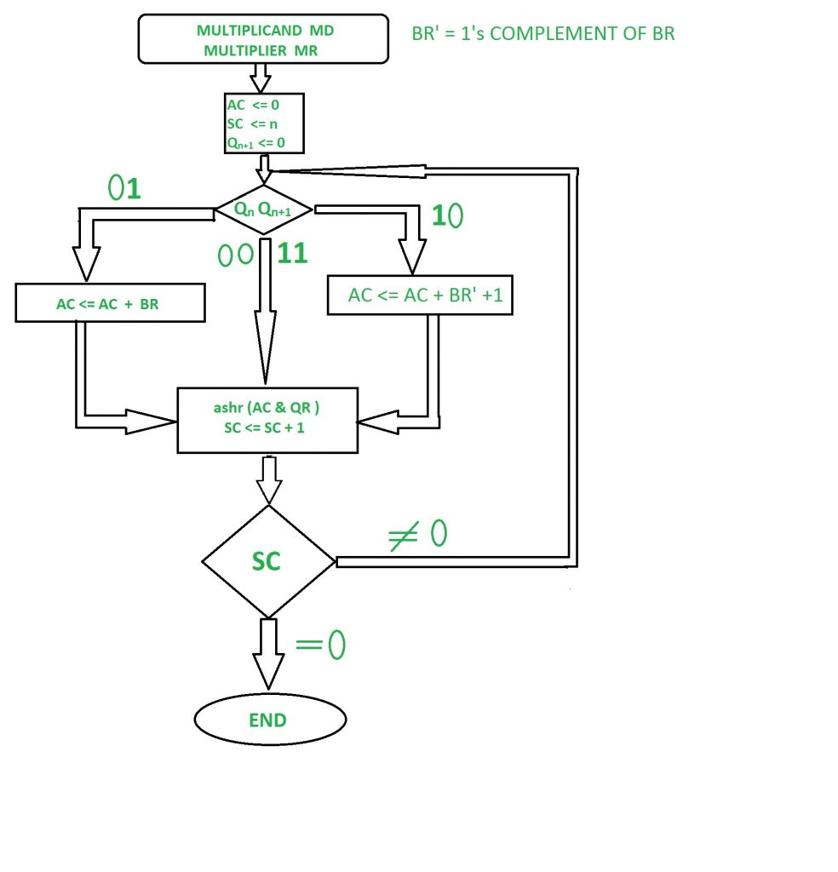

# Example

Let **A: 3** and **B: 17**

|  |  |
| --- | --- |
| **Multiplicand -** |  |
| **Decimal:** | 3 |
| **Binary:** | 00000011 |
| **Multiplier -** |  |
| **Decimal:** | 17 |
| **Binary:** | 00010001 |
| **Two's Complement:** | 11101111 |
| **Steps -** |  |
| **Starting Out:** | 0000000000000011 |
| **Subtract:** | 1110111100000011 |
| **Shift:** | 1111011110000001 |
| **Shift:** | 1111101111000000 |
| **Add:** | 0000110011000000 |
| **Shift:** | 0000011001100000 |
| **Shift:** | 0000001100110000 |
| **Shift:** | 0000000110011000 |
| **Shift:** | 0000000011001100 |
| **Shift:** | 0000000001100110 |
| **Shift:** | 0000000000110011 |
| **Final Product (Binary):** | 0000000000110011 |
| **Final Product (Decimal):** | 51 |

Implementation of a Booth’s algorithm uses various sub-modules, as described below.

# Worst and Ideal Case

The **worst case of an implementation** using Booth’s algorithm is when pairs of 01s or 10s occur very frequently in the multiplier.

# Modules and Sub Modules

Implementation of a Booth’s algorithm uses various sub-modules, as described below.

1. **boothmul():** This module is the main module which uses the help of other sub-modules or counterparts to solve our problem.  
     
   This module takes in two **8-bit** **signed** inputs, which are our multiplicand and multiplier. It has one **16-bit signed** output. Inside the module, we have **eight** 8-bit signed wires hold the value of the changed bits after shifting so that we can manipulate them later.
2. **booth_substep()**: This sub-module does the main operation of either adding/subtracting or just shifting the bits according to the last two positions.  
     
   This module takes in an 8-bit signed **accumulator**, 8-bit signed **multiplier**, the last bit of the accumulator, 8-bit signed **multiplicand**, and the output consists of two 8-bit signed registers containing first 8 and last 8 bits of the product, and cq0 is the changed q0 after the shift operation.
3. **Adder()**: This sub-module adds two 8-bit register values, and gives out their sum. This uses a library module of **fa** which is nothing but a simple full adder.
4. **Subtractor()**: This sub-module subtracts two 8-bit register values, and gives out their difference. This uses a library module of **invert** to invert each bit separately, and then uses **fa** which is nothing but a simple full adder as described above.
5. **Lib.v:**
   1. **invert(output ib,input b);**
   2. and2 (input wire i0, i1, output wire o);
   3. or2 (input wire i0, i1, output wire o);
   4. xor2 (input wire i0, i1, output wire o);
   5. **nand2 (input wire i0, i1, output wire o);**
   6. **nor2 (input wire i0, i1, output wire o);**
   7. xnor2 (input wire i0, i1, output wire o);
   8. and3 (input wire i0, i1, i2, output wire o);
   9. or3 (input wire i0, i1, i2, output wire o);
   10. nor3 (input wire i0, i1, i2, output wire o);
   11. nand3 (input wire i0, i1, i2, output wire o);
   12. xor3 (input wire i0, i1, i2, output wire o);
   13. xnor3 (input wire i0, i1, i2, output wire o);
   14. **fa (input wire i0, i1, cin, output wire sum, cout);**

Apart from using the above modules, we use a testbench to supply the initial values.

a = 8'b11110000;

b = 8'b11110000;

#10

a = 8'b10010101;

b = 8'b100000;

And so on and so forth.

# Final Result on Screen

The results on the screen are printed like this:

VCD info: dumpfile tb_boothsalgo.vcd opened for output.

0 -16 X -16 = 256

10 -107 X 32 = -3424

20 7 X 0 = 0

30 1 X 1 = 1

40 60 X 5 = 300

50 -86 X 35 = -3010

60 17 X 28 = 476

70 8 X -65 = -520