BK docu scratch:

20261015:

Updated main and created a verification branch.
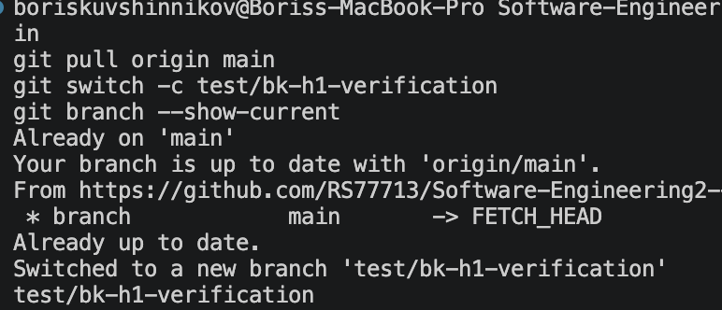

Installed project dependencies with npm ci.
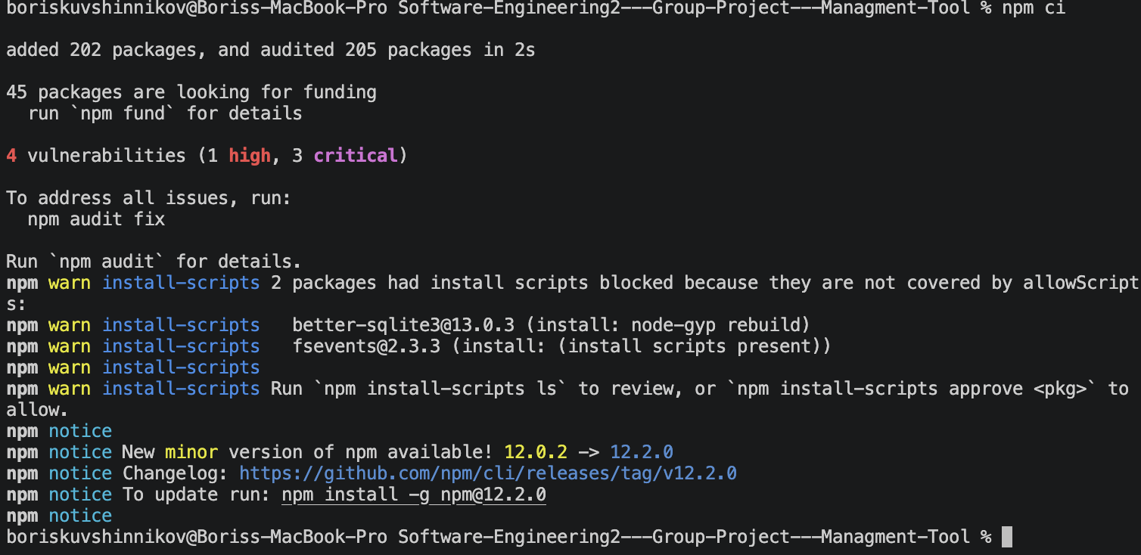
Checked code quality; lint completed with no warnings or errors.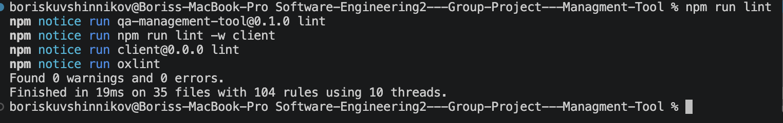

Ran npm test; all 58 client and server tests passed, covering the application, API, CSV workflows, and test runs.
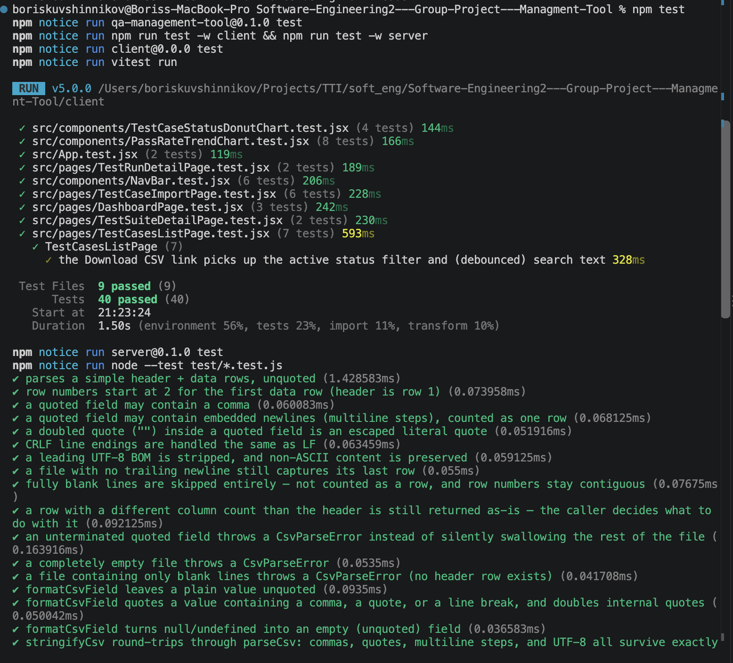

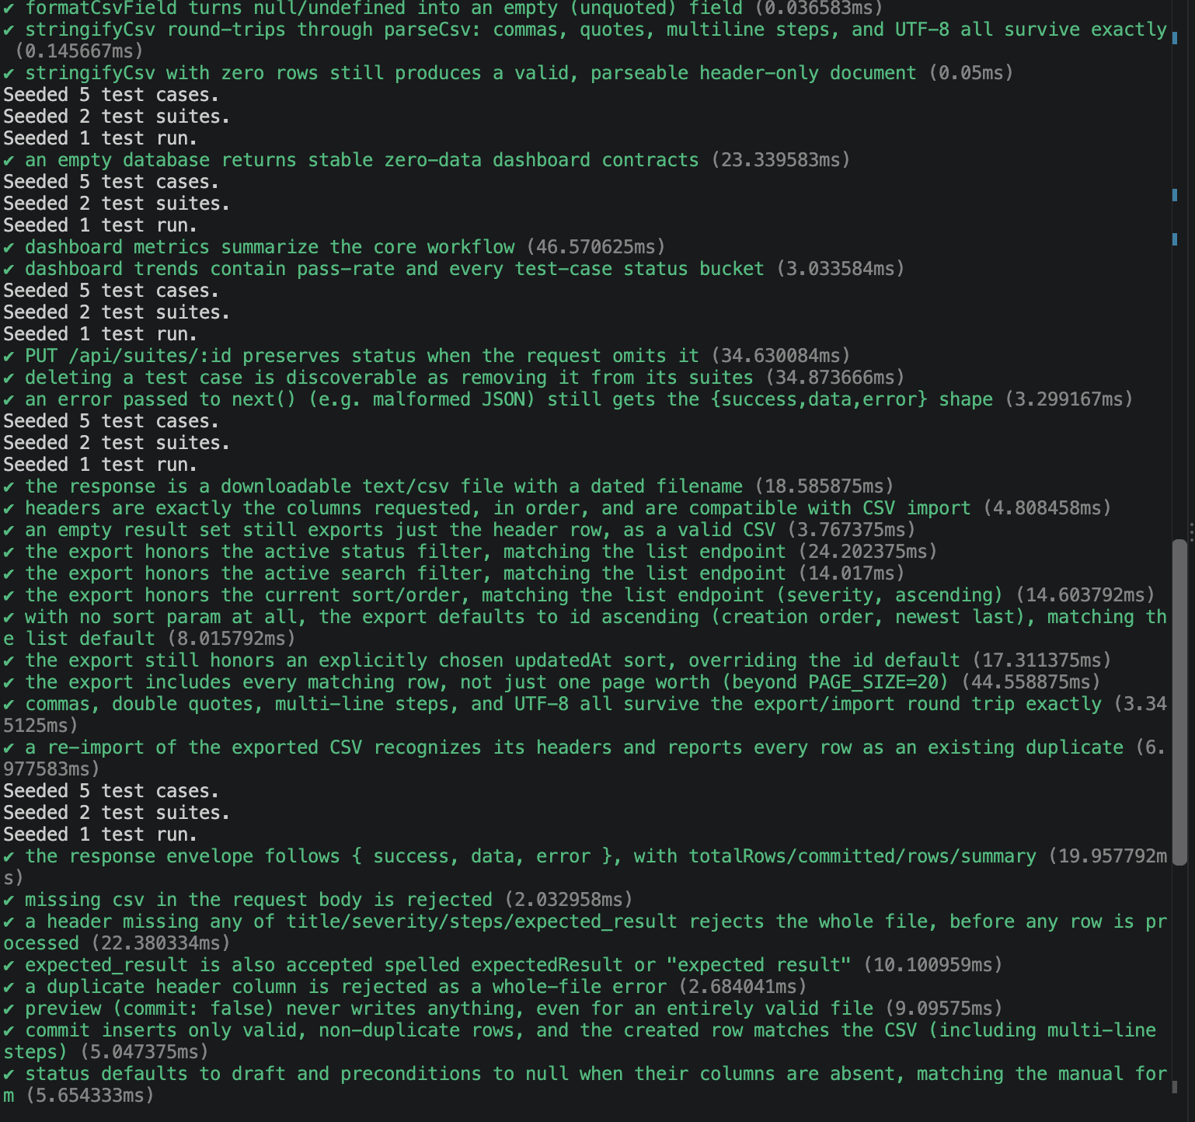
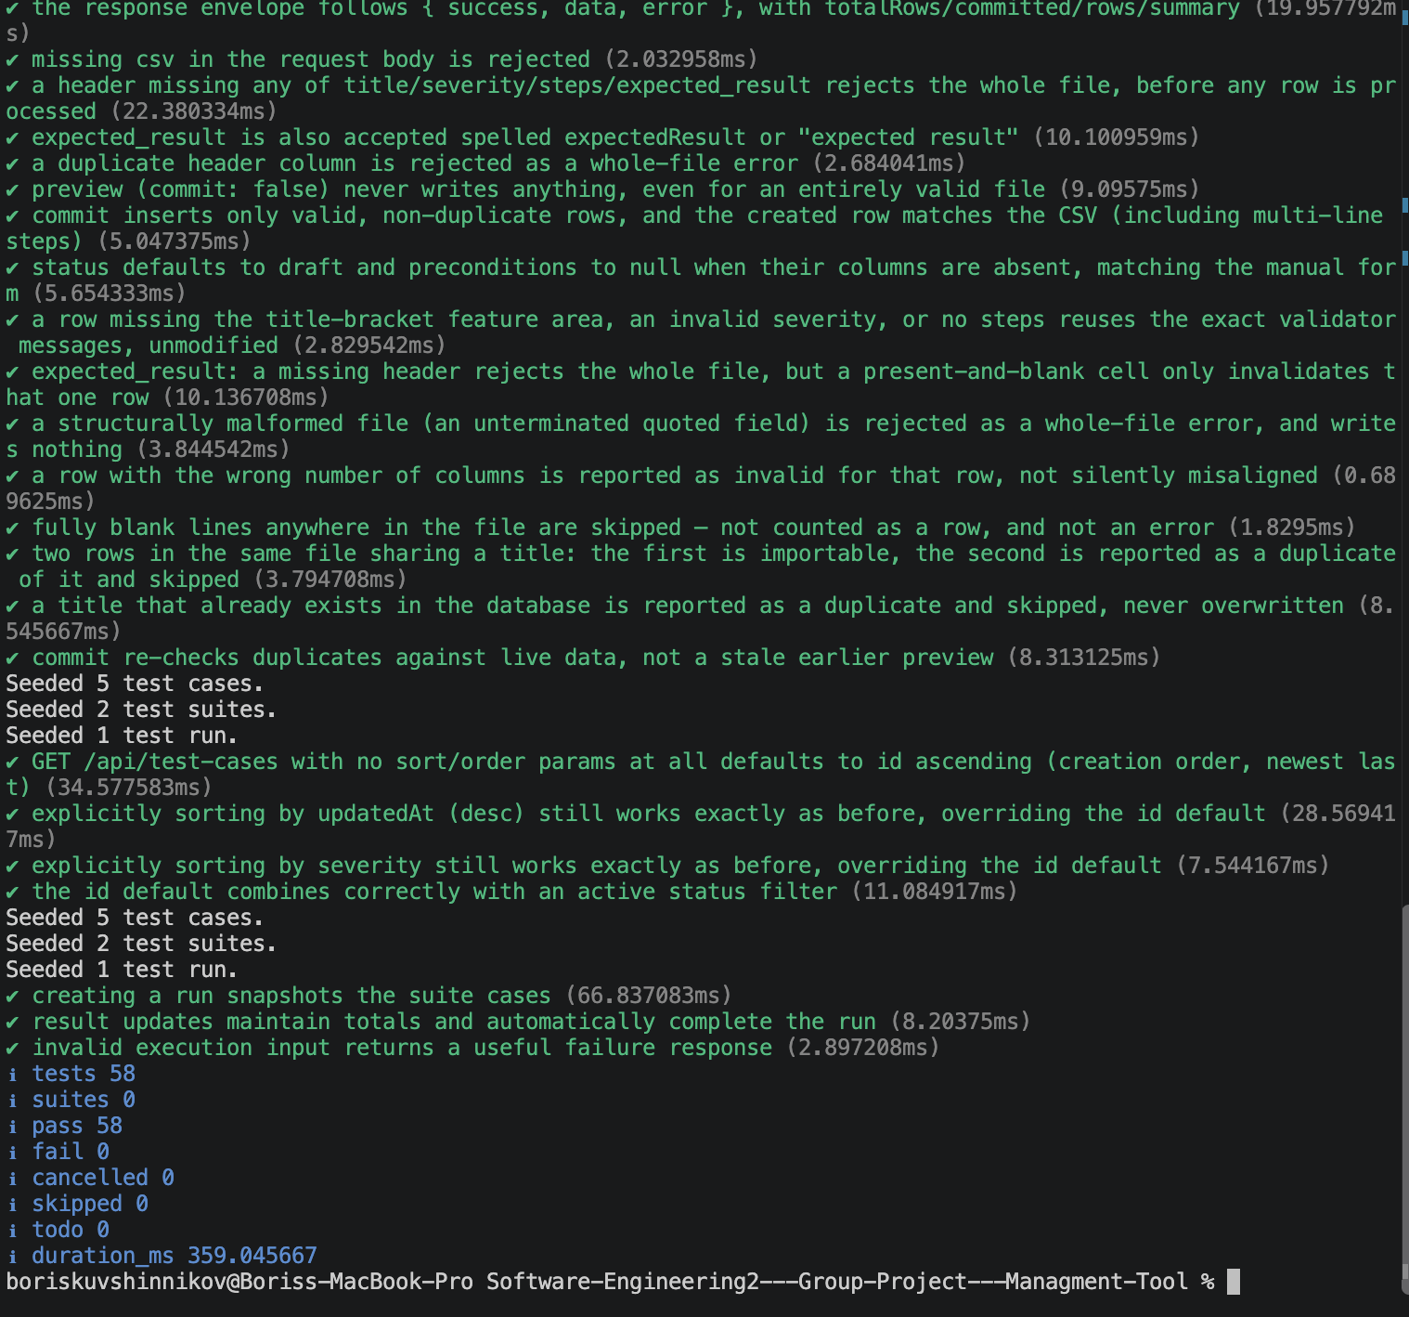

Built the client for production successfully.
