**EDA: SWORD Dataset**

| **Total Count of Records** |
| --- |
| 15582 |

The MEANS Procedure

| **Analysis Variable : member_age** | | | | |
| --- | --- | --- | --- | --- |
| **N** | **Mean** | **Std Dev** | **Minimum** | **Maximum** |
| 15582 | 55.5136054 | 11.4503715 | 15.0000000 | 90.0000000 |

The FREQ Procedure

| **fund_type** | | **Frequency** | | **Percent** | | **Cumulative Frequency** | | **Cumulative Percent** | |
| --- | --- | --- | --- | --- | --- | --- | --- | --- | --- |
| **Frequency Missing = 13** | | | | | | | | | |
| **1** | | 3043 | | 19.55 | | 3043 | | 19.55 | |
| **2** | | 3453 | | 22.18 | | 6496 | | 41.72 | |
| **3** | | 2028 | | 13.03 | | 8524 | | 54.75 | |
| **4** | | 5400 | | 34.68 | | 13924 | | 89.43 | |
| **6** | | 1146 | | 7.36 | | 15070 | | 96.79 | |
| **N** | | 499 | | 3.21 | | 15569 | | 100.00 | |
| **lob** | **Frequency** | | **Percent** | | **Cumulative Frequency** | | **Cumulative Percent** | |
| **Frequency Missing = 13** | | | | | | | | |
| **ACF** | 231 | | 1.48 | | 231 | | 1.48 | |
| **ACN** | 321 | | 2.06 | | 552 | | 3.55 | |
| **ACX** | 976 | | 6.27 | | 1528 | | 9.81 | |
| **ASO** | 499 | | 3.21 | | 2027 | | 13.02 | |
| **FEP** | 51 | | 0.33 | | 2078 | | 13.35 | |
| **IMA** | 1995 | | 12.81 | | 4073 | | 26.16 | |
| **L51** | 611 | | 3.92 | | 4684 | | 30.09 | |
| **LG+** | 1469 | | 9.44 | | 6153 | | 39.52 | |
| **LMA** | 100 | | 0.64 | | 6253 | | 40.16 | |
| **MEW** | 1090 | | 7.00 | | 7343 | | 47.16 | |
| **SGA** | 127 | | 0.82 | | 7470 | | 47.98 | |
| **SGN** | 615 | | 3.95 | | 8085 | | 51.93 | |
| **TPA** | 7484 | | 48.07 | | 15569 | | 100.00 | |

| **relationship** | **Frequency** | **Percent** | **Cumulative Frequency** | **Cumulative Percent** |
| --- | --- | --- | --- | --- |
| **Frequency Missing = 13** | | | | |
| **Dependent** | 66 | 0.42 | 66 | 0.42 |
| **Spouse** | 3583 | 23.01 | 3649 | 23.44 |
| **Subscriber** | 11920 | 76.56 | 15569 | 100.00 |

The MEANS Procedure

| **Variable** | **N Miss** |
| --- | --- |
| member_key  member_age  session_date  session_datetime | 13  0  0  0 |

RESULTS:

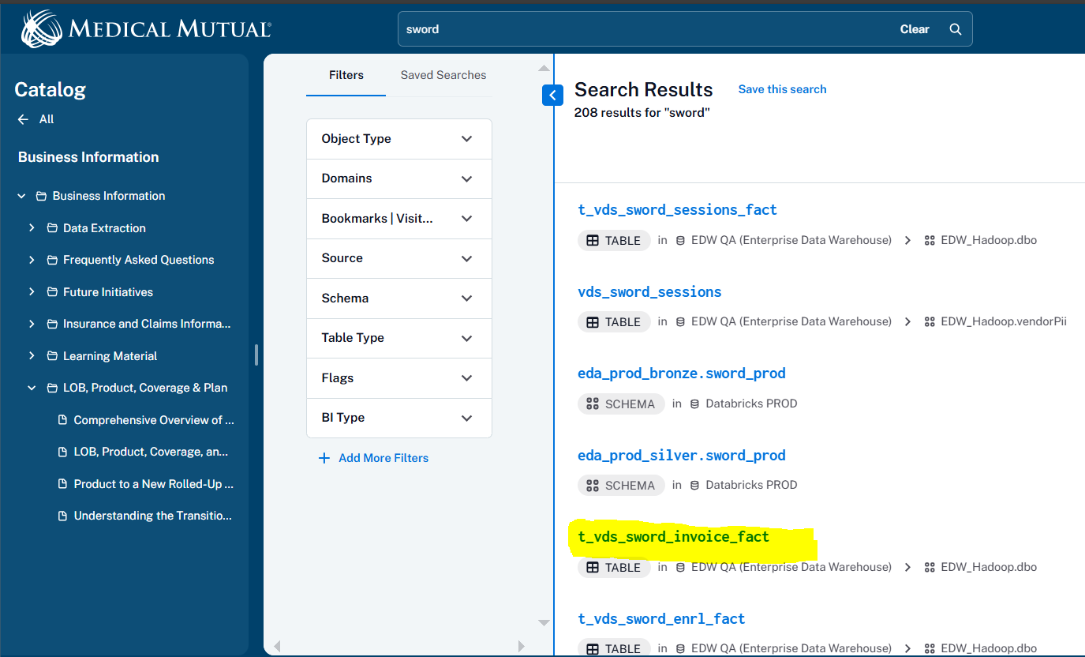

1. 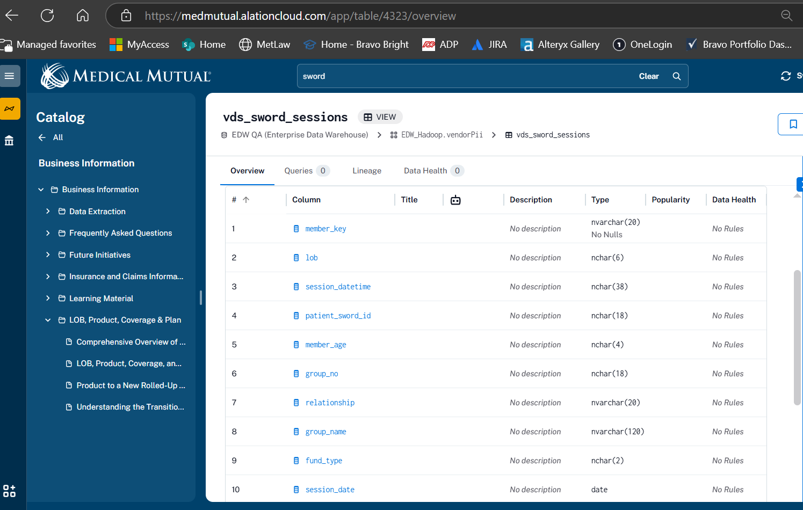

Query

/* Union 4 weekly tables into one table */

**proc** **sql**;

CREATE TABLE MMO_ENRL AS

select * from SWORD.SWORD_MMO_ENRL_20250209055359

quit;

/* Get total count of union-ed records from above table */

**proc** **sql**;

SELECT count(*) FROM WORK.MMO_ENRL

run;

/* Summary statistics */

**proc** **means** data=WORK.MMO_ENRL n mean std min max;

var total_sessions total_message_count surgery_intent_baseline surgery_intent_treatment pain_level_baseline pain_level_treatment anxiety_baseline anxiety_treatment member_satisfaction total_messages_member_sent total_messages_member_received;

**run**;

/* Frequency distribution */

**proc** **freq** data=WORK.MMO_ENRL;

tables program program_therapy current_state inactive_reason;

**run**;

/* Check for missing values */

**proc** **means** data=WORK.MMO_ENRL nmiss;

**run**;

/* Correlation analysis */

**proc** **corr** data=WORK.MMO_ENRL;

var total_sessions total_message_count surgery_intent_baseline surgery_intent_treatment pain_level_baseline pain_level_treatment anxiety_baseline anxiety_treatment member_satisfaction total_messages_member_sent total_messages_member_received;

**run**;

/* Visualize data */

**proc** **sgplot** data=WORK.MMO_ENRL;

histogram total_sessions;

density total_sessions;

**run**;

**proc** **sgplot** data=WORK.MMO_ENRL;

vbar program_therapy / response=total_sessions stat=mean;

**run**;

**proc** **sgplot** data=WORK.MMO_ENRL;

scatter x=total_sessions y=total_message_count / group=current_state;

**run**;

**proc** **sgplot** data=WORK.MMO_ENRL;

series x=date_enrolled y=total_sessions / group=program_therapy;

**run**;