**Analysis of the tourism industry for Market Segmentation**



**Presented By-**

**Team-Rahul(CodeBreakers)**

**Gett Sett Goo!!**

**Rahul Sharma**

**Jeet Kuntal Thakkar**

**Shubham Trivedi**

**Swati Prakash Mallick**



1

Introduction

Overview

2

Step 1 Deciding (not) to segment

Step 2 Specifying the Ideal target segment

3

Step 3 Data Collection

Step 4 Exploring Data

Introduction-

What is tourism? Tourism is defined and understood as the activity of travelling and touring. It is basically a set of interconnected activities of tourists while travelling to a place. And, so tourism as an industry means and covers the same things but from an economic and monetary point of view. **Tourism Industry** is and comprises of all the companies which provide the products and services that are meant and used by tourists at different stages of travel and tourism.

Tourism is a very vast, vibrant, dynamic and growth-oriented industry. Tourism as an industry is the set of all business activities which serves the needs tourists while they visit different places by way of tourism, touring or travelling.

Overview-

In this study we have explored the Australian travel motives and to illustrate data exploration using real data, we use a travel motives data set. Tourism is in fact a very broad industry comprises of different sectors or sub industries which produce and offer various similar and different products and services which create the demand for tourism and actually make the act of touring and travelling for tourism possible. By identifying proper segments, we can gain meaningful insights and can understand the behaviour of the travelers as well as we will be able to use resources more efficiently. This would ultimately lead to customer satisfaction as well as we can make the business more profitable.

What is market segmentation?

Well to be concise and clear market segmentation is **the delineation or disaggregation of the market into uniquely distinct submarkets.**

**Benefits of Market Segmentation in tourism-**

Market segmentation is a decision-making tool for the marketing manager in the crucial task of selecting a target market. In tourism industry a company willing to offer different services to different target audience will lead to a sustainable growth of the company. Customers would get what they are seeking for and tourism company would emerge as a best possible service provider. Deploying appropriate market segmentation strategy will also provide a competitive advantage over other similar companies.

Step 1 Deciding (not ) to segment

Market segmentation has developed to be a key marketing strategy applied in many organisations however it is not always the best decision to pursue such a strategy. Before investing time and resources in a market segmentation analysis, it is important to understand the implications of pursuing a market segmentation strategy. As per Cahill recommendation, it is not advisable to pursue market segmentation unless there are chances of increase in sales that could justify our efforts in deciding the target segments. Thus, before investing our efforts and resources for segmentation we should carefully analyze the scenario.

Implementation Barriers-

There are several obstacles which can be faced by the team performing segmentation . These obstacles should be carefully analyzed before moving further. By doing so we can not only save our time and resources but can also preserve our organization’s reputation of making right decisions.

Few obstacles which are encountered-

* Lack of active leadership
* Lack of market or consumer orientation
* Lack of creative thinking, bad communication
* Lack of financial resources
* Inability to make structural changes
* Unwillingness to making changes and office politics

And many more.

However, these challenges do not stop you from making decisions rather they help in understanding the problems more efficiently. Therefore, before making any decisions each limitations should be carefully examined as it would ultimately impact on your further decisions.

Step 2-

Specifying the Ideal target segment-

It is important to consider user inputs throughout the process. Instead of briefing at the start of the process or while deciding the marketing strategy at the end, user needs to be involved in most of the stages. In fact, the majority of the technical process should be wrapped around the user. This process is essential because it initially helps in data collection and thereafter it assists with deciding the target segments .Therefore, in order to execute this process, we need to setup an evaluation criteria. These criteria are further splitted into knockout criteria and attractiveness criteria.

Knockout Criteria-

This criteria basically evaluates if particular segment should be considered as an individual independent segment or not. Basically, it helps in deciding whether the segment is further suitable for assessing it on the basis of attractiveness criteria.

It checks the following things-

* Is it large enough?
* Is the member of the segments homogenous?
* Does it comply with your organization motives?
* Are the members of the segment reachable?

On the basis of this a segment can be further qualified for assessment of attractiveness critera and the unsuitable segments are either discarded or further looked upon as per the decision of the management.

Attractiveness Criteria-

Attractiveness criteria is used to scale a segment based on its priority or usefulness . It is not binary in nature as one cannot decide whether a segment complies with attractiveness criteria or not, in fact it actually determines the importance of a segment. A panel can decide which segment should be looked upon as per their interest and feasibility. Each segments can be rated as per their impact on company’s growth.

Step 3-

Data Collection-

In this step to illustrate data exploration using real data, we use a travel motives dataset. This data set contains 20 travel motives reported by 1000 Australian residents in relation to their last vacation. The CSV file can be downloaded from the web page of the book [http://www.MarketSegmentationAnalysis.org](http://www.marketsegmentationanalysis.org)

Initial data-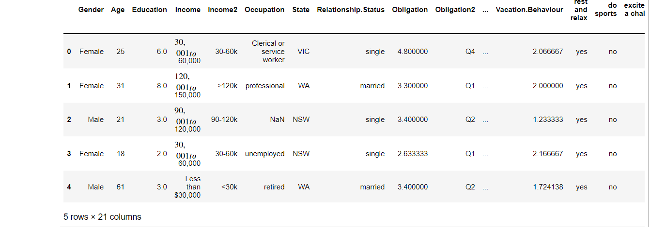 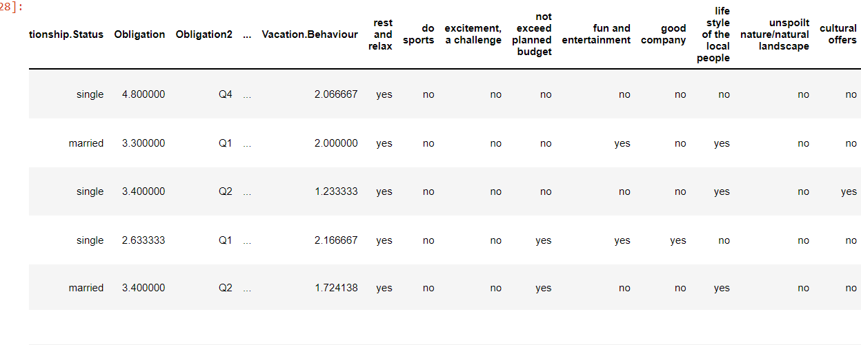

Each row in the table represents a consumer whereas each column represents the charecteristics of the consumer.

Segmentation Variable-

Segmentation variable is the key charecteristic which is used to create an individual segment in the data. For example gender can be used as a segmentation variable so each and every consumer characteristics can be displayed according to their gender.

Descriptors-

Charecteristics in column such as education ,income, occupation are descriptors of the consumer which provide details about their lifestyle and preferences.

Segmentation Criteria-

Before extracting the segments, one should determine certain criteria for selection. This step is extremely important as it would directly impact to the company’s future. In order to classify segments, one must carefully examine the market behaviour and the what makes our product or service more reachable to the consumers. In order to do so we must calculate the risks of deployment of particular strategy. We must select a criteria which is suitable for the long-term growth of the company, and which makes our product more sellable to the target audience.

On the basis of that there are mainly four types of segmentation techniques

1. Geographic segmentation-

* Geographic information can be used as a segmentation criterion. Services can be provided or advertised to the consumers belonging to the same locality. This segmentation criterion basically provides the information about the purchasing preferences of the people belonging to a certain geographic location.

1. Socio demographic segmentation-

* Social information about the person such as age,gender,income can be utilized to gain insights about the preferences of the consumers. This process groups the data according to these charecteristics and people with similar charecteristics can be analyzed further.

1. Physchographic segmentation- Customers can be divided as per their beliefs, goals,opinions,aspirations and ideologies they demonstrate while making a purchase. Such information is extremely helpful in determing the consumer’s choice regardless of his gender or occupation. For example, a person going on a vacation for adventure sports is more likely to book activities which include more thrill such as safari expedition or a bike riding experience.
2. Behaviour segmentation-This process is data driven a consumer can be targeted on the basis of their past behaviour while making purchases. For example, the different amount spent by a person on different activities. These predictions become more accurate if there is sufficient information of the past of consumer.

STEP 4: EXPLORING THE DATA

The Introduction to Data:

Exploratory plays an important role for cleaning and pre- processing the data. This plays a vital role for extracting meaningful market segments.

Data exploration helps us in below mentioned segments

* Identify the measurement levels of the variables
* Investigate the univariate distributions of each of the variables.
* Assess dependency structures between variables

In addition, data may need to be pre-processed and prepared so it can be used as input for different segmentation algorithms. Results from the data exploration stage provide insights into the suitability of different segmentation methods for extracting market segments.

To read the data set into python ,we use the following command:

* data = pd.read_csv('vacation.csv')

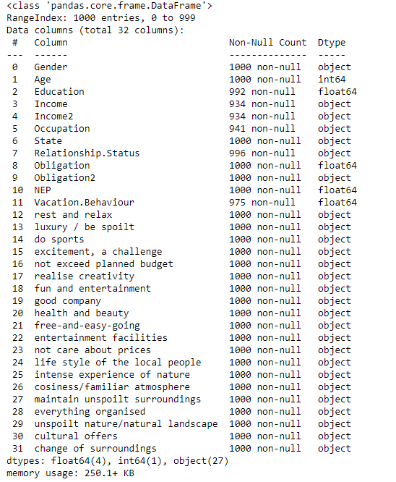

There are 32 variables out of which 4 are float types,1 is integer type,17 is object type. For implementing the data set we removed some variables and described the dataset.

Data Cleaning:

The first step for data analysis is to clean the data. Here we check if all the values have been recorded properly, and if consistent labels for the levels of categorical variables have been used. Similarly, levels of categorical variables can be checked to ensure they contain only permissible values. For example, gender typically has two values in surveys: female and male. Unless the questionnaire did offer a third option, only those two should appear in the data. Any other values are not permissible, and need to be corrected as part of the data cleaning procedure.

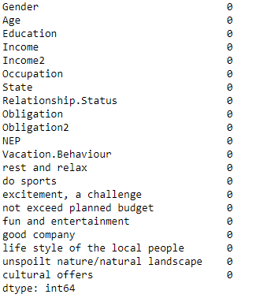  
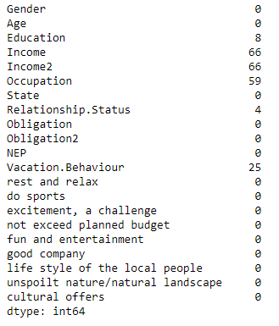

We checked the dataset for null values present in the dataset and successfully cleared all the anomalies.

Descriptive Analysis:

Being familiar with the data avoids misinterpretation of results from complex analyses. Descriptive numeric and graphic representations provide insights into the data. Statistical software packages offer a wide variety of tools for descriptive analysis. In python we use describe() function to do the same.

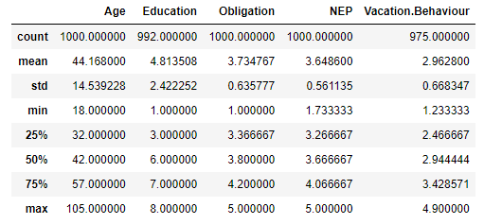

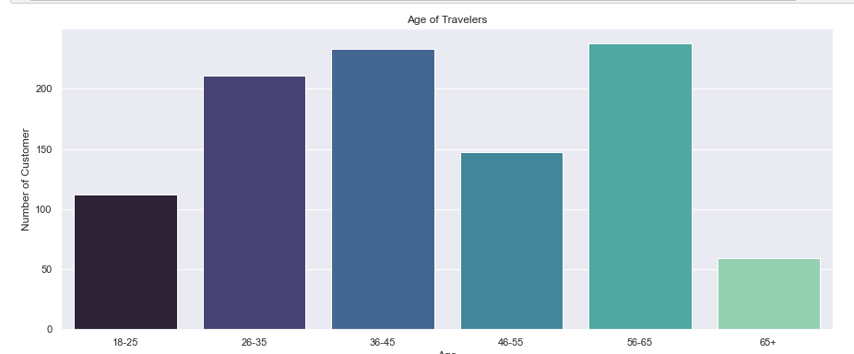

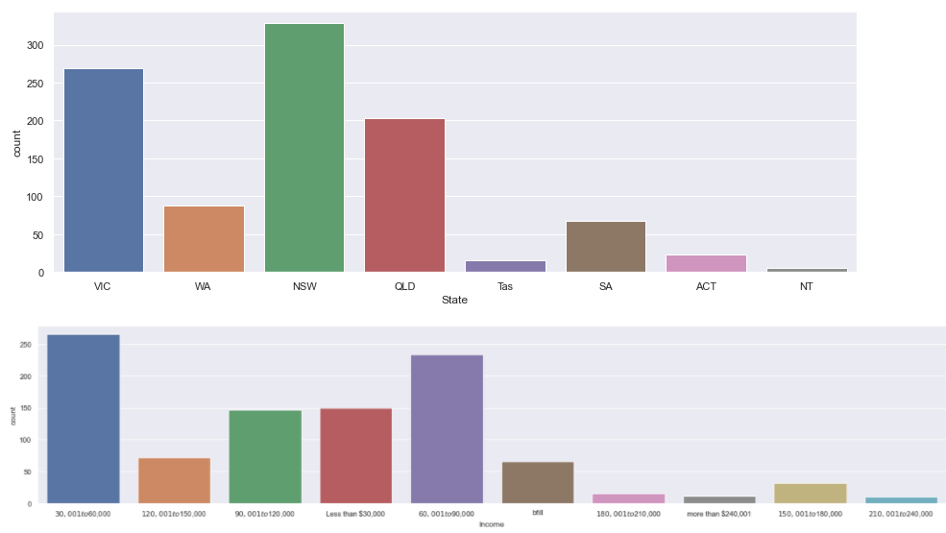

Age Vs Relationship:

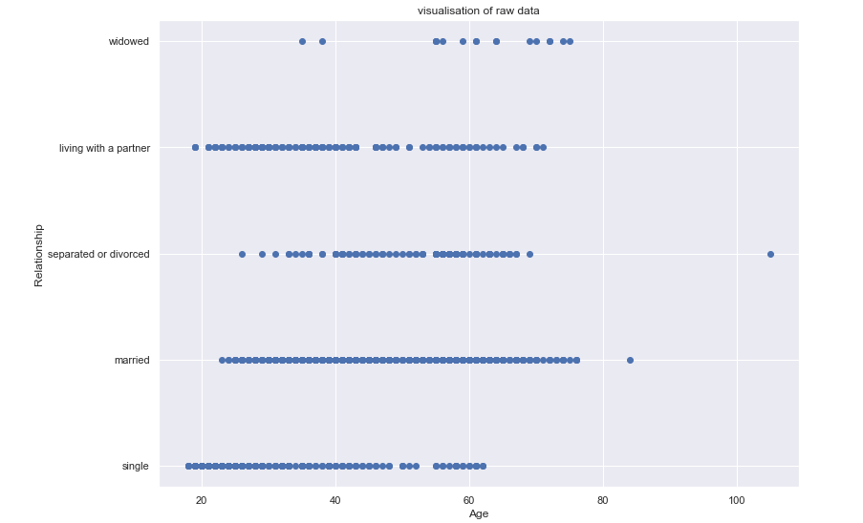

Age Vs Obligation:

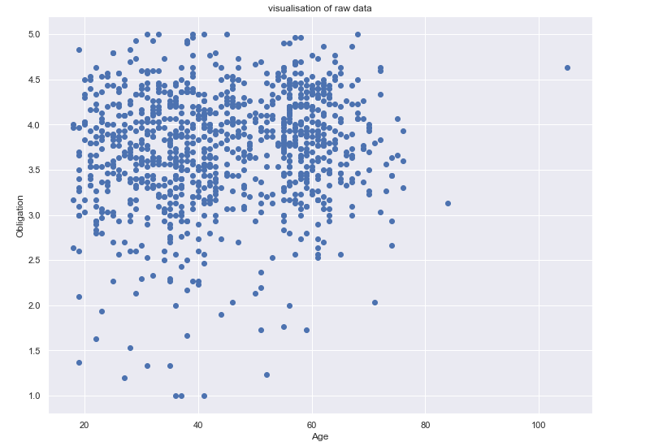

Gender Vs Age:

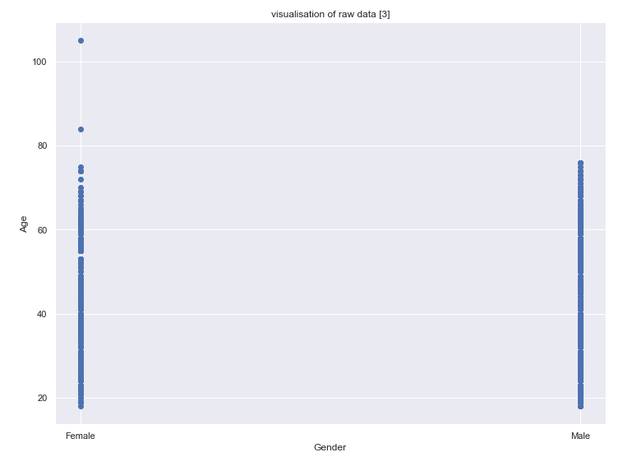

Pre-Processing:

* Categorical Variables:

Two pre-processing procedures are often used for categorical variables. One is merging levels of categorical variables before further analysis, the other one is converting categorical variables to numeric ones

* Numeric Variables:

The range of values of a segmentation variable affects its relative influence in distance-based methods of segment extraction. If, for example, one of the segmentation variables is binary (with values 0 or 1 indicating whether or not a tourist likes to dine out during their vacation), and a second variable indicates the expenditure in

dollars per person per day (and ranges from zero to $1000), a difference in spend per person per day of one dollar is weighted equally as the difference between liking to dine out or not. To balance the influence of segmentation variables on segmentation results, variables can be standardised. Standardising variables means transforming them in a way that puts them on a common scale.

PRINCIPAL COMPONENT ANALYSIS:

Principal components analysis (PCA) transforms a multivariate data set containing metric variables to a new data set with variables – referred to as principal components – which are uncorrelated and ordered by importance. The first variable (principal component) contains most of the variability, the second principal component contains the second most variability, and so on.

Principal components analysis works off the covariance or correlation matrix

of several numeric variables. If all variables are measured on the same scale, and

have similar data ranges, it is not important which one to use. If the data ranges are different, the correlation matrix should be used (which is equivalent to standardizing the data).

STEP – 5:

GROUPING CONSUMERS:

Data-driven market segmentation analysis is exploratory by nature. Consumer data sets are typically not well structured. Consumers come in all shapes and forms; a two-dimensional plot of consumers’ product preferences typically does not contain clear groups of consumers. Rather, consumer preferences are spread across the entire plot. The combination of exploratory methods and unstructured consumer data means that results from any method used to extract market segments from such data will strongly depend on the assumptions made on the structure of the segments implied by the method. The result of a market segmentation analysis, therefore, is determined as much by the underlying data as it is by the extraction algorithm chosen. Segmentation methods shape the segmentation solution.

* Distance-Based Methods :

Market segmentation aims at grouping consumers into groups with similar needs or behavior, in this example: groups of tourists with similar patterns of vacation activities.

1. Distance Measures :

Numerous approaches to measuring the distance between two vectors exist; several are used routinely in cluster analysis and market segmentation.

A distance measure has to comply with a few criteria. One criterion is symmetry,

that is: d(x, y) = d(y, x).

A second criterion is that the distance of a vector to itself and only to itself is 0: d(x, y) = 0 ⇔ x = y.

In addition, most distance measures fulfil the so-called triangle inequality :d(x, z) ≤ d(x, y) + d(y, z).

The triangle inequality says that if one goes from x to z with an intermediate stop in y, the combined distance is at least as long as going from x to z directly.

Euclidean distance is the most common distance measure used in market segmentation analysis. Euclidean distance corresponds to the direct “straight-line” distance between two points in two-dimensional space.

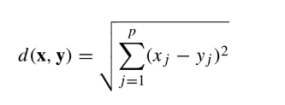

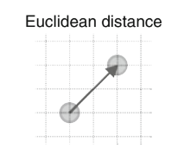

Manhattan distance derives its name from the fact that it gives the distance between two points assuming that streets on a grid (like in Manhattan) need to be used to get from one point to another.

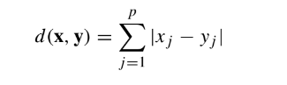

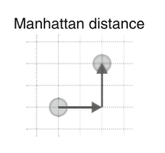

1. Hierarchical Methods :

Hierarchical clustering methods are the most intuitive way of grouping data because they mimic how a human would approach the task of dividing a set of n observations (consumers) into k groups (segments).

Divisive hierarchical clustering methods start with the complete data set X and splits it into two market segments in a first step. Then, each of the segments is again split into two segments. This process continues until each consumer has their own market segment.

Agglomerative hierarchical clustering approaches the task from the other end. The starting point is each consumer representing their own market segment (n singleton clusters). Step-by-step, the two market segments closest to one another are merged until the complete data set forms one large market segment.

Single linkage: distance between the two closest observations of the two sets.

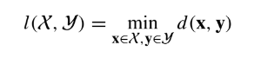

Complete linkage: distance between the two observations of the two sets that are farthest away from each other.

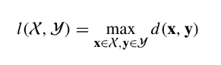

Average linkage: mean distance between observations of the two sets.

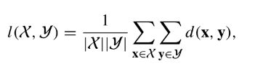

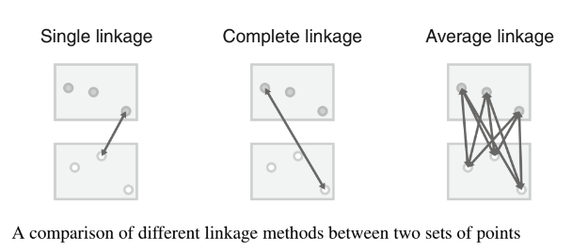

A dendrogram is a tree diagram. The root of the tree represents the one-cluster solution where one market segment contains all consumers. The leaves of the tree are the single observations (consumers), and branches in-between correspond to the hierarchy of market segments formed at each step of the procedure. The height of the branches corresponds to the distance between the clusters. Higher branches point to more distinct market segments.

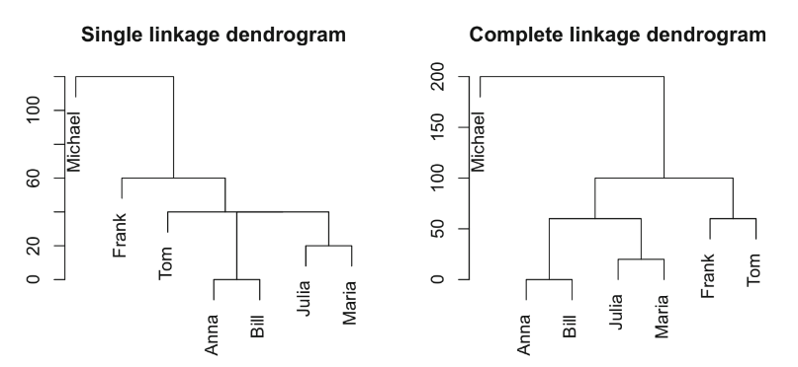

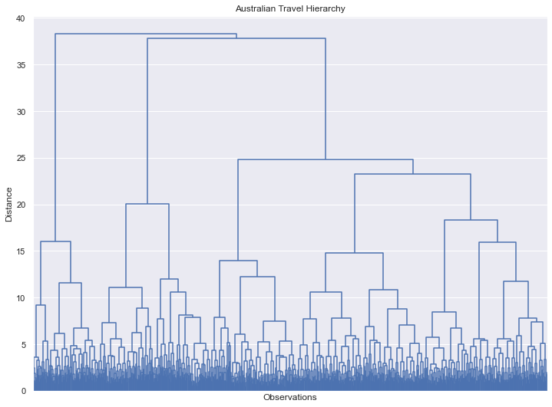

Above figure is visualization that we obtained in our analysis of Australian travels by hierarchical method of grouping.

1. Partitioning Methods:

Hierarchical clustering methods are particularly well suited for the analysis of small data sets with up to a few hundred observations.

k-Means and k-Centroid Clustering:

The most popular partitioning method is k-means clustering. Within this method, a number of algorithms are available. R function kmeans() implements the algorithms by Forgy (1965), Hartigan and Wong (1979), Lloyd (1982) and MacQueen(1967). These algorithms use the squared Euclidean distance. A generalisation to other distance measures, also referred to as k-centroid clustering, is provided in R package flexclust.

Let X = {x1,..., xn} be a set of observations (consumers) in a data set. Partitioning clustering methods divide these consumers into subsets (market segments) such that consumers assigned to the same market segment are as similar to one another as possible, while consumers belonging to different market segments are as

dissimilar as possible. The representative of a market segment is referred to in many partitioning clustering algorithms as the centroid. For the k-means algorithm based on the squared Euclidean distance, the centroid consists of the column-wise mean

values across all members of the market segment.Below figure shows simple representation of how k-means clustering works.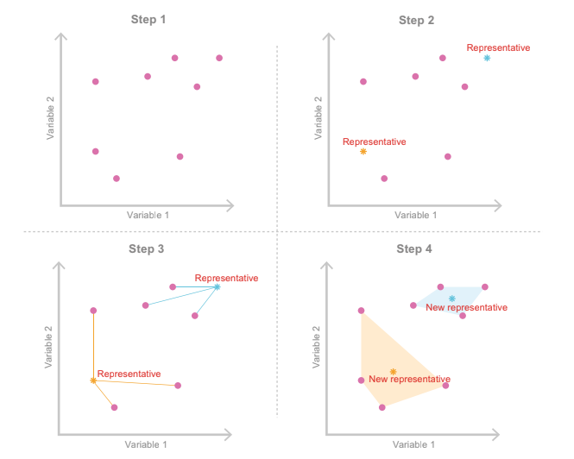

**Step 6: Profiling Segments**

The aim of the profiling step is to get to know the market segments resulting from the extraction step. Profiling is only required when data-driven market segmentation is used. For commonsense segmentation, the profiles of the segments are predefined. If, for example, age is used as the segmentation variable for the commonsense segmentation, it is obvious that the resulting segments will be age groups. Therefore, Step 6 is not necessary when commonsense segmentation is conducted. The situation is quite different in the case of data-driven segmentation: users of the segmentation solution may have decided to extract segments on the basis of benefits sought by consumers. Yet – until after the data has been analysed – the defining characteristics of the resulting market segments are unknown. Identifying

these defining characteristics of market segments with respect to the segmentation variables is the aim of profiling. Profiling consists of characterising the market segments individually, but also in comparison to the other market segments. If winter tourists in Austria are asked about their vacation activities, most state they are going alpine skiing. Alpine skiing may characterise a segment, but alpine skiing may not differentiate a segment from other market segments. At the profiling stage, we inspect a number of alternative market segmentation solutions. This is particularly important if no natural segments exist in the data, and either a reproducible or a constructive market segmentation approach has to be taken. Good profiling is the basis for the correct interpretation of the resulting segments. The correct interpretation, in turn, is critical to making good strategic marketing decisions.\

**Traditional Approaches to Profiling Market Segments**

Data-driven segmentation solutions are typically users (customers,

Manager) In one of two ways: (1) As a high-level summary to simplify the segment Properties until seemingly trivial, or (2) as a large table

It provides the exact percentage of each segmentation variable for each segment. Such tables are difficult to interpret and are virtually impossible to obtain immediate Summary of the most important findings.

Sometimes – to deal with the size of this task – information is provided about

the statistical significance of the difference between segments for each of the

segmentation variables. This approach, however, is not statistically correct. Segment membership is directly derived from the segmentation variables, and segments are

created in a way that makes them maximally different, thus not allowing to use

standard statistical tests to assess the significance of differences.

**Segment Profiling with Visualisations**

Neither the highly simplified, nor the very complex tabular representation typically used to present market segmentation solutions make much use of graphics, although data visualisation using graphics is an integral part of statistical data analysis. Graphics are particularly important in exploratory statistical analysis (like cluster analysis) because they provide insights into the complex relationships between variables. In addition, in times of big and increasingly bigger data, visualisation offers a simple way of monitoring developments over time. Visualisations are useful in the data-driven market segmentation process to inspect, for each segmentation solution, one or more segments in detail. Statistical graphs facilitate the interpretation of segment profiles. They also make it easier to assess the usefulness of a market segmentation solution. The process of segmenting data always leads to a large number of alternative solutions. Selecting one of the possible solutions is a critical decision. Visualisations of solutions assist the data analyst and user with the tasks like:

1. Identifying Defining Characteristics of Market Segments

A good way to understand the defining characteristics of each segment is to produce a segment profile plot. The segment profile plot shows – for all segmentation variables – how each market segment differs from the overall sample. This kind of knowledge is necessary to know consumers in this specific segment and predict what kind of expectations and what kind of financial willingness they have to spend on certain products or services.

1. Assessing Segment Separation

Segment separation can be visualised in a segment separation plot. The segment separation plot depicts – for all relevant dimensions of the data space – the overlap of segments. Segment separation plots are very simple if the number of segmentation variables is low, but become complex as the number of segmentation variables increases. But even in such complex situations, segment separation plots offer data analysts and users a quick overview of the data situation, and the segmentation solution.

**Step 7: Describing Segments**

This is similar to the profiling step. The only difference is that the variables being inspected have *not* been used to extract market segments. Rather, in Step 7 market segments are described using *additional* information available about segment members.

For example, when conducting an analysis using the Australian travel motives data set, profiling means investigating differences between segments with respect to the travel motives themselves. The segment description step uses additional information, such as segment members’ age, gender, past travel behaviour, preferred vacation activities, media use, use of information sources during vacation planning, or their expenditure patterns during a vacation. These additional variables are referred to as *descriptor variables*. Good descriptions of market segments are critical to gaining detailed insight into the nature of segments. In addition, segment descriptions are essential for the development of a customised marketing mix.

We can study differences between market segments with respect to descriptor variables in two ways: we can use descriptive statistics including visualisations, or we can analyse data using inferential statistics.

**Using Visualisations to Describe Market Segments**

A variety of plots exist to visualize differences in descriptive variables. Here we discuss two basic approaches that are appropriate for nominal and ordinal descriptors (such as gender, education level, country of origin) or metric descriptors ( such as age, number of nights in tourist attractions, money spent on accommodation). Using graphical statistics to describe market segments has two main advantages: it simplifies the interpretation of results for both data analysts and users and combines information about the statistical significance of the differences, thus avoiding over-interpretation of insignificant differences.

**Testing for Segment Differences in Descriptor Variables**

Simple statistical tests can be used to formally test descriptor differences

That varies by market segment. The easiest way to check the difference is

To run a series of independent tests for each variable of interest. The result of

The segment extraction step is segment member, assigning each consumer

to a market segment. Belonging to a category that can be considered any other nomination Change. It represents a nominal summary statistic of the fractional variables. Therefore, any test of the association between a nominal variable and another variable is suitable.

**Predicting Segments from Descriptor Variables**

Another way to learn more about market segments is to try to predict segments members from descriptor variables. For this, we use a regression model with segment membership as dependent categorical variable and descriptor variables as independent variables. One can use methods developed in statistics for classification and methods developed in machine learning for supervised learning.

Regression analysis is the basis of prediction models. Regression analysis

assumes that a dependent variable y can be predicted using independent variables or regressors x1,..., xp:

y ≈ f (x1,...,xp).

Regression models differ with respect to the function f (·), the distribution assumed for y, and the deviations between y and f (x1,...,xp).

The basic regression model is the linear regression model. The linear regression model assumes that function f (·) is linear, and that y follows a normal distribution with mean f (x1,...,xp) and variance σ2. The relationship between the dependent variable y and the independent variables x1,...,xp is given by:

y = β0 + β1x1 + ... + βpxp + **ε**,

This type of regression is known as the Multilinear regression model as the model developed by this method will consider various variables at the same time and will try to predict from those a value of a dependent variable. This process is carried out linearly and thus a straight line can be seen if we visualize this process on a plot.

**Step 8: Selecting the Target Segment(s)**

This is the step where a very important question has to be answered and that is which of the many possible market segments will be selected for targeting?

After an international marketplace segmentation answer has been chosen – normally on the give up of Step 5 – some of the segments are to be had for designated inspection. These segments are profiled in Step 6 and defined in Step 7. In Step eight, one or greater of these marketplace segments want to be decided on for targeting. The segmentation crew can construct the final results of Step 2. During Step 2, knock-out standards for marketplace segments were agreed upon, and section elegance standards were decided on and weighted to mirror the relative significance of every one of the standards to the organization. Optimally, the knock-out standards have already been carried out in the preceding steps. For example, in Step 6 marketplace segments have been profiled via way of means of analyzing their key traits in phrases of the segmentation variables. It might have come to be apparent in step 6 if a marketplace section isn't always big enough, now no longer homogeneous or now no longer wonderful enough. It might have come to be apparent in step 7 – withinside the technique of designated section describes the use of descriptor variables – if a marketplace section isn't always identifiable or reachable. And in each Step 6 and 7, it'd have come to be clean if a marketplace section has wishes the organization can't satisfy. Imagine, for example, that the big-spending metropolis traveler emerged as one of the very wonderful and appealing segments from a marketplace segmentation evaluation, however, the vacation spot engaging in the evaluation is a nature-primarily based totally vacation spot in outback Australia. The possibilities of this vacation spot assembly the wishes of the exceedingly appealing section of big-spending metropolis travelers are as an alternative slim. Optimally, therefore, all of the segments of the marketplace beneath neath attention in Step eight need to already follow the knock-out standards. Nevertheless, it does now no longer harm to double-check. The first challenge in Step eight, therefore, is to make certain that every one of the marketplace segments which are nevertheless beneath neath attention to be decided on as goal markets have nicely and certainly surpassed the knock-out standards test.

How do you choose a target segment?

Selecting the target segments boils down to the following questions, which connect to the “ideal segment” conditions listed above:

* Whose needs can you best satisfy?
* Who will be the most profitable customers?
* Can you reach and serve each target segment effectively?
* Are the segments large and profitable enough to support your business?
* Do you have the resources available to effectively reach and serve each target segment?

As you answer these questions with regard to the different market segments you have defined, you will confirm which segments are most likely to be good targets for your product(s). These segments become your target market—the object of your targeting strategy, marketing mix, and marketing activities. Always remember you would never be successful if you try to impress everyone. Be specific Identify individuals who show similar characteristics. Put them in one group to create a target market within a broad market.

**Step 9: Customising the Marketing Mix**

There are so many marketing ingredients in the early days of the market segmentation concept but as time goes by four tools were identified as commonly effective in this line of business which then comes to be known as the 4 Ps which are as follows

1. Product
2. Price
3. Promotion
4. Place

Market segmentation is not a marketing strategy in and of itself. Rather, it is intertwined with the other aspects of strategic marketing, the most essential of which are positioning and competition. In reality, the segmentation process is commonly viewed as part of the segmentation-targeting-positioning (STP) strategy. A sequential procedure is assumed in the segmentation-targeting-positioning strategy. Market segmentation (the extraction, profiling, and description of segments), targeting (the assessment of segments and selection of a target segment), and finally positioning (the measures an organisation can take to ensure that their product is perceived as distinct from competing products and in line with segmentation) are the first steps in the process.

Targeting and customizing a mix that will attract the specific target segment is the main goal of this process and to make an effective mix for a specific target. Now, let’s dive into details for the 4P’s:

1. **Product**

The marketplace segments acquired for the Australian tourist through the view of Product. Imagine, for example, being a vacation spot with a completely wealthy cultural heritage. And believe having selected to goal a particular segment. The key characteristics

of this group of people have three contributors are that they have interaction much extra than the common visitor in travelling museums, monuments and gardens. They additionally love to do scenic walks and visit markets. The percentage of each of those tendencies with a number of the opposite marketplace segments.

Like maximum different segments, they prefer to relax, devour out, keep and have interaction in sightseeing. In phrases of the product-focused at this marketplace phase, viable product measures might also additionally encompass growing a brand-new product. For example, MUSEUMS and MONUMENTS enable contributors of this group to discover sports they're fascinated in, and factors to the lifestyles of those given on the vacation spot at some stage in the holiday planning process. Another possibility for focusing on this phase is that of proactively making gardens on the vacation spot an enchantment of their personal right.

1. **Price**

Price is the cost consumers pay for a product. Marketers must link the price to the product's real and perceived value, but they also must consider supply costs, seasonal discounts, and competitors' prices. In some cases, business executives may raise the price to give the product the appearance of being a luxury. Alternatively, they may lower the price so more consumers can try the product.

Marketers also need to determine when and if discounting is appropriate. A discount can sometimes draw in more customers, but it can also give the impression that the product is less exclusive or less of a luxury compared to when it is was priced higher.

1. **Place**

When a company makes decisions regarding place, they are trying to determine where they should sell a product and how to deliver the product to the market. The goal of business executives is always to get their products in front of the consumers that are the most likely to buy them.

In some cases, this may refer to placing a product in certain stores, but it also refers to the product's placement on a specific store's display. In some cases, placement may refer to the act of including a product on television shows, in films, or on web pages in order to garner attention for the product.

1. **Promotion**

Promotion includes advertising, public relations, and promotional strategy. The goal of promoting a product is to reveal to consumers why they need it and why they should pay a certain price for it.

Marketers tend to tie promotion and placement elements together so they can reach their core audiences. For example, In the digital age, the "place" and "promotion" factors are as much online as they are offline. Specifically, where a product appears on a company's web page or social media, as well as which types of search functions trigger corresponding, targeted ads for the product.