Begin original design testing

(10357, 1128) to (10357, 1)

(10357, 1128) (10357,) (10357,) (10357,)

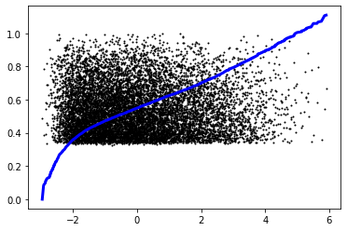

Lin Reg Results:

R^2: 0.6994272472553351

Explained Variance: 0.6994298275835684

RMSE: 0.08122500373892591

(10357, 1128) to (10357, 1)

(10357, 1128) (10357,) (10357,) (10357,)

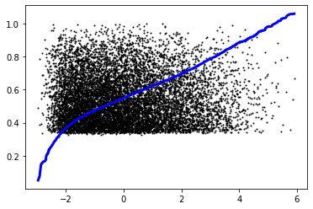

Lin Ridge Reg Results:

R^2: 0.7327748803432526

Explained Variance: 0.7327974163756157

RMSE: 0.0765867385974159

(10357, 1128) to (10357, 1)

(10357, 1128) (10357,) (10357,) (10357,)

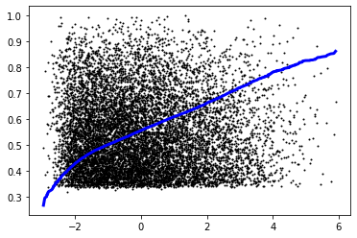

SVM Reg Results:

R^2: 0.6532265170992781

Explained Variance: 0.6576755563766539

RMSE: 0.0872444633978087

(10357, 1128) to (10357, 1)

(10357, 1128) (10357,) (10357,) (10357,)

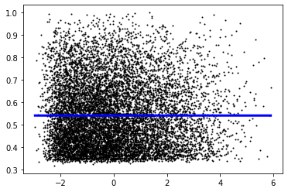

Lasso Reg Results:

R^2: -8.166504039230915e-06

Explained Variance: 0.0

RMSE: 0.14815513513655415

/usr/local/lib/python3.7/dist-packages/sklearn/linear_model/_ridge.py:190: UserWarning: Singular matrix in solving dual problem. Using least-squares solution instead.

warnings.warn("Singular matrix in solving dual problem. Using "

(10357, 1128) to (10357, 1)

(10357, 1128) (10357,) (10357,) (10357,)

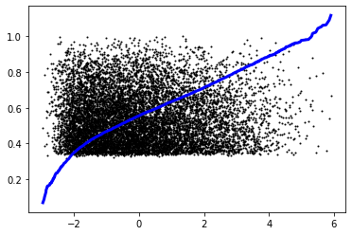

Kernel Ridge Reg Results:

(with additive_chi2 kernel type:)

R^2: 0.7901642925016567

Explained Variance: 0.7904099012106609

RMSE: 0.06786637185875086

(10357, 1128) to (10357, 1)

(10357, 1128) (10357,) (10357,) (10357,)

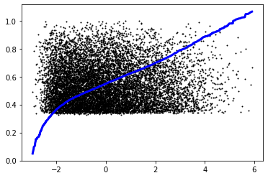

Kernel Ridge Reg Results:

(with linear kernel type:)

R^2: 0.7257415309160784

Explained Variance: 0.7257643565012452

RMSE: 0.0775880718588463

(10357, 1128) to (10357, 1)

(10357, 1128) (10357,) (10357,) (10357,)

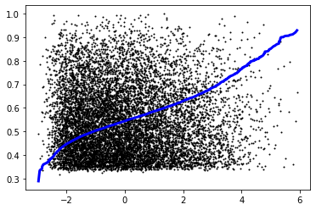

Kernel Ridge Reg Results:

(with poly kernel type:)

R^2: 0.5210257967465333

Explained Variance: 0.5211980139917832

RMSE: 0.102534731255415

(10357, 1128) to (10357, 1)

(10357, 1128) (10357,) (10357,) (10357,)

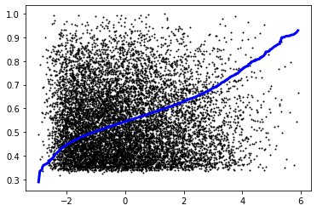

Kernel Ridge Reg Results:

(with polynomial kernel type:)

R^2: 0.5210257967465333

Explained Variance: 0.5211980139917832

RMSE: 0.102534731255415

(10357, 1128) to (10357, 1)

(10357, 1128) (10357,) (10357,) (10357,)

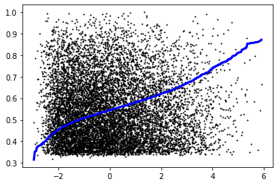

Kernel Ridge Reg Results:

(with rbf kernel type:)

R^2: 0.4556554584210958

Explained Variance: 0.45579481789913334

RMSE: 0.10930798079603801

(10357, 1128) to (10357, 1)

(10357, 1128) (10357,) (10357,) (10357,)

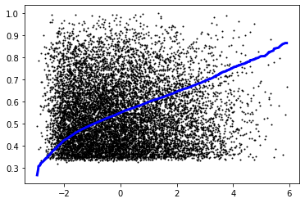

Kernel Ridge Reg Results:

(with laplacian kernel type:)

R^2: 0.6604180007109841

Explained Variance: 0.6605091694533464

RMSE: 0.08633507409869638

(10357, 1128) to (10357, 1)

(10357, 1128) (10357,) (10357,) (10357,)

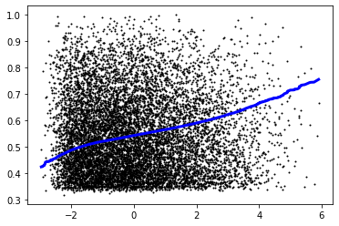

Kernel Ridge Reg Results:

(with sigmoid kernel type:)

R^2: 0.2700290602409461

Explained Variance: 0.2700702248613812

RMSE: 0.1265807665055072

(10357, 1128) to (10357, 1)

(10357, 1128) (10357,) (10357,) (10357,)

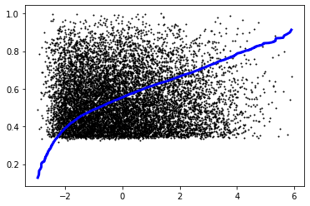

Kernel Ridge Reg Results:

(with cosine kernel type:)

R^2: 0.658370720929564

Explained Variance: 0.6583734752555469

RMSE: 0.08659493246916372

Begin testing after removal of low variance

(13809, 1128) to (13809, 2)

(10357, 2) to (10357, 1)

(10357, 2) (10357,) (10357,) (10357,)

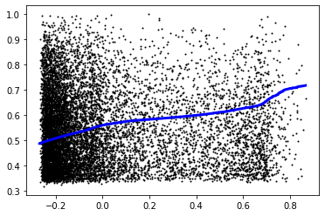

Lin Reg Results:

R^2: 0.09265877413570633

Explained Variance: 0.09285624859895547

RMSE: 0.1411237985394743

(10357, 2) to (10357, 1)

(10357, 2) (10357,) (10357,) (10357,)

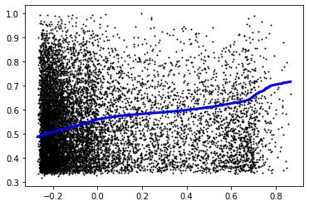

Lin Ridge Reg Results:

R^2: 0.09268270990748417

Explained Variance: 0.09287819792272567

RMSE: 0.1411219370957221

(10357, 2) to (10357, 1)

(10357, 2) (10357,) (10357,) (10357,)

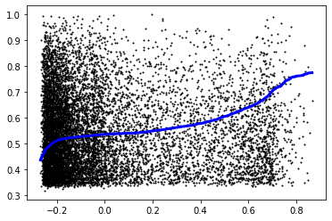

SVM Reg Results:

R^2: 0.119351435401993

Explained Variance: 0.12061946283563751

RMSE: 0.13903247418190595

(10357, 2) to (10357, 1)

(10357, 2) (10357,) (10357,) (10357,)

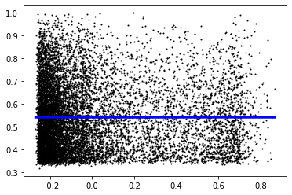

Lasso Reg Results:

R^2: -8.166504039230915e-06

Explained Variance: 0.0

RMSE: 0.14815513513655415

/usr/local/lib/python3.7/dist-packages/sklearn/linear_model/_ridge.py:190: UserWarning: Singular matrix in solving dual problem. Using least-squares solution instead.

warnings.warn("Singular matrix in solving dual problem. Using "

(10357, 2) to (10357, 1)

(10357, 2) (10357,) (10357,) (10357,)

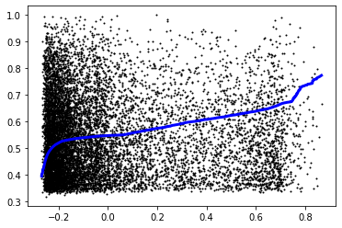

Kernel Ridge Reg Results:

(with additive_chi2 kernel type:)

R^2: 0.12079338979088461

Explained Variance: 0.12115150964732802

RMSE: 0.13891860320861624

(10357, 2) to (10357, 1)

(10357, 2) (10357,) (10357,) (10357,)

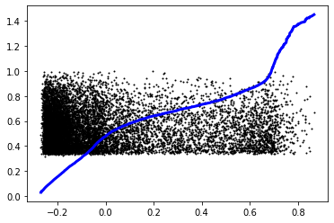

Kernel Ridge Reg Results:

(with linear kernel type:)

R^2: -3.825715179419615

Explained Variance: -2.556518817699312

RMSE: 0.32545861987350005

(10357, 2) to (10357, 1)

(10357, 2) (10357,) (10357,) (10357,)

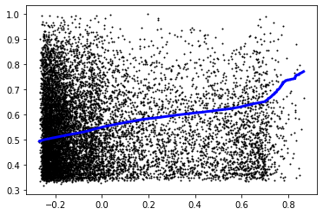

Kernel Ridge Reg Results:

(with poly kernel type:)

R^2: 0.0987253314330131

Explained Variance: 0.09890498017130378

RMSE: 0.1406512246953457

(10357, 2) to (10357, 1)

(10357, 2) (10357,) (10357,) (10357,)



Kernel Ridge Reg Results:

(with polynomial kernel type:)

R^2: 0.0987253314330131

Explained Variance: 0.09890498017130378

RMSE: 0.1406512246953457

(10357, 2) to (10357, 1)

(10357, 2) (10357,) (10357,) (10357,)

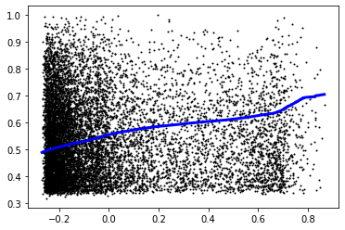

Kernel Ridge Reg Results:

(with rbf kernel type:)

R^2: 0.09655692331562438

Explained Variance: 0.09669716272497775

RMSE: 0.14082032188750007

(10357, 2) to (10357, 1)

(10357, 2) (10357,) (10357,) (10357,)

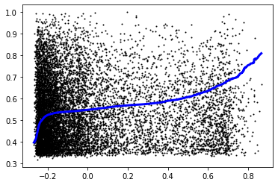

Kernel Ridge Reg Results:

(with laplacian kernel type:)

R^2: 0.12610528812469446

Explained Variance: 0.12628631209652175

RMSE: 0.13849831550703917

/usr/local/lib/python3.7/dist-packages/sklearn/linear_model/_ridge.py:190: UserWarning: Singular matrix in solving dual problem. Using least-squares solution instead.

warnings.warn("Singular matrix in solving dual problem. Using "

(10357, 2) to (10357, 1)

(10357, 2) (10357,) (10357,) (10357,)

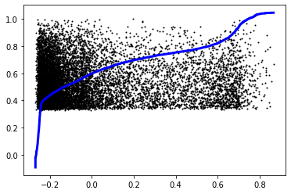

Kernel Ridge Reg Results:

(with sigmoid kernel type:)

R^2: -1.3684660695995752

Explained Variance: -1.3684036994629776

RMSE: 0.22800717795456465

(10357, 2) to (10357, 1)

(10357, 2) (10357,) (10357,) (10357,)

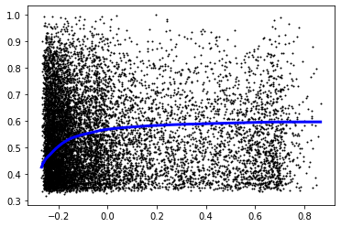

Kernel Ridge Reg Results:

(with cosine kernel type:)

R^2: -0.1683851726077601

Explained Variance: -0.16710459698042146

RMSE: 0.16014299782218028

Incorrect feature dimensions