Abdul Haseeb | Saim Anjum | Laiba Idrees

20F-1066 | 20F-0326 | 20F-0281 | BSE-7A

DevOps Project Report

Phase 2 – TASK 3

**Setting up Vagrant Environment**

# **Introduction**

This report outlines the steps taken to set up a Vagrant environment for the local development environment. Vagrant allows for consistent and reproducible development environments across different machines.

# **Objective**

The goal of this setup is to provide a standardized development environment that can be easily shared among team members.

## **Prerequisites:**

* + Install Vagrant from the [official website](https://www.vagrantup.com/downloads.html).

## **Initialization:**

* + Navigate to the project directory in the terminal.
  + Run **vagrant init** to create a new **Vagrantfile**.

## **Starting the VM:**

* + Execute **vagrant up** to start the virtual machine.

## **Accessing the VM:**

* + Connect to the VM via SSH with **vagrant ssh**.

# **Configure Environment**

## **Vagrantfile**

A Vagrantfile is created to define the configuration of the virtual machine.

## **Screenshot**

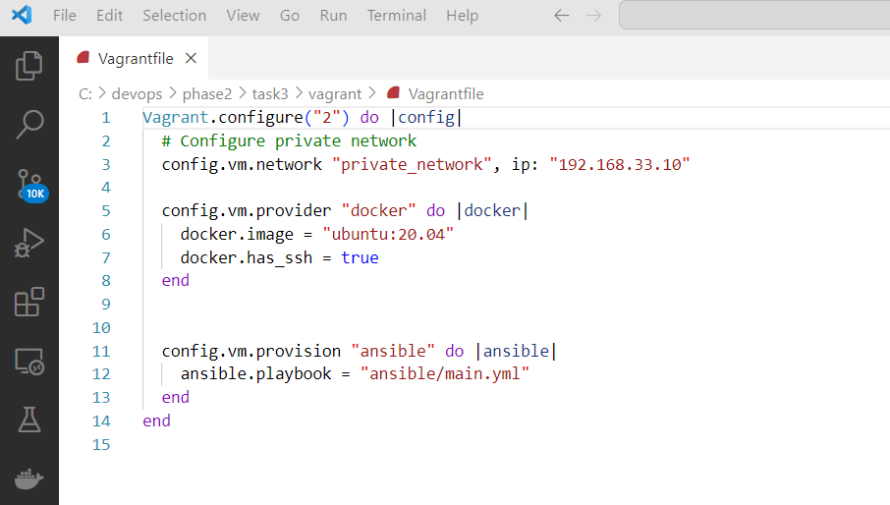

# **Conclusion**

The Vagrant environment has been successfully set up for the local development. This configuration provides a consistent and reproducible environment for all team members, ensuring a smoother development process.

**Setting up Multiple Ansible Files using Vagrant file**

# **Introduction**

The process of integrating multiple Ansible files with a Vagrant environment to automate the provisioning and configuration of virtual machines.

# **Objective**

The primary goal is to streamline the setup process, improve consistency, and reduce manual intervention in deploying development environments.

# **Configure Environment**

## **Ansible Playbooks**

Two separate Ansible playbooks are created to handle the provisioning of the VMs.

# **Usage**

## **Initialization:**

* + Navigate to the project directory in the terminal.
  + Run **vagrant up** to create and provision the VMs.

## **Accessing the VMs:**

* + Connect to the VMs via SSH with **vagrant ssh.**

# **Creating Playbooks for Odoo, Jitsu, and Superset**

# **Odoo Playbook**

# **Jitsu Playbook**

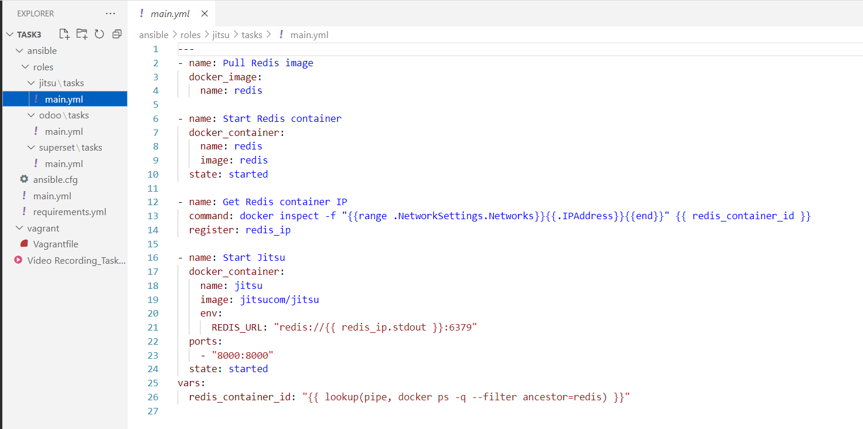

# **Superset Playbook**

# **Conclusion**

By incorporating multiple Ansible files with Vagrant, we have established an automated and consistent approach to provisioning virtual machines for our project. This setup will enhance the development process by reducing manual configuration steps and ensuring a standardized environment across team members.