Report on Deploying Apache Superset from GitHub using Docker

# 1. Downloading Docker:

The first step involved downloading Docker onto my laptop. I visited the official Docker website and downloaded the application suitable for my operating system.

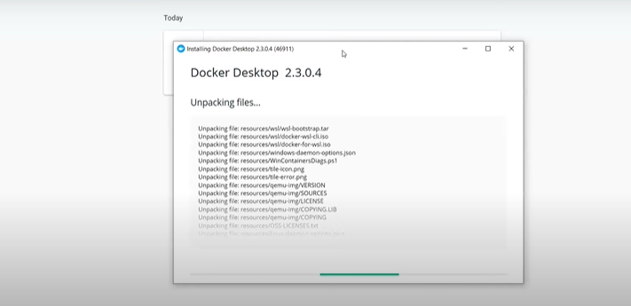

# 2. Cloning Superset's GitHub Repository:

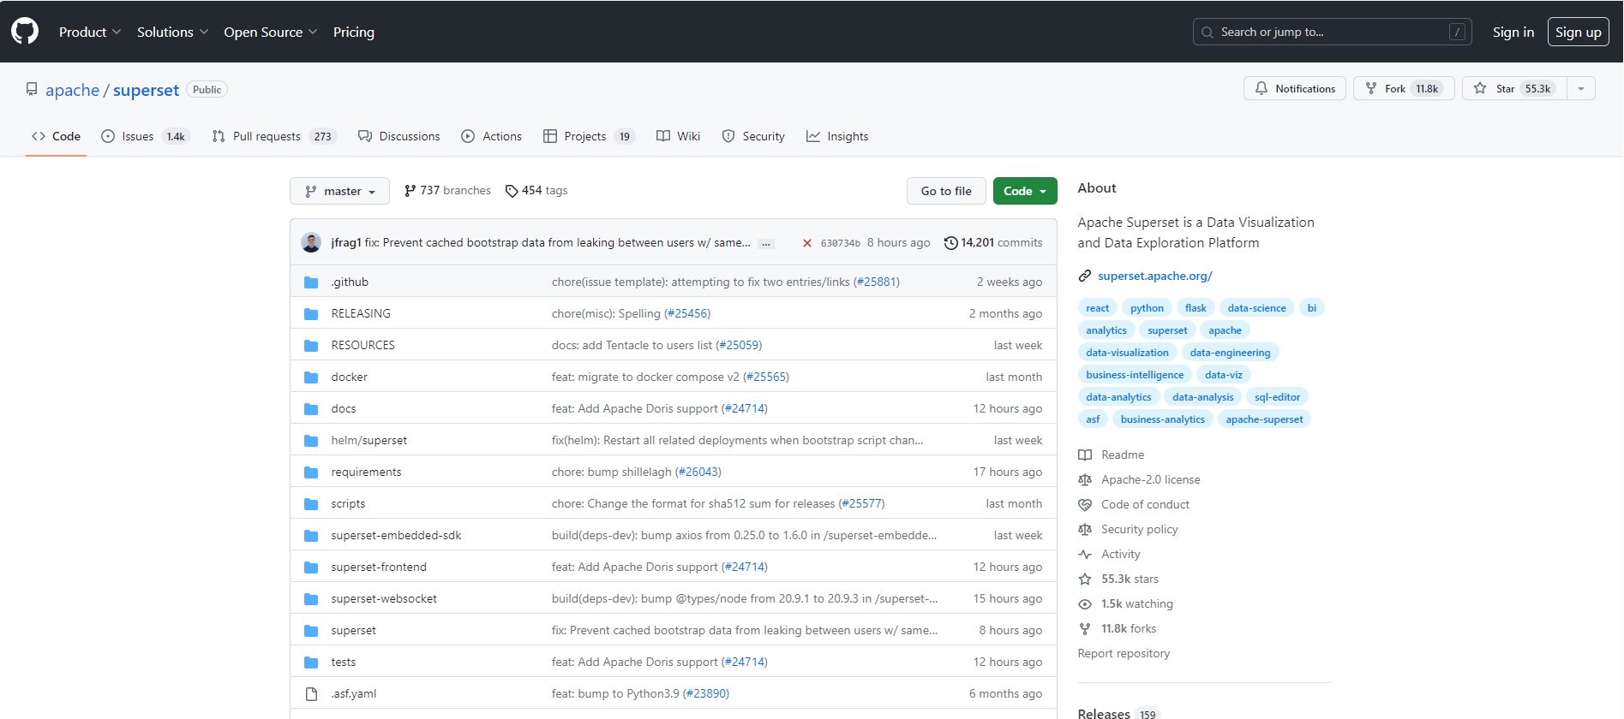

Next, I cloned the Apache Superset GitHub repository to my local machine. Using the following command in my terminal:

**git clone** [**https://github.com/apache/superset.git**](https://github.com/apache/superset.git)

This created a new 'superset' folder in my current directory.

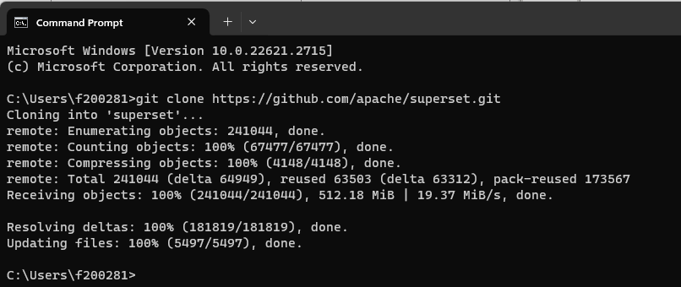

# 3. Launching Superset Through Docker Compose:

After navigating to the 'superset' folder, I used Docker Compose to launch Superset in development mode. I ran the following commands:

**git checkout 3.0.0**

**set TAG=3.0.0**

**docker compose -f docker-compose-non-dev.yml pull**

**docker compose -f docker-compose-non-dev.yml up**

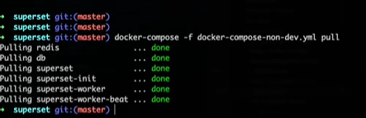

# Configuration:

Configuration settings were stored in the '/app/pythonpath' folder, mounted from './docker/pythonpath_dev.'

Local overrides were facilitated by copying 'superset_config_local.example' to 'superset_config_docker.py' and filling in the required overrides.

Additional Python packages (numpy, pandas) were added through a local requirements file, and Docker was rebuilt accordingly.

# Initializing Database:

The database initialized itself upon startup using the init container (superset-init), which may take a minute.

# Normal Operation:

To run the container, the command docker compose up was used. After a few minutes, Superset initialization finished, and I accessed http://localhost:8088 in a browser to begin using Superset.

# Developing:

While running, the container server reloaded on modifications to Superset Python and JavaScript source code. A page reload was necessary to reflect frontend changes.

# Production:

To run Superset in non-development mode, the 'docker-compose-non-dev.yml' file was utilized. This file excludes volumes needed for development and uses './docker/.env-non-dev' to set the variable SUPERSET_ENV to production.

