Abdul Haseeb

20F-1066 | BSE-7A

DevOps Project

phase 3 | Task 1

**Setting Up Docker for FYP Development**

# **Project Structure**

Created a following project structure for this setup:

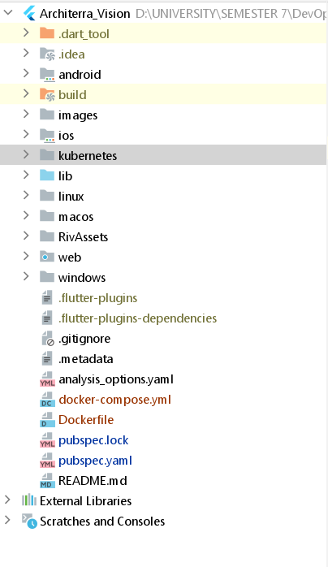

# **Dockerfile**

Created a dockerfile in the project root directory:

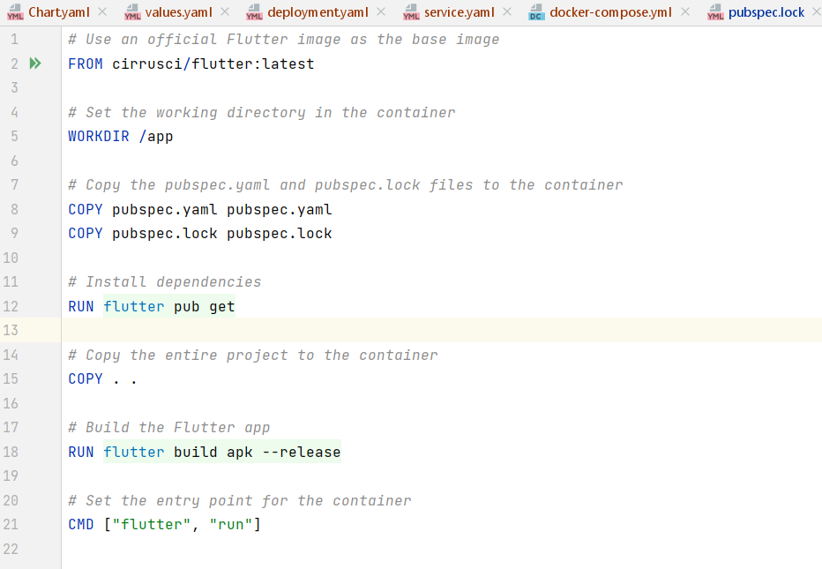

# **Docker Compose**

Created docker compose file to run project locally.

# **Configure Flutter Dependencies**

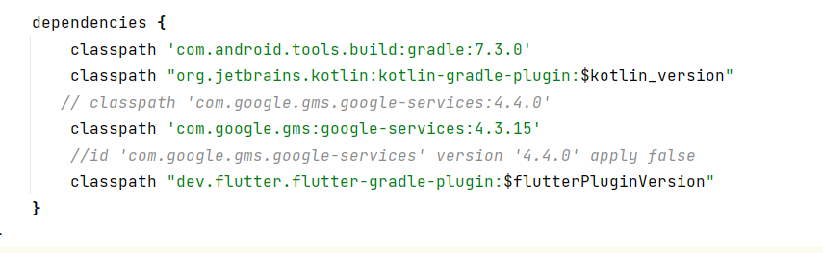

# **Build and Run**

Used the following command to build and run the docker compose.

‘docker-compose up –build’

