Abdul Haseeb

20F-1066 | BSE-7A

DevOps Project

PHASE 3 | Task 2

**Kubernetes Deployment Report**

# **Requirements**

* A running Kubernetes cluster.
* Helm installed on your local machine.

# **Project Organization**

Organized my Flutter project and Helm chart directory in the following way:

# **Helm Chart Setup**

Created a Chart.yaml file for metadata.

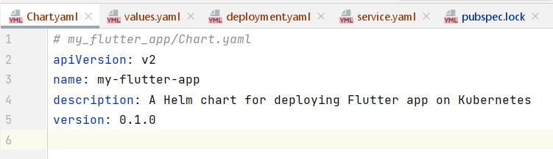

**Values.yaml**

# **Deployment and Service Definition**

Created a deployment.yaml file.

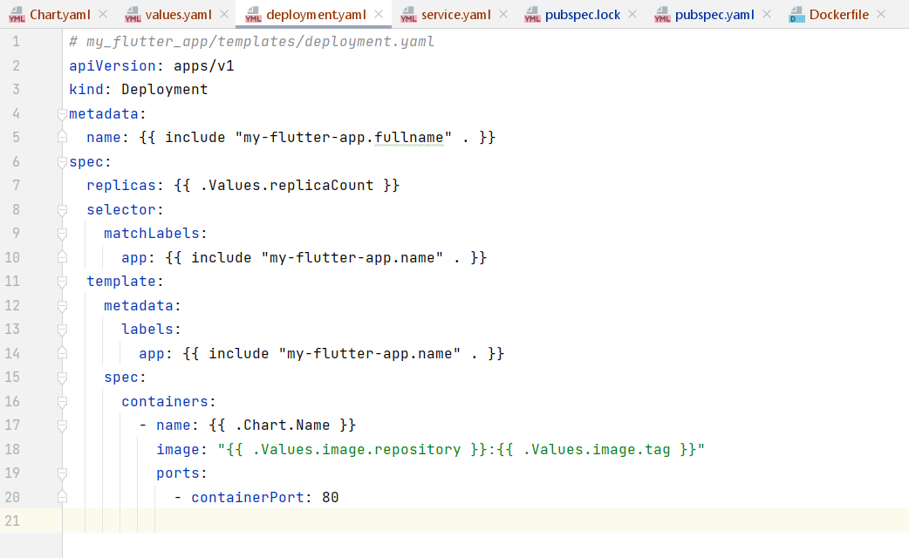

**Service.yaml file**

# **Install Helm Chart**

Installed the helm chart by using following command:

‘helm install my-flutter-app .’

# Verify Deployment

I used following commands to verify deployment:

‘kubectl get pods’

‘kubectl get services’