Storyboard for ......Swimming..club.................................................................
Designer ......Mohamed...Bamba....................................................................
Screen Size…………………….
..........................1600x900.............................
.......................................................................
Legend..........................................................
.......................................................................
.......................................................................
.......................................................................
.......................................................................
.......................................................................
.......................................................................
.......................................................................
.......................................................................
.......................................................................
.......................................................................

Links .........................Navigation….buttons.......................................................................................................................................................................................................
................................................................................................................................................................................................................................
Styles ..........................................background…colour.#6699FF.....................................................................................................................................................................................
................................................................................................................................................................................................................................
Production Notes ................................................................................................................................................................................................................................
................................................................................................................................................................................................................................
Home page

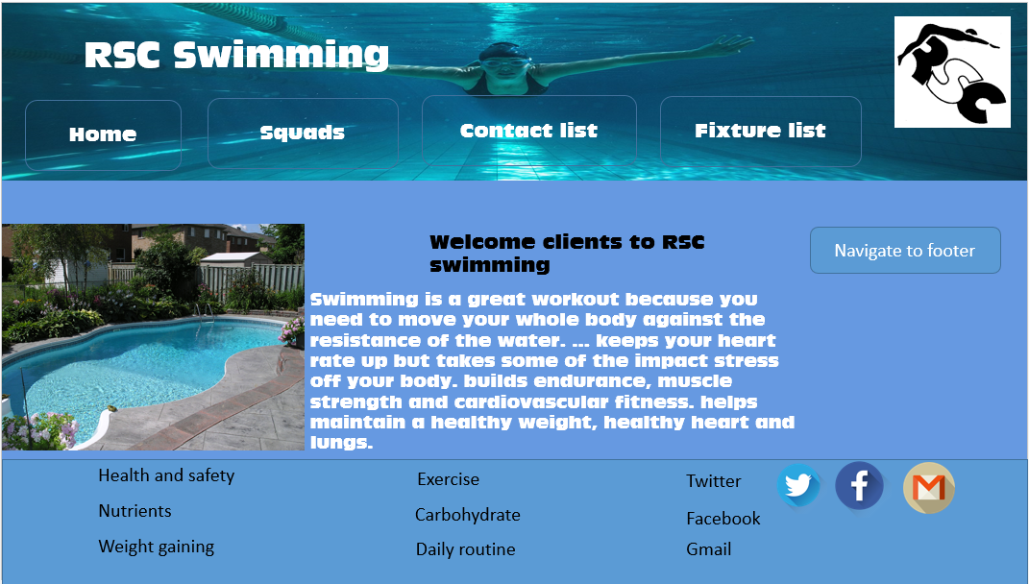

Squads
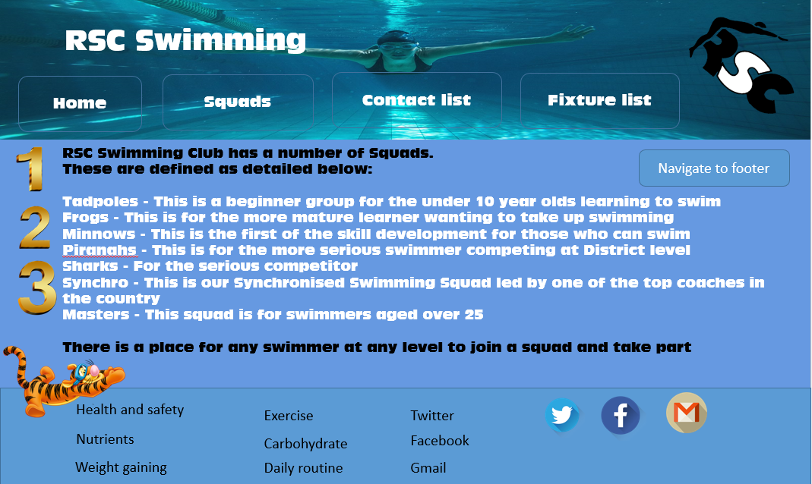

Fixture
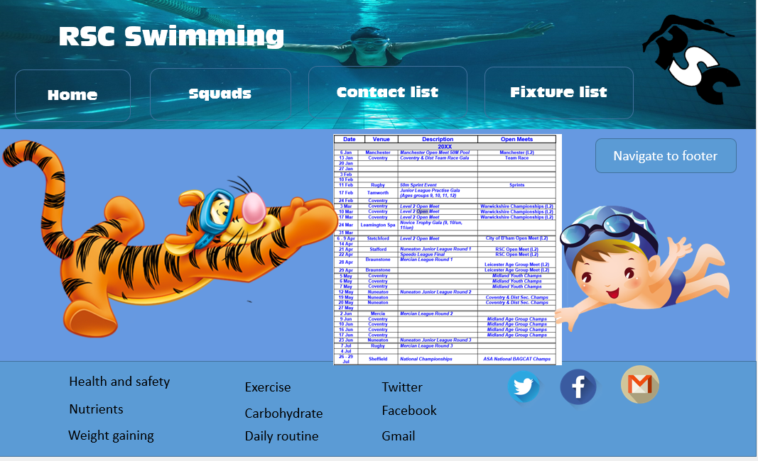

Contact
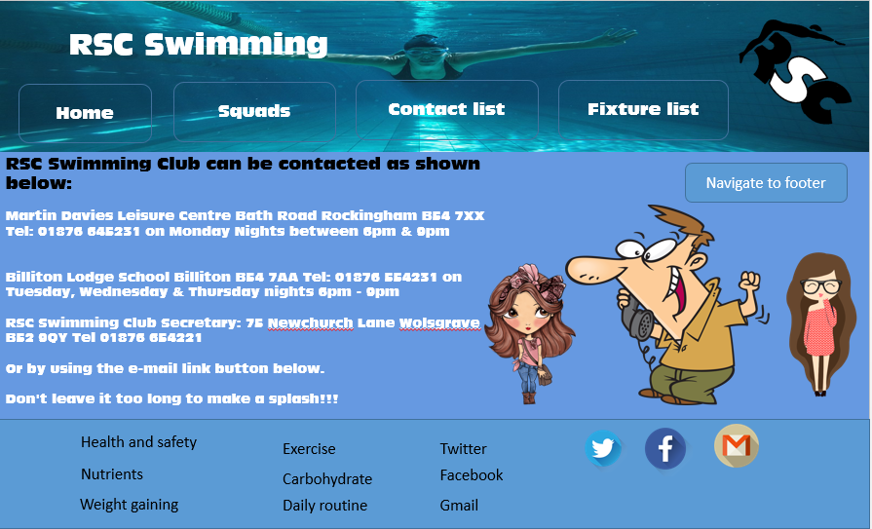

Buttons edited by

Navigation button

Home
Squad
Fixtures Lists
Contact Us

Email link
mailto:mobamba10@gmail.com

External link
https://en.wikipedia.org/wiki/Domain_name_registrar#Domain_name_transfer

Images
