Puertollano Dynamic Simulator Project

Document code:

Document type: ALTERLEGO 2.1 OVERVIEW

ALTERLEGO FEATURES DOCUMENTATION

DISTRIBUTION RESERVED
PROPRIETARY

00 | 11/03/98
Rev | Date | Pages | ENEL  CRA | ENEL  CRT | ELM | EDF |  | ENEL  CRA | ENEL  CRT | ELM | EDF |  | Project Manager
 |  | changed | Prepared by |  |  |  | Checked by |  |  |  |  | Approval

TABLE OF CONTENTS

1. ALTERLEGO 2.1 SUITE
2. LEGOCAD
3. REGOMMI
4. EXECUTIVE
5. SCADA
6. MMI
7. ALG_DB

ALTERLEGO 2.1 SUITE
Alterlego 2.1 suite is composed by tools covering from simulator’s construction, debugging and monitoring to the complete configuration and use of a plant simulator training environment.
In the following picture Alterlego suite components and their scope of usage are shown:

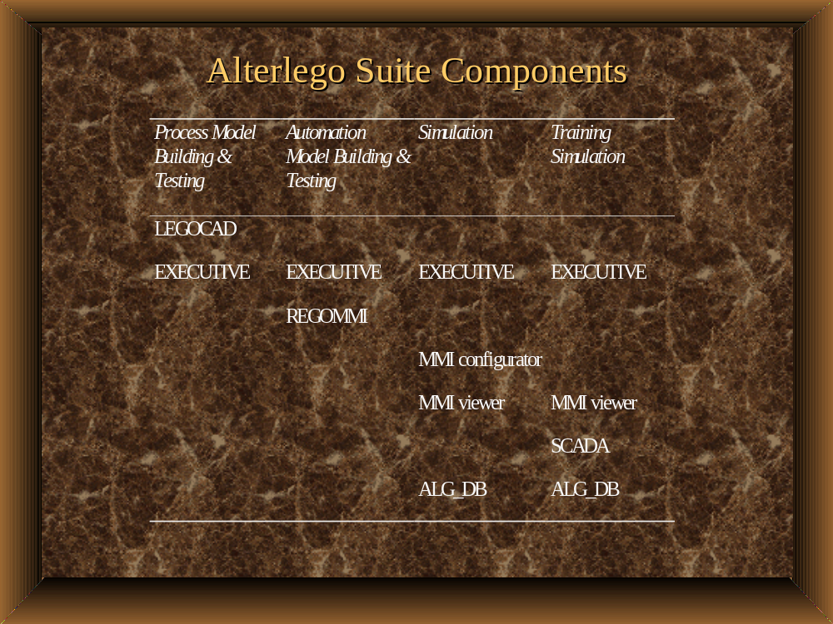

LEGOCAD is used in process models development: models testing is achieved using EXECUTIVE tool in a single model environment.
Automation models are built using REGOMMI configuration tool that allows full graphic editing of automation schemes: testing is then realized with EXECUTIVE tools.
The whole simulator is created connecting process and automation models and running EXECUTIVE tool in multiple models environment. Man machine interface (MMI tools) is provided via animated Plant Display, Operating Window and Automation Schemes.
For Training Simulator Environment a Supervisory Control and Data Acquisition system (SCADA) is provided for simulation data acquisition, data treatment and alarm management. Furthermore all simulator related information and documents can be stored in ALTERLEGO database using ALG_DB.
A brief description of each Alterlego 2.1 suite component follows.

LEGOCAD
Full life cycle of power plant model development is achieved using LEGOCAD tool.
In the following figure LEGOCAD toolbox is shown.
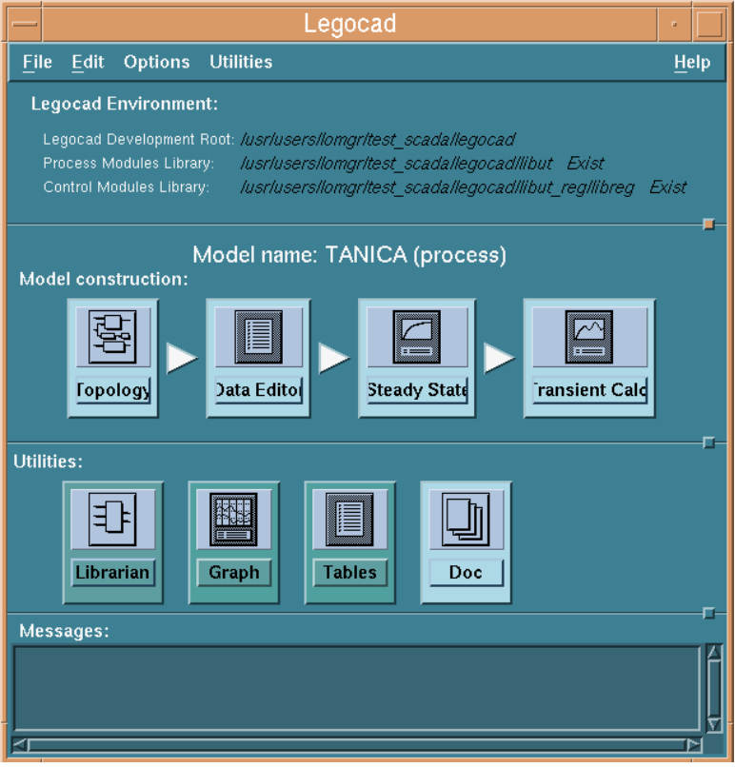
LEGOCAD Toolbox first row (labeled model construction) shows the four steps that constitutes model development:
Topology: allows model construction by instantiation and connection of single library modules.
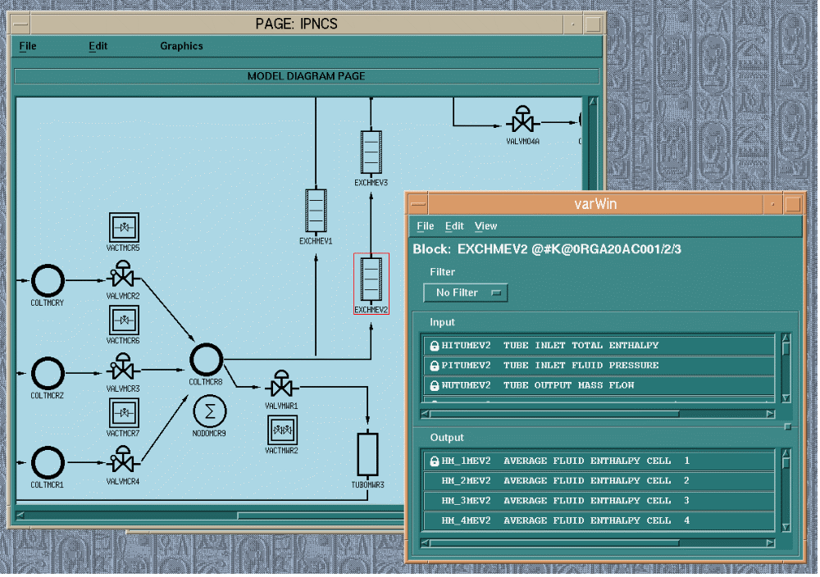
Data Editor: leads user to complete modules definition by physical and geometrical data configuration: moreover it provides editing functionality for attempt simulator variables values that will be used as initial condition in model steady state calculation.

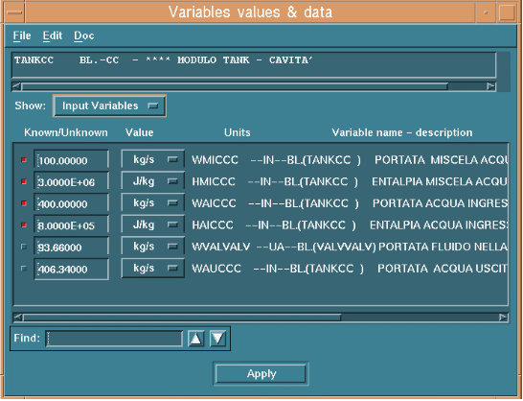
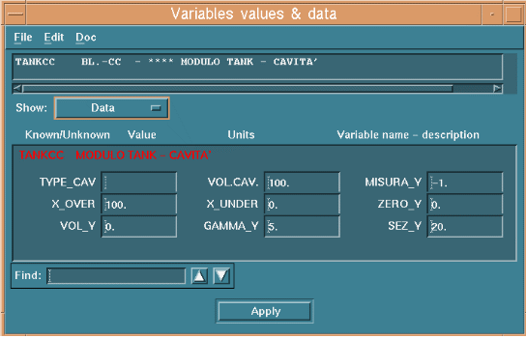

SteadyState execute model steady state computation starting from previously edited initial condition allowing mathematical convergence analysis and problems detection.
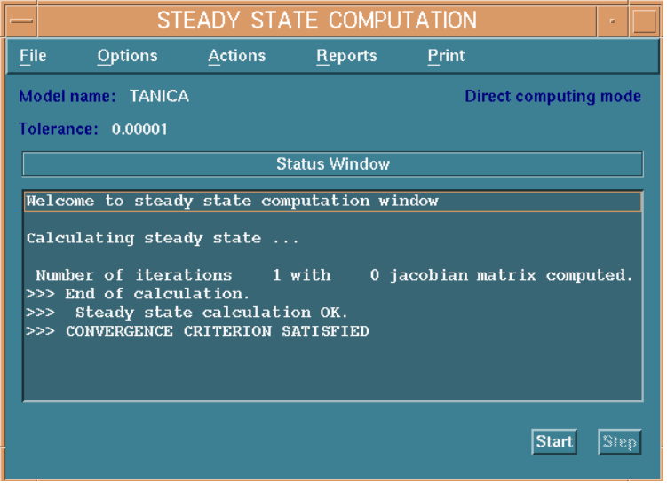
Transient calculation performs model execution (simulation) in an interactive environment. It make available to user all Alterlego EXECUTIVE utilities from simulation control (commands) to variables tracing for debugging purposes.
Legocad Toolbox second row (labeled utilities) contains facilities for modules library maintenance (Librarian), for the analysis of model’s variables trends sampled during simulation (Graphics) , for interactive examination of physical properties of water at liquid and steam state (H2O Tables) and for automated model documentation (Documents)

REGOMMI
REGOMMI describes automation models by means of interconnected automation schemes: it is a graphical editor where automation components (regulator, actuators, logic functions...) are icons dropped from an automation library ready to be connected each other and configured by user.
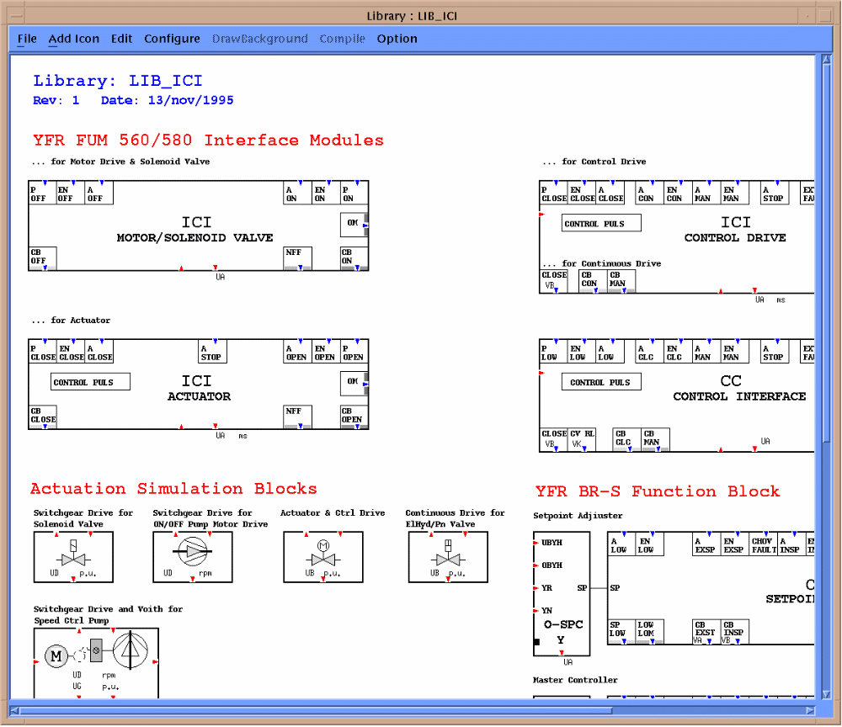

Automation schemes compilations leads to an executable automation model, that can be tested using EXECUTIVE in single model mode. An useful debugging feature is achieved viewing simulation variable animated schemes during automation model execution.
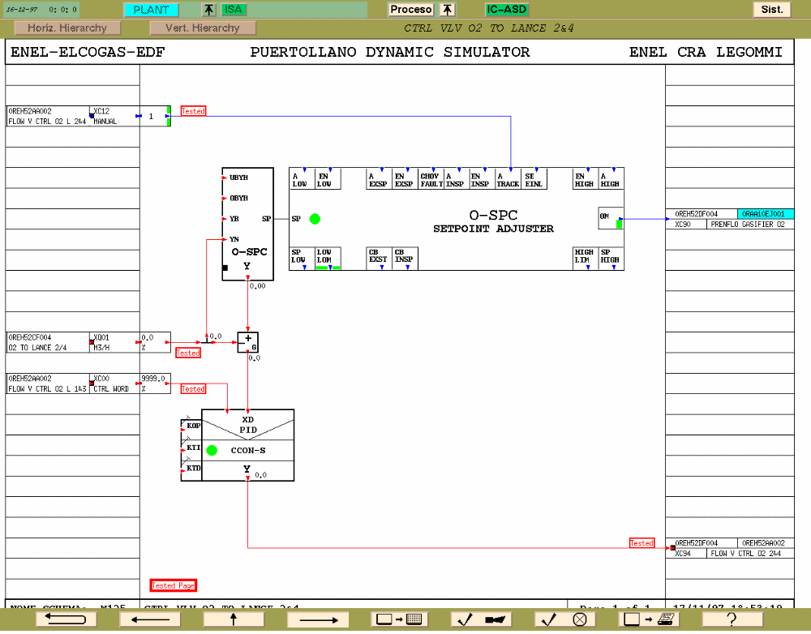

EXECUTIVE
Alterlego real time general executive provides the functionality to execute multiple models simulation. The EXECUTIVE is composed by a task scheduler, auxiliary services (such as historical data archives, snapshot and backtrack manager) and communication services updating simulation data to MMI and SCADA.
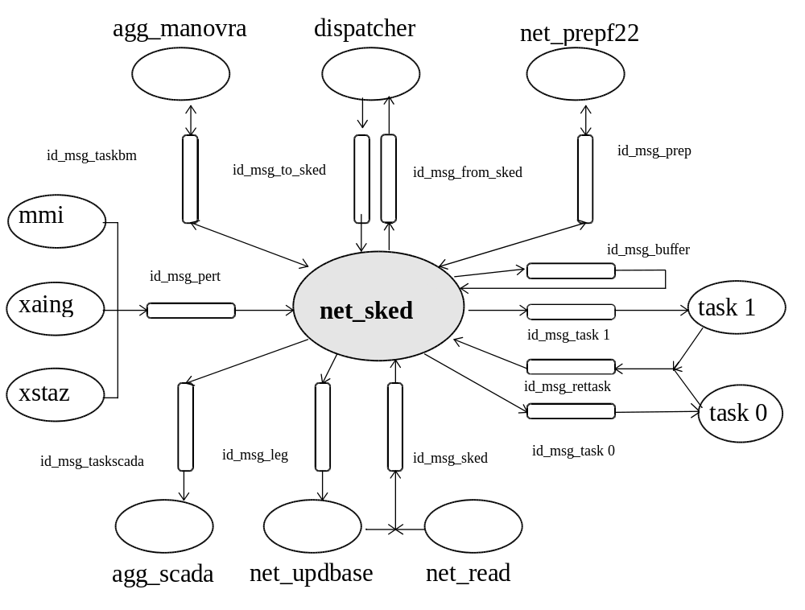
The EXECUTIVE graphical user interface called instructor’s station controls the execution of simulation (included typical instructor station operations like snapshots, backtrack management, session replay, malfunction management) and provides utilities for variables values modification (xaing), values monitoring (mandb) or variables’ trends analysis (graphics).
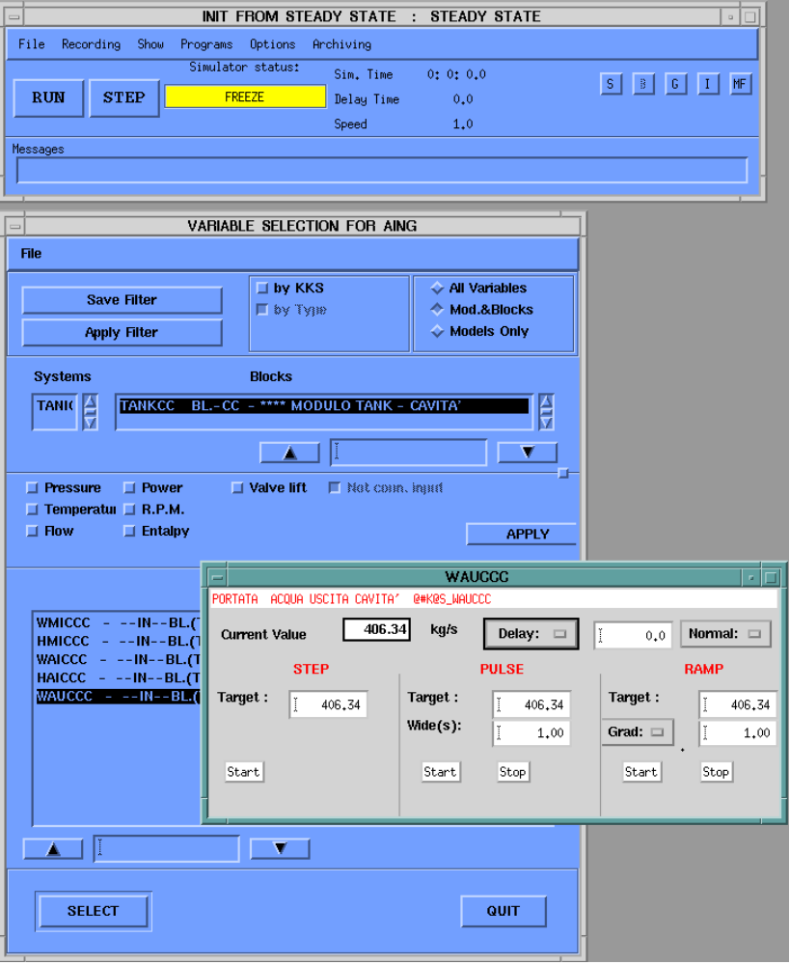

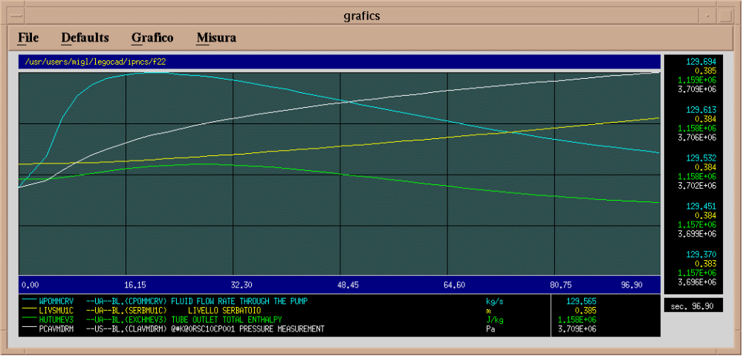

SCADA
Alterlego Supervisory Control and Data Acquisition system (SCADA) reads simulation variables values and provides a series of elaboration such as data conversion, calculated values, digital and analog alarm management, additional data archiving.
SCADA communicates with MMI providing data for Plant Displays and managing Alarm Sequence Display and hierarchy organized information about alarms in the plant.

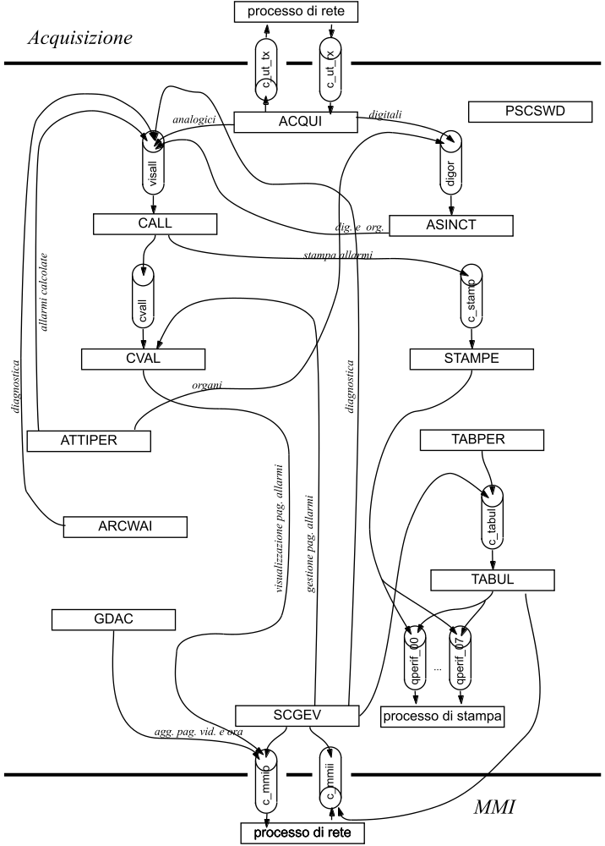

MMI
MMI provides user interface for viewing or interacting with simulation or SCADA elaborated data.
MMI is composed by an editor for the construction of Plant Display or Operating Window and a viewer that in connection with EXECUTIVE and SCADA allows animation of plant representation pages and interaction with simulator.
Plant displays are an effective way to both give to the user some key information about the plant and allow him to operate, in a visual environment that reminds him the structure of the process, in term of piping lines, components etc. Plant Displays are organized in a hierarchical, tree-like, structure.

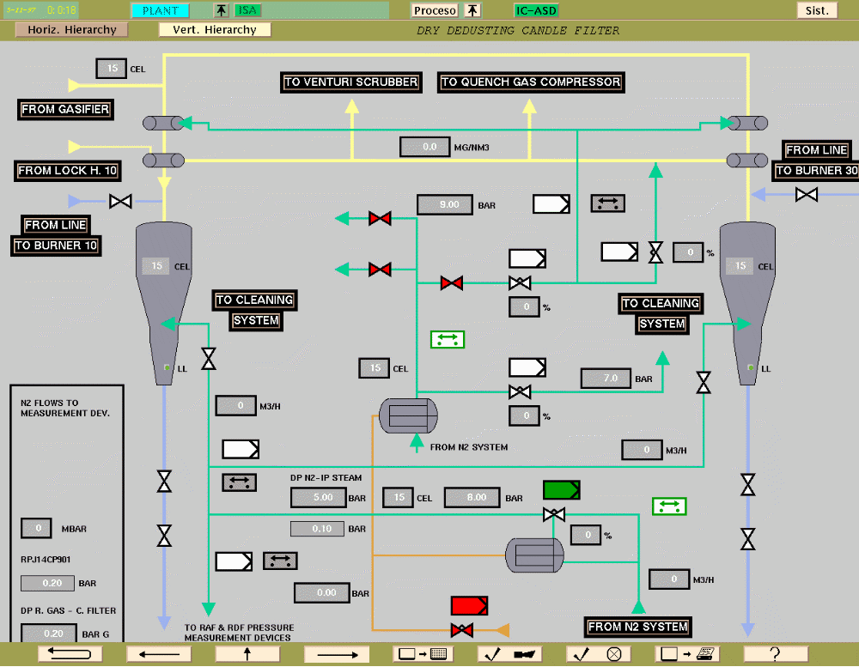

Detailed information about devices status and interaction with actuators is provided via Operating and Indicating Windows.
The main difference between these two windows categories is that only Operating windows allow the user to execute a command (e.g. opening a valve).
An example of a typical Operating window is shown below.
Selection of window extension 1
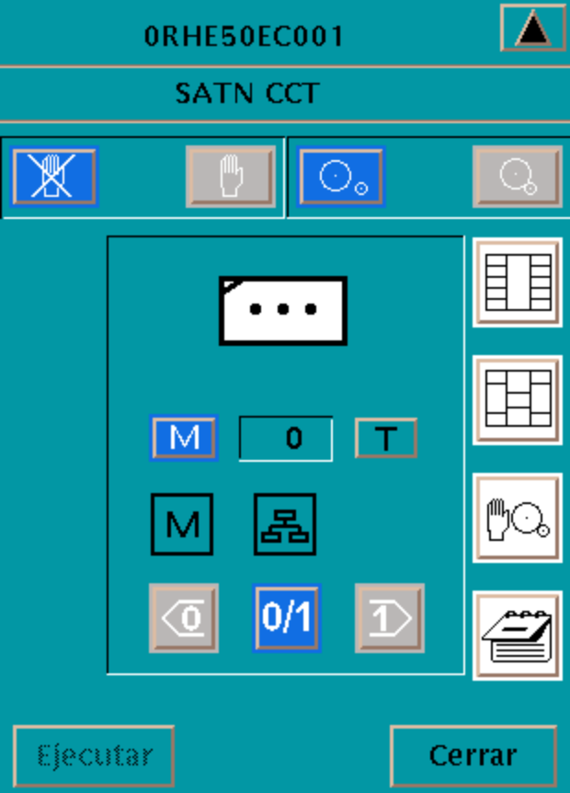
Enable
Disable
Disconnect
Couple
Open the detail window
Open the function diagram
Selection / deselection of window extension 2
Open the notebook window
Command release
Close the window
Subgroup controller pictograph
Step number
Operator guide mode
Branching
Shutdown
Startup
Off / on
Stepping mode
The system can be configured to manage alarm conditions, both deviations from regular or planned operations and faulty devices. When the alarm system is active (SCADA is running) , MMI provides some additional features, like CAI (Common alarm indicator) animation, window extension 1 full management and alarm sequence display (ISA).
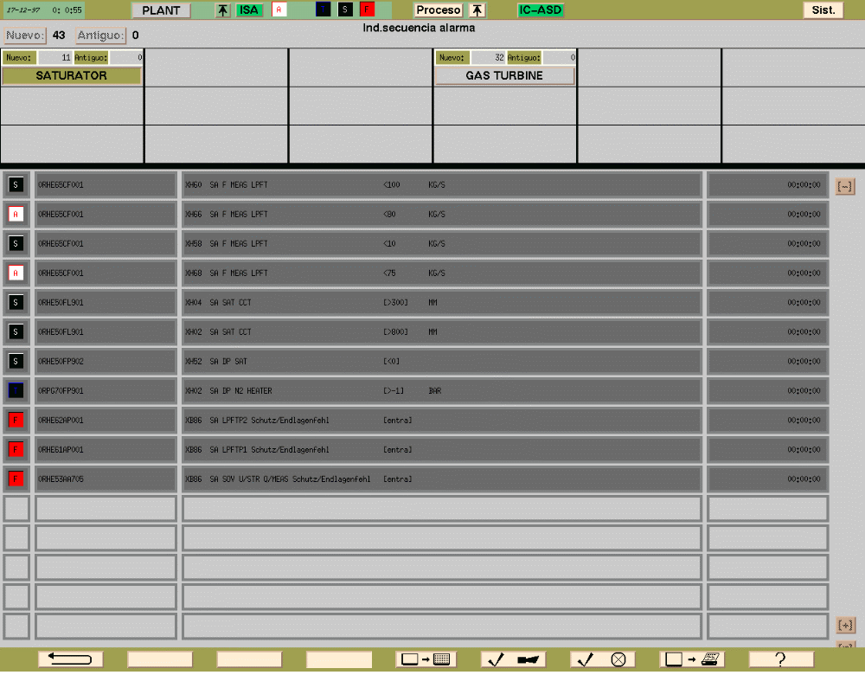
An other useful MMI is Curve display: it show the chronological courses of values in the form of a curve. The time period in the past that may be covered by a curve is limited by the size of the circular archive file and depends on the event rate in the simulator.
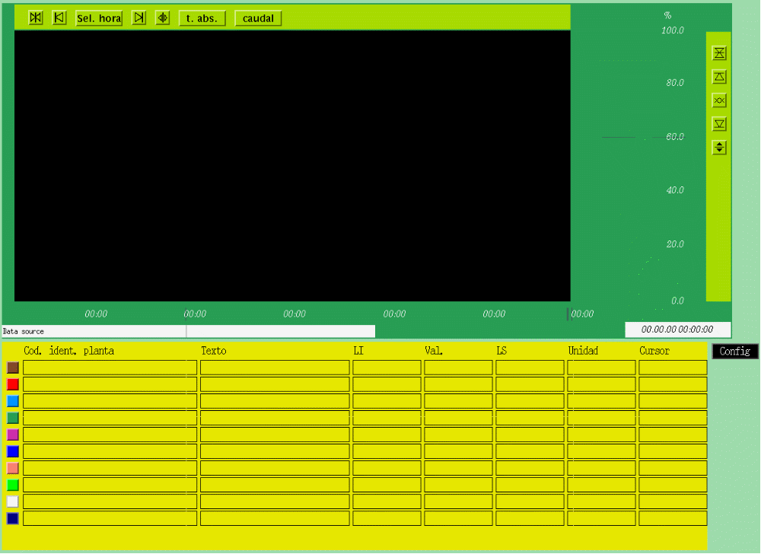

ALG_DB
ALG_DB is an INFORMIX based database structured for containing all interesting information about the simulator from physical plant data to functional plant decomposition used for building the simulator, from SCADA variables configuration to simulator and plant related documentation.
ALG_DB is provided with a Microsoft Access based graphical user interface for ODBC clients, running on Windows or Windows NT platforms.

