Puertollano Dynamic Simulator Project

Document code:

Document type: INSTRUCTOR STATION USER MANUAL

DISTRIBUTION RESERVED
PROPRIETARY

0 | 11/04/96
Rev | Date | Page | ENEL  CRA | ENEL  CRT | ELM | EDF |  | ENEL  CRA | ENEL  CRT | ELM | EDF |  | Project Manager
 |  | changed | Prepared by |  |  |  | Checked by |  |  |  |  | Approval
TABLE OF CONTENTS

1. OVERVIEW
2. USER ENVIRONMENT
3. GENERALITIES
3.1 STATES OF THE SIMULATOR
3.1.1 Stop
3.1.2 Freeze
3.1.3 Run
3.1.4 Backtrack
3.1.5 Replay
3.2 INSTRUCTOR STATION CAPABILITIES
3.2.1 Superuser privileges
3.2.2 Simulator start-up and shutdown
3.2.3 Change of the simulator state
3.2.4 Snapshot management
3.2.5 Backtrack management
3.2.6 Record and replay
3.2.7 Time scaling
3.2.8 Continuos recording
3.2.9 Configurability
3.3 INSTRUCTOR STATION FILES
4. INSTRUCTOR STATION INTERFACES DESCRIPTION
4.1 SIMULATOR STARTUP AND SHUTDOWN
4.1.1 Simulator startup
4.1.2 Simulator shutdown
4.2 MASTER MENU INTERFACE
4.2.1 Interface description
4.2.2 Interface operation
4.2.3 Exit the interface
4.3 SNAPSHOT MANAGEMENT
4.3.1 Interface description
4.3.2 Interface operation
4.4 VIEW INTERFACE
4.4.1 Interface description
4.4.2 Interface operation
4.5 FILTER FOR VIEW INTERFACE
4.5.1 Interface description
4.5.2 Interface operation
4.6 BACKTRACK MANAGEMENT
4.6.1 Interface description
4.6.2 Interface operation
4.6.3 Restoring the previous session
4.7 CONTINUOS RECORDING
4.7.1 Activation of the trend program
4.7.2 Filter for configuring the recorded variables
4.8 SHOW STATISTICS
4.8.1 Interface description
4.8.2 Interface operation
4.9 PROGRAM ACTIVATION
4.9.1 Xaing activation
4.9.2 User programs activation
4.10 OPTIONS CONFIGURATION
4.10.1 Interface description
4.10.2 Interface operation
5. APPENDIX
5.1 USER ENVIRONMENT CONFIGURATION
5.2 INTERFACE RESOURCE SETTINGS
5.3 MMI ACTIVATION
5.4 MANUAL SHUTDOWN

LIST OF FIGURES

Figure 4-1 - States of simulator
Figure 3-1 - Master Instructor Station interface
Figure 3-2 - Master Menu interface
Figure 3-3 - Snapshot Management interface
Figure 3-4 - View interface
Figure 3-5 - Filter interface for View Function
Figure 3-6 - All the filters applied
Figure 3-7 - Backtrack Management interface
Figure 3-8 - The graphics program interface
Figure 3-9 - Filter for Cont. Recording function
Figure 3-10 - The statistics interface
Figure 3-11 - User Program Activation interface
Figure 3-12 - Option Selection interface

OVERVIEW
This document is the User Manual of the Instructor Station Interface, rev. 0.0, provided with the first release of the Puertollano simulator.
Chapter 3 contains general information explaining how the system works and is useful to understand the following part of the manual.
Chapter 4 is the core of this manual. It contains both a description of the functionalities available in the instructor station and a guide to use it in a typical session.

User environment
The instructor logs in the instructor station machine with the account used to install the simulator.
The environment variables provide paths for executable programs and for location where instructor station software stores special files.
The .Xdefaults file located in the user login directory provides resource settings for the instructor station graphic interface.
If the installation process ran without errors and no modifications are requested from the standard installation the user does not need any configuration of these 2 files.

Generalities

STATES OF THE SIMULATOR
system not initialized

Stop
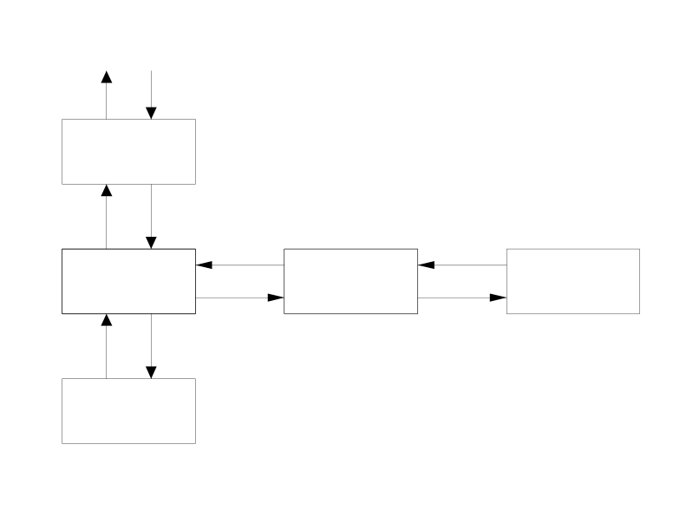
Figure 3-1 - States of simulator
stop
freeze
run
backtrack
replay
This is the transitory state indicating that the simulator is initializing.

Freeze
In this state the simulator tasks are active but not running. The simulation time is not incremented and the automatic functions of the Instructor Station are not executed.
It is possible to switch to a different state (but REPLAY).

Run
The simulator tasks are running and the Instructor Station executes the automatic functions: backtrack snapshots, continuos recording, commands recording.

Backtrack
The simulator tasks are not running and the Instructor Station does not execute the automatic functions.
From BACKTRACK state it is possible to load the snapshots automatically recorded or initialize the replay function.

Replay
In this state, reached from the BACKTRACK state, it’s possible to “replay” one of the recorded sessions or part of that. The models run like in the RUN state but the inputs coming from the operator are inhibited. Starting from the loaded backtrack snapshot, all of the actions previously recorded (of both the instructor and the operator) are proposed to the simulator at the appropriate time.

instructor station capabilities
The following is the list of the Instructor Station software capabilities:

- Superuser privileges
- Simulator start-up and shutdown
- Change of the simulator state
- Snapshot management
- Backtrack management
- Record and replay
- Time scaling
- Continuos recording
- Configurability

Superuser privileges
The startup procedure allows the instructor to activate the simulator as normal user or as superuser.
In the latter case the instructor has the possibility to protect Initial Conditions, to override these protections and to validate Initial Conditions flagged as invalid after a simulator compilation.
The protected operations are:

Area | Function
Snapshot management | possibility to override the I.C. protection
 | possibility to accept I.C. tagged as invalid
Options | Possibility to modify the list of the I.C. protected against destruction (but the ones protected by default)

Simulator start-up and shutdown
In the simulator configuration, based on three workstations, one will be used as master and the others as slaves.
The simulator is activated at the master machine with a single command; all the commands and functions needed to initialize, configure and use the simulator are available from the graphical interface of the Instructor Station console.
The instructor is required to type a command at the keyboard of the Instructor station machine. All the software will be initialized and the simulator will come up in the FREEZE state.

The initialization procedure restores the simulator situation left before the last shutdown: the simulation time is recovered from the recorded files and the last backtrack record can be used to load the last valid database.

Change of the simulator state
All the permitted transitions between the states of the simulator are manually driven by the instructor.

While the RUN state is selected, the instructor is prompted to enter a “title” of the session that will start from this moment on, if the selection comes after a database replacement (initial condition or backtrack snapshot loading).

Snapshot management
The instructor has the possibility to record, load and maintain up to 60 initial conditions.

An appropriate interface is provided that make possible to:

- save a snapshot of the simulator database as an initial condition chosen by the instructor along with a comment. This functionality is available from all the simulator states.

- load the simulator database from a selected initial condition. This functionality is available from the FREEZE state only.

- delete, move and copy initial conditions, as well as modify the comments associated to the initial conditions. This functionality is available from all the simulator states.

- view the values of all the simulator variables as they are recorded into the initial conditions records, on lists provided and maintained through the instructor station interface. This functionality is available from all the simulator states.

Backtrack management
An automatic function is provided that, at the time interval specified by the instructor, records the simulator database into a file in circular fashion. The file is sized for 120 records.

An interface is provided that make possible to:

- view the values of all the simulator variables as they are recorded into the backtrack records, on lists provided and maintained through the instructor station interface. This functionality is available from all the simulator states.

- manually select a backtrack record for loading into the simulator database. The first time such a load is requested the simulator is automatically switched to the backtrack state.

- switch from the BACKTRACK state to the REPLAY state, and back to BACKTRACK state. The REPLAY state stops automatically at the session limit.

- switch from the BACKTRACK state to the FREEZE state in two possible ways:
- by validating the database substitution made while in BACKTRACK state
- recovering the situation left while entering in BACKTRACK state

The backtrack snapshot list is displayed by record time order, and are clearly pointed out the start and the end of the sessions.
The file can be cleared by using the appropriate function.

Record and replay
All the events coming from outside the models that affect the simulation (generally: modification of input variables of the models, such as trainee actions) are automatically recorded. In REPLAY mode these “perturbations” are submitted to the models at the appropriate time, so producing an effective “replay” of a previous session. The REPLAY mode stops automatically at the session limit or on instructor’s request.

Time scaling
An interface is provided that make possible to modify the “speed” of the simulator by introducing a multiplier of the system clock. Requesting the “maximum speed”, the scheduler is forced to run the models at the maximum frequency that don’t causes the delay time to increase.
This feature is available from all the simulator states.

Continuos recording
An interface is provided that make possible to select from the simulator database up to 1000 variables that will be recorded, at a fixed frequency, on an apposite circular file.
A trend function is available to display the recorded values; an interface permits the configuration of up to 100 trends. The instructor has the possibility to modify on line the preassigned parameters that define the trends (time scale, engineering units and scale of the displayed variables and the variables themselves). All these functions are available from all the simulator states.

Configurability
The instructor can configure some of the menus showed by the instructor station.

The feature allows the following selection:

Area | Function or Menu affected
Initialization | availability of the Clear button
Snapshot Management | availability of the Snapshot menubar option
 | availability of the Cut & Paste buttons
 | availability of the Copy & Paste buttons
I.C. protection | Selection of the protected I.C.
Recording | availability of the Recording menubar option
 | availability of the Backtrack button
 | availability of the Continuos recording button
Tasks performance | availability of the Show menubar option
Display selection | possibility to declare up to five possible screens where the continuos recording trends can be displayed
User programs | possibility to declare up to eight shell commands that will be available through the Programs menu

Instructor station files
During the training session the instructor station software uses some files for log and configuration purposes.
They are:

.message_list | contains the log of all the operations the instructor made since the simulator startup; it is the copy of the master menu message list.
.preview | contains the list of the 10 default variables used by the view function.
*.view | files created by the instructor to hold sets of variables used by the view function.
.bi_options | holds the informations related to the user configurable portion of the instructor station interface.
*.c_rec | files created by the instructor to hold sets of variables used by the continuos recording function as alternative to the default file (recorder.edf).
All the above files are stored in the directory specified by the environment variable $BANCO_FILES. They are created and maintained by the instructor station interface.

Other files used by the instructor station software, that reside in the directory where the simulator is initialized, are:

S01 | contains the simulator topology
S02_OSF1 | contains the simulator topology database
variabili.edf  variabili.rtf | contain the ASCII and binary variables database
recorder.edf  recorder.rtf | contain the ASCII and binary database for the continuos recording function
snapshot.dat | holds up to 60 initial conditions. If not existent, it is created at startup time.
backtrack.dat | holds up to 120 time based automatically recorded snapshots. If not existent, it is created at startup time.
perturbazioni.dat | records all the commands to the models issued by the instructor and the trainee. If not existent, it is created at startup time.
f22circ.hd f22circ.dat  f22_fgraf.edf | set of files that hold the header and the data recorded by the continuos recording function. The last one records the groups of variables as they are aggregated by the user during the view function. If not existent, they are created at startup time.

instructor station interfaces description

Simulator startup and shutdown

The instructor station software is the only program that needs to be activated interactively. Once the instructor has logged in the instructor station machine with the correct account, he must change the current directory to the one containing the simulator main files (S01, S02_OSF1, variabili.rtf, etc).

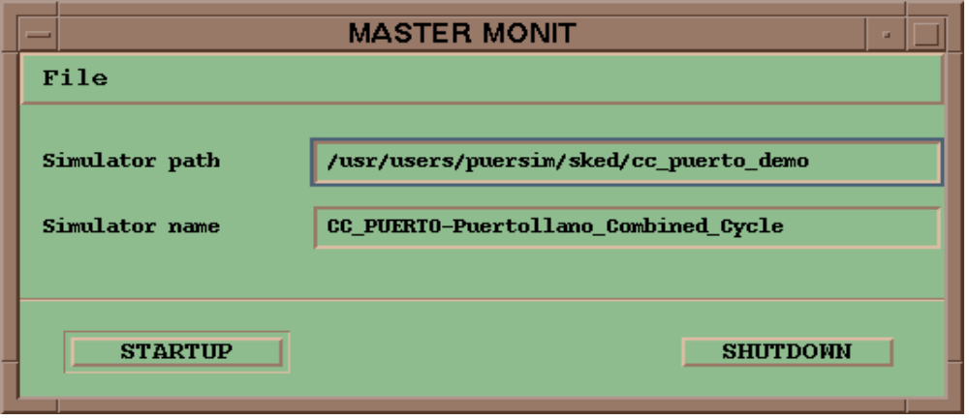
Figure 4-1 - Master Instructor Station interface

From this directory the simulator can be activated by typing the command :

startup
or
startup SUPERUSER to have access to superuser privileges

The MASTER INSTRUCTOR STATION interface will appear. It provides information related to the simulator currently going to be activated: the simulator path, i.e. the current directory, and the simulator name and description, as it has been written in the S01 file.

Simulator startup
The selection of the STARTUP pushbutton initiates the simulator startup procedure.
The MASTER INSTRUCTOR STATION interface is iconified and the MASTER MENU interface is displayed on the top of the screen.
This is the interface through which the instructor has the possibility to control the simulation.
During the startup, the Instructor Station activates all the processes involved in the simulation. This phase may take some minutes; while the simulator is not yet available the status display shows the STOP label and the buttons present in the interface are not available for actuation. Once the simulator is correctly activated, the status display switch to FREEZE and the pushbuttons become sensitive.

Simulator shutdown
There are two ways to terminate the simulation.
The selection of the SHUTDOWN pushbutton terminates the current session (i.e. stops all the simulation processes) and leave the MASTER INSTRUCTOR STATION interface available for the next startup.
The selection of the File -> Quit pushbutton, on the contrary, terminates definitively the simulator, including the instructor station interface. To initiate a new simulation session the instructor should retype the startup command.

master menu interface
The master menu is always present at the instructor station interface and allows to initiate all the functions provided by the instructor station.

Interface description

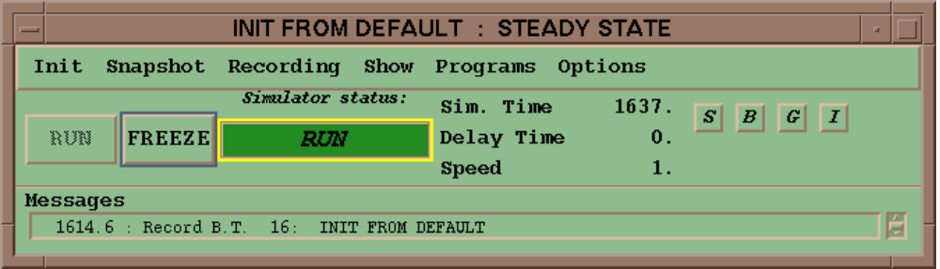
Figure 4-2 - Master Menu interface
The interface is divided in the following parts:

- a menubar, through which it is possible to initiate all the instructor station functions
- a two button command area, that give the possibility to run, freeze and step the simulator
- a display area, that shows the simulator current state, the simulation time, the delay time and the speed of the simulator
- a command area, that provides direct access to some of the instructor station functions
- a message list area, where are listed all the commands issued by the instructor
- the title bar that specifies the session title (as written by the instructor) and where the database was coming from (I.C., B.T. or steady state)

The commands provided by the menubar are:

Init -> | Speed ... | to set the desired simulator speed
Init -> | Max speed | to impose the maximum speed without delay
Init -> | Clear | to put the simulation time to zero, and clear all the recording files
Snapshot-> | Snapshot management | to activate the snapshot management interface
Recording -> | Backtrack management | to activate the backtrack management interface
Recording -> | Continuos recording | to access the C.R. menu
Continuos recording -> | Select variables | to activate the filter that allows the instructor to select the variables that are to be recorded by the C.R. function
Continuos recording -> | View recorded data | to activate the program that shows the recorded data in trend format
Show -> | Statistics | to activate the interface that shows the CPU time occupancy of all the simulator models
Programs -> | Xaing | to activate the filter that allows the instructor to select variables to be modified by the Xaing program
Programs -> | User programs ... | to show the list of the configured custom shell commands
Options -> | Edit | to initiate the interface that allows user configurations

In the command area are located four buttons:

“S” to activate the snapshot management interface
“B” to activate the backtrack management interface
“G” to activate the graphics program
“I” to activate the Xaing functionality

When the simulator is in RUN or REPLAY status, a frame situated around the status label will blink at the simulation executing frequency.

Interface operation
The master menu interface becomes available once the instructor has request the startup of the simulator. When popped up, the interface will show that the simulator is in the STOP state (because the models are non initialized yet), and the buttons are not available.
At the end of the initialization procedure the simulator goes in FREEZE status, the simulation time field shows the current time and the buttons become sensitive.
At that time the instructor can RUN the simulation starting from the steady state or from an I.C. or a B.T. (if any); if sessions were previously recorded, the REPLAY function is also available.

The selection of the buttons presented by the menubar will drive the instructor station to activate the available interfaces.

Exit the interface
The master menu interface is terminated by the Instructor Station interface when either the SHUTDOWN or Quit function is requested.

snapshot management
The function can be activated by clicking the Snapshot -> Snapshot Management button, or, more quickly, through the selection of the S button shortcut, both providing the initial condition interface to open.

Interface description

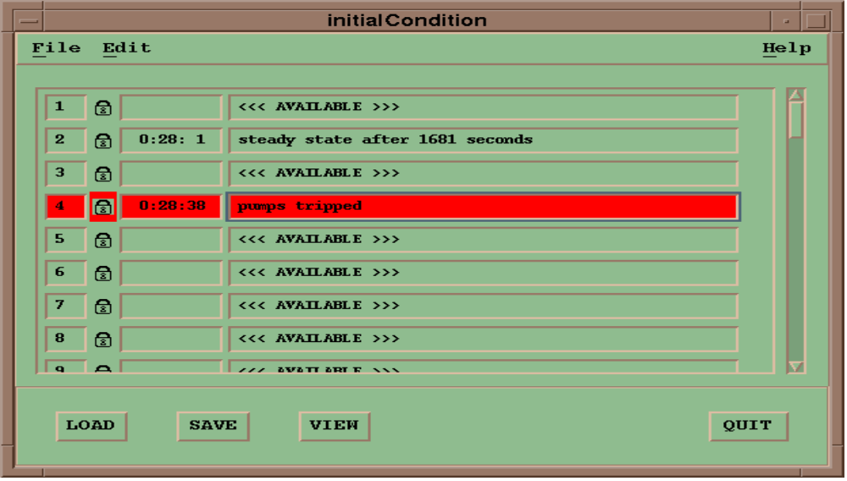
Figure 4-3 - Snapshot Management interface
The window shows five fields for each of the 60 possible Initial Conditions:

- the I.C. number
- the padlock, displayed if the I.C. is protected
- the simulation time at which the I.C. was snapped, or blank if the I.C. is available
- the comment the instructor entered when the I.C. was snapped, or the phrase <<< AVAILABLE >>> if the I.C. is not snapped
- the “previous topology” icon, if the snapshot was recorded before the last time the simulator has been compiled.

The bottom side of the window contains the following buttons:

- LOAD to load the selected I.C. in the simulator database, making it the starting point of a new training session
- SAVE to snap the present simulator database into the selected I.C.
- VIEW to initiate the conversation that allows to select and view the recorded values of patterns of simulator variables
- QUIT to terminate the Initial Condition interface

The same commands are available from a popup menu activated by clicking the rightmost mouse button while the pointer is in the snapshot list area.

More commands are provided via the menubar:

File -> | Quit | to terminate the Initial Condition interface
Edit -> | Cut | to free the selected I.C.
Edit -> | Copy | to copy the selected I.C. in a buffer
Edit -> | Paste | to copy the buffer filled by a previously executed Copy or Cut operation into the selected I.C.
Edit -> | Check | to accept as correct an I.C. tagged as possibly unaligned with the current simulator version

Interface operation
This interface is used to save, load and maintain a set of 60 simulator snapshots (Initial Conditions).

Saving Initial Conditions

The SAVE buttons are not available when:

- the simulator state is STOP or ERROR
- the I.C. selected as destination of the snapshot is protected by the padlock and the instructor is not SUPERUSER

and are available in all the other cases.

To save the simulator database into an I.C.:

- select a valid I.C. from the list
- click on one of the provided SAVE button
- answer to the warning message if the I.C. is busy
- enter the comment and push the SAVE button

The save initial condition protocol presents a warning message if a snapshot is already present in the destination I.C.. Choose the OK pushbutton to continue or the Cancel pushbutton to abort the operation.
Before the I.C. is actually saved the instructor is prompted to enter his own comment, that will be the phrase displayed in the comment field of the I.C. list. Choosing the SAVE pushbutton the operation will take place, while the QUIT pushbutton is the last chance the instructor has to abort the operation.
After the operation has been successfully executed the I.C. list is refreshed.

Loading Initial Conditions

The LOAD buttons are available when:

- the simulator is in the FREEZE state and a valid snapshot is recorded in the selected I.C. (snapshot recorded and not flagged as “previous topology”)

and are not available in all the other cases.

To load an I.C. into the simulator database:

- select a valid I.C. from the list
- click on one of the provided LOAD buttons

The function is immediately executed and the new content of the database can be explored by looking at the mimics interface.
The initial condition interface remain active for further operations.

Remove Initial Conditions

The CUT button is available when:

- the selected I.C. contains a valid snapshot and it is not protected by the padlock
- the selected I.C. contains a valid snapshot and the instructor has SUPERUSER privileges

and is insensitive in all the other cases.

To remove an I.C. from the list:

- select a valid I.C. from the list
- click on the Cut button
- answer to the warning message

The cut initial condition protocol presents a warning message. Choose the OK pushbutton to continue or the Cancel pushbutton to abort the operation.
After the operation has been successfully executed the I.C. list is refreshed.
The removed I.C. has been copied into an Instructor Station buffer, and is available for subsequent Paste operations.

Copy an Initial Conditions into the local buffer

The COPY button is available when:

- the selected I.C. contains a valid snapshot (snapshot recorded and not flagged as “previous topology”)

and is insensitive in all the other cases.

To copy an I.C. into the local buffer:

- select a valid I.C. from the list
- click on the Copy button

The function is immediately executed: the I.C. is copied into an Instructor Station buffer, and is available for subsequent Paste operations.

Paste the local buffer into an Initial Condition

The PASTE button is available when:

- the local buffer has been filled from a previously executed Cut or Copy operation and the selected I.C. is not protected by the padlock
- the local buffer has been filled from a previously executed Cut or Copy operation and the instructor has the SUPERUSER privileges

and is insensitive in all the other cases.

To paste the local buffer into an I.C.:

- fill the local buffer by copying or removing an I.C.
- select the destination I.C.
- click the Paste button
- answer to the warning message if the I.C. is busy

The paste I.C. protocol presents a warning message if a snapshot is already present in the destination I.C.. Choose the OK pushbutton to continue or the Cancel pushbutton to abort the operation.
After the operation has been successfully executed the I.C. list is refreshed.

Validation of “old topology” Initial Conditions

The check button is available when:

- the selected I.C. is flagged as “previous topology” and the instructor has the SUPERUSER privileges

and is insensitive in all the other cases.

To accept as valid a “previous topology” I.C.:

- select a flagged I.C.
- click on the Check button
- answer to the warning message

The Check I.C. protocol presents a warning message. Choose the OK pushbutton to continue or the Cancel pushbutton to abort the operation. After the operation has been successfully executed the I.C. list is refreshed. The “previous topology” flag is not present anymore and the I.C. is available for normal operations.

View the variables value recorded into an Initial Condition

The VIEW buttons are available when:

- a valid snapshot is recorded in the selected I.C. (snapshot recorded and not flagged as “previous topology”)

and are not available in all the other cases.

To inspect the values of the recorded variables:

- select a valid I.C.
- click on one of the provided VIEW buttons

At this time a new window will appear that shows the values of up to 10 variables. From this interface the instructor can configure and select different patterns of variables using a filter function. See the appropriated paragraph to know more about this interface.

Exit the dialog

To close the interface select one of the QUIT buttons provided by the interface.

View interface

This function allows the instructor to read the value of all the simulator variables as they are recorded into a snapshot or backtrack record.

The interface is activated selecting one of the VIEW buttons provided in the snapshot and backtrack management interfaces.
The instructor can have any number of VIEW INTERFACES opened at any given time.

Interface description

The window shows the values of up to 10 variables and the title bar specifies what I.C. or B.T. record they are related to.
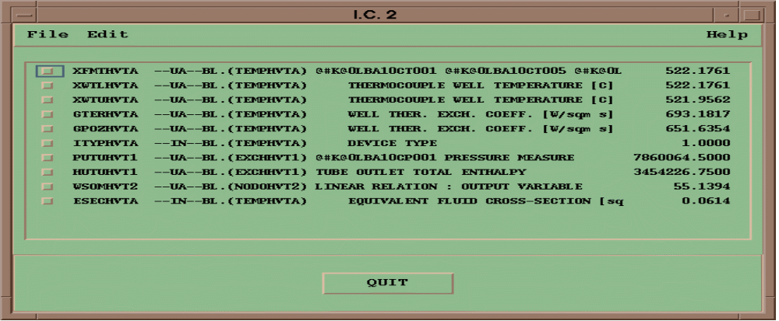
Figure 4-4 - View interface

The menubar provides the following commands:

File -> | Open default | to select the default configuration file
File -> | Open ... | to open an alternative configuration file
File -> | Save default | to save the current configuration as the default one
File -> | Save as ... | to save the current configuration in a selectable file
File -> | Quit | to terminate the VIEW interface
Edit -> | Select new ... | to activate the filter that allows the instructor to select variables for the VIEW interface
Edit -> | Cut | to remove a selected entry from the list
Edit -> | Clear all | to clean the list

Interface operation

Deleting items from the list

To remove one variable at a time from the displayed list:

- select an entry clicking the toggle button at the left side of the window
- click on the Cut button

The list will be immediately updated.

To clean the entire list:

- click on the Clear all button

The list will be immediately updated.

Selecting new variables

To select new variables to fill the displayed list:

- activate the filter selecting the Select new ... button
- select a position in the list clicking the toggle button at the left side of the window
- choose a variable in the filter interface
- push the SELECT button in the filter interface

The list will be immediately updated.

The selection is rejected if no position in the list is selected.
No protection exists against the replacement of occupied position in the list.
See the appropriated paragraph to know more about this interface.

Saving the configuration files

The present set of variables can be stored in a file for future use; to make it the default set (i.e. the one first accessed when calling the interface):

- click on the Save default button

To save the set present on display:

- click on the Save as ... button to activate the file selection interface
- enter a new file name or select an existent one if it is desired to overwrite that file
- select OK on the file selection interface

It is recommended to respect the termination suggested by the interface.

Opening the configuration files

The list of the variables the values of which are to be displayed is stored in a default file by the instructor station.
However, the instructor has the possibility to save different sets of variables in different files.

To load the default configuration file:

- push the Open default button

The list will be immediately updated.

To load an instructor configured pattern of variables:

- push the Open ... button to activate the file selection interface
- choose a valid file from the list
- select OK in the file selection interface

The list will be immediately updated.

Exit the dialog

To close the interface select one of the QUIT buttons provided by the interface.

Filter for VIEW interface
This interface is activated from the Select New button of a VIEW interface; it allows the selection of variables among the entire database for the VIEW interface.

Interface description

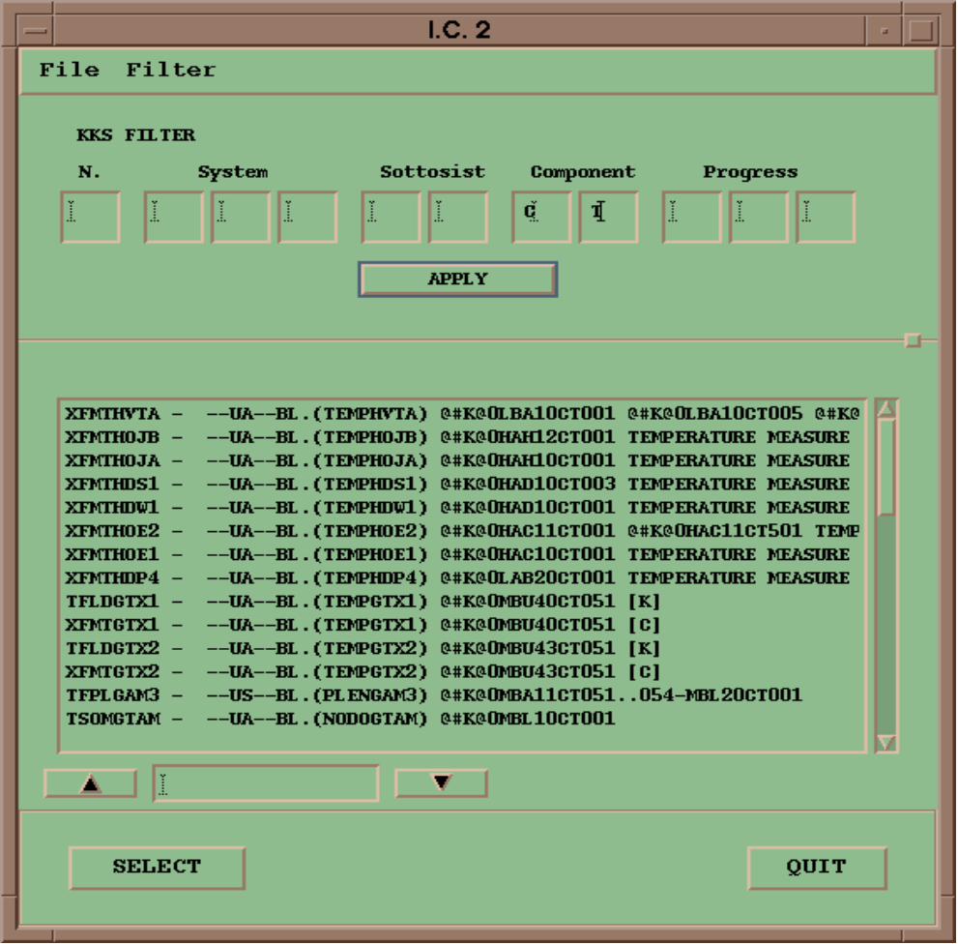
Figure 4-5 - Filter interface for View Function
The interface is divided into 4 main zones:

- the menubar
- the filter area
- the variables list area
- the command area

The commands provided by the menubar are:

File -> | Quit | to terminate the interface
Filter -> | All variables | to keep variables of all the models
Filter -> | models & blocks | to provide filtering by models & blocks
Filter -> | models only | to provide filtering by model
Filter -> | KKS filter | to provide filtering by KKS tag
Filter -> | by type | to provide filtering by type of variable (temperature, pressure, etc)

The filter area presents the filters currently selected.

The variable list area lists all the variables that currently satisfy the filter selection criterion. Furthermore, a “find” function is available for string search.

The command area presents two buttons:

- SELECT to transfer the selected variable to the VIEW list
- QUIT to terminate this dialog

Interface operation

Variable selection

The interface is activated with the KKS filter activated by default; in that way all the variables of the simulator that have been tagged with a KKS label are displayed. Further selection among the displayed variables is possible by typing characters in the KKS FILTERS fields and clicking on the APPLY button.

Using the menubar, the instructor can activate the Models & Blocks filter or the Models Only filter (they are both alternatives to the All Variables default filter).
In the first case the lists of the models constituting the simulator is displayed along with, for each model, the list of the respective blocks. At the bottom of the Blocks list a “find” function is provided for string search.
In the latter case it is displayed the list of the models only.

The activation of the By Type filter makes available the part of the interface that allows to restrict the visibility to the variables that match the type selection (no type selected means no filter applied); further selection is available filtering by Input, Output and Not connected input variables. The APPLY button starts the procedure that updates the variables list area.

The selection is made at the variables list area, eventually using the provided “find” function, clicking on the desired item of the list.

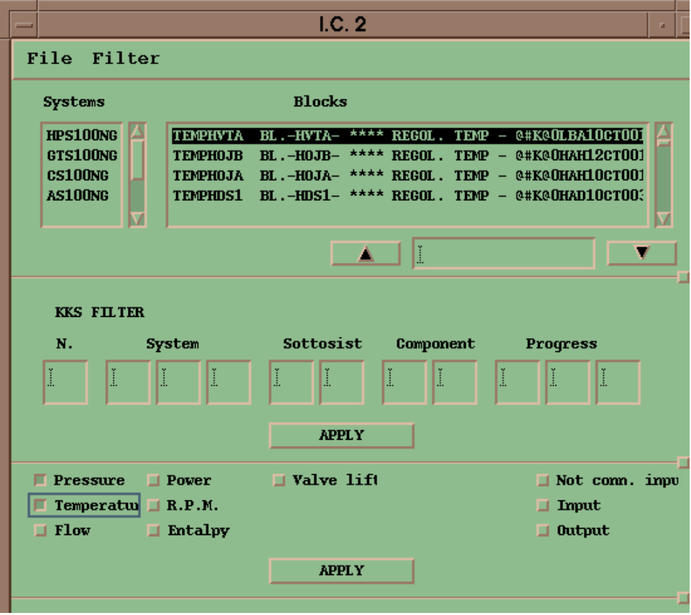
Figure 4-6 - All the filters applied
The SELECT button transfers the selected variable to the tagged entry of the VIEW interface.

Exit the dialog

To close the interface select the QUIT button provided by the interface.

Backtrack management
This is the interface through which the instructor can go back to previous sessions, access data recorded in the backtrack snapshots automatically recorded, load the backtrack snapshots themselves for restart the simulation or to “replay” the recorded sessions.
It is activated by clicking the Recording -> Backtrack Management button, or, more quickly, through the selection of the B button shortcut in the master menu interface.

Interface description

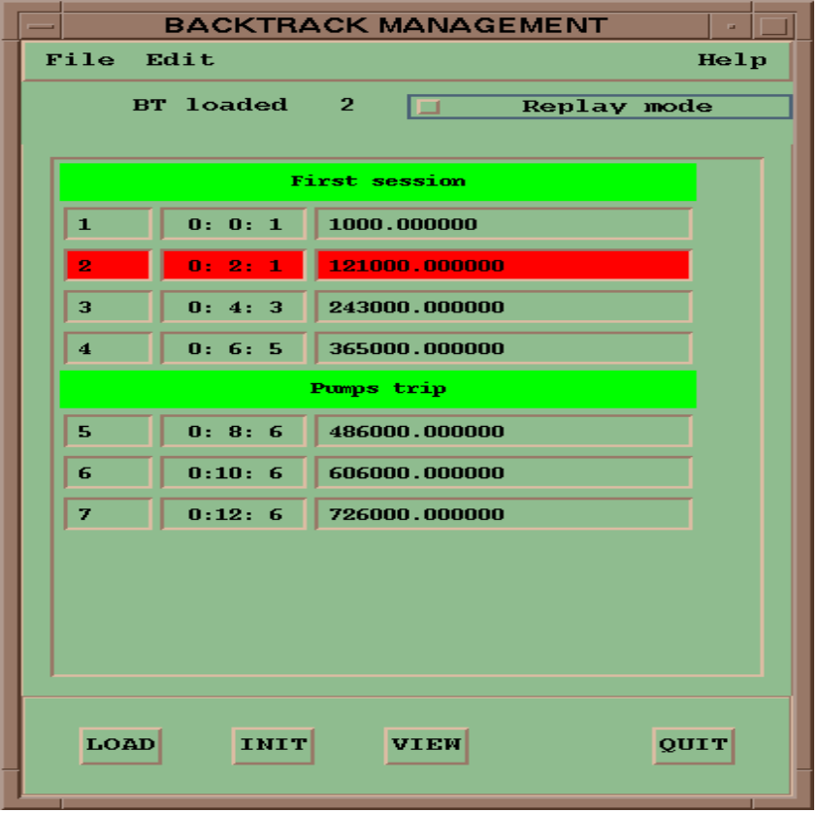
Figure 4-7 - Backtrack Management interface
The interface is divided into 4 zones:

- the menubar
- the replay area
- the backtrack snapshots scrolling list
- the command area, at the bottom side of the window

The command area contains the following buttons:

- LOAD to load the selected backtrack in the simulator database
- INIT to validate the last loaded backtrack as the one that will be the starting point of a new training session
- VIEW to initiate the conversation that allows to select and view the recorded values of patterns of simulator variables
- QUIT to terminate the interface

The same commands are available from a popup menu activated by clicking the rightmost mouse button while the pointer is in the backtrack list area.

The menubar provides the following commands:

File -> | Quit | to terminate the interface
Edit -> | Timer Recording | to modify the time between the automatic snapshots

The replay area shows which backtrack was last loaded, either manually, or automatically by the replay function, and a button that permits to activate and deactivate the simulator replay function.

Interface operation
The interface is used to view and load backtrack snapshots, for purposes of initialize new sessions or to replay recorded sessions.
The interface is not available when no records are recorded in the backtrack file.

Loading backtrack records

The LOAD buttons are available when:

- the simulator is in the FREEZE, RUN or BACKTRACK state and a backtrack record is selected on the list.

To load a backtrack snapshot into the simulator database:

- select a backtrack record from the list
- click on one of the provided LOAD buttons

The request activates the following sequence:

- the simulator state is switched to FREEZE
- the current simulator database is saved on I.C. n. 60 (default snapshot)
- the simulator state is switched to BACKTRACK
- the selected backtrack snapshot is actually loaded
- the backtrack interface is updated

Initializing from a backtrack snapshot

The INIT buttons are available when:

- a backtrack snapshot has been successfully loaded into the simulator database and the simulator is in BACKTRACK state

To initialize the simulator from a backtrack snapshot:

- click on one of the provided INIT buttons

This causes the interface to close and the simulator state to switch to the FREEZE state.

View the variables value recorded into a backtrack snapshot

The VIEW buttons are available when:

- a backtrack snapshot is currently selected from the list

To inspect the values of the recorded variables:

- select a backtrack snapshot
- click on one of the provided VIEW buttons

At this time a new window will appear that shows the values of up to 10 variables. From this interface the instructor can configure and select different patterns of variables using a filter function. See the appropriated paragraph to know more about this interface.

Restoring the previous session
The instructor has the possibility to restore the session left before entering BACKTRACK mode.
The function is activated by the selection of one of the QUIT buttons after at least one backtrack snapshot has been loaded (the original database has been replaced).
The protocol presents a warning that advise the instructor. Choose the OK pushbutton to continue or the Cancel pushbutton to abort the operation.
If confirmed, the function replaces the current simulator database with the I.C. n. 60 (the one recorded when first entered the BACKTRACK state), and the simulator state is switched to FREEZE.

Changing the recording frequency

It is given the possibility to modify the interval at which the instructor station triggers the recording of the backtrack snapshots.
The function is activated by clicking the Edit -> Timer Recording button: an interface is opened with the current value of the interval.
The instructor can modify that value and click the OK button to activate the new value.

Replay mode

The replay button is available whenever a backtrack snapshot has been loaded into the simulator database.

To activate the replay mode:

- load a backtrack snapshot
- click on the Replay Mode button

The simulator state switches from BACKTRACK to REPLAY state. In this state the models are running, the frame around the status label on the master menu interface is blinking, and all the commands that the models received during the previously recorded session are repeated to the simulator at the appropriated time.

While in this state the automatic recording functions are inhibited and the users should avoid the use of the commands.

The replay mode terminates automatically at the end of a session, or when the instructor toggles the Replay Mode button; at this point the simulator state switch back to BACKTRACK.

Exit the dialog

There are three ways to terminate the interface:

- using the INIT buttons, to initiate a new session starting from a backtrack snapshot
- using the QUIT buttons after a backtrack snapshot has been loaded, to restore the previous session
- using the QUIT buttons before loading of a backtrack snapshot to simply quit the interface

Continuos recording
The continuos recording is the automatic function that records the values of a instructor defined set of variables. The recorded values are displayed by the program Graphics in trend format.
The functions that the instructor station provides are basically two:
- the possibility to maintain the list of the recorded variables
- the possibility to activate the trend program

Activation of the trend program
The trend program (Graphics) can be activated selecting the Recording -> View Recorded Data button or, more quickly, selecting the G button on the Master Menu interface.
A dialog is initiated that allows to select the destination display for the program. Choose the Continue pushbutton to go ahead or the Quit pushbutton to abort the operation.
Using the interface of the trend program the instructor can select and group the recorded variables, modify the engineering units and the limits.

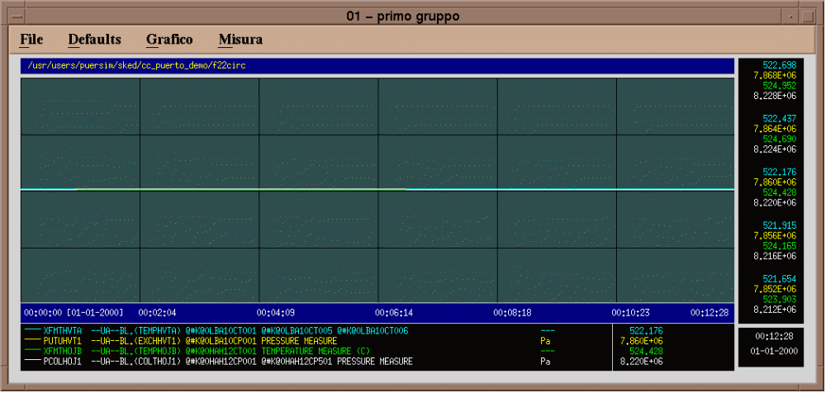
Figure 4-8 - The graphics program interface

Filter for configuring the recorded variables
The interface is activated selecting the Recording -> Select Variables button from the master menu interface; it allows the selection of variables among the entire database.

Interface description

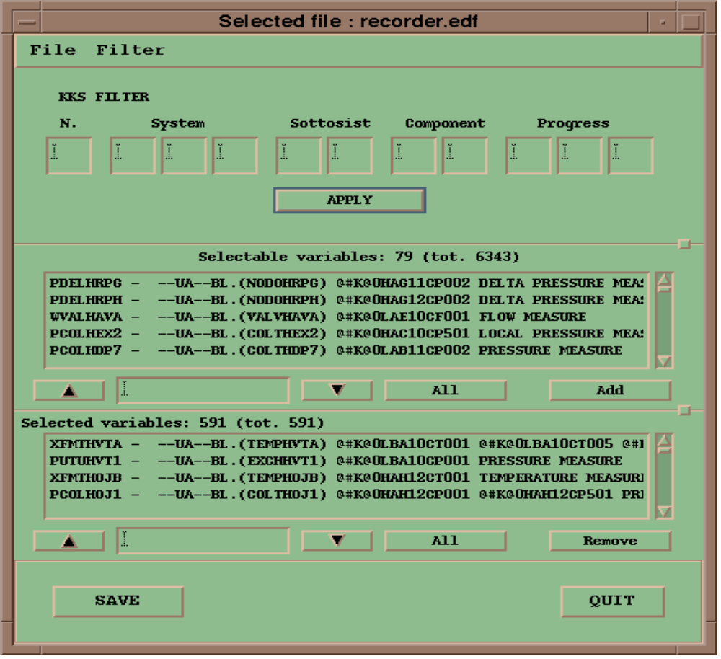
Figure 4-9 - Filter for Cont. Recording function
The interface is divided into 6 main zones:

- the title bar
- the menubar
- the filter area
- the selectable variables list area
- the selected variables list area
- the command area

The title bar informs about the currently loaded configuration file.

The commands provided by the menubar are:

File -> | Load ... | to activate an interface that allows to choose an instructor configured file for loading into the interface
File -> | Save ... | to activate an interface that allows to save the current configuration into an instructor selectable file
File -> | Quit | to terminate the interface
Filter -> | All variables | to keep variables of all the models
Filter -> | models & blocks | to provide filtering by models & blocks
Filter -> | models only | to provide filtering by model
Filter -> | KKS filter | to provide filtering by KKS tag
Filter -> | by type | to provide filtering by type of variable (temperature, pressure, etc)

The filter area presents the filters currently selected.

The selectable variables list area lists all the variables that are not selected yet and that satisfy the filter selection criterion.

The selected variables list area lists all the variables that are already selected and that satisfy the filter selection criterion.

The command area presents two buttons:

- SAVE to make active the current selection
- QUIT to terminate the interface

Interface operation

Filter selection

The interface is activated with the KKS filter activated by default; in that way all the variables of the simulator that have been tagged with a KKS label are displayed. Further selection among the displayed variables is possible by typing characters in the KKS FILTERS fields and clicking on the APPLY button.

Using the menubar, the instructor can activate the Models & Blocks filter or the Models Only filter (they are both alternatives to the All Variables default filter).
In the first case the lists of the models constituting the simulator is displayed along with, for each model, the list of the respective blocks. At the bottom of the Blocks list a “find” function is provided for string search.
In the latter case it is displayed the list of the models only.

The activation of the By Type filter makes available the part of the interface that allows to restrict the visibility to the variables that match the type selection (no type selected means no filter applied); further selection is available filtering by input, output and not connected input variables. The APPLY button starts the procedure that updates the variables list area.

Adding variables

The selectable variables list area lists all the variables that satisfy the filters criterion and that are not selected for recordings.
New variables can be added to the list of the recorded ones by selecting them from the list.

It is possible to select items in the list in several ways:

- with a single selection, selecting the desired variable using the mouse
- with a multiple selection using the mouse, clicking on the first of a contiguous block of variables and dragging the mouse up to the last one of the block
- with a multiple selection using the mouse and the keyboard; the use of Ctrl key allows for selection of non contiguous blocks
- using the All button, that selects all the variables matching the “find” field, if not empty, or all the variables in the list if empty

The Add button activates the function that updates the displayed lists.

Removing variables

The selected variables list area lists all the variables that satisfy the filters criterion and that are selected for recordings.
Entries can be eliminated from the list of the recorded variables by selecting them from the list.

It is possible to select items in the list in several ways:

- with a single selection, selecting the desired variable using the mouse
- with a multiple selection using the mouse, clicking on the first of a contiguous block of variables and dragging the mouse up to the last one of the block
- with a multiple selection using the mouse and the keyboard; the use of Ctrl key allows for selection of non contiguous blocks
- using the All button, that selects all the variables matching the “find” field, if not empty, or all the variables in the list if empty

The Remove button activates the function that updates the displayed lists.

Saving and loading sets of variables

Once the list of the recorded variables has been configured, it can be saved for future use in an instructor defined file clicking the File -> Save ... button. An interface is opened that provides the possibility to choose the destination file.

A previously saved file can be loaded clicking the File -> Load ... button. An interface is opened that provides the possibility to choose the source file.

Replacing the current set

To immediately activate the selections made by the interface the instructor is required to select the LOAD button from the command area. This request activate a procedure that:

- updates the files recorder.edf/rtf (the ones that the continuos recording function looks for when initializing)
- reinit the program that actually records the data with the new set of variables (a maximum of 1000 variables is permitted)
- rearrange the f22circ.hd and f22circ.dat files for the new configuration

This procedure take time depending on the differences between the original and the final set of data.

Exit the dialog

To close the interface select one of the QUIT buttons provided by the interface.

Show statistics
This interface shows the CPU time used by each one of the models while in RUN state.

Interface description

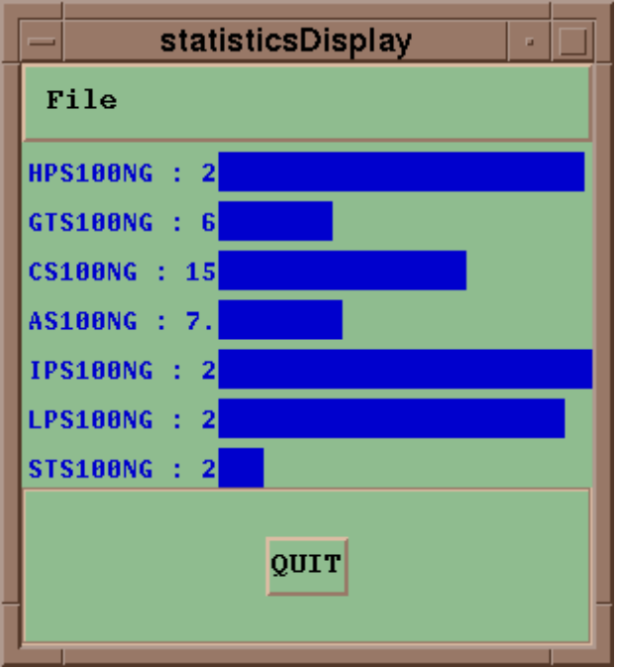
Figure 4-10 - The statistics interface
The interface shows, for each model, the name and the milliseconds spent during the last simulation cycle. A bar graph allows graphical comparison among tasks.

Interface operation
The interface can be opened selecting the Show -> Statistic button on the Master Menu interface. The displayed values are continuously refreshed.

Exit the dialog

To close the interface select one of the QUIT buttons provided by the interface.

program activation
The function allows the instructor to activate programs such as the Xaing, to manipulate input variables, and the user configured commands.

Xaing activation
The selection of the Programs -> Xaing button or, more quickly, the selection of the I button, on the Master Menu interface causes the interface activation.

Interface description

The interface is divided into 4 main zones:

- the menubar
- the filter area
- the variables list area
- the command area

The commands provided by the menubar are:

File -> | Quit | to terminate the interface
Filter -> | All variables | to keep variables of all the models
Filter -> | models & blocks | to provide filtering by models & blocks
Filter -> | models only | to provide filtering by model
Filter -> | KKS filter | to provide filtering by KKS tag
Filter -> | by type | to provide filtering by type of variable (temperature, pressure, etc)

The filter area presents the filters currently selected.

The variable list area lists all the variables that currently satisfy the filter selection criterion. Furthermore, a “find” function is available for string search.

The command area presents two buttons:

- SELECT to actuate the selected variable
- QUIT to terminate this dialog

Interface operation

Variable selection

The interface is activated with the KKS and the By Type filters activated by default; the By Type filter is locked on the Not Connected Input selection. In that way all the not connected input variables of the simulator that have been tagged with a KKS label are displayed. Further selection among the displayed variables is possible by typing characters in the KKS FILTERS fields and clicking on the APPLY button.

Using the menubar, the instructor can activate the Models & Blocks filter or the Models Only filter (they are both alternatives to the All Variables default filter).
In the first case the lists of the models constituting the simulator is displayed along with, for each model, the list of the respective blocks. At the bottom of the Blocks list a “find” function is provided for string search.
In the latter case it is displayed the list of the models only.

The By Type filter, always active, makes available the part of the interface that allows to restrict the visibility to the variables that match the type selection (no type selected means no filter applied). The APPLY button starts the procedure that updates the variables list area.

The selection is made at the variables list area, eventually using the provided “find” function, clicking on the desired item of the list.
The SELECT button activate the Xaing program for the selected variable.

Exit the dialog

To close the interface select one of the QUIT buttons provided by the interface.

User programs activation

The selection of Programs -> User Programs ... button on the Master Menu opens the interface that shows the list of the user configured commands.

Interface description

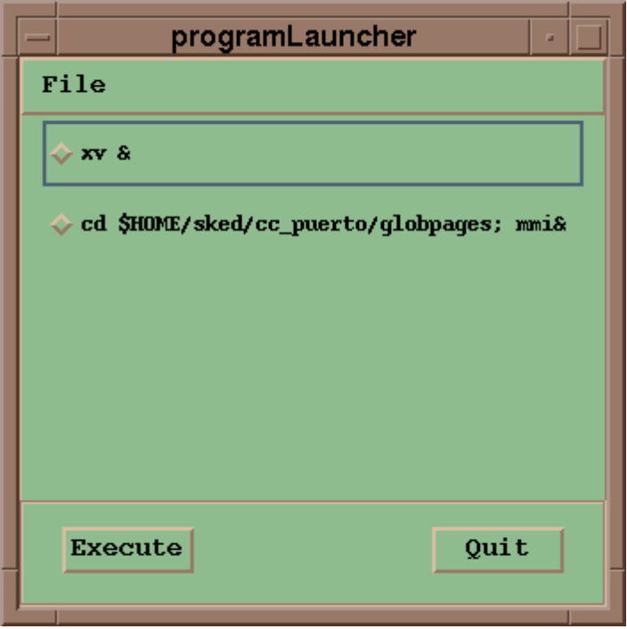
Figure 4-11 - User Program Activation interface
The interface is divided into 3 main zones:

- the menubar
- the commands list area
- the command area

The menubar provide the following command:

File -> | Quit | to terminate the interface

The command list area lists the configured commands. When a command is selected, the diamond shape symbol at the left side of the entry will figure pushed.

The command area presents two buttons:

- Execute to actuate the selected command
- Quit to terminate the interface

Interface operation

To activate a command:

- select one of the user configured commands showed by the interface
- click on the Execute button

Exit the dialog

To close the interface select one of the QUIT buttons provided by the interface.

options configuration
The interface is activated selecting the Options -> Edit button on the Master Menu. This configurator give the possibility to customize part of the graphical interface.

Interface description
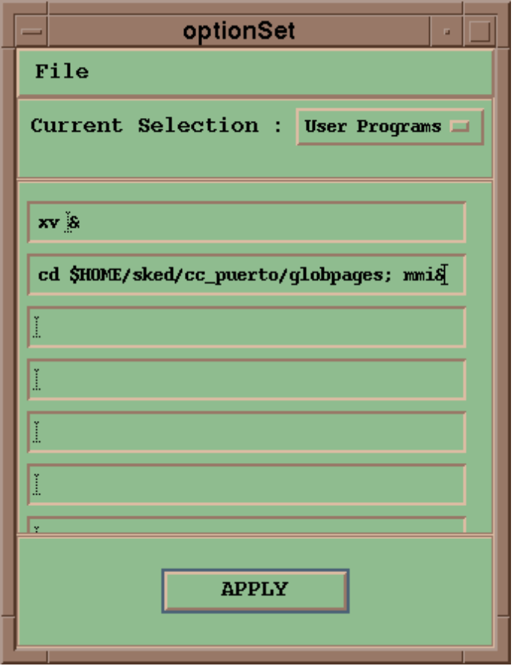
Figure 4-12 - Option Selection interface

The window is divided into 4 main parts:

- the menubar
- the item selection area
- the option selection area
- the command area

The menubar provide the following commands:

File -> | Save | to save the current configuration on the default file
File -> | Load | to load the default file
File -> | Quit | to terminate the interface

The item selection area shows an option menu that permits to select the item for customization.

The option selection area, show the options applicable to the selected item

The command area is constituted by the APPLY button, for instantaneous application of options.

Interface operation

Modify the current options

To modify the currently active options:

- select the item to be modified in the item selection area
- modify the options presented in the option selection area

The possibility given by the present version of the Instructor Station are:

Area | Function or Menu affected
Initialization | availability of the Clear button
Snapshot Management | availability of the Snapshot menubar option
 | availability of the Cut & Paste buttons
 | availability of the Copy & Paste buttons
I.C. protection | Selection of the protected I.C.
Recording | availability of the Recording menubar option
 | availability of the Backtrack button
 | availability of the Continuos recording button
Tasks performance | availability of the Show menubar option
Display selection | possibility to declare up to five possible screens where the continuos recording trends can be displayed
User programs | possibility to declare up to eight shell commands that will be available through the Programs menu

Init options

The toggle buttons presented are:

Clear | to configure or remove the Clear button from the Master Menu

Using this option the instructor can avoid the lost of recorded data (the clear function zeroes the simulation time and clear all the recording files).

Snapshot options

The toggle buttons presented are:

Active | to configure or remove the Snapshot button from the Master Menu
Cut & Paste | to configure or remove the Cut and Paste buttons from the Snapshot interface
Copy & Paste | to configure or remove the Copy and Paste buttons from the Snapshot interface

Through this option it is possible to inhibit the deletion and the rearrangement of snapped I.C..
The Snapshot entry on the Master Menu manubar can also be removed (use the S button, rather).

protection options

This option is available for the superuser only.
The interface allows to choose, among all the I.C., the ones that will be protected against destruction by non superuser instructor.
The I.C. from 1 to 10, the 59 and 60 are hard protected by the software.

Recording options

The toggle buttons presented are:

Active | to configure or remove the Recording button from the Master Menu
Backtrack | to configure or remove the Backtrack button from the Master Menu
Continuos Recording | to configure or remove the Continuos Recording button from the Master Menu

The Continuos Recording entry on the Master Menu manubar can be removed; this prevents the possibility to modify the list of the recorded variables while leaving the possibility to activate the Graphics program (G button).
The Backtrack entry on the Master Menu manubar can also be removed (use the B button, instead).

Display options

The interface allows to enter up to 5 available displays for output the Graphics program. The configured displays are selectable at the time the Graphics program is started.

User programs option

The interface allows to enter up to 8 UNIX shell commands. The configured commands are activable using the Programs option in the Master Menu.
Attention must be paid to the environment the commands are to be executed: if a configured command executes for a long time (a program that executes compilation, a program that opens graphical interfaces, etc), is to be executed in the background environment. On this purpose terminate the command with the “&” character.

Application of the current options

To apply the current options, click on the APPLY button when the options selection area displays the modified options. The modifications that apply to the Master Menu interface are immediately visible.
Modifications do not apply to an already opened interface: to activate the modification first close the interface, then call it again.

Saving the current options

To save the configuration select the File -> Save button.
The modified configuration is saved into the file read by the instructor station at startup.

Loading the default configuration

To load the default configuration file select the File -> Load button.
The interface closes, and the default values are restored.

Exit the dialog

To close the interface select one of the QUIT buttons provided by the interface.

Appendix

User environment configuration

The user environment is configured by executing the .profile file. The following is a sample of such a file.

# modulo .profile
# tipo
# release 1.11
# data 94/12/23
# reserved @(#).profile 1.11
#
#############################################################
#
# Sezione dedicata alle variabili di LEGOCAD.
#
#############################################################
#
# COMPLETARE !!!!!!!!!!!!!!!!!!!!!!!!!!!
#
export OLD_SKED="NO"
export LEGOROOT="/usr/users/sked2"
export LEGOSUP="."
export EASEROOT=""
export VERSIONE="-DENEL_CRA"
export MOTIF_VER="11"
export BANCO_FILES="." #directory per la memorizzazione files bi
PS1='! $PWD> '
export PS1
#
#############################################################
if [ -f /etc/scologin ]
then
export OS=SCO_UNIX
fi
if [ -d "$LEGOROOT" ]
then
if [ "$OS" != "SCO_UNIX" ]
then
echo DIRECTORY LEGOROOT: $LEGOROOT
. $LEGOROOT/install/user.profile
fi
else
echo DIRECTORY $LEGOROOT non ESISTENTE !!!!
fi
if [ -d "$LEGOSUP" ]
then
echo DIRECTORY LEGOSUP: $LEGOSUP
export PATH=$PATH:$LEGOSUP/install
else
echo DIRECTORY $LEGOSUP non ESISTENTE !!!!
fi
if [ "$OS" = "AIX" ]
then
if [ -d "$EASEROOT" ]
then
echo DIRECTORY EASEROOT: $EASEROOT
. $EASEROOT/install/user.profile
else
echo DIRECTORY $EASEROOT non ESISTENTE !!!!
fi
PATH=$PATH:$HOME/bin:.
if [ $TERM = "hft" ]

then

open ksh

open xinit # Lancio X_Window con parametri adeguati

fi

fi
if [ "$OS" = "ULTRIX" ]
then
tty -s
if test $? = 0
then
stty dec crt
fi
PATH=$PATH:$HOME/bin:/usr/ucb:/bin:/usr/bin:/usr/local/bin:/usr/new:/usr/hosts:.
MAIL=/usr/spool/mail/$USER
tset -n -I
export TERM MAIL PATH
biff n
fi
if [ "$OS" = SCO_UNIX ]
then
if [ -z "$LOGNAME" ]; then
LOGNAME=`logname` # name of user who logged in
export LOGNAME
fi
PATH=$PATH:/usr/bin/X11:.
MAIL=/usr/spool/mail/$LOGNAME # mailbox location
export MAIL
if [ -z "$PWD" ]; then
PWD=$HOME # assumes initial cwd is HOME
export PWD
fi

if [ -f $HOME/.kshrc -a -r $HOME/.kshrc ]; then
ENV=$HOME/.kshrc # set ENV if there is an rc file
export ENV
fi

# use default system file creation mask (umask)

#eval `tset -m ansi:ansi -m $TERM:\?${TERM:-ansi} -r -s -Q`

# If job control is enabled, set the suspend character to ^Z (control-z):
case $- in
*m*) stty susp '^z'
;;
esac

set -o ignoreeof # don't let control-d logout

case $LOGNAME in # include command number in prompt
root) PS1="uc15_root_!# " ;;
*) PS1="un15_$LOGNAME> " ;;
esac
export PS1

/usr/bin/prwarn # issue a warning if password due to expire

fi
if [ "$OS" = VMS -o "$OS" = OSF1 ]
then
echo spazio per personalizzazioni
fi
# Inserire dopo questa linea, le eventuali modifiche dell'utente
# fine modifiche utente
if [ "$OS" = OSF1 ]
then
export PATH=/usr/opt/ultrix/usr/bin:/usr/local/bin:$PATH
export F_FLAGS="$F_FLAGS -synchronous_exceptions -g"
export LEGOCAD_EMM=YES
fi
if [ $OS = "ULTRIX" ]
then
echo csh
fi
if [ "$OS" = VMS -o "$OS" = SCO_UNIX -o "$OS" = OSF1 ]
then
echo spazio per personalizzazione
export LEGO_BACK=/usr/users/puerback
fi
export DEBUG=YES
PATH=$PATH:$HOME/bin:.
alias sim="cd ~/legocad/hps100NG"
if [ $OS = "AIX" ]
then
xrdb -load .Xdefaults
fi

Interface resource settings
When the user logs into the Instructor Station machine, the graphical environment is set up by the directive contained the .Xdefaults file located in the user home directory.
The contents of this file is listed here.

!Start of the Instructor Station configuration
banco*Background: DarkSeaGreen
banco*fontList: -*-courier-bold-r-*-*-14-*
banco*masterMenu*labelStatusHead*fontList: -*-courier-bold-o-*-*-12-*
banco*masterMenu*tastieraMaster*fontList: -*-courier-bold-o-*-*-14-*
banco*masterMenu*labelStatus*fontList: -*-courier-bold-o-*-*-18-*
banco*areaMessaggi.fontList: -*-courier-medium-r-*-*-12-*
banco*attenzioneDialog*fontList: -*-courier-bold-r-*-*-20-*
banco*previewSnap*viewRc*fontList: -*-courier-bold-r-*-*-12-*
banco*topLevelShell1*bulletinBoard1*fontList: -*-courier-bold-r-*-*-12-*
banco*selVar*form40*fontList: -*-courier-bold-r-*-*-12-*
banco*selVar*selByModelForm1*fontList: -*-courier-bold-r-*-*-12-*
banco*selVarCr*panedWindow1*fontList: -*-courier-bold-r-*-*-12-*
banco*selVar*panedWindow2*fontList: -*-courier-bold-r-*-*-12-*
banco*statisticsDisplay*drawingArea1*fontList: -*-courier-medium-r-*-*-12-*
banco*selezMalf*fontList: -*-courier-bold-r-*-*-12-*
banco*initialCondition*IcRc*fontList: -*-courier-bold-r-*-*-12-*
banco*backtrackManagement*BtRc*fontList: -*-courier-bold-r-*-*-12-*
banco*scenarioMalf*scenMalfRc*fontList: -*-courier-bold-r-*-*-12-*
banco*optionSet*optionSetForm*fontList: -*-courier-bold-r-*-*-12-*
banco*optionSet*optSelectionMenu*fontList: -*-courier-bold-r-*-*-12-*
banco*programLauncher*rowColumn4*fontList: -*-courier-bold-r-*-*-12-*
!End of the Instructor Station configuration

MMI activation
To activate the mmi interface on the instructor station machine:

- log in whit the same account used to startup the simulator
- change directory to the location where the mmi pages are located (i.e. $HOME/sked/cc_puerto/globpages)
- type mmi &

Alternatively, a command such the following can be configured with the options interface:

- cd $HOME/sked/cc_puerto/globpages ; mmi &

This command will have the same effect of the previous procedure.

To activate the mmi interface on a machine other the instructor station:

- log in the machine with the correct account
- change directory to the location where the mmi pages are located (i.e. $HOME/sked/cc_puerto/globpages)
- type mmi &

The Host field of the Context.ctx file located in the mmi directory should contain the name of the machine running the simulation.

Manual shutdown

Should the normal procedure fail to shutdown the simulator (due to UNIX problems), follow this manual list:

- log in whit the same account used to startup the simulator
- execute the command killsim
- check if there are simulation process still active; if any, kill them using the kill UNIX function

