SUMMARY

LEGOCAD is an interactive tool that allows LEGO developer to create and manage dynamic models.
It handles all phases of model development (described in Model construction area of LEGOCAD main window) from model topological definition to dynamic simulations analysis.

HOW TO
Set up LEGOCAD
Librarian
Select operating mode
Open/Create a model
Define model's Topology
Insert numeric data
Recover numeric data (edi14)
Calculate Steady State
Run simulations (Transient Calc)
View Graphical results (Trends)
Use water-steam tables
Documentation

LEGOCAD MAIN WINDOW LAYOUT
Pulldown menu
Legocad environment area
Model construction arealgc_mw_costruction
Utilities arealgc_mw_utilities
Message area

LEGOCAD: set-up

Definition of some environment variables is needed for correct use of LEGOCAD tool. A sample .profile file is provided for LEGOCAD users.
LEGOROOT environment variable contains legocad installation directory's path name; this variable can be modified accordingly to the particular LEGOCAD installation.
LEGOCAD_USER environment variable contains LEGOCAD user directory's path name; it defaults to HOME variable. In this way legocad user directory is the user login directory.
You can override this default setting redefining in .profile LEGOCAD_USER variable (N.B. definition must be inserted after the $LEGOROOT/install/user.profile call).

N.B. Modification of .profile file is suggested only if you are familiar with system management otherwise contact system manager.

Next step in LEGOCAD set-up consists of the use of LIBRARIAN utility for the creation or copy from standard ones of the following libraries :
1. process modules library (for process modelling)
2. control modules library (for control modelling)
3. graphic icons (for diagram interface use).

LEGOCAD: operating mode

LEGOCAD provides two different operating mode: symbolic diagram and only by lists.
Symbolic diagram operating mode allows the use of a schematic representation (diagram) of the model internal structure. All user operations are accessed by selection of model components on the diagram. Typical windows displayed are diagram page's index and model diagram page (with the diagram).
Use of LEGOCAD by lists is provided for compatibility with models developed with previous versions of LEGOCAD: user operations on models are accessed via selections on scrolled lists.
You can set Operating Mode selecting from LEGOCAD main window's pull down menu (Display button) one of the following options :
Symbolic diagram
Only by list

LEGOCAD: open & create a model

To create/open a new model select process modelling, control system modelling or mixed system modelling from File pulldown menu depending on model type you have to build (or modify).
A list of all legocad models owned by the user (i.e. created in LEGOCAD user directory ) is displayed.
You can select one of the models listed or specify a new model name in the text field below.
Additional information on models listed (model description, list of LEGO modules used, auxiliary fortran file FORAUS.FOR for the LEGO model ) are available selecting a model in the list and activating View button.
Model opened (or created) is loaded in LEGOCAD main window, model construction activities buttons are enabled according to the step of development reached. If the model is newly created you are prompted for model description.

LEGOCAD: edi14

Edi14 is useful for recovering variables and data values from other data files in F14 format.
A source data file specified by the user is merged with the actual f14 model file; the produced file is named edi14.out.
Merge performed preserves actual f14 model file structure (i.e. variable, blocks and data names) and assigns values of variables having same names or data values of blocks with same names from source file to newly created file (edi14.out).
User can rename edi14.out file as needed, eventually substituting original f14 file.

LEGOCAD: WATER STEAM TABLES

Water steam tables provide an interface to Mollier diagram for H2O properties.
Water steam tables utility provides a series of predefined functions whose input values may be entered by the user; calculated value is displayed. Tables used are the same mapped for LEGO blocks calculation. Values between two tables points are calculated by interpolation.

HOW TO
1 Calculate water steam property

H2O TABLES LAYOUT
1 Displayed window

LEGOCAD main window layout: pulldown menu

LEGOCAD main window contains the following pull-down menu :

File
Process modelling... | The first three options allow to load
Control system modelling | an already existent model (process, control
Mixed system modelling | or mixed) from a list or to create a new one.
General management... | Delete models, modify models' description or auxiliary fortran.
Quit | Exit the system
Edit
Copies model | Copy a model.
Copies training examples | Copy one of the standard training examples provided with  the LEGOCAD tool.
Option
Display | Select legocad operating mode (default: Symbolic diagram)
Symbolic diagram | LEGOCAD shows a symbolic plant's representation.
Only by list | LEGOCAD only displays editors by lists.

LEGOCAD main window layout: environment area

In this area is displayed the directories' tree for legocad developer (defined by means of LEGOCAD_USER environment variable):
•. the development root directory path name;
• the path of process modules library
• the path of control modules library
If a directory needed for libraries doesn't exist, its path name is followed by the label: Not Defined (red coloured); if the directory exists but the library is not found, the label is: Not Present (red coloured); if the library exists but recompilation of new modules (created or copied) is needed, the label is Not Compiled.
Correct environment creation (directories needed), libraries creation or copy are provided using librarian utility.

LEGOCAD main window layout: model construction area

Model construction is the outcome of several subsequent steps which are activated by two kinds of push buttons.
1) "Activity push buttons"
they are inserted in specific icons representing steps in model development:
2) "Link arrows buttons"

Type 1 buttons run some interactive edit activities required to build up model and to carry out the simulation.
Type 2 buttons generate and run some executable files (lg1, lg2...) which complete the user's interactive activity, while allowing him to access to the next modelling phases.

The push button of every activity has two possible colour to indicate whether execution is enabled or not (if execution is not allowed buttons are also insensitive preventing activation). The user can thus start his work from one of the activity enabled.

The following picture shows a logical scheme of model construction phases; most important files produced (or used) during model development are also shown. From the file f01.dat that contains topological data, through the creation of a switch fortran file (ltm.f) is obtained a data and variable values file (f14.dat). Steady state calculation produce a f14-like file (f24.dat) containing steady state calculated values and a binary file (f04.dat) containing the same data plus topological information. F04 is used for start-up of transient calculation. During transient calculation (simulation) values of some user-selected variables at each simulation step time are saved on f22.dat file.

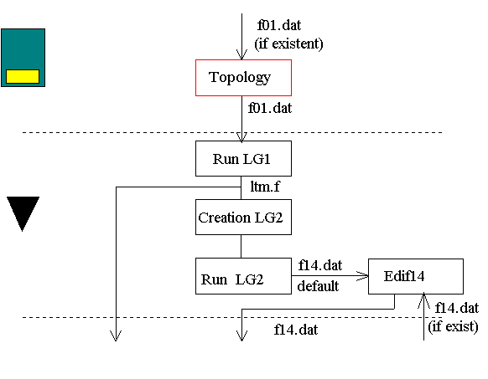
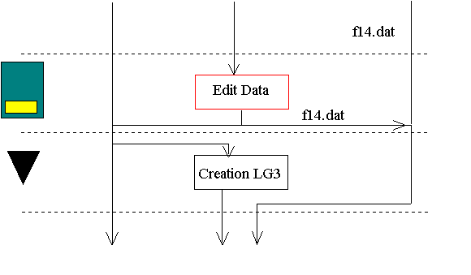
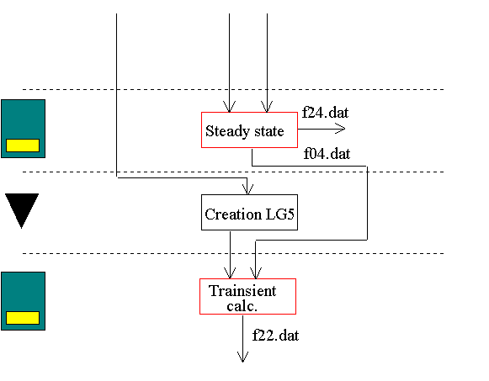

LEGOCAD main window layout: utilities area

This area of the LEGOCAD main window contains four push buttons to choose the following functions :
Librarian, edit, view LEGO libraries.
Graphics, display graphical trends from simulation f22 files.
H2O Table, look up at water steam tables via predefined functions.
Documentation edit, view model documentation
The first three functions are always enabled while documentation is enabled only if model has been loaded.

LEGOCAD main window layout: messages area

This area of the LEGOCAD main window is available for output messages such as logging during link arrow buttons activities. Problems in LEGO modules or incorrect environment may cause errors during these activities that are reported in the messages window.

H2O TABLES: calculate water steam property

When the tables are activated the following pre-defined functions are available:

Function |  | Output m.u. | Input m.u.
T(P,S) | Temperature | ^C | bar KJ/Kg/^C
S(P,H) | Entropy | KJ/Kg/^C | bar KJ/Kg
H(P,T,Y) | Entalpy | KJ/Kg | bar ^C
CP(P,T,Y) | Specific heat capacity | KJ/Kg/^C | bar ^C
R0* R0** | Density of water  and saturated steam | Kg/m3 | bar
T(P,H) | Temperature | ^C | bar KJ/Kg
S(P,T,Y) | Entropy | KJ/Kg/^C | bar ^C
R0(P,H) |  | Kg/m3 | bar KJ/Kg
H* H** | Entalpy of water  and saturated steam | KJ/Kg | bar
Y(P,H) | Steam ratio |  | bar KJ/Kg
TSAT(P) | Temperature | ^C | bar
H(P,S) | Entalpy | KJ/Kg | bar KJ/Kg/^C
R0(P,T,Y) | Density | Kg/m3 | bar ^C
S* S** | Entropy of water  and saturated steam | KJ/Kg/^C | bar

Every function can be activate clicking on its push buttons; below will appear the input and output areas with their text fields for the input and output values. Every text field has a label with the unit of measurements.

H2O TABLES layout: tables page

The page displays a pulldown menu to use the tables. The area under the pulldown menu is available for the use of the tables functions.
Tables page's pulldown menu :

File
Quit | Exits from the tables
Select
H2O | Selects the H2O tables and shows the usable functions
History
Show | Shows a window displaying the previous operations performed and values calculated using tables
Clear | Clears the history window

If H20 Select's pulldown menu is chosen, LEGOCAD displays fifteen option buttons, one for every function available.

The area below the push buttons is reserved for the input and the output of the functions.

