SIMULATION ACTIVITY

The simulation activity allows the user to manage the models under exam interactively through net_monit process.
Although net_monit allows the simulation of many models simultaneously - its typical use -, some applications may use net_monit with one task only. LEGOCAD for example, tests exclusively the model being developed. The following description is generally referred to the typical use of net_monit.
The models can be synchronised according to absolute time and simulated in real, accelerated and delayed time (the simulation speed can be varied at any time). Besides starting and stopping the simulation, the simulator can freeze or awaken it as well as perform a snapshot (saving information allowing the user to continue a simulation from the stage previously reached) and obtain information on the simulation development (CPU charge, simulation time, accrued delay, etc.).
Automatic start-up of the simulator follows the activation of the net_monit process. An interactive window will appear to carry out the simulation.

HOW TO
1 Use net_monit
2 Set archived variables
3 Start-up the simulation
4 Configure parameter after start-up
5 Define perturbation

SIMULATION WINDOWS LAYOUT
1 Net_monit main window layout
2 Time scaling dialog window
3 Continuos recording dialog window
4 Archived variables dialog window
5 Snapshot dialog windows
6 Statistic dialog window
7 XAING page layout
8 Input perturbation dialog windows

Simulation: use net_monit

The researcher can manage the simulation through the net_monit requiring the following steps: basic parameter sets, simulation start-up, configuration during the simulation, perturbation dispatch. By operating through the net_monit described above the user will set different simulation states as it is shown in the following figure.

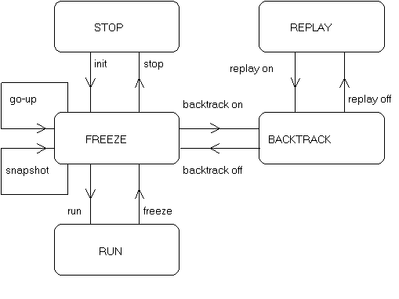

Meaning of the simulator status

STOP
Status before initializing.
FREEZE
Status of simulation block.
RUN
Status of full dynamic simulation.
REPLAY
Status which allows to load snapshot and the repetition of the related simulation.
BACKTRACK
Status which allows the automatic or manual loading of a snapshot saved periodically and automatically by the simulator.

Information on net_monit layout is available in:

1 Net_monit main window layout

Simulation: set archived variables

Only before the start-up of the simulation the user will have to choose the number and the set of variables to be saved periodically in the archive file (f22 file). Also archive frequency can be defined by the user as a multiple (or equal) of the time step of simulation. The graphics activity will allow to display trends to be saved .
The user can perform these selection by pressing Configure continuos recording on the Configure's pulldown menu and by working on the displayed page.

Information on this page layout is available in:

1 Archived variables dialog window

Simulation: start-up simulation

The user can start the simulations by pressing Initialize on Control's pulldown menu. After the initializing step, net_monit will display FREEZE in a yellow label and the simulator will be frozen. Start-up must follow the set of archived variables.

Information about net_monit pulldown menu and archived variables page layout is available in:

1 Net_monit main window layout
2 Archived variables dialog window

Simulation: configure after start-up

The user can manage the simulation through net_monit by modifying some parameters and introducing perturbation during the simulation either in freeze or in the run status.
Through the Configure's pulldown menu the user can change the simulation speed and maximum simulation time; change the frequency of data saving in archive; change the task integration step to select the best one. It is also possible to change the simulation state (Control's pulldown menu), to display CPU charge time (Statistic's pulldown menu), to saves, load or delete snapshots. Net_monit also allows step-by-step calculation. All these operations are available through a number of displayed dialog windows.

Information about all the above windows layout is available in:

1 Net_monit main window layout
2 Time scaling dialog window
3 Continuos recording dialog window
4 Snapshot dialog windows
5 Statistic dialog window

Simulation: define perturbation

The user can test the model in use by supplying perturbations such as step, pulse, ramp, delay to the input variables. This operation is made through XAING process which is activated by clicking "Aing" on the Input's pulldown menu. Furthermore the user can monitor the inputs by clicking "Edit input" and "Statistic" on the Input's pulldown menu.
XAING displays a variable selection window named "Input" where the user can select the inputs to perturb. After selection a window is displayed to insert the perturbation. XAING can manage simultaneously ten independent windows.

Available perturbation

The perturbation sent is selected from an option menu which offers three choices:

1 | NORMAL:with this selection three kinds of perturbation are available:  STEP: through a Target text field (value) and a Start push button.  PULSE: through a Target (value) and Wise (duration) text fields and the Start, Stop push buttons.  RAMP: through a Target (value) and duration modality text fields and the Start, Stop push buttons. The second text field depends on the made choice on the option menu; i.e. available modality are Grad (value increment for every sec.) Time (simulation time) Delta (the time necessary to reach the target value)

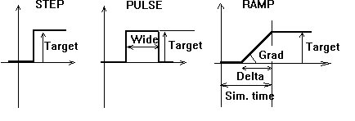

2 | PERIODIC: with this selection some text fields are available to introduce the characteristic of a periodic perturbation.  Below the General label the Period, Mean Value, Wide and Phase text fields are displayed.  Below the Sinusoidal label two push buttons to Start and Stop a sinusoidal perturbation are displayed.  Below the Trapezoidal label there are three text fields (T1, T2, T3) and the Start, Stop push buttons. An example is shown in the figure below.

3 | NOISE: by this selection will define a white noise filling Variance and Mean Value text fields. Start and Stop push buttons are also available.

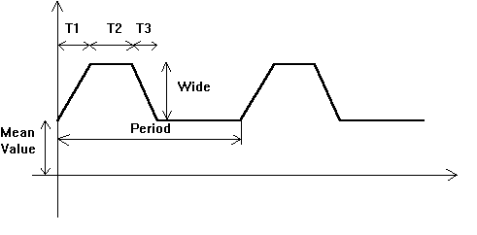

The user can also assign a delay by choosing between two input modalities: Delay and Start at. The first modality asks the duration of the delay and the second one the absolute time necessary to activate the perturbation.

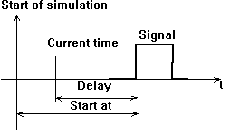

By clicking on the window with the first mouse button a Quit pop up menu to close the window will appear.

Information on the page layout is available in:
1 Net_monit main window layout
2 XAING page layout
3 Input perturbation dialog windows

Simulation layout: net_monit main window

Net_monit displays an interactive window featuring a pulldown menu to choose any operative actions and to display the simulation state on a panel (red at first with the STOP label)

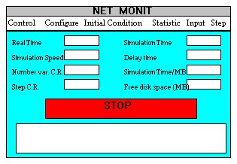

The pulldown menu has the following options:

Control
Initialize | Initializes the simulator
Run | Starts the simulation, must follow initialition
Freeze | Freezes the simulation
Backtrack | Sets the backtrack modality
Replay | Sets the replay modality
Clear | Clears continuos recording, backtrack and snapshot the file
Stop | Stops both the task and net_monit
Quit | Stops net_monit
Configure
Time scaling | Chooses the simulation speed (1.0 by default)
Set max simulation time | Sets a fixed time for the simulation and freezes the simulation at the end
Step scaling | Integration step multiplier (1.0 by default)
Step continuos recording | Sets the continuos recording
Configure continuous recording
By selection | Selects the f22 recording variables
All variables | Selects all variables for f22 recording
Initial conditions
Load initial conditions | Selections of a snapshot
Save initial conditions | Saves actual data like snapshot
Edit initial conditions | Modifies initial conditions
Statistic
Statistic | Displays the task induced CPU charge
Input
Aing | Selections of variables perturbation
Staz | Selections of command station
Edit input | Shows and modifies perturbations
Statistic | Shows and modifies perturbations
Step
Step | Manages the simulation step-by-steps
About
About | Shows net_monit about

Before starting the simulator, only the Control/Initialize, Control/Quit and Configure/Configure continuos recording options are available with net_monit. The others are available only after pressing Initialize Control's pulldown menu.
The red panel bearing the STOP label will become yellow and will contain the FREEZE label at the end of initializing.

Meaning of the text field displayed

Real Time
contains the clock time. This time is related to the simulation speed.
Simulation Speed
contains the speed value given by a ratio to the real time.
Number var C.R.
contains the number of archived variables.
Step C.R.
contains data recording interval.
Simulation Time
contains the effective time of the simulation.
Delay time
contains the time resulting from the difference between real and simulation time.
Simulation time/MB
contains a number indicating the time necessary to fill a disk MB.
Free disk space (MB)
contains the free disk space.

By, using the options in the pulldown menu, the user will display many other dialog windows; more details are available in:

1 Time scaling dialog window
2 Continuos recording dialog window
3 Archived variables dialog window
4 Snapshot dialog windows
5 Statistic dialog window
6 XAING page layout
7 Input perturbation dialog windows

Simulation layout: time scaling window

This window is displayed by pressing "Time scaling" on the Configure's pulldown menu.
Configure|Time scaling - :allows the insertion of a new the simulation speed (1.0 by default).

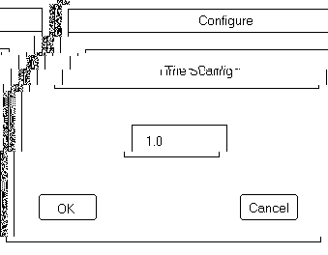

Simulation layout: continuos recording window

This window is displayed by pressing "Step continous recording" on the Configure's pulldown menu.
Configure|Step continuous recording - allows to insert the time interval for data recording. 1 is the default values displayed in net_monit main window in the Step C.R. box; it means that data recording will occur at every simulation step.

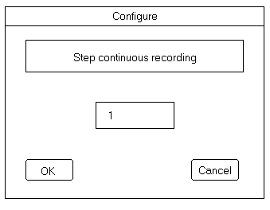

Simulation layout: archived variables window

This window is displayed by pressing "Configure continuos recording" on Configure's pulldown menu.
Configure|Configure continuous recording. allows the selection of the f22.dat stored variables.

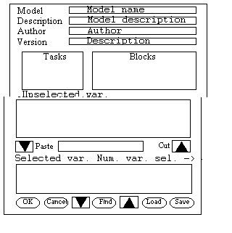

In this window two lists with selected and available variables for the configuration saved are displayed . It is possible to load the configuration, to search for a variable by the name (find area) and to move a group of variables between the lists by using the past/cut arrow buttons after selecting them.

Simulation layout: snapshot windows

The researcher, with the snapshot, can display three kinds of windows either to load, to save or delete a snapshot. These windows are displayed by pressing "Load initial condition", "Save initial condition", "Edit initial condition" on the Initial condition's pulldown menu.

Initial conditions|Load initial conditions -allows the selection of the starting data set on a list of saved snapshots.

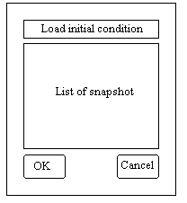

Initial conditions|Save initial conditions -allows the saving of the current data (snapshot). Snapshot is identified by a name given by user.

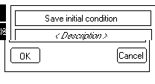

Initial conditions|Edit initial conditions -allows the deletion of a snapshot.

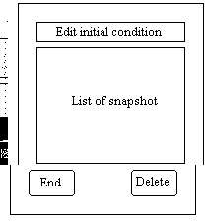

Simulation layout: statistic window

This window is displayed by pressing "Statistic" on the Statistic's pulldown menu.
Statistics|Statistics -Shows the CPU time.

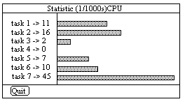

Simulation layout: XAING windows

XAING process is activated by pressing "Aing" on the Input's pulldown menu.
Input|Aing -Displays a variable selection window named "Input" where the user can choose the variable to perturb. This variable must not be connected with another module.

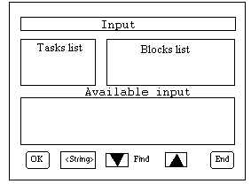

Once the user has selected the variable (and pressed the OK button) a new window will be displayed to define the perturbation. It is better to use this function with the simulator in FREEZE mode.

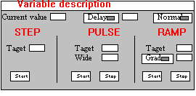

Furthermore the user can monitor the inputs by clicking "Edit input" and "Statistic" on the Input's pulldown menu. More information about the input perturbation windows is contained in:

1 Input perturbation dialog window

Simulation layout: input windows

These windows are displayed by pressing "Statistic" and "Edit input" on the Input's pulldown menu.
Input|Statistics -Displays a window featuring the list of the already set perturbation and their state (Active/Inactive). For the inactive ones, it is displayed also the time lacking for the activation.

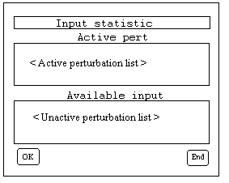

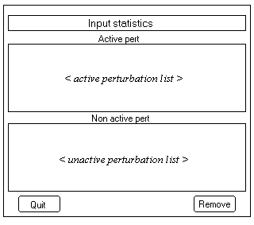

Input|Edit Input -Displays two windows: the first is the variable selection window named "Input", which is necessary to choose the variable (see XAING windows) and the second is the "Edit input" window which shows the variable and the associated already set perturbation with its state.

