MODULE ADIV CARD 0

Summary

• model generalities

• topological data

• physical and geometrical data

• module variables initialization

• user's subprograms

• residuals

• module subprograms

• test cases

MODULE ADIV CARD A

Model Generalities

SIGNALS DIVISOR

The module ADIV calculates the division of one analog signal into another.
Two data are provided as saturation values for the result (min and max).

MODULE ADIV CARD B

Topological data

INPUT-OUTPUT SCHEME

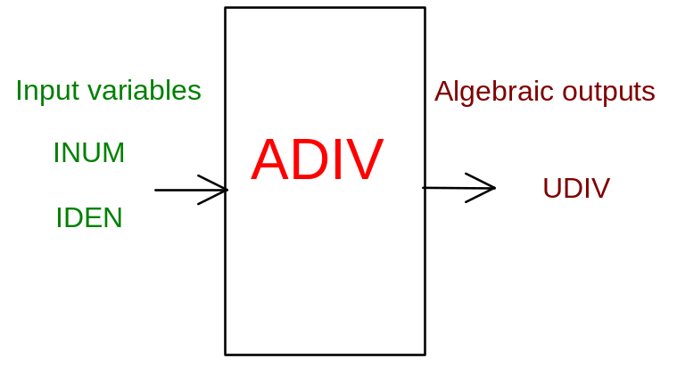

PHYSICAL MEANING OF MODULE INPUT-OUTPUT VARIABLES

[…] UDIV result
[…] INUM numerator
[…] IDEN denominator

MODULE ADIV CARD C

Physical and Geometrical Data

In addition to the initial values of input and output variables, one must assign the following data:
[…] U MAX max saturation
[…] U MIN min saturation
[…] NORM NUM numerator normalization
[…] NORM DEN denominator normalization

MODULE ADIV CARD D

Module Variables Initialization

To initialize the ADIV module variables no particular prescription is required.

MODULE ADIV CARD E

User's Subprograms

ADIV doesn’t prescribe any FORAUS subroutine.

MODULE ADIV CARD F

Residuals

UCAL = VNUM / VDEN
IF (UCAL .GT. UMAX) THEN
UCAL = UMAX
ELSE IF (UCAL .LT. UMIN) THEN
UCAL = UMIN
ENDIF
C
RNI(1) = (UDIV - UCAL)/CNO3

MODULE ADIV CARD G

Module subprograms

SUBROUTINE ADIVI2(IFUN,VAR,MX1,IV1,IV2,XYU,DATI,ID1,ID2,
$ IBL1,IBL2,IER,CNXYU,TOL)
SUBROUTINE ADIVI3(IFO,IOB,DEBL)
SUBROUTINE ADIVI4(IOB,MOD)
SUBROUTINE ADIVC1(IFUN,AJAC,MX5,IXYU,XYU,IPD,DATI,RNI,IBL1,IBL2)
SUBROUTINE ADIVD1(BLOCCO,NEQUAZ,NSTATI,NUSCIT,NINGRE,SYMVAR,
$ XYU,IXYU,DATI,IPD,SIGNEQ,UNITEQ,COSNOR,ITOPVA,MXT)

MODULE ADIV CARD H

Test cases

Reference test cases related to this module aren’t yet available.

