MODULE AEXT CARD 0

Summary

• model generalities

• topological data

• physical and geometrical data

• module variables initialization

• user's subprograms

• residuals

• module subprograms

• test cases

MODULE AEXT CARD A

Model Generalities

AIR EJECTOR OR VACUUM PUMP

The AEXT module deals with the problem of calculating the mass flow rate in a
plant component such as an air ejector or a vacuum pump.

The reference component for modelling is the air ejector.

The working fluid is air.

The mathematical model is a semi-empirical one.
It is based on a simplified momentum equation in which the inertial term, the
flux term and the gravitational term are neglected.
The downstream pressure is reduced depending on the value of a control
parameter, the driving flow for an air ejector, in order to have the right
pressure difference between the inlet of the driven flow and the mixing
chamber.
If the downstream pressure changes, the reduced pressure too varies affecting
the driven mass flow rate.

Data of a working point allow to determine the internal data, namely the
driven flow pressure loss coefficient and the downstream pressure reduction
coefficient, to match the component performances.

No mass storage in the component is considered.
No heat balance is performed.

The main simplifications are:

-The drive flow is not taken into account in the computation of the mass flow
rate, that is the outlet mass flow is equal to the driven mass flow;

-The outlet flow temperature is not calculated.

The module can simulate a vacuum pump, making use of the rotational speed as
control parameter.
Of course, in this case the reduced downstream pressure has no physical
meaning.
The service water mass flow rate appears among the input variables in this
case.

MODULE AEXT CARD B

Topological data

INPUT-OUTPUT SCHEME

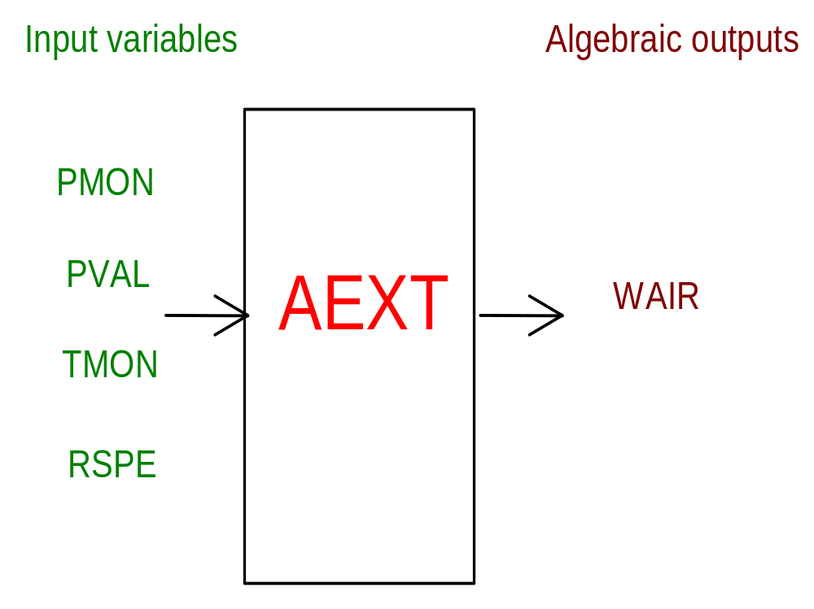

PHYSICAL MEANING OF MODULE INPUT-OUTPUT VARIABLES

[kg/S] WAIR air mass flow rate through the device

[Pa] PMON air pressure at device inlet

[Pa] PVAL air pressure at device outlet

[K] TMON air temperature at device inlet

[rpm] RSPE rotational speed

Note 1
The RSPE variable has really not the meaning of a rotational speed, but it is
rather a control variable

MODULE AEXT CARD C

Physical and Geometrical Data

In addition to initial values of input and output variables (meaning defined in card B1) user must assign the following data:

[Pa] PMONOM nominal air pressure at device inlet

[Pa] PVANOM nominal air pressure at device outlet

[K] TMONOM nominal air temperature at device inlet

[kg/s] WNOM nominal air mass flow rate through the device

[kg/s] WMAX maximum air mass flow rate through the device

[Pa] PMMIN minimum allowable air pressure at device outlet in nominal conditions

[rpm] RSPMA nominal rotational speed

[ ] REVFLI reverse flow index ( 0 reverse flow allowed)
( 1 reverse flow not allowed)

MODULE AEXT CARD D

Module Variables Initialization

To initialize the AEXT module variables no particular prescription is required.

MODULE AEXT CARD E

User's Subprograms

In the AEXT module no user subprograms are requested.

MODULE AEXT CARD F

Residuals

The module mathematical model consists of the momentum equation which gives
rise to the following residual:

RNI(1) = CVMAX*SQRT((PMOC-PVAC)*RING)-WAIR

(normalization factor = WO)

where CVMAX flow coefficient dependent on nominal conditions
PMOC inlet pressure
PVAC fictitious downward pressure dependent on nominal
conditions, true outlet pressure and control variable
RING inlet air density

MODULE AEXT CARD G

Module subprograms

SUBROUTINE AEXTI3(IFO, IOB, DEBL)

SUBROUTINE AEXTI4(IOB, MOD, IBLOC)

SUBROUTINE AEXTI2(IFUN, VAR, MX1, IV1, IV2, XYU, DATI, ID1, ID2,
$ IBL1, IBL2, IER, CNXYU, TOL)

SUBROUTINE AEXTC1(IFUN, AJAC, MX5, IXYU, XYU, IPD, DATI, RNI,
$ IBL1, IBL2)

SUBROUTINE AEXT(IFUN, IXYU, XYU, IPD, DATI, RNI)

MODULE CFAS CARD H

Test cases

No reference test case is available.

