MODULE AMDI CARD 0

Summary

• model generalities

• topological data

• physical and geometrical data

• module variables initialization

• user's subprograms

• residuals

• module subprograms

• test cases

MODULE AMDI CARD A

Model Generalities

ANALOG MULTIPLIER OF TWO SIGNALS

The module AMDI multiplies two analog signals. The output value is restricted between an assigned low and high limit value.

MODULE AMDI CARD B

Topological data

INPUT-OUTPUT SCHEME

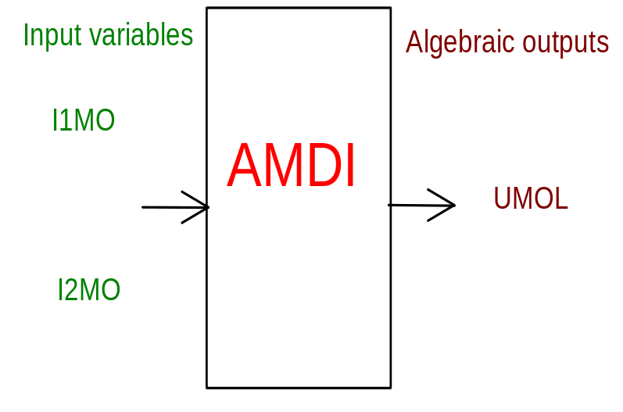

PHYSICAL MEANING OF MODULE INPUT-OUTPUT VARIABLES

[…] UMOL product
[…] I1MO first factor
[…] I2MO second factor

MODULE AMDI CARD C

Physical and Geometrical Data

In addition to the initial values of input and output variables, the user must assign the following data:

[…] U_MAX product high limit value
[…] U_MIN product low limit value
[…] NORM FA1 first factor normalization
[…] NORM FA2 second factor normalization

MODULE AMDI CARD D

Module Variables Initialization

To initialize the AMDI module variables no particular prescription is required.

MODULE AMDI CARD E

User's Subprograms

AMDI doesn’t prescribe any FORAUS subroutine.

MODULE AMDI CARD F

Residuals

RNI(1) = (UMOL-I1MO*I2MO)/(NORM FA1*NORM FA2)

MODULE AMDI CARD G

Module subprograms

SUBROUTINE AMDII2(IFUN,VAR,MX1,IV1,IV2,XYU,DATI,ID1,ID2,
$ IBL1,IBL2,IER,CNXYU,TOL)
SUBROUTINE AMDII3(IFO,IOB,DEBL)
SUBROUTINE AMDII4(IOB,MOD)
SUBROUTINE AMDIC1(IFUN,AJAC,MX5,IXYU,XYU,IPD,DATI,RNI,IBL1,IBL2)
SUBROUTINE AMDISI(IFUN,DATI,ID,NIN)
SUBROUTINE AMDISR(UU,II,ID,DATI,SAT,NIN,UMAX,UMIN)
SUBROUTINE AMDID1(BLOCCO,NEQUAZ,NSTATI,NUSCIT,NINGRE,SYMVAR,
$ XYU,IXYU,DATI,IPD,SIGNEQ,UNITEQ,COSNOR,ITOPVA,MXT)

MODULE AMDI CARD H

Test cases

Reference test cases related to this module aren’t yet available.

