#$K+!MODULE AMME CARD 0

Summary

∗ model generalities

∗ topological data

∗ physical and geometrical data

∗ module variables initialization

∗ user's subprograms

∗ residuals

∗ module subprograms

∗ test cases

#$K+!MODULE AMME CARD A

Model Generalities

VARIABLE ADMITTANCE

The AMME module simulates the beahviour of a passive load, consisting of a variable admittance.
The equations of the AMME module are written according to generator set convention, that is considering currents output as positive, and absorbed currents as negative ones.

Equations used are:

1) Ohm law
2) Current module equation
3) Equations of powers

#$K+!MODULE AMME CARD B

Topological data

INPUT - OUTPUT SCHEME

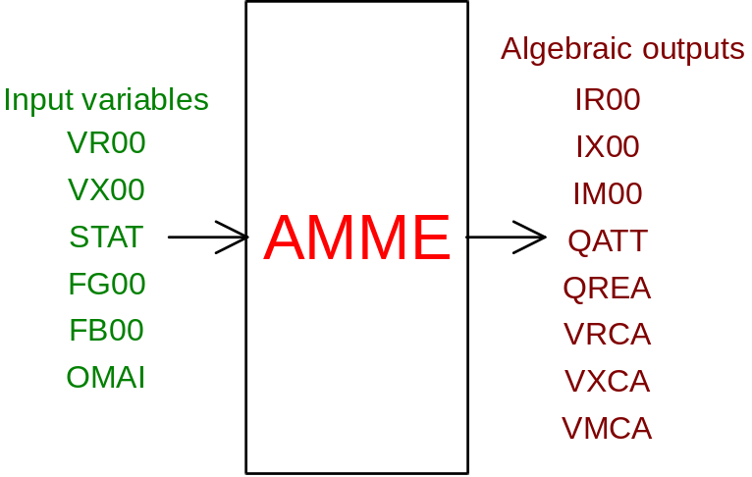

PHYSICAL MEANING OF MODULE INPUT-OUTPUT VARIABLES

[A] IR00 actual load current
[A] IX00 imaginary load current
[A] IM00 load current in module
[W] QATT active power absorbed by load
[VAR] QREA reactive power absorbed by load
[V] VRCA actual phase voltage at load terminals
[V] VXCA imaginary phase voltage at load terminals
[V] VMCA load voltage between lines in module
[V] VR00 actual phase voltage at bus bar
[V] VX00 imaginary phase voltage at bus bar
[ ] FG00 load conductance multiplier
[ ] FB00 load susceptance multiplier
FB00>0. ---> INDUCTIVE LOAD
FB00<0. ---> CAPACITIVE LOAD
[ ] STAT switch status (=1 closed, =0 open)
[rad/s] OMAI pulsation at load input

#$K+!MODULE AMME CARD C

Physical and Geometrical Data

In addition to the initial values of input and output variables of the AMME module, whose meaning has been defined in card B1, the user must assign the following set of data to complete the input required by the module:
[V] VBASE basic voltage between lines of the system in p.u.
[W] QBASE basic power of the system in p.u.
[A] INOM load rated current
[V] VNOM load rated voltage between lines
[W] QNOM load active rated power
[rad/s] OMBA basic system pulsation in p.u.

#$K+!MODULE AMME CARD D

Module Variables Initialization

No particular prescription is required for the initialization of AMME module variables.

#$K+!MODULE AMME CARD E

User's Subprograms

No user’s subprogram is required in the AMME module.

#$K+!MODULE AMME CARD F

Residuals

The equations of the mathematical model, mentioned in card A1, originate the following residuals:

RNI(1) = IROO-VXCA*BMOD+VRCA*GMOD

RNI(2) = IXOO+VRCA*BMOD+VXCA*GMOD

RNI(3) = IM00-SQRT(IR00**2+IX00**2)

RNI(4) = QATT-VRCA*IR00-VXCA*IX00

RNI(5) = QREA-VXCA*IR00-VRCA*IX00

RNI(6) = VMCA-SQRT(3.*(VRCA**2+VXCA**2))

RNI(7) = VR00-VRCA

RNI(8) = VX00-VXCA

These residuals are valid in switch closed conditions. When the switch is open, residuals are:

RNI(1) = -IROO

RNI(2) = -IXOO

RNI(3) = -IM00

RNI(4) = -QATT

RNI(5) = -QREA

RNI(6) = -VMCA

RNI(7) = -VRCA

RNI(8) = -VXCA

where

BMOD = load susceptance
GMOD = load conductance

In particular, for load susceptance we have the following expressions:

BMOD = FB00*BNOM/OMAI for inductive loads
BMOD = FB00*BNOM*OMAI for capacitive loads

where

BNOM = load rated susceptance

#$K+!MODULE AMME CARD G

Module subprograms

SUBROUTINE AMMEI2 (IFUN,VAR,MX1,IV1,IV2,XYU,DATI,ID1,ID2,
IBL1,IBL2,IER,CNXYU,TOL)
SUBROUTINE AMMEC1 (IFUN,AJAC,MX5,IXYU,XYU,IPD,DATI,RNI,IBL1,IBL2)
SUBROUTINE AMMEJC (IFUN,AJAC,MX5,IXYU,XYU,IPD,DATI,RNI,IBL1,IBL2)
SUBROUTINE AMME (IFUN,IXYU,XYU,IPD,DATI,RNI)
SUBROUTINE AMMEI3 (IFO,IOB,DEBL)
SUBROUTINE AMMEI4 (IOB,MOD)
SUBROUTINE AMMED1 (BLOCCO,NEQUAZ,NSTATI,NUSCIT,NINGRE,SYMVAR,XYU,
IXYU,DATI,IPD,SIGNEQ,UNITEQ,COSNOR,ITOPVA,MXT)

#$K+!MODULE AMME CARD H

Test cases

# lg_libproc_AMME_summ
$ AMME process module
K AMME process module
+ lg_pag_modu:0040
! EnableButton("button_up"); ChangeButtonBinding("button_up", "JumpId(`lglibpro.hlp',`lg_libproc_main')")
# lg_libproc_AMME_A
$ AMME process module (A)
K AMME process module (A)
+ lg_pag_amme:0002
! EnableButton("button_up"); ChangeButtonBinding("button_up", "JumpId(`lglibpro.hlp',`lg_libproc_AMME_summ')")
# lg_libproc_AMME_B
$ AMME process module (B)
K AMME process module (B)
+ lg_pag_amme:0003
! EnableButton("button_up"); ChangeButtonBinding("button_up", "JumpId(`lglibpro.hlp',`lg_libproc_AMME_summ')")
# lg_libproc_AMME_C
$ AMME process module (C)
K AMME process module (C)
+ lg_pag_amme:0004
! EnableButton("button_up"); ChangeButtonBinding("button_up", "JumpId(`lglibpro.hlp',`lg_libproc_AMME_summ')")
# lg_libproc_AMME_D
$ AMME process module (D)
K AMME process module (D)
+ lg_pag_amme:0005
! EnableButton("button_up"); ChangeButtonBinding("button_up", "JumpId(`lglibpro.hlp',`lg_libproc_AMME_summ')")
# lg_libproc_AMME_E
$ AMME process module (E)
K AMME process module (E)
+ lg_pag_amme:0006
! EnableButton("button_up"); ChangeButtonBinding("button_up", "JumpId(`lglibpro.hlp',`lg_libproc_AMME_summ')")
# lg_libproc_AMME_F
$ AMME process module (F)
K AMME process module (F)
+ lg_pag_amme:0007
! EnableButton("button_up"); ChangeButtonBinding("button_up", "JumpId(`lglibpro.hlp',`lg_libproc_AMME_summ')")
# lg_libproc_AMME_G
$ AMME process module (G)
K AMME process module (G)
+ lg_pag_amme:0008
! EnableButton("button_up"); ChangeButtonBinding("button_up", "JumpId(`lglibpro.hlp',`lg_libproc_AMME_summ')")
# lg_libproc_AMME_H
$ AMME process module (H)
K AMME process module (H)
+ lg_pag_amme:0009
! EnableButton("button_up"); ChangeButtonBinding("button_up", "JumpId(`lglibpro.hlp',`lg_libproc_AMME_summ')")

