#$K+!MODULE ATTU CARD 0

Summary

∗ model generalities

∗ topological data

∗ physical and geometrical data

∗ module variables initialization

∗ user's subprograms

∗ residuals

∗ module subprograms

∗ test cases

#$K+!MODULE ATTU CARD A

Model Generalities

SIMPLIFIED ACTUATORS

The module ATTU belongs to the thermodinamic base library. It simulates the behaviour of a group of simplified actuators (maximum 7).
Each actuator is modelized as a simple first-order filter (with an user-assigned time constant) between the actuated variable and its set-point (e.g.: the stem position of a valve an tre position set-point evaluated by the control system).

In order to allow the correct connection with other LEGO modules (avoiding the emission of program warnings) the first character of the input and output variables can be choosen by the user.

#$K+!MODULE ATTU CARD B

Topological data

INPUT-OUTPUT SCHEME

User-defined variables first character (which takes places of the “a”):

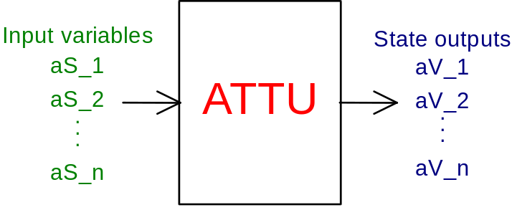

Defult variables names:

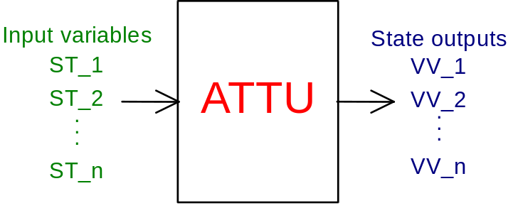

PHYSICAL MEANING OF MODULE INPUT-OUTPUT VARIABLES

The first character of the input and output variables can be choosen by the user. In this case the name of the input and output variables are the following (where the “a” is replaced with the character assigned by the user):

[ ] aS_1, ... aS_n set-point of the variable to be actuated
[ ] aV_1, ... aV_n value set-point of the variable to be actuated

If the user doesn’t assign the initial character, the default names are used for input and output variables:

[ ] ST_1, ... ST_n set-point of the variable to be actuated
[ ] VV_1, ... VV_n value set-point of the variable to be actuated

#$K+!MODULE ATTU CARD C

Physical and Geometrical Data

In addition to initial values of TPAF module input and output variables, user must assign the following data set to complete the module input on the file F14:
[s] TAU1...TAUn actuators time constants
[ ] GAIN1...GAINn scale factors (filter gains)
[ ] VMAX1...VMAXn maximum variation speed of the outputs
[ ] NORU1...NORUn normalization factors for the input variables
[ ] NORX1...NORXn normalization factors for the output variables

In order to assign the normalization factors, both for the input and the output variables of the ATTU module (required by LEGO for the normalization of the equations) the user must assign in the F14 file the following alphanumeric data:
P0 for pressures
H0 for enthalpies
T0 for temperatures
W0 for flow rates
RO0 for densities
AL0 for lenghts
V0 for volumes
DP0 for differential pressures
blank value = 1. (e.g: for valve stem positions)

The maximum variation speeds are assigned in the same measurement units of the related variable divided by the default time measurement unit (second).

#$K+!MODULE ATTU CARD D

Module Variables Initialization

To initialize the ATTU module variables on the file F14, no particular prescription is required.

#$K+!MODULE ATTU CARD E

User's Subprograms

In the ATTU module no user subprogram is required.

#$K+!MODULE ATTU CARD F

Residuals

DO I = 1,NVARX
RN(I) = -X(I)/TAU(I)+U(I)/TAU(I)*GAIN(I)
ENDDO

#$K+!MODULE ATTU CARD G

Module subprograms

SUBROUTINE ATTUI3(IFO,IOB,DEBL)

SUBROUTINE ATTUI4(IOB,MOD,IBLOC,NCEL,INIZ)

SUBROUTINE ATTUI2(IFUN,SYMB,MX,IV1,IV2,XYU,DATI,ID1,ID2,
$ IBL1,IBL2,IER,CNXYU,TOL)

SUBROUTINE ATTUC1(IFUN,AJAC,MX5,IXYU,XYU,IPD,DATI,RN,IBL1,IBL2)

SUBROUTINE ATTUD1(BLOCCO,NEQUAZ,NSTATI,NUSCIT,NINGRE,SYMVAR,XYU,
$ IXYU,DATI,IPD,SIGNEQ,UNITEQ,COSNOR,ITOPVA,MXT)

#$K+!MODULE ATTU CARD H

Test cases

Reference test cases related to this module are reported in the user manual section devoted to the examples developed under the abbreviation:

"........."

# lg_libproc_ATTU_summ
$ ATTU process module
K ATTU process module
+ lg_pag_modu:0080
! EnableButton("button_up"); ChangeButtonBinding("button_up", "JumpId(`lglibpro.hlp',`lg_libproc_main')")
# lg_libproc_ATTU_A
$ ATTU process module (A)
K ATTU process module (A)
+ lg_pag_attu:0002
! EnableButton("button_up"); ChangeButtonBinding("button_up", "JumpId(`lglibpro.hlp',`lg_libproc_ATTU_summ')")
# lg_libproc_ATTU_B
$ ATTU process module (B)
K ATTU process module (B)
+ lg_pag_attu:0003
! EnableButton("button_up"); ChangeButtonBinding("button_up", "JumpId(`lglibpro.hlp',`lg_libproc_ATTU_summ')")
# lg_libproc_ATTU_C
$ ATTU process module (C)
K ATTU process module (C)
+ lg_pag_attu:0004
! EnableButton("button_up"); ChangeButtonBinding("button_up", "JumpId(`lglibpro.hlp',`lg_libproc_ATTU_summ')")
# lg_libproc_ATTU_D
$ ATTU process module (D)
K ATTU process module (D)
+ lg_pag_attu:0005
! EnableButton("button_up"); ChangeButtonBinding("button_up", "JumpId(`lglibpro.hlp',`lg_libproc_ATTU_summ')")
# lg_libproc_ATTU_E
$ ATTU process module (E)
K ATTU process module (E)
+ lg_pag_attu:0006
! EnableButton("button_up"); ChangeButtonBinding("button_up", "JumpId(`lglibpro.hlp',`lg_libproc_ATTU_summ')")
# lg_libproc_ATTU_F
$ ATTU process module (F)
K ATTU process module (F)
+ lg_pag_attu:0007
! EnableButton("button_up"); ChangeButtonBinding("button_up", "JumpId(`lglibpro.hlp',`lg_libproc_ATTU_summ')")
# lg_libproc_ATTU_G
$ ATTU process module (G)
K ATTU process module (G)
+ lg_pag_attu:0008
! EnableButton("button_up"); ChangeButtonBinding("button_up", "JumpId(`lglibpro.hlp',`lg_libproc_ATTU_summ')")
# lg_libproc_ATTU_H
$ ATTU process module (H)
K ATTU process module (H)
+ lg_pag_attu:0009
! EnableButton("button_up"); ChangeButtonBinding("button_up", "JumpId(`lglibpro.hlp',`lg_libproc_ATTU_summ')")

