MODULE AXCH CARD 0

Summary

• model generalities

• topological data

• physical and geometrical data

• module variables initialization

• user's subprograms

• residuals

• module subprograms

• test cases

MODULE AXCH CARD A

Model Generalities

AIR DUCT

The AXCH module simulates the thermal exchange between air flowing through a duct and the external surface of several elements which (also belonging to the duct itself) can have mean temperatures considerably different.
Symplifying hypoteses used in definition of physical-mathematical model are the following:

- duct which air is flowing through is subdivided in cells (max.9) along motion direction;
- in each cell air can exchange with several surfaces (max.6) having different mean temperatures;
- air can be dry or wet;
- humidity cannot condensate, that is to say steam can be superheated or saturated dry;
- convective thermal exchange can occur as longflow;
- all accumulation phenomena are not considered.

The used equations are:

- conservation equation of air energy
- conservation equation of air mass
- equation of thermal exchange between air and duct walls .

Not considering all accumulation phenomena, all mentioned equations are algebraical.

MODULE AXCH CARD B

Topological data

INPUT-OUTPUT SCHEME

Nc = number of cells (max.9) in which the duct is subdivided
Np(i) = number of surfaces (max.6) exchanging heat with air flowing through the
i-th duct cell

i = 1, 2,... Nc
j = 1, 2,... Np(i)

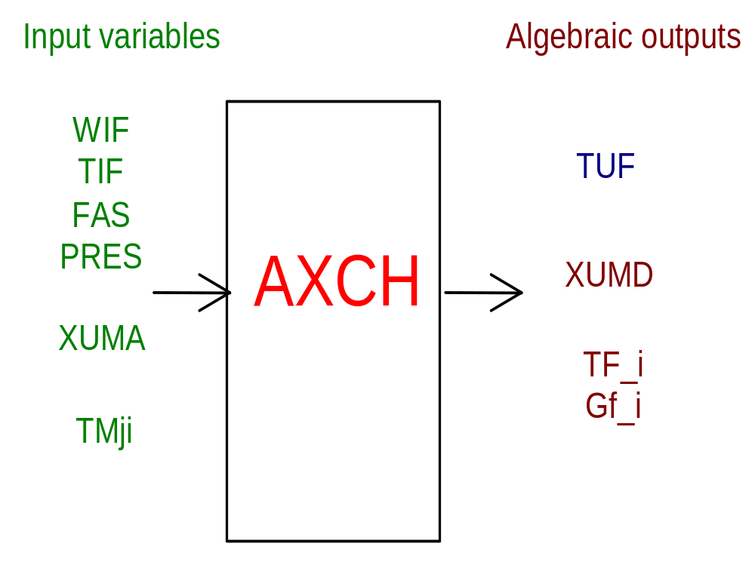

PHYSICAL MEANING OF MODULE INPUT-OUTPUT VARIABLES

[K] TUF flue gas temperature at the duct outlet

[%] XUMD air absolute humidity (mass fraction)

[K] TF_1 (i=1,2,...,Nc) mean temperature of air flowing through the i-th cell

[W/m**2/K] GF_1 heat transfer coefficient in the i-th cell

[kg/s] WIF flow rate of air flowing through the duct

[K] TIF air temperature at the duct inlet

[ ] FAS dirty factor of bench pipes

[Pa] PRES air pressure

[%] XUMA air humidity (mass fraction)
if TYUM = 0 relative humidity
if TYUM = 1 absolute humidity

[K] TMji mean temperature of the j-th surface exchanging heat with air flowing
through the i-th cell

MODULE AXCH CARD C

Physical and Geometrical Data

In addition to initial values of the AXCH module input and output variables (meanings defined in card B1), user must assign the following data:

[ ] TYUM air humidity definition
TYUM = 0 relative humidity
TYUM = 1 absolute humidity

and, for each cell:

[ ] NTUB number of pipes forming the bench

[m] DIDR hydraulic diameter of bench pipes (air side)

[m] LUNG length of bench pipes

[m**2] SCAN cell cross section area

[ ] FA correction factor for heat trasfer coefficient

[m**2] SUP.j (j=1,...,6) area of the j-th surface exchanging heat with air flowing
through the cell.

MODULE AXCH CARD D

Module Variables Initialization

To initialize the AXCH module variables no particular prescription is required.
Care must be used in assigning realistic values of inlet air humidity.

MODULE AXCH CARD E

User's Subprograms

In the AXCH module no user programs are requested.

MODULE AXCH CARD F

Residuals

Equations forming the module mathematical model, mentioned in card A1 give rise to a residual set whose are only indicated their respective normalization factor.
Further explanation are given in the related section of the manual "LEGOCAD -
Modelling Library for Simulation of Power Generation Plants - Theory".

MODULE AXCH CARD G

Module subprograms

SUBROUTINE AXCHI1(IFUN, K, IBLOC1, IBLOC2, NSTATI, NUSCIT, NINGRE)

SUBROUTINE AXCHI3(IFO, IOB, DEBL)

SUBROUTINE AXCHI4(IOB, MOD)

SUBROUTINE AXCHI2(IFUN, VAR, MX1, IV1, IV2, XYU, DATI, ID1, ID2,
$ IBLOC1, IBLOC2, IER, CNXYU, TOL)

SUBROUTINE AXCHC1(IFUN, AJAC, MX5, IXYU, XYU, IPD, DATI, RNI,
$ IBLOC1, IBLOC2)

SUBROUTINE AXCH(IFUN, IXYU, XYU, IPD, DATI, RN)

SUBROUTINE AXCHDA(T, P, ROAR, CPAR, CTAR, VDAR)

SUBROUTINE AXCHWA(T, RPVP, ROAR, CPAR, CTAR, VDAR, ROAC, CPAC, CTAC,
$ VDAC, ROM, CPM, CTM, VDM)

MODULE AXCH CARD H

Test cases

Reference test cases related to this module are in the manual section
dedicated to the examples developed under the abbreviations:

"....module application example not available yet..."

