#$K+!MODULE BTGS CARD 0

Summary

∗ model generalities

∗ topological data

∗ physical and geometrical data

∗ module variables initialization

∗ user's subprograms

∗ residuals

∗ module subprograms

∗ test cases

#$K+!MODULE BTGS CARD A

Model Generalities

SYNGAS-FED TURBOGAS COMBUSTION CHAMBER

The BTGS module simulates the thermal and chemical part of the combustion of natural gas mixed-syngas. It is devoted to the simulation of the combustion chamber of turbogas groups in turbogas plants, combined cycle plants and coal gasification plants.
For the complete simulation of the combustion chamber is so needed the simulation of the other components and thermodynamical effects (head losses, pressure nodes and bypass and cooling channels) with the existing library modules for the simulation of compressed air subsystems (SERA, VAIN, CMSC, …).
The module allows the simulation of the injection of steam in the combustion chamber (De-NOx steam) in case of natural gas functioning and the combustion of the coal gasification gas (mixed-syngas). Also it allows the correct simulation of the commutation transient from one kind of fuel to the other.
The BTGS module performs the calculation of the flow rate, the temperature and the chemical composition of the flue gases at the combustion chamber outlet. In order to allow the correct simulation of the chemical composition, it is possible to mix to the flue gases air coming from bypass or cooling channels external to the chamber.
The physical inlets of the BTGS module are five:
∗ the combustive air;
∗ the natural gas and steam mixture (DeNOx steam);
∗ a second inlet of auxiliary natural gas;
∗ the mixed-syngas;
∗ the air coming from the bypass channels.

For each of these physical inlets are required the values of flow rate and temperature; for the natural gas mixture and steam is required also the mass fraction of natural gas; for the mixed-syngas is instead required the chemical composition (given as mass fractions of CO, H2, CH4, H2O and CO2: the mass fraction of N2 is the complement to one).
The physical outlet is one (corresponding to the turbine inlet). For this physical outlet the model supplies the flow rate, the temperature and the chemical composition of the flue gas. As in a turbogas there is always a considerable air excess, one may assume that the combustion is always complete. So the chemical composition of the flue gas is computed as mass fractions of CO2, H2O, O2 and Ar (the mass fraction of N2 is the complement to one).
The module evaluates also the temperature before the bypass mixing, that should correspond to the maximum temperature in the combustion chamber. But the exact calculation of this quantity should take into account the kinetical-chemical effects of the combustion, which are not considered inside the BTGS module. Thus the supplied value must be intended in a qualitative manner.
For the calculation and the conversion of the thermodynamical properties of all the fluids incoming and exiting is used the functions library devoted to the evaluation of the properties of gas mixtures (Tavsyngas library).

#$K+!MODULE BTGS CARD B

Topological data

INPUT-OUTPUT SCHEME

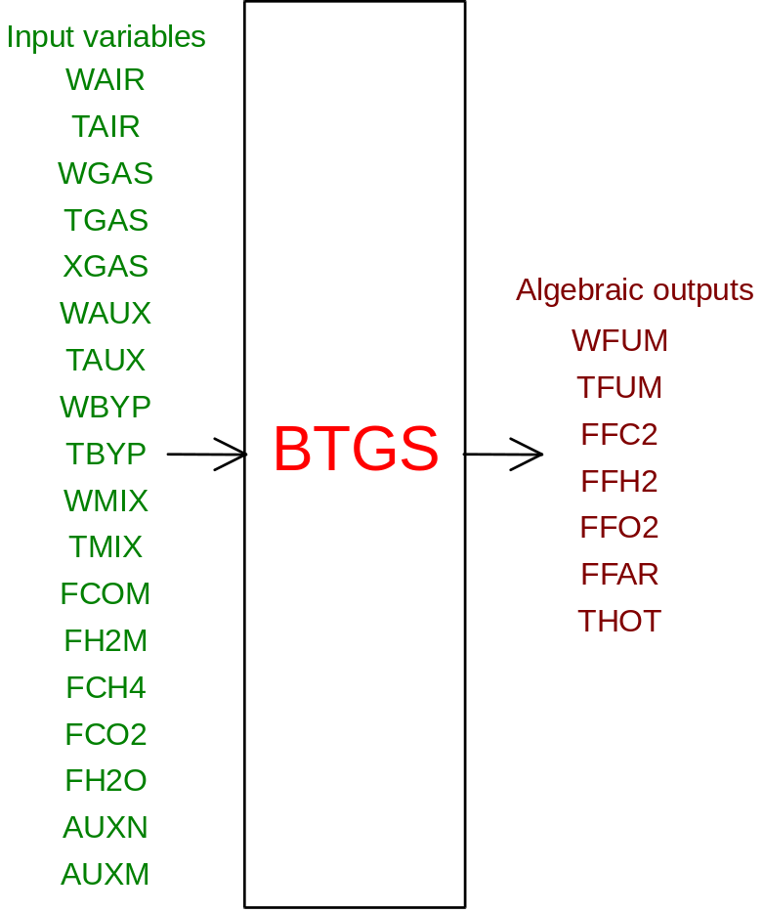

PHYSICAL MEANING OF MODULE INPUT-OUTPUT VARIABLES

[kg/s] WAIR Flow rate of combustive air at the comustion chamber inlet
[K] TAIR Temperature of combustive air at the combustion chamber inlet
[kg/s] WGAS Flow rate of natural gas and steam mixture at chamber inlet
[K] TGAS Temperature of natural gas and steam mixture at chamber inlet
[ ] XGAS Mass fraction of natural gas in the mixture
[kg/s] WAUX Flow rate of the natural gas through the auxiliary nozzles
[K] TAUX Temperature of the natural gas through the auxiliary nozzles
[kg/s] WBYP Flow rate of mixing air through the chamber bypass
[K] TBYP Temperature of mixing air through the chamber bypass
[kg/s] WMIX Flow rate of mixed-syngas at the combustion chamber inlet
[K] TMIX Temperature of mixed-syngas at the combustion chamber inlet
[ ] FCOM Mass fraction from CO in the incoming mixed-syngas
[ ] FH2M Mass fraction of H2 in the incoming mixed-syngas
[ ] FCH4 Mass fraction of CH4 in the incoming mixed-syngas
[ ] FCO2 Mass fraction of CO2 in the incoming mixed-syngas
[ ] FH2O Mass fraction of H2O in the incoming mixed-syngas
[ ] AUXN Corrective coefficient of the thermal power for the natural gas
[ ] AUXM Corrective coefficient of the thermal power for the mixed-syngas
[kg/s] WFUM Flow rate of flue gas at the combustion chamber outlet
[K] TFUM Temperature of the flue gas at the comb. chamber outlet
[ ] FFC2 Mass fraction of CO2 in the flue gas at the chamber outlet
[ ] FFH2 Mass fraction of H2O in the flue gas at the chamber outlet
[ ] FFO2 Mass fraction of O2 in the flue gas at the chamber outlet
[ ] FFAR Mass fraction of Ar in the flue gas at the chamber outlet
[K] THOT Flue gases temperature before bypass air mixing

INPUT-OUTPUT VARIABLES NORMALIZATION FACTORS

Variables Normalization
WAIR, WGAS, WAUX, WBYP, WMIX, WFUM W0
TAIR, TGAS, TAUX, TBYP, TMIX, TFUM, THOT T0
XGAS, AUXN, AUXM 1.
FCOM, FH2M, FCH4, FCO2, FH2O, FFC2, FFH2, FFO2, FFAR 0.1

#$K+!MODULE BTGS CARD C

Physical and Geometrical Data

In addition to initial values of BTGS module input and output variables (meanings defined above), user must assign the following data set to complete the module input on the file F14:
[ ] ETA comb Combustion efficiency
[J/kg] LHV met. LHV (low heat value) of the natural gas
[ ] X CnHxn Mean molar ratio hydrogen/carbon in the natural gas
[ ] Xm Inert Inerts mass fraction (assumed as N2) in the natural gas

#$K+!MODULE BTGS CARD D

Module Variables Initialization

To initialize the BTGS module variables on the file F14, no particular prescription is required.

#$K+!MODULE BTGS CARD E

User's Subprograms

No user subprograms are present in the BTGS module.
The BTGS module makes use of the procedures contained in the syngas thermodynamic tables (TAVSYNGAS) which must be present in the user library.

#$K+!MODULE BTGS CARD F

Residuals

The equations forming the BTGS module mathematical model give rise to a set of residuals. Here only their correspondences with the output variables equations have been indicated, also mentioning the respective normalization factors. Further explanations are given in the related theoretical description.
1) RNI(1) - normalization factor = W0
related to the combustion chamber outlet flue gas flow rate;
2) RNI(2) - normalization factor = T0
related to the combustion chamber outlet flue gas temperature;
3) RNI(3) - normalization factor = 0.1
related to the combustion chamber outlet flue gas chemical composition;
4) RNI(4) - normalization factor = 0.1
related to the combustion chamber outlet flue gas chemical composition;
5) RNI(5) - normalization factor = 0.1
related to the combustion chamber outlet flue gas chemical composition;
6) RNI(6) - normalization factor = 0.1
related to the combustion chamber outlet flue gas chemical composition;
7) RNI(7) - normalization factor = T0
related to the maximum flue gas temperature inside the chamber.

#$K+!MODULE BTGS CARD G

Module subprograms

SUBROUTINE BTGSI3 (IFO,IOB,DEBL)

SUBROUTINE BTGSI2 (IFUN,VAR,MX1,IV1,IV2,XYU,DATI,ID1,ID2,
$ IBL1,IBL2,IER,CNXYU,TOL)

SUBROUTINE BTGSC1 (IFUN,AJAC,MX5,IXYU,XYU,IPD,DATI,RNI,IBL1,IBL2)

SUBROUTINE BTGS (IFUN,IXYU,XYU,IPD,DATI,RNI)

SUBROUTINE BTGSD1 (BLOCCO,NEQUAZ,NSTATI,NUSCIT,NINGRE,SYMVAR,
$ XYU,IXYU,DATI,IPD,SIGNEQ,UNITEQ,COSNOR,ITOPVA,MXT)

#$K+!MODULE BTGS CARD H

Test cases

Reference test cases related to this module are reported in the user manual section devoted to the examples developed under the abbreviation:
"........."

# lg_libproc_BTGS_summ
$ BTGS process module
K BTGS process module
+ lg_pag_modu:0100
! EnableButton("button_up"); ChangeButtonBinding("button_up", "JumpId(`lglibpro.hlp',`lg_libproc_main')")
# lg_libproc_BTGS_A
$ BTGS process module (A)
K BTGS process module (A)
+ lg_pag_btgs:0002
! EnableButton("button_up"); ChangeButtonBinding("button_up", "JumpId(`lglibpro.hlp',`lg_libproc_BTGS_summ')")
# lg_libproc_BTGS_B
$ BTGS process module (B)
K BTGS process module (B)
+ lg_pag_btgs:0003
! EnableButton("button_up"); ChangeButtonBinding("button_up", "JumpId(`lglibpro.hlp',`lg_libproc_BTGS_summ')")
# lg_libproc_BTGS_C
$ BTGS process module (C)
K BTGS process module (C)
+ lg_pag_btgs:0005
! EnableButton("button_up"); ChangeButtonBinding("button_up", "JumpId(`lglibpro.hlp',`lg_libproc_BTGS_summ')")
# lg_libproc_BTGS_D
$ BTGS process module (D)
K BTGS process module (D)
+ lg_pag_btgs:0006
! EnableButton("button_up"); ChangeButtonBinding("button_up", "JumpId(`lglibpro.hlp',`lg_libproc_BTGS_summ')")
# lg_libproc_BTGS_E
$ BTGS process module (E)
K BTGS process module (E)
+ lg_pag_btgs:0007
! EnableButton("button_up"); ChangeButtonBinding("button_up", "JumpId(`lglibpro.hlp',`lg_libproc_BTGS_summ')")
# lg_libproc_BTGS_F
$ BTGS process module (F)
K BTGS process module (F)
+ lg_pag_btgs:0008
! EnableButton("button_up"); ChangeButtonBinding("button_up", "JumpId(`lglibpro.hlp',`lg_libproc_BTGS_summ')")
# lg_libproc_BTGS_G
$ BTGS process module (G)
K BTGS process module (G)
+ lg_pag_btgs:0010
! EnableButton("button_up"); ChangeButtonBinding("button_up", "JumpId(`lglibpro.hlp',`lg_libproc_BTGS_summ')")
# lg_libproc_BTGS_H
$ BTGS process module (H)
K BTGS process module (H)
+ lg_pag_btgs:0011
! EnableButton("button_up"); ChangeButtonBinding("button_up", "JumpId(`lglibpro.hlp',`lg_libproc_BTGS_summ')")

