MODULE CFAS CARD 0

Summary

• model generalities

• topological data

• physical and geometrical data

• module variables initialization

• user's subprograms

• residuals

• module subprograms

• test cases

MODULE CFAS CARD A

Model Generalities

COSPHI CALCULATION

The module CFAS receives in input the real and the imaginary components of a sinusoidal voltage and a sinusoidal current, and calculates the following three output variables:
- the “cosϕ” between voltage and current.
The cosϕ is calculated starting from the concept of scalar product between the two vectorial variables V and I. If 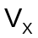and 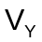 are the components of the V vector, and and the components of the I vector, the scalar product V•I is 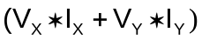. The definition of scalar product between two vectors says also that 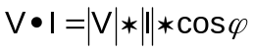 where 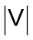and are the modules of the vectorial variables V and I. The previous expressions take to the final result: 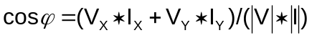

- the phase angle of the voltage 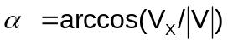

- the active power produced by the current Q = 3*( V•I). (The current has three phases, so the constant 3 has to multiply the scalar product V•I)

MODULE CFAS CARD B

Topological data

INPUT-OUTPUT SCHEME

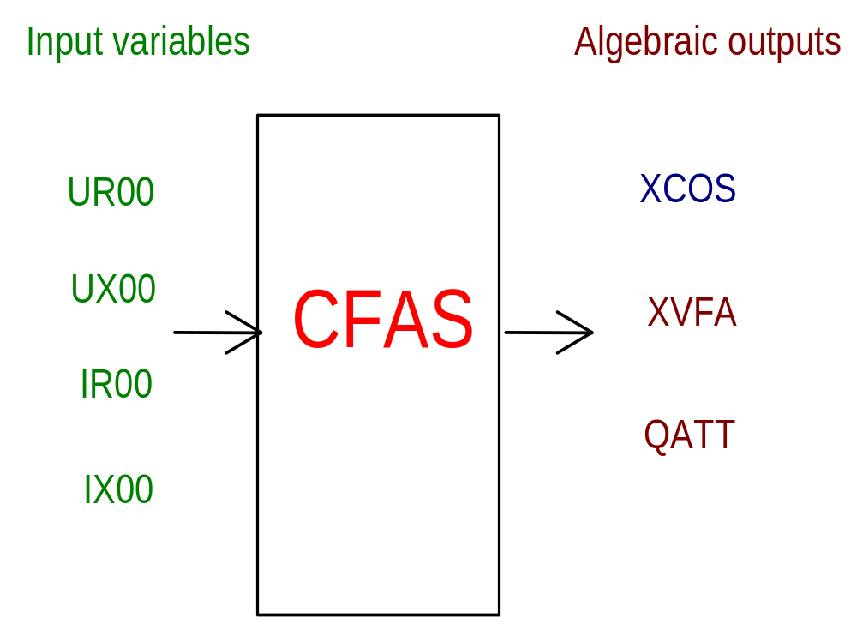

PHYSICAL MEANING OF MODULE INPUT-OUTPUT VARIABLES

[Volt] UR00 real component of the voltage
[Volt] UX00 imaginary component of the voltage
[A] IR00 real component of the current
[A] IX00 imaginary component of the current
[p.u.] XCOS cosϕ between voltage and current
[deg] XVFA phase angle of the voltage
[W] QATT electrical active power

MODULE CFAS CARD C

Physical and Geometrical Data

In addition to the initial values of input and output variables, user must assign the following data:
[W] QBASE normalization constant for electrical power
[Volt] VBASE normalization constant for electrical voltage

MODULE CFAS CARD D

Module Variables Initialization

To initialize the CFAS module variables no particular prescription is required.

MODULE CFAS CARD E

User's Subprograms

No items

MODULE CFAS CARD F

Residuals

- cosϕ (residual nr. 1)

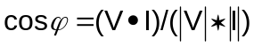

- voltage phase angle (residual nr. 2)

- electrical active power (residual nr. 3)

Q = 3*( V•I)

MODULE CFAS CARD G

Module subprograms

No items.

MODULE CFAS CARD H

Test cases

Reference test cases related to this module aren’t yet available.

