MODULE CMOD CARD 0

Summary

• model generalities

• topological data

• physical and geometrical data

• module variables initialization

• user's subprograms

• residuals

• module subprograms

• test cases

MODULE CMOD CARD A

Model Generalities

MODULE CALCULATION

The module CMOD receives in input the real and the imaginary components of an electrical sinusoidal variable X and calculates its module 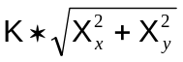. The constant K must be assigned by the user. For instance, in the case of a three phase voltage, the value of K is 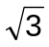.

MODULE CMOD CARD B

Topological data

INPUT-OUTPUT SCHEME

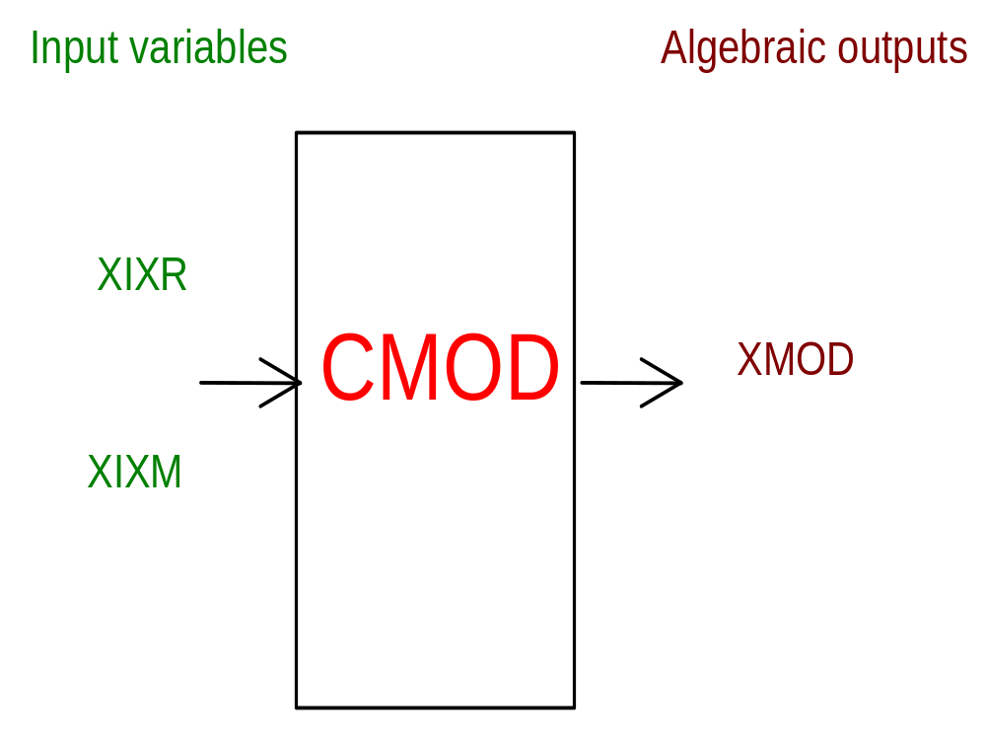

PHYSICAL MEANING OF MODULE INPUT-OUTPUT VARIABLES

[] XIXR real component of the electrical variable
[] XIXM imaginary component of the electrical variable
[] XMOD module of the electrical variable

MODULE CMOD CARD C

Physical and Geometrical Data

In addition to the initial values of input and output variables, user must assign the following data:
[] NORMAL normalization constant for the electrical variable
[] COSTANTE constant that multiplies the module of the variable

MODULE CMOD CARD D

Module Variables Initialization

To initialize the CMOD module variables no particular prescription is required.

MODULE CMOD CARD E

User's Subprograms

No items

MODULE CMOD CARD F

Residuals

- module of the electrical variable (residual nr. 1)

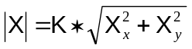

MODULE CMOD CARD G

Module subprograms

No items.

MODULE CMOD CARD H

Test cases

Reference test cases related to this module aren’t yet available.

