#$K+!MODULE COLT CARD 0

Summary

∗ model generalities

∗ topological data

∗ physical and geometrical data

∗ module variables initialization

∗ user's subprograms

∗ residuals

∗ module subprograms

∗ test cases

#$K+!MODULE COLT CARD A

Model Generalities

WATER-STEAM MANIFOLD

The COLT module simulates the perfect mixing of "n" water flow rates (at liquid or steam state) flowing into a distribution header. It determines the enthalpy and pressure temporal evolution of fluid flowing through the header as well as the temperature of the metallic walls.
In the physic-mathematical model the following simplifying hypotheses are adopted:
- it is admitted that fluid back-flow can occur inside one or more header branches (both at inlet and outlet)
- header metallic walls are able to exchange heat with the external environment
- only one temperature value identifies the thermal condition of metallic walls
- the exchange coefficient of fluid inside the header is admitted as a function of the fluid temperature and strenght (while the exchange coefficient at the header outside and in the metallic wall are provided by user: see below).

The used equations are:
1) conservation equation of fluid energy
2) conservation equation of fluid mass
3) conservation equation of metal energy.

They are integrated inside the module and give rise to some residuals which formally represent algebraical equations.

#$K+!MODULE COLT CARD B

Topological data

INPUT-OUTPUT SCHEME

Ne = number of header inlet branches (max.40)
Nu = number of header outlet branches (max.40)
i = 1, 2, ... Ne
j = 1, 2, ... Nu
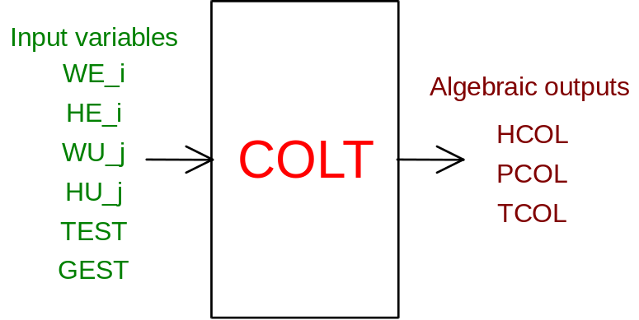

PHYSICAL MEANING OF MODULE INPUT-OUTPUT VARIABLES

[J/kg] HCOL mean enthalpy of fluid in the header
[Pa] PCOL mean pressure of fluid in the header
[K] TCOL header metal temperature
[kg/s] WE_i (i = 1, 2,..., Ne) flow rate of fluid flowing into the header coming through the i-th branch
[J/kg] HE_i (i = 1, 2,..., Ne) enthalpy of fluid flowing into the header coming through the i-th branch
[kg/s] WU_j (j = 1, 2,..., Ne) flow rate of fluid flowing out the header through the j-th branch
[J/kg] HU_j (j = 1, 2,..., Ne) enthalpy of fluid flowing out the header through the j-th branch (in case of back-flow)

Note 1
During the model topology definition user is asked to indicate the number of inlet or outlet pipes in the header to simulate.
In particular on screen the following string appears:
BRANCH POINT OF FLOW RATES
NUMBER OF ENTERING BRANCHES (01 - 40) ?
and when inserted numeric values out of the indicated range the following string appears:
ERROR - N.ENT. =
followed by wrong numerical value.
In this case the first string is presented again so that user can insert the correct value.
Afterwards the following string appears:
NUMBER OF COMING OUT BRANCHES (01 - 40) ?
and, in case, an error signal similar to the above mentioned one.
The information concerning the number of inlet and outlet pipes must be also inserted among the model geometrical data (see below).

#$K+!MODULE COLT CARD C

Physical and Geometrical Data

In addition to initial values of input and output variables (meaning defined above) user must assign the following data:
[ ] NU.TU.EN number of header inlet branches (max.40)
[ ] NU.TU.US number of header outlet branches (max.40)
[m³] VOLUME volume of fluid inside the header
[kg] MASSA ME header metallic mass
[J/k*kg] CP MET. metal specific heat
[W/m*k] COND MET. metal thermal conductivity
[m] SPESSORE header walls thickness
[m²] SUP ES header external surface through which the header thermal exchange occurs

#$K+!MODULE COLT CARD D

Module Variables Initialization

To initialize the COLT module variables no particular prescription is required.

#$K+!MODULE COLT CARD E

User's Subprograms

In the COLT module no user subprograms are foreseen.

#$K+!MODULE COLT CARD F

Residuals

The module mathematical model consists of the equations which give rise to the following residuals:
- under stationary condition
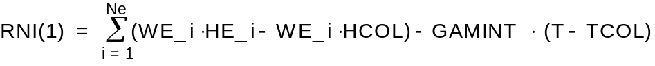
(normalization factor = W0*H0)
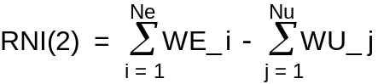
(normalization factor = W0)
RNI(3) = TCOL - (GAMINT*T + GAMEST*TEST) / (GAMINT + GAMEST)
(normalization factor = T0)
where T represents the temperature of fluid contained in the header whereas GAMINT and GAMEST represent the product of header exchange surface for the thermal exchange coefficient.
For GAMINT, T represents the thermal exchange coefficient related to the fluid contained in the header and at half thickness of header wall.
For GAMEST, T represents the thermal exchange coefficient related to the external fluid and at the second half thickness of header wall.

#$K+!MODULE COLT CARD G

Module subprograms

SUBROUTINE COLTI3(IFO, IOB, DEBL)

SUBROUTINE COLTI4(IOB, MOD)

SUBROUTINE COLTI2(IFUN, VAR, MX1, IV1, IV2, XYU, DATI, ID1, ID2,
$ IBL1, IBL2, IER, CNXYU, TOL)

SUBROUTINE COLTC1(IFUN, AJAC, MX5, IXYU, XYU, IPD, DATI, RNI,
$ IBL1, IBL2)

SUBROUTINE COLT(IFUN, IXYU, XYU, IPD, DATI, RNI)

#$K+!MODULE COLT CARD H

Test cases

Reference test cases related to this module are in the manual section dedicated to the examples developed under the abbreviations:
"POMPE"
"RISC_VER"

# lg_libproc_COLT_summ
$ COLT process module
K COLT process module
+ lg_pag_modu:0260
! EnableButton("button_up"); ChangeButtonBinding("button_up", "JumpId(`lglibpro.hlp',`lg_libproc_main')")
# lg_libproc_COLT_A
$ COLT process module (A)
K COLT process module (A)
+ lg_pag_colt:0002
! EnableButton("button_up"); ChangeButtonBinding("button_up", "JumpId(`lglibpro.hlp',`lg_libproc_COLT_summ')")
# lg_libproc_COLT_B
$ COLT process module (B)
K COLT process module (B)
+ lg_pag_colt:0003
! EnableButton("button_up"); ChangeButtonBinding("button_up", "JumpId(`lglibpro.hlp',`lg_libproc_COLT_summ')")
# lg_libproc_COLT_C
$ COLT process module (C)
K COLT process module (C)
+ lg_pag_colt:0005
! EnableButton("button_up"); ChangeButtonBinding("button_up", "JumpId(`lglibpro.hlp',`lg_libproc_COLT_summ')")
# lg_libproc_COLT_D
$ COLT process module (D)
K COLT process module (D)
+ lg_pag_colt:0006
! EnableButton("button_up"); ChangeButtonBinding("button_up", "JumpId(`lglibpro.hlp',`lg_libproc_COLT_summ')")
# lg_libproc_COLT_E
$ COLT process module (E)
K COLT process module (E)
+ lg_pag_colt:0007
! EnableButton("button_up"); ChangeButtonBinding("button_up", "JumpId(`lglibpro.hlp',`lg_libproc_COLT_summ')")
# lg_libproc_COLT_F
$ COLT process module (F)
K COLT process module (F)
+ lg_pag_colt:0008
! EnableButton("button_up"); ChangeButtonBinding("button_up", "JumpId(`lglibpro.hlp',`lg_libproc_COLT_summ')")
# lg_libproc_COLT_G
$ COLT process module (G)
K COLT process module (G)
+ lg_pag_colt:0010
! EnableButton("button_up"); ChangeButtonBinding("button_up", "JumpId(`lglibpro.hlp',`lg_libproc_COLT_summ')")
# lg_libproc_COLT_H
$ COLT process module (H)
K COLT process module (H)
+ lg_pag_colt:0011
! EnableButton("button_up"); ChangeButtonBinding("button_up", "JumpId(`lglibpro.hlp',`lg_libproc_COLT_summ')")

