#$K+!MODULE DAMP CARD 0

Summary

∗ model generalities

∗ topological data

∗ physical and geometrical data

∗ module variables initialization

∗ user's subprograms

∗ residuals

∗ module subprograms

∗ test cases

#$K+!MODULE DAMP CARD A

Model Generalities

AIR-GAS CIRCUIT DAMPER

The DAMP module simulates a plant air-gas circuit damper. The mathematical model consists of only one algebraical equation deriving from the momentum conservation equation which puts in relation the delta P pressure on both sides of the damper and the fluid flow rate flowing through it.
Such delta P pressure is subdivided in two terms. One of them takes into account the pressure drop on the concerned circuit ducts whereas the second one is related to the losses that the damper actually has.
The model main hypotheses are:
- the thermal capacity of damper metal is negligible;
- the isoenthalpic thermodynamic transformation of fluid in the damper;
- the absence of fluid accumulation in the damper
- the validity of perfect gas law;
- the head losses related to the duct are expressed as a function of one quadratic and one linear term in the flow rate.

The module is also applicable in case of back-flow.

#$K+!MODULE DAMP CARD B

Topological data

INPUT-OUTPUT SCHEME

The module can be interconnected with other ones according to the following two methods:
1) output in flow rate
prescription about block name: none
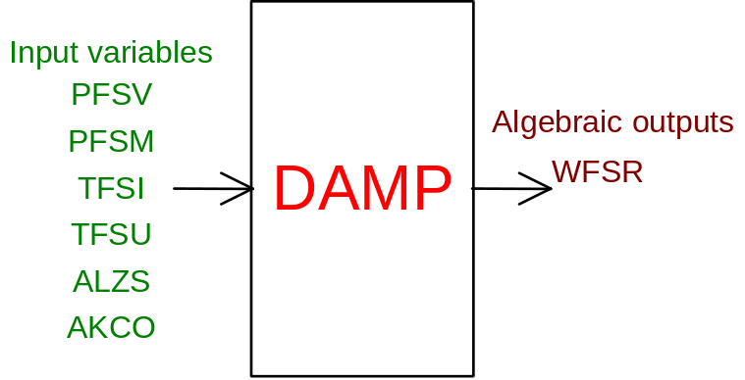

2) output in outlet pressure
prescription about block name: preceded by '-' sign
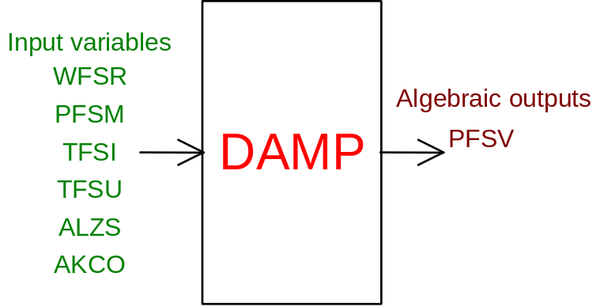

PHYSICAL MEANING OF MODULE INPUT-OUTPUT VARIABLES

[Pa] PFSV fluid pressure at the damper outlet
[Pa] PFSM fluid pressure at the damper inlet
[kg/s] WFSR flow rate of fluid flowing through the damper
[K] TFSI fluid temperature at the damper inlet
[K] TFSU fluid temperature at the damper outlet (used in case of back-flow)
[p.u.] ALZS damper opening degree
[p.u.] AKCO head loss corrective on the duct

#$K+!MODULE DAMP CARD C

Physical and Geometrical Data

In addition to the initial values of input and output variables (meanings defined above), user must assign the following data:
[kg/s] WNOM nominal flow rate of fluid flowing through the damper
[C] TNOM nominal temperature of fluid flowing through the damper
[J/kg*K] RGAS constant used in the perfect gas law or, as alternative, index defining the default value used for air and flue gas respectively (see note).

Data related to the damper
[Pa] DP S NOM pressure drop on the damper under nominal conditions
[m²] AREA cross section area with fully opened damper
[ ] ALFA coefficient used to define the damper characteristic, that is the variation law of SEZ cross section area as a function of the ALZS opening degree following the formula:
SEZ = AREA*ALZS**ALFA.
If user knows the characteristic of the damper supplied by the manufacturer, this can be assigned through the FUNCTION ADNS10(ALZS, ALFA) (see below). In this case to ALFA is assigned any value >10.
NB: at present for ALFA = 11 the equipercentage characteristic is available.

Data related to the duct
[C] DP C NOM pressure drop on the duct under nominal conditions

Note
The perfect gas law is expressed by the state equation:
P*V = n*R*T
where:
P is the gas pressure
V is the gas volume
T is the gas temperature
R is the universal constant
n is the mole number of considered gas
Dividing for the gas mass M we obtain:
P/RO = (n*R/M)*T
where RO is the gas density.
Assuming
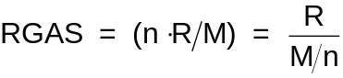
where M/n is the gas molecular mass, we obtain:
P/RO = RGAS*T
The above indicated relation is used to determine the RO gas density as a function of the temperature only, assigning to the pressure a constant value P = 101300. Pa.
For the RGAS datum a default value is foreseen, precisely assuming RGAS = 1, the value RGAS = 287 (air) is used. For RGAS = 2 the value RGAS = 274 (flue gas) is used.
In the DP C NOM are summarized all head losses distributed on the line between two dampers under nominal conditions, whereas DP S NOM provides the pressure drop on the damper when it is fully opened.

#$K+!MODULE DAMP CARD D

Module Variables Initialization

To initialize the DAMP module variables no particular prescription is required.

#$K+!MODULE DAMP CARD E

User's Subprograms

To assign damper characteristic, when user knows those provided by the manufacturer, a user subprogram is needed. Its declarative statement is:
FUNCTION ADNS10(ALZS, ALFA)
Input parameters: ALZS, ALFA
Output parameters: ADNS10
[p.u.] ALZS damper opening degree
[ ] ALFA (>10) parameter, coming from the input data; it can be used as choosing index whether different standard characteristic have to be introduced by one only FUNCTION ADNS10(ALZAS, ALFA).
[p.u.] ADNS10 calculated value of the cross section area. Such value has to be normalized as regards to the cross section area when the damper is fully opened.
Hereinafter the function related to the module equipercentage characteristic is indicated, as example:

FUNCTION ADNS10(Z,ALFA)
DIMENSION X1(12),Y1(12)
LOGICAL IS
DATA X1/0.,.1,.2,.3,.4,.5,.6,.7,.8,.9,1.,1.2/
DATA Y1/0.,.055,.085,.125,.17,.22,.28,.35,.43,.55,.7,1./
DATA IS/.TRUE./ C
IF (IS) THEN
WRITE(6,*)' '
WRITE(6,*)' '
WRITE(6,*)'*** Warning!!! ',
$ ' ***'
WRITE(6,*)'*** Damper characteristic: tabulated ',
$ 'equipercentage ***'
WRITE(6,*)' '
WRITE(6,*)' '
IS=.FALSE.
END IF
CALL ADNSIN(Z,X1,Y1,12,A)
ADNS10=A
RETURN
END
SUBROUTINE ADNSIN(Z,X,Y,NP,A)
DIMENSION X(1),Y(1)
A=0.
IF(Z.LE.X(1))RETURN
A=1.
IF(Z.GE.X(NP))RETURN
DO I=1,NP-1
J=I
IF(Z.GE.X(J).AND.Z.LE.X(J+1))GO TO 15
END DO
15 A=Y(J)+(Z-X(J))*(Y(J+1)-Y(J))/(X(J+1)-X(J))
RETURN
END

#$K+!MODULE DAMP CARD F

Residuals

In the module only one residual is present related to the algebraical equation deriving from the fluid momentum conservation equation, putting in relation the delta P pressure on the two damper sides, with the flow rate flowing through it.
Its expression is:
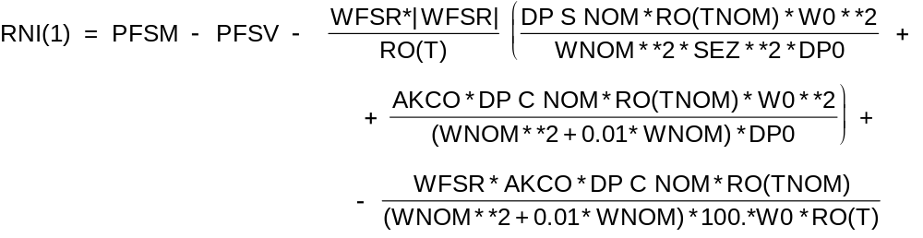

where WNOM, TNOM, RO, DP S NOM, DP C NOM, SEZ, have the physical meaning defined in the section on module's data, whereas remaining variables have that defined in module's variables.

W0 and DP0 are normalization constants.
The residual is normalized as regards to the delta P pressure DP0.

#$K+!MODULE DAMP CARD G

Module subprograms

SUBROUTINE DAMPI3(IFO, IOB, DEBL)

SUBROUTINE DAMPI4(IOB, MOD)

SUBROUTINE DAMPI2(IFUN, VAR, MX1, IV1, IV2, XYU, DATI, ID1, ID2,

SUBROUTINE DAMPC1(IFUN, AJAC, MX5, IXYU, XYU, IPD, DATI, RNI,
$ IBL1, IBL2)

SUBROUTINE DAMP(IFUN, IXYU, XYU, IPD, DATI, RNI)

FUNCTION ADAM10(Z, ALFA)

FUNCTION ADNS10(Z, ALFA)

SUBROUTINE ADNSIN(Z, X, Y, NP, A)

#$K+!MODULE DAMP CARD H

Test cases

Reference test cases related to this module are in the manual section dedicated to the examples developed under the abbreviations:
"ARIAGAS"

# lg_libproc_DAMP_summ
$ DAMP process module
K DAMP process module
+ lg_pag_modu:0380
! EnableButton("button_up"); ChangeButtonBinding("button_up", "JumpId(`lglibpro.hlp',`lg_libproc_main')")
# lg_libproc_DAMP_A
$ DAMP process module (A)
K DAMP process module (A)
+ lg_pag_damp:0002
! EnableButton("button_up"); ChangeButtonBinding("button_up", "JumpId(`lglibpro.hlp',`lg_libproc_DAMP_summ')")
# lg_libproc_DAMP_B
$ DAMP process module (B)
K DAMP process module (B)
+ lg_pag_damp:0003
! EnableButton("button_up"); ChangeButtonBinding("button_up", "JumpId(`lglibpro.hlp',`lg_libproc_DAMP_summ')")
# lg_libproc_DAMP_C
$ DAMP process module (C)
K DAMP process module (C)
+ lg_pag_damp:0005
! EnableButton("button_up"); ChangeButtonBinding("button_up", "JumpId(`lglibpro.hlp',`lg_libproc_DAMP_summ')")
# lg_libproc_DAMP_D
$ DAMP process module (D)
K DAMP process module (D)
+ lg_pag_damp:0006
! EnableButton("button_up"); ChangeButtonBinding("button_up", "JumpId(`lglibpro.hlp',`lg_libproc_DAMP_summ')")
# lg_libproc_DAMP_E
$ DAMP process module (E)
K DAMP process module (E)
+ lg_pag_damp:0007
! EnableButton("button_up"); ChangeButtonBinding("button_up", "JumpId(`lglibpro.hlp',`lg_libproc_DAMP_summ')")
# lg_libproc_DAMP_F
$ DAMP process module (F)
K DAMP process module (F)
+ lg_pag_damp:0008
! EnableButton("button_up"); ChangeButtonBinding("button_up", "JumpId(`lglibpro.hlp',`lg_libproc_DAMP_summ')")
# lg_libproc_DAMP_G
$ DAMP process module (G)
K DAMP process module (G)
+ lg_pag_damp:0010
! EnableButton("button_up"); ChangeButtonBinding("button_up", "JumpId(`lglibpro.hlp',`lg_libproc_DAMP_summ')")
# lg_libproc_DAMP_H
$ DAMP process module (H)
K DAMP process module (H)
+ lg_pag_damp:0011
! EnableButton("button_up"); ChangeButtonBinding("button_up", "JumpId(`lglibpro.hlp',`lg_libproc_DAMP_summ')")

