#$K+!MODULE DEGN CARD 0

Summary

∗ model generalities

∗ topological data

∗ physical and geometrical data

∗ module variables initialization

∗ user's subprograms

∗ residuals

∗ module subprograms

∗ test cases

#$K+!MODULE DEGN CARD A

Model Generalities

DEAERATOR WITH ONE PRESSURE NODE

The DEGN module simulates the dynamics of thermo-hydraulic phenomena which the liquid-steam mixture contained in a degasifier cavity is subjected to.
To define the module mathematical model, the volume engaged by the fluid is subdivided in the following zones:
- upper zone identified as "steam zone"
- lower zone identified as "liquid zone"
In these zones, that may not be in thermodynamic equilibrium, water can be present as a two-phase mixture. So, it is possible to consider:
- the condensation flow rate proportional to the mass of liquid present in the steam zone
- the evaporation flow rate proportional to the mass of steam present in the liquid zone
To take into account the power exchanged by degasifier feeding liquid with the steam present into the dome, it is supposed that (whatever the conditions are at the degasifier inlet), the feeding liquid exchanges with the steam inside dome the power needed to reach saturation conditions.
Further hypotheses introduced in the module are:
- absence of incondensable gas
- the thermal exchange between fluid and cavity walls is negligible
- the distribution of pressure and enthalpy in the steam zone is uniform
- the distribution of enthalpy in the liquid zone is uniform.
Hereinafter the utilized equations are indicated with the same programming order:
1) the conservation equation of energy in the liquid zone
2) the conservation equation of energy in the steam zone
3) the conservation equation of mass in the liquid zone
4) the conservation equation of mass in the steam zone
5) the equation for pressure calculation on the cavity bottom.
The first four equations are differential whereas the fifth one is algebraical.
The equation 5) (useful for a correct evaluation of NPSH concerning the liquid extraction pump) is formulated for a cylindrical cavity having horizontal axis, considering this geometry the most common one used in manufacturing of degasifier collecting tanks. User must supply the characteristic dimensions of the cavity among the input data required in the DEGN module (see below).
It is useful to note that it is possible to simulate both the heating phase of degasifier during start-up and pumps recirculation.

#$K+!MODULE DEGN CARD B

Topological data

INPUT-OUTPUT SCHEME

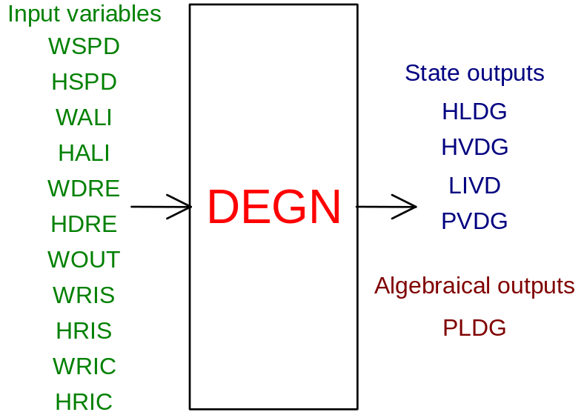

PHYSICAL MEANING OF MODULE INPUT-OUTPUT VARIABLES

[kg/s] WSPD flow rate of steam bled from the turbine and supplied into the degasifier dome
[J/kg] HSPD enthalpy of steam bled from the turbine and supplied into the degasifier dome
[kg/s] WALI flow rate of feedwater to the dome
[J/kg] HALI enthalpy of feedwater to the dome
[kg/s] WDRE flow rate of drainages flowing into the degasifier
[J/kg] HDRE enthalpy of drainages flowing into the degasifier
[kg/s] WOUT flow rate of liquid flowing out from the tank
[kg/s] WRIS flow rate of steam flowing into the tank during start-up phase
[J/kg] HRIS enthalpy of steam flowing into the tank during start-up phase
[kg/s] WRIC flow rate of liquid flowing into the tank coming from the recirculation of boiler feed pumps
[J/kg] HRIC enthalpy of liquid flowing into the tank coming from the recirculation of boiler feed pumps
[Pa] PVDG pressure of steam in the tank
[J/kg] HVDG enthalpy of steam in the tank
[J/kg] HLDG enthalpy of liquid in the tank
[m] LIVD level of liquid inside the tank
[Pa] PLDG pressure on the tank bottom (condensate outlet)

#$K+!MODULE DEGN CARD C

Physical and Geometrical Data

In addition to the initial values of input and output variables (meanings defined above), user must assign the following data:
[m³] VOL.CAV. internal volume available for the fluid (dome volume + tank volume - internal parts volume)
[m] D. SERB. tank internal diameter
[m] L. SERB. tank internal length.

#$K+!MODULE DEGN CARD D

Module Variables Initialization

To initialize the DEGN variables no particular prescription is required.

#$K+!MODULE DEGN CARD E

User's Subprograms

In the DEGN module no user subprograms are foreseen.

#$K+!MODULE DEGN CARD F

Residuals

The equations, mentioned above, give rise to the following residuals:
RNI(1) = WDRE*(HDRE-HLDG)+(QC+WALI)*(HLS-HLDG)-QEV*(HVS-HLDG)+
+QSUP+WRIC*(HRIC-HLDG)-WOUT*(HLS-HL)
(normalization factor = W0*H0)
RNI(2) = WSPD*(HSPD-HVDG)+WRIS*(HRIS-HVDG)+QEV*(HVS-HVDG)+
-QC*(HLS-HVDG)+QQ-QSUP
(normalization factor = W0*H0)
RNI(3) = WDRE+QC-WOUT-QEV+WRIC+WALI
(normalization factor = W0)
RNI(4) = WSPD+WRIS+QEV-QC
(normalization factor = W0)
RNI(5) = PLDG-PVDG-9.80665*ROWS*LIVD/P0
(normalization factor = P0)
Where:
QC is the condensation flow rate
HLS is the enthalpy of saturated liquid
QEV is the evaporation flow rate
HWS is the enthalpy of saturated steam
QSUP is the thermal power exchanged through liquid-steam separation surface
QQ is the power given up from saturated steam to the dome feed liquid
ROWS is the density of saturated liquid
The physical meanings of remaining variables are defined above.
Further explanations about the quantities of above-mentioned meanings are available in the section concerning the DEGN module of the manual "LEGOCAD - Modelling Library for Simulation of Power Generation Plants - Theory".

#$K+!MODULE DEGN CARD G

Module subprograms

SUBROUTINE DEGNI3(IFO, IOB, DEBL)

SUBROUTINE DEGNI4(IOB, MOD)

SUBROUTINE DEGNI2(IFUN, VAR, MX1, IV1, IV2, XYU, DATI, ID1, ID2,
$ IBL1, IBL2, IER, CNXYU, TOL)

SUBROUTINE DEGNC1(IFUN, AJAC, MX5, IXYU, XYU, IPD, DATI, RNI,
$ IBL1, IBL2)

SUBROUTINE DGNDEC(P, HL, HV, Y, PF, QV, HVI, QCOND, HCOND, QDR,
$ HDR, QEC, QVV, HVV, QWR, HWR, VCAV, RSERB,
$ ALSERB, XYU, IXYU, DATI, IPD)

SUBROUTINE DGNTAV(P, HL, HV, ROL, ROV, ROWS, BELI, BEVA, A2LI,
$ A2VA, XL, XV, TLS, TV, HLS, HVS, PF)

SUBROUTINE DGNTYP(Y, VL, DVLDY, RSERB, ALSERB)

SUBROUTINE DGNTAU(A2LI, BELI, ROL, TLS, A2VA, BEVA, ROV, TV, Y,
$ VCAV, VL, DVLDY, TAU11, TAU14, TAU22, TAU24,
$ TAU31, TAU33, TAU34, TAU42, TAU43, TAU44)

SUBROUTINE DGNDER(P, HL, HV, Y, PF, QV, HVI, QCOND, HCOND, QDR,
$ HDR, QEC, QVV, HVV, QWR, HWR, VCAV, RSERB,
$ ALSERB, VL, DVLDY, ROL, ROV, ROWS, XL, XV,
$ HLS, HVS, TLS, TV, IFUN, TAU11, TAU14, TAU22,
$ TAU24, TAU31, TAU33, TAU34, TAU42, TAU43,
$ TAU44, DATI, IPD, RNI)

SUBROUTINE DGNSOL(A11, A14, A22, A24, A31, A33, A34, A42,
$ A43, A44, B1, B2, B3, B4, X1, X2, X3, X4)

SUBROUTINE DGNJAC(AJAC, MX5, IXYU, XYU, DATI, IPD, RNI, IFUN)

#$K+!MODULE DEGN CARD H

Test cases

Reference test cases concerning this module are in the user manual section dedicated to the examples developed under the abbreviations:
"DEG_S_L"

# lg_libproc_DEGN_summ
$ DEGN process module
K DEGN process module
+ lg_pag_modu:0420
! EnableButton("button_up"); ChangeButtonBinding("button_up", "JumpId(`lglibpro.hlp',`lg_libproc_main')")
# lg_libproc_DEGN_A
$ DEGN process module (A)
K DEGN process module (A)
+ lg_pag_degn:0002
! EnableButton("button_up"); ChangeButtonBinding("button_up", "JumpId(`lglibpro.hlp',`lg_libproc_DEGN_summ')")
# lg_libproc_DEGN_B
$ DEGN process module (B)
K DEGN process module (B)
+ lg_pag_degn:0003
! EnableButton("button_up"); ChangeButtonBinding("button_up", "JumpId(`lglibpro.hlp',`lg_libproc_DEGN_summ')")
# lg_libproc_DEGN_C
$ DEGN process module (C)
K DEGN process module (C)
+ lg_pag_degn:0005
! EnableButton("button_up"); ChangeButtonBinding("button_up", "JumpId(`lglibpro.hlp',`lg_libproc_DEGN_summ')")
# lg_libproc_DEGN_D
$ DEGN process module (D)
K DEGN process module (D)
+ lg_pag_degn:0006
! EnableButton("button_up"); ChangeButtonBinding("button_up", "JumpId(`lglibpro.hlp',`lg_libproc_DEGN_summ')")
# lg_libproc_DEGN_E
$ DEGN process module (E)
K DEGN process module (E)
+ lg_pag_degn:0007
! EnableButton("button_up"); ChangeButtonBinding("button_up", "JumpId(`lglibpro.hlp',`lg_libproc_DEGN_summ')")
# lg_libproc_DEGN_F
$ DEGN process module (F)
K DEGN process module (F)
+ lg_pag_degn:0008
! EnableButton("button_up"); ChangeButtonBinding("button_up", "JumpId(`lglibpro.hlp',`lg_libproc_DEGN_summ')")
# lg_libproc_DEGN_G
$ DEGN process module (G)
K DEGN process module (G)
+ lg_pag_degn:0010
! EnableButton("button_up"); ChangeButtonBinding("button_up", "JumpId(`lglibpro.hlp',`lg_libproc_DEGN_summ')")
# lg_libproc_DEGN_H
$ DEGN process module (H)
K DEGN process module (H)
+ lg_pag_degn:0011
! EnableButton("button_up"); ChangeButtonBinding("button_up", "JumpId(`lglibpro.hlp',`lg_libproc_DEGN_summ')")

