#$K+!MODULE DISN CARD 0

Summary

∗ model generalities

∗ topological data

∗ physical and geometrical data

∗ module variables initialization

∗ user's subprograms

∗ residuals

∗ module subprograms

∗ test cases

#$K+!MODULE DISN CARD A

Model Generalities

LINEAR ALGEBRAIC EQUATIONS

In the DISN module, differently from most of LEGOCAD library modules, the coded equations do not represent the physical-mathematical model of a given plant component, but a set of linear algebraical relations (max 30) of the following kind:
Xu(j) = K * Xi (j = 1, 2, ..., n)
Once the K coefficient and the Xi variable values have been assigned, the module determines the Xu(j) variables values.
During the topology construction activity, the module requires an alphanumeric character that will be used as the initial character of the FORTRAN symbol adopted for the Xu(j) output variables.
In the following paragraph the function of such a character is carried out by the letter "U".

#$K+!MODULE DISN CARD B

Topological data

INPUT-OUTPUT SCHEME

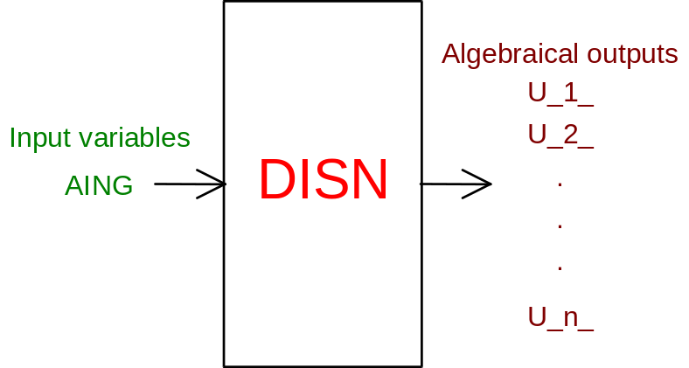
n = number of output variables (max 30)

PHYSICAL MEANING OF MODULE INPUT-OUTPUT VARIABLES

[ ] U_1_, ..., U_n_ variables to be calculated
[ ] AING known variable

#$K+!MODULE DISN CARD C

Physical and Geometrical Data

In addition to initial values of DISN module input and output variables (meanings defined above), user must assign the following data set to complete the module input on the file F14:
[ ] NORM alphanumeric value identifying the normalization factor of the input variable (also used to normalize the output variables) according to the following rule:
blank = 1.
W0 = default value for flow rates
H0 = default value for enthalpies
T0 = default value for temperatures
P0 = default value for pressures
Q0 = default value for powers (= W0 * H0)
RO0 = default value for densities
AL0 = default value for lengths
V0 = default value for volumes
DP0 = default value for pressure differences
numeric value = value to be used as normalization factor
[ ] COEF input variable coefficient.

#$K+!MODULE DISN CARD D

Module Variables Initialization

To initialize the DISN module variables on the file F14, no particular prescription is required.

#$K+!MODULE DISN CARD E

User's Subprograms

No user subprograms are present in the DISN module.

#$K+!MODULE DISN CARD F

Residuals

The linear algebraical equation, quoted in first paragraph, gives rise to the following residuals:
RNI(j) = U_j_ - COEF * AING (j = 1, 2,..., n)
(normalization factor = NORM)
where U_j_ are the output variables to be calculated, AING is the known input variable, COEF and NORM are defined above.

#$K+!MODULE DISN CARD G

Module subprograms

SUBROUTINE DISNI2(IFUN,VAR,MX1,IV1,IV2,XYU,DATI,ID1,ID2,
$ IBL1,IBL2,IER,CNXYU,TOL)

SUBROUTINE DISNC1(IFUN,AJAC,MX5,IXYU,XYU,IPD,DATI,RNI,IBL1,IBL2)

SUBROUTINE DISNJAC(IFUN,AJAC,MX5,IXYU,XYU,IPD,DATI,RNI,IBL1,IBL2)

SUBROUTINE DISN(IFUN,IXYU,XYU,IPD,DATI,RNI)

SUBROUTINE DISNI3(IFO,IOB,DEBL)

SUBROUTINE DISNI4(IOB,MOD)

#$K+!MODULE DISN CARD H

Test cases

Reference test cases related to this module are reported in the user manual section devoted to the examples developed under the abbreviation:
"ARIAGAS"

# lg_libproc_DISN_summ
$ DISN process module
K DISN process module
+ lg_pag_modu:0460
! EnableButton("button_up"); ChangeButtonBinding("button_up", "JumpId(`lglibpro.hlp',`lg_libproc_main')")
# lg_libproc_DISN_A
$ DISN process module (A)
K DISN process module (A)
+ lg_pag_disn:0002
! EnableButton("button_up"); ChangeButtonBinding("button_up", "JumpId(`lglibpro.hlp',`lg_libproc_DISN_summ')")
# lg_libproc_DISN_B
$ DISN process module (B)
K DISN process module (B)
+ lg_pag_disn:0003
! EnableButton("button_up"); ChangeButtonBinding("button_up", "JumpId(`lglibpro.hlp',`lg_libproc_DISN_summ')")
# lg_libproc_DISN_C
$ DISN process module (C)
K DISN process module (C)
+ lg_pag_disn:0005
! EnableButton("button_up"); ChangeButtonBinding("button_up", "JumpId(`lglibpro.hlp',`lg_libproc_DISN_summ')")
# lg_libproc_DISN_D
$ DISN process module (D)
K DISN process module (D)
+ lg_pag_disn:0006
! EnableButton("button_up"); ChangeButtonBinding("button_up", "JumpId(`lglibpro.hlp',`lg_libproc_DISN_summ')")
# lg_libproc_DISN_E
$ DISN process module (E)
K DISN process module (E)
+ lg_pag_disn:0007
! EnableButton("button_up"); ChangeButtonBinding("button_up", "JumpId(`lglibpro.hlp',`lg_libproc_DISN_summ')")
# lg_libproc_DISN_F
$ DISN process module (F)
K DISN process module (F)
+ lg_pag_disn:0008
! EnableButton("button_up"); ChangeButtonBinding("button_up", "JumpId(`lglibpro.hlp',`lg_libproc_DISN_summ')")
# lg_libproc_DISN_G
$ DISN process module (G)
K DISN process module (G)
+ lg_pag_disn:0010
! EnableButton("button_up"); ChangeButtonBinding("button_up", "JumpId(`lglibpro.hlp',`lg_libproc_DISN_summ')")
# lg_libproc_DISN_H
$ DISN process module (H)
K DISN process module (H)
+ lg_pag_disn:0011
! EnableButton("button_up"); ChangeButtonBinding("button_up", "JumpId(`lglibpro.hlp',`lg_libproc_DISN_summ')")

