#$K+!MODULE FUMN CARD 0

Summary

∗ model generalities

∗ topological data

∗ physical and geometrical data

∗ module variables initialization

∗ user's subprograms

∗ residuals

∗ module subprograms

∗ test cases

#$K+!MODULE FUMN CARD A

Model Generalities

GAS DUCT EXCHANGER

The FUMN module simulates the thermal exchange between the combustion flue gas flowing through a duct and the external surface of several elements which (also belonging to the duct itself) can have mean temperatures considerably different.
The module is used in carrying out models of radiance boiler for taking into account all thermal exchanges between flue gas flowing out from the combustion furnace and all the elements (thermal shields, pipe benches etc.) with which have contact before coming out from the boiler.
Simplifying hypotheses used in definition of physic-mathematical model are the following:
- duct which flue gas are flowing through is subdivided in cells (max.9) along motion direction
- in each cell flue gas can exchange with several surfaces (max.6) having different mean temperatures
- flue gas arise from combustion of fuel oil
- convective thermal exchange can occur as cross-flow or long-flow
- in radiative thermal exchange the contribution coming from flue gas among bench pipes is only taken into account (inter-tube radiation). Contribution coming from flue gas inside the cavities interposed among pipe benches (cavity radiation) are not considered.
- all accumulation phenomena are not considered.
The used equations are:
- conservation equation of flue gas energy
- conservation equation of flue gas mass
- equation of thermal exchange between flue gas and surfaces.
Not considering all accumulation phenomena, all mentioned equations are algebraical.

#$K+!MODULE FUMN CARD B

Topological data

INPUT-OUTPUT SCHEME

Nc = number of cells (max.9) in which the duct is subdivided
Np(i) = number of surfaces (max.6) exchanging heat with flue gas flowing through the i-th duct cell
i = 1, 2, ... Nc
j = 1, 2, ... Np(i)
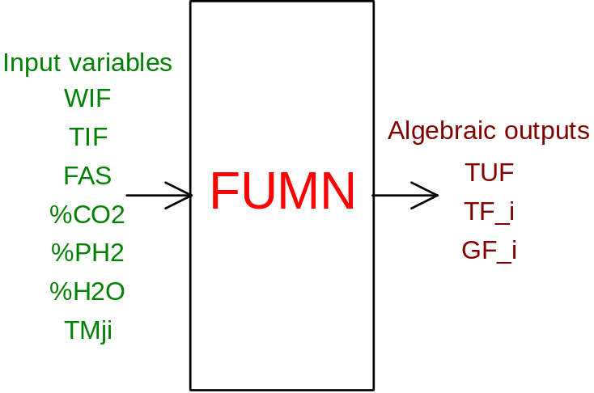

PHYSICAL MEANING OF MODULE INPUT-OUTPUT VARIABLES

[K] TUF flue gas temperature at the duct outlet
[K] TF_i (i = 1, 2,..., Nc) mean temperature of flue gas flowing through the i-th cell
[W/m²/K] GF_i total thermal exchange coefficient (convective + radiative) between exchange total surface in the i-th cell and flue gas flowing through it
[kg/s] WIF flow rate of flue gas flowing through the duct
[K] TIF flue gas temperature at the duct inlet
[ ] FAS dirty factor of bench pipes
[%] %CO2 partial pressure of CO2 present in the flue gas
[%] %PH2 partial pressure of H2O present in the flue gas
[%] %H2O mass fraction of H2O present in the flue gas
[K] TMji mean temperature of the j-th surface exchanging heat with flue gas flowing through the i-th cell

#$K+!MODULE FUMN CARD C

Physical and Geometrical Data

In addition to initial values of the FUMN module input and output variables (meanings defined above), user must assign the following data:
[ ] NTUB number of pipes forming the bench
[m] DIAE external diameter of bench pipes
[m] LUNG length of bench pipes
[m] PASP transverse row pitch (at the right angle to the direction of flue gas flow) of bench pipes
[m] PASL longitudinal row pitch (along direction of the flue gas flow) of bench pipes
[m²] SCAN cell transverse cross section area
[ ] FA geometrical arrangement factor of bench pipes (see note)
[m²] SUP.j (j = 1, ..., 6) area of the j-th surface exchanging heat with flue gas flowing through the cell (if such value is negative the exchange is long-flow type).
When several consecutive cells have the same geometrical data, it is enough to assign those related to the first one. To the remaining cells the same data are automatically assigned.

Note
In physic-mathematical model encoded in the module both cross-flow and long-flow convective exchanges are taken into account.
FA is a non dimensional factor both depending on flue gas flow in the cell and geometrical arrangement of exchanger bench pipes.
In particular FA is a function type:
FA = FA(Re, PASL/DIAE, PASP/DIAE)
where for 2000. < Re < 40000., 1. < PASL/DIAE < 2. and 1. < PASP/DIAE < 6., assumes the values within interval [0.3, 1.1].
In the physic-mathematical model such factor (called arrangement factor) is considered as constant.
When a cell exchanges only (or prevalently) with one or several shields (only one row of pipes), user have to assign to FA unitary value (FA = 1.) and to PASL a negative value (PASL < 0. is equivalent to impose zero the radiative thermal exchange coefficient).

#$K+!MODULE FUMN CARD D

Module Variables Initialization

To initialize the FUMN module variables no particular prescription is required.

#$K+!MODULE FUMN CARD E

User's Subprograms

In the FUMN module no user programs are foreseen.

#$K+!MODULE FUMN CARD F

Residuals

Equations forming the module mathematical model give rise to a residual set whose are only indicated their respective normalization factor.
Further explanation are given in the related section of the manual "LEGOCAD - Modelling Library for Simulation of Power Generation Plants - Theory".
i = 1, 2, ..., Nc
RNI(1) normalization factor = T0
RNI(1+i) normalization factor = Q0
RNI(1+Nc+i) normalization factor = 1000.

#$K+!MODULE FUMN CARD G

Module subprograms

SUBROUTINE FUMNI3(IFO, IOB, DEBL)

SUBROUTINE FUMNI4(IOB, MOD)

SUBROUTINE FUMNI2(IFUN, VAR, MX1, IV1, IV2, XYU, DATI, ID1, ID2,
$ IBLOC1, IBLOC2, IER, CNXYU, TOL)

SUBROUTINE FUMNC1(IFUN, AJAC, MX5, IXYU, XYU, IPD, DATI, RNI,
$ IBLOC1, IBLOC2)

SUBROUTINE FUMN(IFUN, IXYU, XYU, IPD, DATI, RN)

#$K+!MODULE FUMN CARD H

Test cases

Reference test cases related to this module are in the manual section dedicated to the examples developed under the abbreviations:
"....module application example not available yet..."

# lg_libproc_FUMN_summ
$ FUMN process module
K FUMN process module
+ lg_pag_modu:0560
! EnableButton("button_up"); ChangeButtonBinding("button_up", "JumpId(`lglibpro.hlp',`lg_libproc_main')")
# lg_libproc_FUMN_A
$ FUMN process module (A)
K FUMN process module (A)
+ lg_pag_FUMN:0002
! EnableButton("button_up"); ChangeButtonBinding("button_up", "JumpId(`lglibpro.hlp',`lg_libproc_FUMN_summ')")
# lg_libproc_FUMN_B
$ FUMN process module (B)
K FUMN process module (B)
+ lg_pag_FUMN:0003
! EnableButton("button_up"); ChangeButtonBinding("button_up", "JumpId(`lglibpro.hlp',`lg_libproc_FUMN_summ')")
# lg_libproc_FUMN_C
$ FUMN process module (C)
K FUMN process module (C)
+ lg_pag_FUMN:0005
! EnableButton("button_up"); ChangeButtonBinding("button_up", "JumpId(`lglibpro.hlp',`lg_libproc_FUMN_summ')")
# lg_libproc_FUMN_D
$ FUMN process module (D)
K FUMN process module (D)
+ lg_pag_FUMN:0006
! EnableButton("button_up"); ChangeButtonBinding("button_up", "JumpId(`lglibpro.hlp',`lg_libproc_FUMN_summ')")
# lg_libproc_FUMN_E
$ FUMN process module (E)
K FUMN process module (E)
+ lg_pag_FUMN:0007
! EnableButton("button_up"); ChangeButtonBinding("button_up", "JumpId(`lglibpro.hlp',`lg_libproc_FUMN_summ')")
# lg_libproc_FUMN_F
$ FUMN process module (F)
K FUMN process module (F)
+ lg_pag_FUMN:0008
! EnableButton("button_up"); ChangeButtonBinding("button_up", "JumpId(`lglibpro.hlp',`lg_libproc_FUMN_summ')")
# lg_libproc_FUMN_G
$ FUMN process module (G)
K FUMN process module (G)
+ lg_pag_FUMN:0010
! EnableButton("button_up"); ChangeButtonBinding("button_up", "JumpId(`lglibpro.hlp',`lg_libproc_FUMN_summ')")
# lg_libproc_FUMN_H
$ FUMN process module (H)
K FUMN process module (H)
+ lg_pag_FUMN:0011
! EnableButton("button_up"); ChangeButtonBinding("button_up", "JumpId(`lglibpro.hlp',`lg_libproc_FUMN_summ')")

