MODULE GENE CARD 0

Summary

∗ model generalities

∗ topological data

∗ physical and geometrical data

∗ module variables initialization

∗ user's subprograms

∗ residuals

∗ module subprograms

∗ test cases

MODULE GENE CARD A

Model Generalities

SYNCHRONOUS GENERATOR

The GENE module simulates the operation of a three-phase synchronous generator of the third order.

In the mathematical model, the following hypothesis are assumed:

1) hysteresis and magnetic saturations are not considered;
2) the field circuit acts according to the direct axis;
3) there is a damper circuit according to the direct axis and one according to axis in quadrature;
4) distributions of magnetomotive forces and of flows are sinusoidal to the entrefer;
5) the homopolar circuit is neglected;
6) transformer emfs are neglected;
7) subtransient emf time variations are neglected.

Including these simplifications a model of the third order is obtained in which state outputs are SFAS and E1Q0.

The generator model here reported may be a reference synchronous generator, or it may be referred to the absolute one, depending on the value of STIP input variable (for STIP=0 it is a reference generator, for STIP=1 it is referred to the absolute one)

MODULE GENE CARD B

Topological data

INPUT-OUTPUT SCHEME

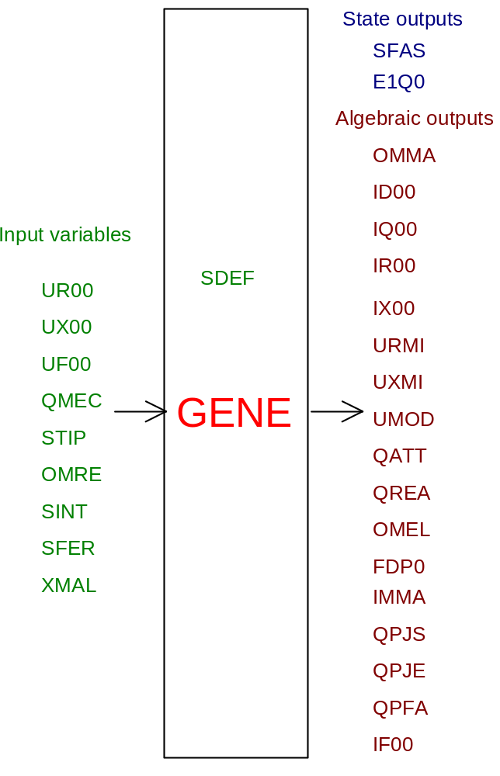

PHYSICAL MEANING OF THE MODULE INPUT OUTPUT VARIABLES

[rad] SFAS angle between rotor and network
[p.u.] E1QO transient voltage according to axis in quadrature
[rad/s] OMMA rotor angular speed
[pum] ID00 component according to current direct axis
[pum] IQ00 component according to current axis in quadrature
[A] IR00 real output current
[A] IX00 imaginary output current
[V] UR00 real voltage before generator circuit breaker
[V] UX00 imaginary voltage before generator circuit breaker
[V] UMOD module of voltage before generator circuit breaker
[W] QATT active output power
[VAR] QREA reactive output power
[rad/s] OMEL generator pulsation
[ ] FDP0 power factor
[%] IMMA current output with respect to the rated one
[W] QPJS stator joule losses
[W] QPJE excitation joule losses. Whenever RECC (or IEBA) are not known, excitation losses are estimated equal to:
QPJE = .0015*QNOM
[W] QPFA power lost in iron
[A] IF00 excitation current
[V] UR00 actual phase voltage at terminals
[V] UX00 imaginary phase voltage at terminals
[V ] UF00 excitation voltage
[W] QMEC turbine mechanical capacity
[] STIP for STIP=0 the generator is the reference one; for STIP=1 the generator is referred to the absolute one
[rad/s] OMRE electrical grid frequency
[] SINT gen. circuit breaker (SINT=0 open; SINT=1 closed)
[] SFER for SFER=1 the generator is in shutdown or tripped
[] XMAL malfunction index (for XMAL=0 the generator is ok, for XMAL=1 a malfunction of gen. circuit breaker causes its opening)

MODULE GENE CARD C

Physical and Geometrical Data

In addition to the initial values of input and output variables of the GENE module, whose meaning has been defined in card B1, the user must assign the following set of data to complete the input required by the module:
[V] VBASE system basic voltage between lines
[rad/s] OMBA system basic pulsation
[W] QNOM rated apparent capacity of the generator set
[W] QBASE system basic power
[ ] CPOLI number of poles (if not indicated, it is assumed equal to 2)
[pum] XD direct axis synchronous reactance
[pum] X1D direct axis transient reactance
[pum] XQ synchronous reactance axis in quadrature
[s] T1D0 transient time constant according to direct axis in no-load conditions
[s] TA unit starting time
[A] I0F excitation current relevant to rated no-load voltage, with linear magnetic circuit.
[ohm] RECC resistance of the excitation circuit
[ohm] RSTA statoric phase resistance. If RSTA is not indicated, then it is assumed equal to RSTA = .0016*QNOM/3./INOM**2
[W] QPFER losses in iron at rated voltage. If QFER is not indicated, it is assumed equal to QFER = .0016*QNOM

The machine per unit is indicated with pum, that is the one calculated with the alternator rated values.

If one of the following data is null XD,X1D,X2D,XQ,X2Q,T1D0,T2D,T2Q,TA, all are fixed on the basis of the rated equipment capacity QNOM according to the following scheme:

QNOM < 150 150<QNOM<250 250<QNOM<500 QNOM > 500
XD 1. 2. 1.9 2.5
X1D .3 .2 .302 .25
XQ .7 2. 1.7 2.35
T1D0 5. 7. 8. 7.5
TA 7. 9. 8. 8.

where QNOM is in MVA

MODULE GENE CARD D

Module Variables Initialization

No particular prescription is required for the GENE module initialization.

MODULE GENE CARD E

User's Subprograms

No user’s subprogram is required in the GENE module.

MODULE GENE CARD F

Residuals

The equations of the mathematical model, mentioned in Card A, give the following residuals:
If STIP=0
RNI(1) = 0.05*(6.28–SFAS)
If STIP =1
RNI(1) = OMBA*(OMMA-OMRE)

RNI(2) = -A4*E1Q0-A5*ID00+A4*VF00
where
A4 = 1./T1D0
A5 = (XD-X1D)/T1D0
QVENT=.0016

RNI(3) = (QMEC-QATT-(QVENT*OMMA**2)-QPJS-QPFA)*(1./(TA*OMMA))

If STIP = 0
RNI(4) =(UXMI*SQRT(3.)/OMMA)-E1Q0+X1D*ID00
RNI(5) =(URMI*SQRT(3.)/OMMA)-XQ*IQ00

If SINT=1
RNI(6) =IR00-ID00/SQRT(3.)+URMI*GTOT
RNI(7) =IX00-IQ00/SQRT(3.)+UXMI*GTOT
RNI(8) =URMI-UR00
RNI(9) =UXMI-UX00

where
QAUX= SQRT(QATT**2+QREA**2)
QADD= .0016*QAUX
RFER= VBASE**2/QPFER
GADD= QADD/VBASE**2
GFER= 1./RFER
GTOT= GFER+GADD

If SINT=0
RNI(6) =IR00
RNI(7) =IX00
RNI(8) =URMI-ID00/SQRT(3.)/GTOT
RNI(9) =UXMI-IQ00/SQRT(3.)/GTOT

If STIP=1, defining

VD00=(URMI*(COS(SFAS))+UXMI*(SIN(SFAS)))*SQRT(3.)
VQ00=(UXMI*(COS(SFAS))-URMI*(SIN(SFAS)))*SQRT(3.)
IR10=(ID00*(COS(SFAS))-IQ00*(SIN(SFAS)))/SQRT(3.)
IX10=(IQ00*(COS(SFAS))+ID00*(SIN(SFAS)))/SQRT(3.)

we have:

RNI(4) =(VQ00/OMMA)-E1Q0+X1D*ID00
RNI(5) =(VD00/OMMA)-XQ*IQ00

If SINT=1
RNI(6) =IR00-IR10+URMI*GTOT
RNI(7) =IX00-IX10+UXMI*GTOT
RNI(8) =URMI-UR00
RNI(9) =UXMI-UX00
If SINT=0
RNI(6) =IR00
RNI(7) =IX00
RNI(8) =URMI-IR10/GTOT
RNI(9) =UXMI-IX10/GTOT

The remaining residuals are:

RNI(10) =UMOD-SQRT(3.*(URMI*URMI+UXMI*UXMI))
RNI(11) =QATT-3.*(UR00*IR00+UX00*IX00)
RNI(12) =QREA-3.*(UX00*IR00-UR00*IX00)
RNI(13) =OMEL-OMMA*CPOLI

If QATT>0 then
RNI(14)= FDP0-(QATT/QAUX)

else:
RNI(14)= FDP0

RNI(15) =IMMA-(SQRT(IR00**2+IX00**2)/INOM)
RNI(16) =QPJS-3.*(RSTA*((IR00+URMI*GTOT)**2+(IX00+UXMI*GTOT)**2))
RNI(17) =QPJE-(RECC*(IF00*I0F)**2)
RNI(18) =QPFA-3.*(URMI**2+UXMI**2)*GTOT
RNI(19) =IF00-VF00

MODULE GENE CARD G

Module subprograms

SUBROUTINE GENEI2 (IFUN,VAR,MX1,IV1,IV2,XYU,DATI,ID1,ID2,
IBL1,IBL2,IER,CNXYU,TOL)
SUBROUTINE GENEC1 (IFUN,AJAC,MX5,IXYU,XYU,IPD,DATI,RNI,IBL1,IBL2)
SUBROUTINE GENEJC (IFUN,AJAC,MX5,IXYU,XYU,IPD,DATI,RNI,IBL1,IBL2)
SUBROUTINE GENE (IFUN,IXYU,XYU,IPD,DATI,RNI)
SUBROUTINE GENEI3 (IFO,IOB,DEBL)
SUBROUTINE GENEI4 (IOB,MOD)
SUBROUTINE GENED1 (BLOCCO,NEQUAZ,NSTATI,NUSCIT,NINGRE,SYMVAR,XYU,
IXYU,DATI,IPD,SIGNEQ,UNITEQ,COSNOR,ITOPVA,MXT)

MODULE GENE CARD H

Test cases

