MODULE LINA CARD 0

Summary

∗ model generalities

∗ topological data

∗ physical and geometrical data

∗ module variables initialization

∗ user's subprograms

∗ residuals

∗ module subprograms

∗ test cases

MODULE LINA CARD A

Model Generalities

PI-LINE

The LINA module simulates the operation of a three-phase line having adjustable length, acting on the KLIN variable.
The module employs the representation of a line phase with π circuit Cross parameters consist of conductance equivalent to losses which are proportional to the square of voltage and capacitive susceptance of the line considered as a “capacitor”.
The longitudinal impedence consists of the line total resistance and reactance.
The module can simulate a line where the wave propagation phenomenon is neglectable, that is all lines defined “short” ones.
As far as the LINA use is concerned, there is no particular warning.
The line output frequency (OMLU) can be used to determine the status of the switches of the line itself. In fact it is put equal to zero in the case one of the two switches is open.
Duly connecting the input-output frequencies of the transformer and line modules connected in cascade, the output frequency can be used as logic variable tied to the state of upstream supply (OMLU=0 <--> no upstream supply).
This applies only in case of radial network.

In the mathematical model adopted,the following hypothesis are assumed:
∗ the dissymetry of the three phases due to the geometrical arrangement of conductors is neglected;
∗ the wave propagation along the line is neglected, therefore it is assumed that the line is in synusoidal state for each integration time step (hypothesis “short lines”).

As a consequence of this last hypothesis, no load start up transient states can be detected. These last can be obtained entering the current state variables together with the voltage state variable applied to the line.
The equations describing the circuit equivalent to π are used in the mathematical model of the line containing also the expressions of its losses.
Two internal switches are introduced in the line model through conditions on the equation system.

RESIDUALS

If the upstream switch and the downstream switch are closed, then:

1. Equation describing the real current output from side 1, according to the real auxiliary current and to the real current obtained from the cross impedence.
2. Equation describing the imaginary current coming out from side 1, according to the imaginary auxiliary current and to the imaginary current obtained from the cross impedence.
3. Equation describing the real current output from side 2, according to the real auxiliary current and to the real current obtained from the cross impedence.
4. Equation describing the imaginary current coming out from side 2, according to the imaginary auxiliary current and to the imaginary current obtained from the cross impedence.
5. Equation required to introduce the real voltage side 1 at the line terminals, different from that of bus bars should the internal switch be open
6. Equation required to introduce the imaginary voltage side 1 at the line terminals, different from that of bus bars should the internal switch be open
7. Equation required to introduce the real voltage side 2 at the line terminals, different from that of bus bars should the internal switch be open
8. Equation required to introduce the imaginary voltage side 2 at the line terminals, different from that of bus bars should the internal switch be open
9. Equation required to introduce equality between the frequency of supply and output from the line in case both the internal switches are closed (note 1).

If the upstream switch is closed and the downstream switch is open:

1. Equation describing the real current output from side 1, according to the real current obtained from the cross impedence.
2. Equation describing the imaginary current coming out from side 1, according to the imaginary current obtained from the cross impedence.
3. Equation nullifying the real current coming out from side 2.
4. Equation nullifying the imaginary current coming out from side 2.
5. Equation required to introduce the real voltage side 1 at the line terminals, different from that of bus bars should the internal switch be open
6. Equation required to introduce the imaginary voltage side 1 at the line terminals, different from that of bus bars should the internal switch be open
7. Equation required to introduce the real voltage side 2 at the line terminals, different from that of bus bars should the internal switch be open. In this case the real voltage side 2 is equal to the real voltage side 1.
8. Equation required to introduce the imaginary voltage side 2 at the line terminals, different from that of bus bars should the internal switch be open. In this case the imaginary voltage side 2 is equal to the imaginary voltage side 1.
9. Equation required to nullify the output frequency from the line being a switch open (note 1).

If the upstream switch is open and the downstream switch is closed:

1. Equation nullifying the real current coming out from side 1.
2. Equation nullifying the imaginary current coming out from side 1.
3. Equation describing the real current coming out from side 2, according to the real current obtained from the cross impedence.
4. Equation desribing the imaginary current coming out from side 2, according to the imaginary current obtained from the cross impedence.
5. Equation required to introduce the real voltage side 1 at the line terminals, different from that of bus bars should the internal switch be open. In this case the real voltage side 1 is equal to the real voltage side 2. In this case the imaginary voltage side 1 is equal to the imaginary voltage side 2.
6. Equation required to introduce the imaginary voltage side 1 at the line terminals, different from that of bus bars should the internal switch be open.
7. Equation required to introduce the real voltage side 2 at the line terminals, different from that of bus bars should the internal switch be open.
8. Equation required to introduce the imaginary voltage side 2 at the line terminals, different from that of bus bars should the internal switch be open.
9. Equation required to nullify the output frequency from the line being a switch open (note 1).

Otherwise if the upstream switch is open and the downstream switch is open, then:

1. Equation nullifying the real current coming out from side 1.
2. Equation nullifying the imaginary current coming out from side 1.
3. Equation nullifying the real current coming out from side 2.
4. Equation desribing the imaginary current coming out from side 2.
5. Equation nullifying the real voltage side 1 at the line terminals, side 1.
6. Equation nullifying the imaginary voltage at the line terminals, side 1.
7. Equation nullifying the real voltage at the line terminals side 2.
8. Equation nullifying the imaginary voltage at the line terminals, side 2.
9. Equation required to nullify the output frequency from the line being both the switches open (note 1).
10. Equation determining the drop extent of voltage between lines on the line.
11. Equation determining the active power coming out from side 1 of the line.
12. Equation determining the reactive power coming out from side 1 of the line.
13. Equation determining the active power coming out from side 2 of the line.
14. Equation determining the reactive power coming out from side 2 of the line.

Note 1

The line output frequency (OMLU) can be used to determine the state of the line switches. In fact it is placed equal zero should one of the two switches be open. Duly connecting the input-output frequencies of line and transformer modules connected in cascade, the output frequency can be used as logic variable tied to the upstream supply state (OMLU=0 <--> no upstream supply).
This applies in case of radial network only.

MODULE LINA CARD B

Topological data

INPUT OUTPUT SCHEME OF THE LINA MODULE

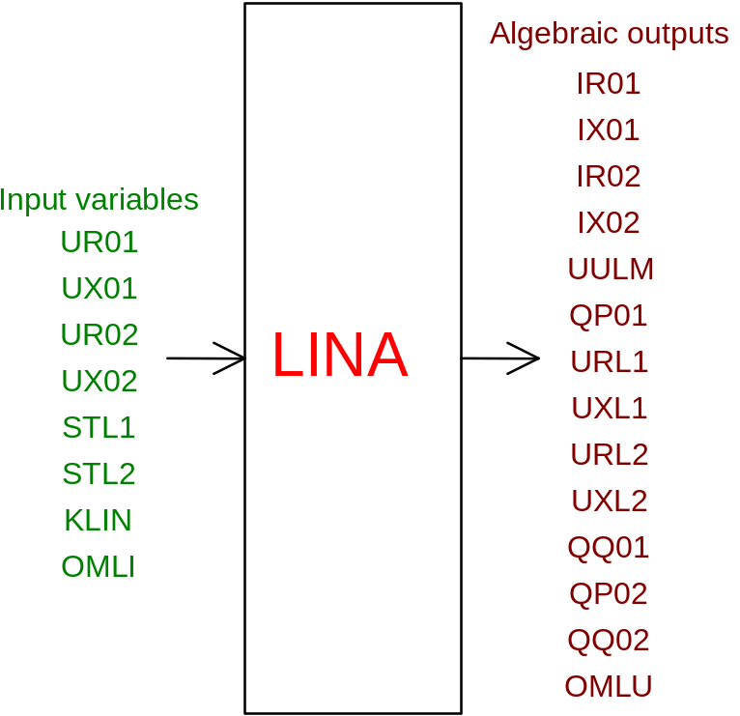

PHYSICAL MEANING OF THE MODULE INPUT- OUTPUT VARIABLES

[V] UR01 supply real phase voltage side 1
[V] UX02 supply imaginary phase voltage side 1
[V] UR02 supply real phase voltage side 2
[V] UX02 supply real phase voltage side 2
[ ] STL1 switch state side 1 (1 = on)
[ ] STL2 switch state side 2 (1 = on)
[ ] KLIN multiplying parameter for line parameters. If KLIN=1 then the line length is not expressely indicated among data, it is the one corresponding to electrical parameters. On the contrary, if KLIN=n then the line length is n times the previous one. If electrical parameters are entered for length unit, then KLIN represents the length of the line
[rad/s] OMLI line input frequency
[A] IR01 real current coming out from side 1
[A] IX01 imaginary current coming out from side 1
[A] IR02 real current coming out from side 2
[A] IX02 imaginary current coming out from side 2
[V] URL1 real phase voltage at terminals side 1
[V] UXL1 imaginary phase voltage at terminals side 1
[V] URL2 real phase voltage at terminals side 2
[V] UXL2 imaginary phase voltage at terminals side 2
[V] UULM extent of voltage between lines drop on the line
[W] QP01 active power coming out from side 1
[VAR] QQ01 reactive power coming out from side 1
[W] QP02 active power coming out from side 2
[VAR] QQ02 reactive power coming out from side 2

MODULE LINA CARD C

Physical and Geometrical Data

In addition to the initial values of input and output variables of the LINA module, whose meaning has been defined in card B2, the user must assign the following set of data to complete the input required by the module:

[ohm] RL resistance of long line L
[ohm] XL reactance of long line at rated frequency
[1/ohm] GTR conductance of the long line L
[1/ohm] BTR capacitive susceptance of the long line L at rated frequency
[W] QBASE basic power
[V] VBASE basic voltage = rated voltage between lines
[rad/s] OMBA basic frequency

MODULE LINA CARD D

Module Variables Initialization

For the calculation of the steady state of the model containing only the LINA module all the module inputs must be known except for an input voltage, for VX01, and an output voltage VR02, and make known the real current side 1 (IR01) and the imaginary current side 2 (IX02). Attention shall be paid to the sign of currents in relation to the sign of the real voltage set, since the generator set conventional coding has been selected for currents. It is not recommended to make known the variables QP01,QQ01,QP02,QP02,VVLM clearing some inputs of the model when you are distant from the desired steady state condition.
It is advised in the first phase of steady state calculation to set the variable KLIN=0, that is have a line degenerating in one point to be then gradually increased to obtained the desired length.
In the case the energy flow runs from side 1 towards side 2, then the active and reactive power of side 1 (QP01,QQ01) are negative while active powers of side 2 are positive (QP02,QQ02). This applies in case the load downstream is an inductive one, in the contrary instance reactive powers have signe opposite to the above mentioned one.

MODULE LINA CARD E

User's Subprograms

MODULE LINA CARD F

Residuals

Equations forming the module mathematical model, given in card A, provide the following residuals:

IF (STL1 .AND. STL2) THEN
RNI(1) = IR01+IRAU+(VR01*GL-VX01*BCL)
RNI(2) = IX01+IXAU+(VR01*BCL+VX01*GL)
RNI(3) = IR02-IRAU+(VR02*GL-VX02*BCL)
RNI(4) = IX02-IXAU+(VR02*BCL+VX02*GL)
RNI(5) = VRL1 - VR01
RNI(6) = VXL1 - VX01
RNI(7) = VRL2 - VR02
RNI(8) = VXL2 - VX02
RNI(9) = OMLU - OMLI
ELSE IF (STL1 .AND. .NOT. STL2) THEN
RNI(1) = IR01+2.*(VR01*GL-VX01*BCL)
RNI(2) = IX01+2.*(VR01*BCL+VX01*GL)
RNI(3) = IR02
RNI(4) = IX02
RNI(5) = VRL1 - VR01
RNI(6) = VXL1 - VX01
RNI(7) = VRL2 - VR01
RNI(8) = VXL2 - VX01
RNI(9) = OMLU
ELSE IF(.NOT. STL1 .AND. STL2) THEN
RNI(1) = IR01
RNI(2) = IX01
RNI(3) = IR02+2.*(VR02*GL-VX02*BCL)
RNI(4) = IX02+2.*(VR02*BCL+VX02*GL)
RNI(5) = VRL1 - VR02
RNI(6) = VXL1 - VX02
RNI(7) = VRL2 - VR02
RNI(8) = VXL2 - VX02
RNI(9) = OMLU
ELSE
RNI(1) = IR01
RNI(2) = IX01
RNI(3) = IR02
RNI(4) = IX02
RNI(5) = VRL1
RNI(6) = VXL1
RNI(7) = VRL2
RNI(8) = VXL2
RNI(9) = OMLU
ENDIF
RNI(10) = VVLM-SQRT(3.*((VR01-VR02)**2.+(VX01-VX02)**2.))
RNI(11) = QP01-VR01*IR01-VX01*IX01
RNI(12) = QQ01-VX01*IR01+VR01*IX01
RNI(13) = QP02-VR02*IR02-VX02*IX02
RNI(14) = QQ02-VX02*IR02+VR02*IX02

MODULE LINA CARD G

Module subprograms

SUBROUTINE LINAI2 (IFUN,VAR,MX1,IV1,IV2,XYU,DATI,ID1,ID2,IBL1,IBL2,
IER,CNXYU,TOL)

SUBROUTINE LINAC1 (IFUN,AJAC,MX5,IXYU,XYU,IPD,DATI,RNI,IBL1,IBL2)

SUBROUTINE LINAJC (AJAC,MX5,IXYU,XYU,DATI,RNI,IBL1,IBL2)

SUBROUTINE LINA (IFUN,IXYU,XYU,IPD,DATI,RNI)

SUBROUTINE LINAI3 (IFO,IOB,DEBL)

SUBROUTINE LINAI4 (IOB,MOD)

SUBROUTINE LINAD1 (BLOCCO,NEQUAZ,NSTATI,NUSCIT,NINGRE,SYMVAR,XYU,
IXYU,DATI,IPD,SIGNEQ,UNITEQ,COSNOR,ITOPVA,MXT)

MODULE LINA CARD H

Test cases

Reference test cases relevant to this module are in the model library under the tag:

"LINA"

