MODULE MITN CARD 0

Summary

• model generalities

• topological data

• physical and geometrical data

• module variables initialization

• user's subprograms

• residuals

• module subprograms

• test cases

MODULE MITN CARD A

Model Generalities

N INPUTS MIXER

The module MITN calculates the mixing mass flow rate and temperature of N inlet branches. In particular:
- The output mass flow rate is the sum of all inlet ones.
- The output temperature is an average of the inlet ones, weighed with the ratio between mass flow rate of the actual branch and the sum of all inlet mass flow rates. It’s equivalent to an enthalpy balance, supposing the specific heat constant enough for all input branches to allow its simplifying among all the terms of the balance.
In the enthalpy balance, negative inlet mass flow rates are set to zero. So, mass flow rate inversion is not supported.
If the sum of all the entering mass flow rates at the present iteration is zero, the sum at the previous iteration is taken instead.

MODULE MITN CARD B

Topological data

INPUT-OUTPUT SCHEME

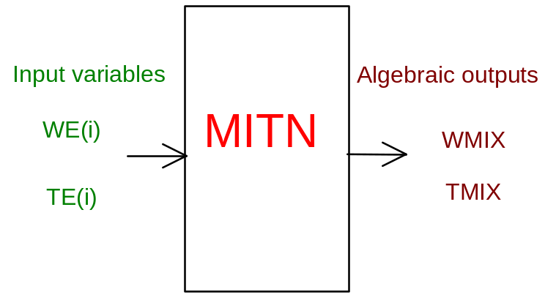

PHYSICAL MEANING OF MODULE INPUT-OUTPUT VARIABLES

[kg/s] WMIX mixing mass flow rate
[K] TMIX mixing temperature
[kg/s] WE(i) i=1..NE i-th branch inlet mass flow rate
[K] TE(i) i=1..NE i-th branch temperature

MODULE MITN CARD C

Physical and Geometrical Data

No data are foreseen.

MODULE MITN CARD D

Module Variables Initialization

To initialize the MITN module variables no particular prescription is required.

MODULE MITN CARD E

User's Subprograms

MITN doesn’t prescribe any FORAUS subroutine.

MODULE MITN CARD F

Residuals

TCALC = 0.
DO I = 1, NE
IF (SUME .GE. WEPS) THEN
AK (I) = AMAX1 (WE(I) / SUME, 0.)
ELSE
AK (I) = DATI (IPD+I)
ENDIF
TCALC = TCALC + TE(I) * AK(I)
ENDDO
C
RNI(1) = WNODO - SUME
RNI(2) = TNODO - TCALC

MODULE MITN CARD G

Module subprograms

SUBROUTINE MITNI2(IFUN,VAR,MX1,IV1,IV2,XYU,DATI,ID1,ID2,
$ IBL1,IBL2,IER,CNXYU,TOL)
SUBROUTINE MITNI3(IFO,IOB,DEBL)
SUBROUTINE MITNI4(IOB,MOD)
SUBROUTINE MITNC1(IFUN,AJAC,MX5,IXYU,XYU,IPD,DATI,RNI,IBL1,IBL2)
SUBROUTINE MITN (IFUN,IXYU,XYU,IPD,DATI,RNI)

SUBROUTINE MITND1(BLOCCO,NEQUAZ,NSTATI,NUSCIT,NINGRE,SYMVAR,
$ XYU,IXYU,DATI,IPD,SIGNEQ,UNITEQ,COSNOR,ITOPVA,MXT)

MODULE MITN CARD H

Test cases

Reference test cases related to this module aren’t yet available.

