#$K+!MODULE MIXN CARD 0

Summary

∗ model generalities

∗ topological data

∗ physical and geometrical data

∗ module variables initialization

∗ user's subprograms

∗ residuals

∗ module subprograms

∗ test cases

#$K+!MODULE MIXN CARD A

Model Generalities

N-FLUIDS ENTHALPIC MIXER

The MIXN module simulates the perfect mixing of "N" fluids flowing into a cavity.
Simplifying hypotheses adopted in the physical-mathematical model definition are the following:
- absence of thermal exchange of the "N" fluids with the surface of the cavity;
- absence of phenomena of mass and energy accumulation in the cavity;

The used equations, both algebraical are:
1) the energy conservation equation
2) the mass conservation equation

The physical-mathematical model inside the module is not able to simulate in a satisfying manner cases of back-flow. If during the simulation of any transient the back-flow of any flows should happen (although simulation is not interrupted), the obtained quantity trends may be little reliable. So it is necessary to check that during the transient evolution this situation does not take place.

#$K+!MODULE MIXN CARD B

Topological data

INPUT-OUTPUT SCHEME

N = number of input branches in the cavity (max. 10)
i = 1, 2, ... N
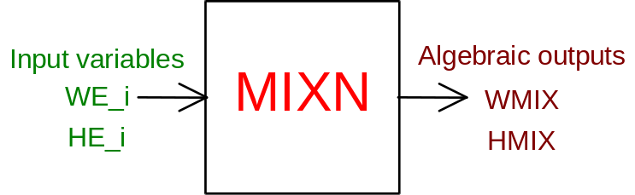

PHYSICAL MEANING OF MODULE INPUT-OUTPUT VARIABLES

[kg/s] WMIX flow rate of fluid flowing out of the cavity
[J/kg] HMIX enthalpy of fluid flowing out of the cavity
[kg/s] WE_i (i = 1, 2, ... N) flow rate of fluid flowing into the cavity from the i-th branch
[J/kg] HE_i (i = 1, 2, ... N) enthalpy of fluid flowing into the cavity from the i-th branch

#$K+!MODULE MIXN CARD C

Physical and Geometrical Data

In the MIXN module there is no request for further data besides starting values of input and output variables.

#$K+!MODULE MIXN CARD D

Module Variables Initialization

To initialize the MIXN module variables no particular prescription is required.

#$K+!MODULE MIXN CARD E

User's Subprograms

In the MIXN module no user subprogram is foreseen.

#$K+!MODULE MIXN CARD F

Residuals

The mass conservation equation, applied to the fluid inside the manifold, gives rise to the following residuals:
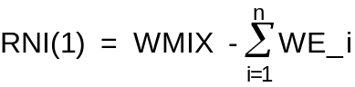
(normalization factor = W0)

During steady state evaluation the second residual (expression of the energy conservation equation applied to the fluid inside the manifold) is:
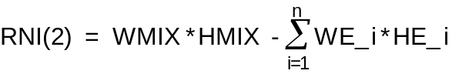
(normalization factor = W0 * H0)

During transient simulation the second residual is not-iterative. The expression of the mixing enthalpy is given by the following relation:
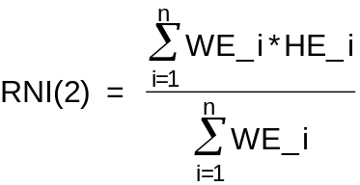
(normalization factor = H0)

In both the cases, the second residual is protected against numerical problems which could occurr in case of null or negative flow rates.

#$K+!MODULE MIXN CARD G

Module subprograms

SUBROUTINE MIXNI3 (IFO, IOB, DEBL)

SUBROUTINE MIXNI4 (IOB, MOD)

SUBROUTINE MIXNI2 (IFUN, VAR, MX1, IV1, IV2, XYU, DATI, ID1, ID2,
$ IBL1, IBL2, IER, CNXYU, TOL)

SUBROUTINE MIXNC1 (IFUN, AJAC, MX5, IXYU, XYU, IPD, DATI, RNI,
$ IBL1, IBL2)

SUBROUTINE MIXND1 (BLOCCO,NEQUAZ,NSTATI,NUSCIT,NINGRE,SYMVAR,XYU,
$ IXYU,DATI,IPD,SIGNEQ,UNITEQ,COSNOR,ITOPVA,MXT)

#$K+!MODULE MIXN CARD H

Test cases

Reference test cases related to this module are in the user manual section dedicated to the examples developed under the abbreviations:
"......... module application examples not available yet........"

# lg_libproc_MIXN_summ
$ MIXN process module
K MIXN process module
+ lg_pag_modu:0840
! EnableButton("button_up"); ChangeButtonBinding("button_up", "JumpId(`lglibpro.hlp',`lg_libproc_main')")
# lg_libproc_MIXN_A
$ MIXN process module (A)
K MIXN process module (A)
+ lg_pag_MIXN:0002
! EnableButton("button_up"); ChangeButtonBinding("button_up", "JumpId(`lglibpro.hlp',`lg_libproc_MIXN_summ')")
# lg_libproc_MIXN_B
$ MIXN process module (B)
K MIXN process module (B)
+ lg_pag_MIXN:0003
! EnableButton("button_up"); ChangeButtonBinding("button_up", "JumpId(`lglibpro.hlp',`lg_libproc_MIXN_summ')")
# lg_libproc_MIXN_C
$ MIXN process module (C)
K MIXN process module (C)
+ lg_pag_MIXN:0005
! EnableButton("button_up"); ChangeButtonBinding("button_up", "JumpId(`lglibpro.hlp',`lg_libproc_MIXN_summ')")
# lg_libproc_MIXN_D
$ MIXN process module (D)
K MIXN process module (D)
+ lg_pag_MIXN:0006
! EnableButton("button_up"); ChangeButtonBinding("button_up", "JumpId(`lglibpro.hlp',`lg_libproc_MIXN_summ')")
# lg_libproc_MIXN_E
$ MIXN process module (E)
K MIXN process module (E)
+ lg_pag_MIXN:0007
! EnableButton("button_up"); ChangeButtonBinding("button_up", "JumpId(`lglibpro.hlp',`lg_libproc_MIXN_summ')")
# lg_libproc_MIXN_F
$ MIXN process module (F)
K MIXN process module (F)
+ lg_pag_MIXN:0008
! EnableButton("button_up"); ChangeButtonBinding("button_up", "JumpId(`lglibpro.hlp',`lg_libproc_MIXN_summ')")
# lg_libproc_MIXN_G
$ MIXN process module (G)
K MIXN process module (G)
+ lg_pag_MIXN:0010
! EnableButton("button_up"); ChangeButtonBinding("button_up", "JumpId(`lglibpro.hlp',`lg_libproc_MIXN_summ')")
# lg_libproc_MIXN_H
$ MIXN process module (H)
K MIXN process module (H)
+ lg_pag_MIXN:0011
! EnableButton("button_up"); ChangeButtonBinding("button_up", "JumpId(`lglibpro.hlp',`lg_libproc_MIXN_summ')")

