MODULE MOLT CARD 0

Summary

• model generalities

• topological data

• physical and geometrical data

• module variables initialization

• user's subprograms

• residuals

• module subprograms

• test cases

MODULE MOLT CARD A

Model Generalities

ANALOG MULTIPLIER OF THREE SIGNALS

The module MOLT multiplies three analog signals.

MODULE MOLT CARD B

Topological data

INPUT-OUTPUT SCHEME

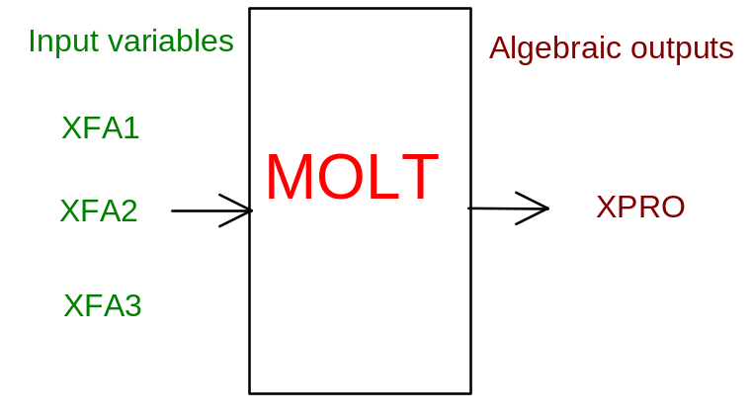

PHYSICAL MEANING OF MODULE INPUT-OUTPUT VARIABLES

[…] XPRO product
[…] XFA1 first factor
[…] XFA2 second factor
[…] XFA3 third factor

MODULE MOLT CARD C

Physical and Geometrical Data

In addition to the initial values of input and output variables, the user must assign the following data:

[…] NORUSC product variable normalization
[…] NORIN1 first factor normalization
[…] NORIN2 second factor normalization
[…] NORIN3 third factor normalization

MODULE MOLT CARD D

Module Variables Initialization

To initialize the MOLT module variables no particular prescription is required.

MODULE MOLT CARD E

User's Subprograms

MOLT doesn’t prescribe any FORAUS subroutine.

MODULE MOLT CARD F

Residuals

RNI(1) = (XPRO-XFA1*XFA2*XFA3)/XNOU

MODULE MOLT CARD G

Module subprograms

SUBROUTINE MOLTI2(IFUN,VAR,MX1,IV1,IV2,XYU,DATI,ID1,ID2,
$ IBL1,IBL2,IER,CNXYU,TOL)
SUBROUTINE MOLTI3(IFO,IOB,DEBL)
SUBROUTINE MOLTI4(IOB,MOD)
SUBROUTINE MOLTC1(IFUN,AJAC,MX5,IXYU,XYU,IPD,DATI,RNI,IBL1,IBL2)
SUBROUTINE MOLT (IFUN,IXYU,XYU,IPD,DATI,RNI)
SUBROUTINE MOLTD1(BLOCCO,NEQUAZ,NSTATI,NUSCIT,NINGRE,SYMVAR,
$ XYU,IXYU,DATI,IPD,SIGNEQ,UNITEQ,COSNOR,ITOPVA,MXT)

MODULE MOLT CARD H

Test cases

Reference test cases related to this module aren’t yet available.

