#$K+!MODULE PLEN CARD 0

Summary

∗ model generalities

∗ topological data

∗ physical and geometrical data

∗ module variables initialization

∗ user's subprograms

∗ residuals

∗ module subprograms

∗ test cases

#$K+!MODULE PLEN CARD A

Model Generalities

GAS DUCT VOLUME

The PLEN module simulates the big cavities in which a gaseous fluid mixing occurs.
In these components the mass accumulation phenomenon is prevailing.
The model is based on the following main hypotheses:
- the surface of cavities is adiabatic
- perfectly mixed gas in the volume so that it is possible to consider its temperature unvarying
- for the fluid in the cavity it is valid the perfect gas law.
The utilized equations are:
1) the equation of gas mass conservation
2) the equation of gas energy conservation.
In applying the equation 1, it is presumed gas temperature varies so slowly that density variations are not influenced by it.
In applying the equation 2, instead, enthalpy variations coming from pressure variations are not considered.
Such hypotheses are valid if the module application is limited to air chambers or precipitators, where there are not sudden temperature variations and pressure variations are so low that fluid enthalpy is not influenced by.
Therefore the module is not suitable to simulate a combustion furnace or a second gas pass zone of a boiler, where the temperature variations are quick and considerable. Instead the model keeps its validity in case of back-flow in the ducts at the cavity inlet.

#$K+!MODULE PLEN CARD B

Topological data

INPUT-OUTPUT SCHEME

NWIN = number of ducts coming in
NWOU = number of ducts coming out
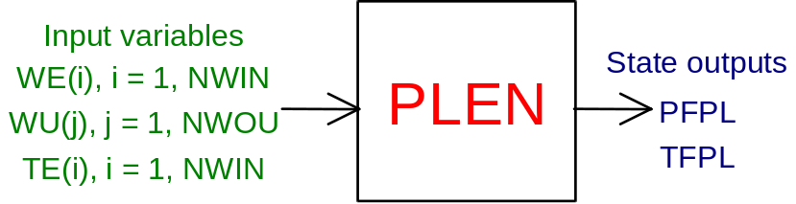

PHYSICAL MEANING OF MODULE INPUT-OUTPUT VARIABLES

[kg/s] WE(i) (i = 1, NWIN) air-gas flow rate in the i-th duct coming into the plenum
[kg/s] WU(j) (j = 1, NWOU) air-gas flow rate in the j-th duct coming out of the plenum
[K] TE(i) (i = 1, NWIN) air-gas temperature in the i-th duct coming into the plenum
[Pa] PFPL fluid pressure in the plenum
[K] TFPL fluid temperature in the plenum

#$K+!MODULE PLEN CARD C

Physical and Geometrical Data

In addition to the initial values of input and output variables, user must assign the following data:
[m³] VOL. plenum internal volume
[ ] NWIN the number of ducts coming into the plenum
[ ] NWOU the number of ducts coming out of the plenum
[J/kg*K] RGAS the constant utilized in the perfect gas law (see note)
[p.u.] UMID gas relative humidity (in weight)

Note
The perfect gas law is expressed by the following state equation:
P*V = n*R*T
where P is the gas pressure, V its volume, T its temperature, R is the gas universal constant and n is the number of considered moles of gas.
Dividing for the gas mass M we have:
P/RO = (n*R/M)*T
where RO is the gas density.
Assuming:
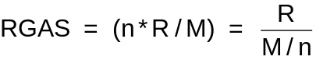
where M/n is the gas molecular mass, we have:
P/RO = RGAS*T

#$K+!MODULE PLEN CARD D

Module Variables Initialization

To initialize the PLEN module variables, no particular prescription is required.

#$K+!MODULE PLEN CARD E

User's Subprograms

In the PLEN module no user subprogram is foreseen.

#$K+!MODULE PLEN CARD F

Residuals

The module mathematical model consists of the equations mentioned in the first paragraph which give rise to the following residuals:
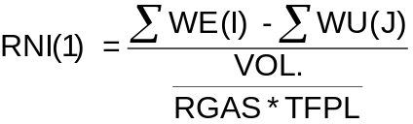
The residual is normalized as regards to the pressure PRIF = 1.E+05 Pa.
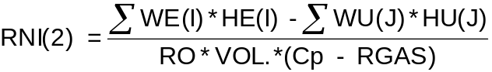
where:
HE(I) is the enthalpy associated to the flow rate entering from the i-th duct
HU(J) is the enthalpy associated to the flow rate coming out from the i-th duct
Cp is the specific heat, at constant pressure, of fluid present in the cavity
The residual is normalized as regards to the temperature T0.

#$K+!MODULE PLEN CARD G

Module subprograms

SUBROUTINE PLENI3(IFO, IOB, DEBL)

SUBROUTINE PLENI4(IOB, MOD)

SUBROUTINE PLENI2(IFUN, VAR, MX1, IV1, IV2, XYU, DATI, ID1, ID2,
$ NOMBL1, NOMBL2, IER, CNXYU, TOL)

SUBROUTINE PLENC1(IFUN, AJAC, MX5, IXYU, XYU, ID2, DATI,
$ RN, NOMBL1, NOMBL2)

#$K+!MODULE PLEN CARD H

Test cases

Reference test cases related to this module are in the user manual section dedicated to the examples developed under the abbreviations:
"ARIAGAS"

# lg_libproc_PLEN_summ
$ PLEN process module
K PLEN process module
+ lg_pag_modu:0940
! EnableButton("button_up"); ChangeButtonBinding("button_up", "JumpId(`lglibpro.hlp',`lg_libproc_main')")
# lg_libproc_PLEN_A
$ PLEN process module (A)
K PLEN process module (A)
+ lg_pag_plen:0002
! EnableButton("button_up"); ChangeButtonBinding("button_up", "JumpId(`lglibpro.hlp',`lg_libproc_PLEN_summ')")
# lg_libproc_PLEN_B
$ PLEN process module (B)
K PLEN process module (B)
+ lg_pag_plen:0003
! EnableButton("button_up"); ChangeButtonBinding("button_up", "JumpId(`lglibpro.hlp',`lg_libproc_PLEN_summ')")
# lg_libproc_PLEN_C
$ PLEN process module (C)
K PLEN process module (C)
+ lg_pag_plen:0005
! EnableButton("button_up"); ChangeButtonBinding("button_up", "JumpId(`lglibpro.hlp',`lg_libproc_PLEN_summ')")
# lg_libproc_PLEN_D
$ PLEN process module (D)
K PLEN process module (D)
+ lg_pag_plen:0006
! EnableButton("button_up"); ChangeButtonBinding("button_up", "JumpId(`lglibpro.hlp',`lg_libproc_PLEN_summ')")
# lg_libproc_PLEN_E
$ PLEN process module (E)
K PLEN process module (E)
+ lg_pag_plen:0007
! EnableButton("button_up"); ChangeButtonBinding("button_up", "JumpId(`lglibpro.hlp',`lg_libproc_PLEN_summ')")
# lg_libproc_PLEN_F
$ PLEN process module (F)
K PLEN process module (F)
+ lg_pag_plen:0008
! EnableButton("button_up"); ChangeButtonBinding("button_up", "JumpId(`lglibpro.hlp',`lg_libproc_PLEN_summ')")
# lg_libproc_PLEN_G
$ PLEN process module (G)
K PLEN process module (G)
+ lg_pag_plen:0010
! EnableButton("button_up"); ChangeButtonBinding("button_up", "JumpId(`lglibpro.hlp',`lg_libproc_PLEN_summ')")
# lg_libproc_PLEN_H
$ PLEN process module (H)
K PLEN process module (H)
+ lg_pag_plen:0011
! EnableButton("button_up"); ChangeButtonBinding("button_up", "JumpId(`lglibpro.hlp',`lg_libproc_PLEN_summ')")

