MODULE REGF CARD 0

Summary

• model generalities

• topological data

• physical and geometrical data

• module variables initialization

• user's subprograms

• residuals

• module subprograms

• test cases

MODULE REGF CARD A

Model Generalities

FREQUENCY REGULATOR

The module REGF simulates the behavior of a primary frequency regulator and of the turbine connected to it (the model output is, in facts, the mechanical power produced by the turbine).
The functioning is described by the following simplified equation:

s = Laplace operator
Kp = regulator gain (reciproque of the statism)
T1 = denominator time constant
T2 = numerator time constant
Omri= reference angular velocity
Omeg= net angular velocity
Qrif= reference power
Qmec= turbine mechanical power

The following relationship provides the turbine mechanical power:

1 + sT2
Qmec = Qrif + (Omri - Omeg) Kp -------
1 + sT1

In steady state:

Qmec = Qrif + Kp (Omri - Omeg) .

MODULE REGF CARD B

Topological data

INPUT-OUTPUT SCHEME

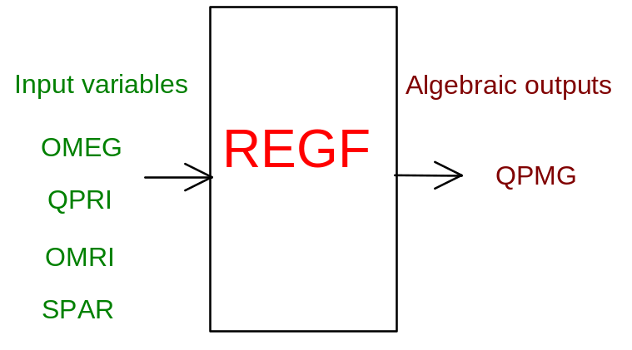

PHYSICAL MEANING OF MODULE INPUT-OUTPUT VARIABLES

[W] QPMG turbine mechanical power

[rad/s] OMEG net angular velocity

[W] QPRI reference power

[rad/s] OMRI reference angular velocity

[ ] SPAR paralel signal (1=true, 0=false)

MODULE REGF CARD C

Physical and Geometrical Data

[W] Qbase_W base power

[rad/s] Omba_r/s base angular velocity

[W] Pn.gr._W generator nominal power

[%] Stat_% statism (reciproque of regulator gain)

[s] T1POLO_s regulator pole time constant

[s] T2ZERO_s regulator zero time constant

[W] Pmax_W generator max power

MODULE REGF CARD D

Module Variables Initialization

To initialize the REGF module variables no particular prescription is required.

MODULE REGF CARD E

User's Subprograms

REGF doesn’t prescribe any FORAUS subroutine.

MODULE REGF CARD F

Residuals

RNI(1) =QPMG-QPM

Where:

If (SPAR=0):

QPM = QPRI

If (SPAR=1):

Steady state:

QPM = QPRI-KP*(OMEG-OMRI)

Transient:

QPM = QPRI - KP*K1*(OMEG-OMRI) + KP*K2*(OMEGP-OMRIP) + K3*(QPMP-QPRIP)

OMEGP=OMEG of previous step
OMRIP=OMRI of previous step
QPMP =QPM of previous step
QPRIP=QPRI of previous step
KP=1/Stat_%
K1=(DTINT+T2)/(DTINT+T1)
K2=T2/(DTINT+T1)
K3=T1/(DTINT+T1).

MODULE REGF CARD G

Module subprograms

SUBROUTINE REGFI2(IFUN,VAR,MX1,IV1,IV2,XYU,DATI,ID1,ID2,
$ IBL1,IBL2,IER,CNXYU,TOL)
SUBROUTINE REGFI3(IFO,IOB,DEBL)
SUBROUTINE REGFI4(IOB,MOD)
SUBROUTINE REGFC1(IFUN,AJAC,MX5,IXYU,XYU,IPD,DATI,RNI,IBL1,IBL2)
SUBROUTINE REGFJC (IFUN,AJAC,MX5,IXYU,XYU,IPD,DATI,RNI,IBL1,IBL2)

SUBROUTINE REGF (IFUN,IXYU,XYU,IPD,DATI,RNI)

SUBROUTINE REGFD1(BLOCCO,NEQUAZ,NSTATI,NUSCIT,NINGRE,SYMVAR,
$ XYU,IXYU,DATI,IPD,SIGNEQ,UNITEQ,COSNOR,ITOPVA,MXT)

MODULE REGF CARD H

Test cases

Reference test cases related to this module aren’t yet available.

