MODULE REGT CARD 0

Summary

• model generalities

• topological data

• physical and geometrical data

• module variables initialization

• user's subprograms

• residuals

• module subprograms

• test cases

MODULE REGT CARD A

Model Generalities

VOLTAGE REGULATOR

The module REGT simulates the behavior of an eccitation device made out of a voltage regulator and a converter. The pole-zero behavior is described by the following relationship:

1 + sT2
Vecc = (Vrge - Vgen) Gv -------
1 + sT1

where:

s = Laplace operator
Gv = regulator gain
T1 = numerator time constant
T2 = denominator time constant
Vrge= generator reference voltage
Vgen= generator voltage
Vecc= eccitation device voltage

In steady state:

Vecc = (Vrge - Vgen) Gv .

MODULE REGT CARD B

Topological data

INPUT-OUTPUT SCHEME

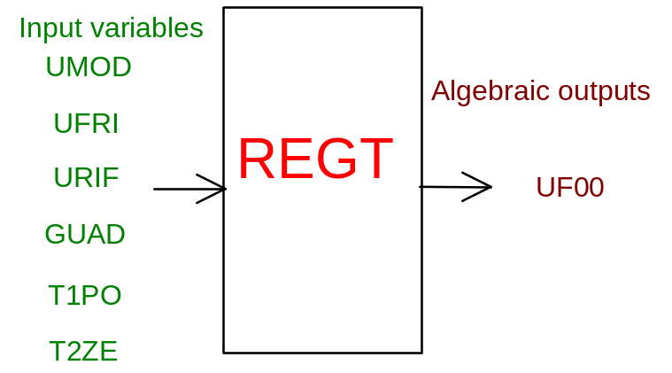

PHYSICAL MEANING OF MODULE INPUT-OUTPUT VARIABLES

[V] UF00 eccitation voltage

[V] UMOD module of generator tension

[V] UFRI eccitation voltage bias

[V] URIF generator reference voltage

[ ] GUAD voltage regulator gain

[s] T1PO denominator time constant

[s] T2ZE numerator time constant

MODULE REGT CARD C

Physical and Geometrical Data

[V] VBASE_v generator base chained voltage

[A] IECC0_A void excitation current

[ohm] RECC_ohm resistence of excitation circuit

[V] VECCN_v nominal excitation voltage

MODULE REGT CARD D

Module Variables Initialization

To initialize the REGT module variables no particular prescription is required.

MODULE REGT CARD E

User's Subprograms

REGT doesn’t prescribe any FORAUS subroutine.

MODULE REGT CARD F

Residuals

RNI(1) = UF00-UFC

Where:

Steady state:

UFC = UFRI-GV*(UMOD-URIF)

Transient:

UFC = UFRI-GV*K1*(UMOD-URIF)+GV*K2*(UMODP-URIFP)+K3*(UFCP-UFRIP)

UMODP=UMOD previous step
UFCP =UFC previous step
URIFP=URIF previous step
UFRIP=UFRI previous step
DTINT=time step
K1=(DTINT+T2)/(DTINT+T1)
K2=T2/(DTINT+T1)
K3=T1/(DTINT+T1)

MODULE REGT CARD G

Module subprograms

SUBROUTINE REGTI2(IFUN,VAR,MX1,IV1,IV2,XYU,DATI,ID1,ID2,
$ IBL1,IBL2,IER,CNXYU,TOL)
SUBROUTINE REGTI3(IFO,IOB,DEBL)
SUBROUTINE REGTI4(IOB,MOD)
SUBROUTINE REGTC1(IFUN,AJAC,MX5,IXYU,XYU,IPD,DATI,RNI,IBL1,IBL2)
SUBROUTINE REGTJC (IFUN,AJAC,MX5,IXYU,XYU,IPD,DATI,RNI,IBL1,IBL2)

SUBROUTINE REGT (IFUN,IXYU,XYU,IPD,DATI,RNI)

SUBROUTINE REGTD1(BLOCCO,NEQUAZ,NSTATI,NUSCIT,NINGRE,SYMVAR,
$ XYU,IXYU,DATI,IPD,SIGNEQ,UNITEQ,COSNOR,ITOPVA,MXT)

MODULE REGT CARD H

Test cases

Reference test cases related to this module aren’t yet available.

