MODULE RETE CARD 0

Summary

• model generalities

• topological data

• physical and geometrical data

• module variables initialization

• user's subprograms

• residuals

• module subprograms

• test cases

MODULE RETE CARD A

Model Generalities

ISOLATED NETWORK EQUIVALENT

RETE contains an equivalent model of an isolated net, considering negligible the electro-mechanical oscillations among the generators. In those conditions frequency dynamics of the isolated net (island) is determined by the unbalance between the amount of electrical power consumed within the island and the mechanical one produced by the generation units.
The interactions between the considered unit and the others can be studied by coupling the boiler-turbine model with a RETE module. The former calculates the power generated by the unit in evidence in function of its inputs (e.g. turbine valve opening), while the latter sums this power up to all the ones produced by other generation units belonging to the same net and translates, approximating the net with a quasi-linear rigid model with primary frequency regulation, the unbalance between total input mechanical power and consumed electrical power in a dynamic frequency drift. That calculated frequency is an input of the speed regulation of the boiler-turbine model, which, in turn, calculates a turbine valve opening and, thus, a mechanical power to be provided back to RETE.

MODULE RETE CARD B

Topological data

INPUT-OUTPUT SCHEME

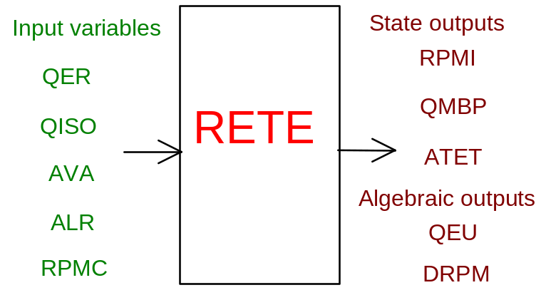

PHYSICAL MEANING OF MODULE INPUT-OUTPUT VARIABLES

[W] QER electrical power absorbed in the whole net

[W] QISO mechanical power produced by the unit in evidence

[p.u.] AVA average voith position for the net units turbines
(fixed the power generated by the network with no frequency error)

[ ] ALR Load Rejection button. If 0.9 < ALR < 1.1 the power QISO of the unit in
evidence is set to zero.

[r.p.m.] RPMC net frequency in the case “infinite power net” (see note 1)

[r.p.m.] RPMI net turbines rotation speed

[W] QMBP mechanical power produced by MP/LP stages of all the units except the one
in evidence

[p.u.] ATET average net turbine valves position

[W] QEU electrical power produced by the unit in evidence

[r.p.m./s] DRPM time derivative of rotation speed RPMI

Note 1

In an “isolated net” RPMC may assume a whatsoever negative value. If this value is positive, a “infinite power net” is assumed and the turbine rotation speed RPMI is set to the net frequency RPMC.

MODULE RETE CARD C

Physical and Geometrical Data

In addition to the initial values of input and output variables, user must assign the following data:

[W] PNOMT nominal power of net units

[W] PNOMG nominal power of unit in evidence

[ ] BETA ratio between mechanical power produced by AP stages and
MP/BP stages of all the network unit except the one in
evidence

[s] TAVVR start-up time of all network units, except the one in
evidence

[s] TAVVG start-up time of the unit in evidence

[s] TAURH time constant with which MP/BP power production is
approximated for all net units except the one in evidence

[ ] EPS1 slope changing point of the speed regulator (see fig. 1.)

[ ] SIG1 differential statism for (f-f)/f < EPS1 in the speed
regulator (see note 1)

[ ] SIG2 differential statism for (f-f)/f > EPS1 in the speed
regulator (see note 1)

[p.u.] TETM superior limit of the position request for turbine valves
(load limiter)

[s] TTURB time constant with which turbine valve actuator is
approximated for all net units

Note 1

The statism SIG for a generator of nominal power Pn is assigned to a speed regulator as:

_ _
(f-f)/f
SIG = ---------- (10)
(P-Pn)/Pn

_
where f is the rotation speed, f the nominal rotation frequency and P the nominal power. RETE refers itself to a non linear algebraic speed regulator, whose characteristics is set by EPS1, SIG1 and SIG2 (fig. 1.).
The derivative discontinuities are smoothed.

^
DV=(P-Pn)/Pn | _______
| /
| /
| /
| *
-EPS1 | *
-------------|--------+--------|--------------->
* | EPS1 _ _
* | (f-f)/f
/ |
/ |
_______/ |
|

DV = average request of turbine valves opening.

fig. 1.

Note 2

For the Termini Imerese unit in Sicily the following parameters can be used:

PNOMT = 2280. MW PNOMG = 320. MW BETA = 0.4 TAVVR = 8. s

TAVVG = 8. s TAURH = 11. s EPS1 = 0. SIG1 = 1.

SIG2 = 0.05 TETM = 1. TTURB = 0.3 s QER = 1310. MW
_
QEU = 320. MW f = 50. Hz

MODULE RETE CARD D

Module Variables Initialization

In an “isolated net” RPMC may assume a whatsoever negative value. If this value is positive, a “infinite power net” is assumed and the turbine rotation speed RPMI is set to the net frequency RPMC.

MODULE RETE CARD E

User's Subprograms

RETE doesn’t prescribe any FORAUS subroutine.

MODULE RETE CARD F

Residuals

QISO + BETA*TETA*(PNOMT - PNOMG) + QMBP - QER
RNI(1) = ------------------------------------------------------ * 100.
TAVVR*(PNOMT - PNOMG) + TAVVG*PNOMG
------------------------------------- * RPMI * PNOMT
PNOMT

(normalization = 300.)

(1.- BETA)*TETA*(PNOMT - PNOMG) - QMBP
RNI(2) = ---------------------------------------
TAURH

(normalization = W0*H0)

RNI(3) = D_TETA/TTURB (D_TETA = variation of TETA)

(normalization = 1.)

PNOMG*TAVVG*[QISO+BETA*TETA*(PNOMT-PNOMG)+QMBP-QER]
RNI(4) = QISO - QEU - ---------------------------------------------------
TAVVR*(PNOMT - PNOMG) + TAVVG*PNOMG
------------------------------------- * PNOMT
PNOMT

(normalization = W0*H0)

RNI(5) = DRPM - RNI(1) (normalization = 300.)

MODULE RETE CARD G

Module subprograms

SUBROUTINE RETEI3(IFO,IOB,DEBL)

SUBROUTINE RETEI4(IOB,MOD)

SUBROUTINE RETEI1(IFUN,K,IBL1,IBL2,NSTATI,NUSCIT,NINGRE)

SUBROUTINE RETEI2(IFUN,VAR,MX1,IV1,IV2,XYU,DATI,ID1,ID2,
1 IBL1,IBL2,IER,CNXYU,TOL)

SUBROUTINE RETEC1(IFUN,AJAC,MX5,IXYU,XYU,IPD,DATI,RNI,IBL1,IBL2)

SUBROUTINE RETE(IFUN,IXYU,XYU,IPD,DATI,RNI)

MODULE RETE CARD H

Test cases

The test cases are tagged as:

"TURBOGAS"

