MODULE RILF CARD 0

Summary

• model generalities

• topological data

• physical and geometrical data

• module variables initialization

• user's subprograms

• residuals

• module subprograms

• test cases

MODULE RILF CARD A

Model Generalities

VOLTAGE REGULATOR

The module RILF calculates the value of angular velocity in a node, once provided the angular velocity of the reference generator and the node voltage (real and imaginary parts).
Indeed, the angular velocity in a node (OMEGAn) is equal to the reference one (OMEGAr) plus DELTOM and DELTOM is tied to the derivatives of the real and imaginary parts of node voltage.
If Vm is the module, Vr the real part, Vx the imaginary part of the node voltage:

Vr dVx Vx dVr
OMEGAn = OMEGAr + DELTOM = OMEGAr + ----- ---- - ----- ----
Vm**2 dt Vm**2 dt

Approximating the derivatives with incremental ratios:

Vr DVx Vx DVr
OMEGAn = OMEGAr + DELTOM =~ OMEGAr + ----- ---- - ----- ----
Vm**2 Dt Vm**2 Dt

If the node tension is zero, also the angular velocity is zero.

In steady state DELTOM = 0 and OMEGAn = OMEGAr

MODULE RILF CARD B

Topological data

INPUT-OUTPUT SCHEME

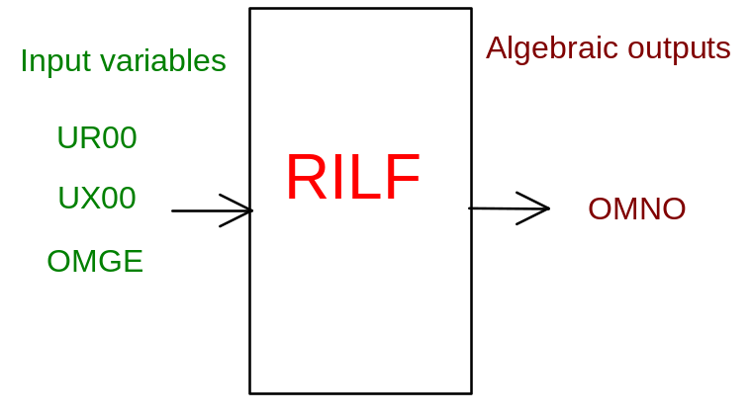

PHYSICAL MEANING OF MODULE INPUT-OUTPUT VARIABLES

[rad/s] OMNO node angular velocity

[V] UR00 phase real component of node voltage

[V] UX00 phase imaginary component of node voltage

[rad/s] OMGE angular velocity of reference node

MODULE RILF CARD C

Physical and Geometrical Data

[V] VBASE system chained base voltage in p.u.

[rad/s] OMBA system base angular velocity in p.u.

MODULE RILF CARD D

Module Variables Initialization

To initialize the RILF module variables no particular prescription is required.

MODULE RILF CARD E

User's Subprograms

RILF doesn’t prescribe any FORAUS subroutine.

MODULE RILF CARD F

Residuals

Steady state:

RNI(1) = OMNO-OMGE

In transients:

If node voltage is negligible:

RNI(1) = OMNO

Else:

RNI(1)=OMNO*OMBA-OMGE*OMBA-(-UX00*(UR00-UR00P)+UR00*(UX00-UX00P))/M1

where

M1=(UR00**2.+UX00**2.)*DTINT

MODULE RILF CARD G

Module subprograms

SUBROUTINE RILFI2(IFUN,VAR,MX1,IV1,IV2,XYU,DATI,ID1,ID2,
$ IBL1,IBL2,IER,CNXYU,TOL)
SUBROUTINE RILFI3(IFO,IOB,DEBL)
SUBROUTINE RILFI4(IOB,MOD)
SUBROUTINE RILFC1(IFUN,AJAC,MX5,IXYU,XYU,IPD,DATI,RNI,IBL1,IBL2)
SUBROUTINE RILFJC (IFUN,AJAC,MX5,IXYU,XYU,IPD,DATI,RNI,IBL1,IBL2)

SUBROUTINE RILF (IFUN,IXYU,XYU,IPD,DATI,RNI)

SUBROUTINE RILFD1(BLOCCO,NEQUAZ,NSTATI,NUSCIT,NINGRE,SYMVAR,
$ XYU,IXYU,DATI,IPD,SIGNEQ,UNITEQ,COSNOR,ITOPVA,MXT)

MODULE RILF CARD H

Test cases

Reference test cases related to this module aren’t yet available.

