#$K+!MODULE SBAR CARD 0

Summary

∗ model generalities

∗ topological data

∗ physical and geometrical data

∗ module variables initialization

∗ user's subprograms

∗ residuals

∗ module subprograms

∗ test cases

#$K+!MODULE SBAR CARD A

Model Generalities

CONNECTION BUS BARS

The SBAR module simulates the operation of a bus bar having N branches connected.

Equations used are:

1) Kirchoff equation at branching points
2) Voltage module equation
3) Current module equation

The equations of the SBAR module are written according to the coding of users, that is considering arriving currents as positive.

#$K+!MODULE SBAR CARD B

Topological data

INPUT - OUTPUT SCHEME

N = number of branches connected to the bus bar (maximum 40)

i = 1,2, ... N

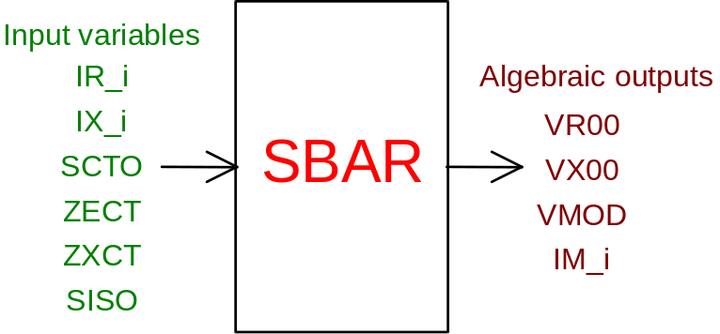

PHYSICAL MEANING OF THE MODULE INPUT-OUTPUT VARIABLES

[V] VR00 real phase voltage at bus bar
[V] VX00 imaginary phase voltage at bus bar
[V] VMOD voltage between lines at bus bar in module
[A] IM_i current of branch i in module
[A] IR_i real current of branch i
[A] IX_i imaginary current of branch i
[ ] SCTO short circuit condition:
SCTO = 1 bars in short-circuit,
SCTO = 0 bars in normal operation conditions
[ohm] ZRCT short circuit resistance
[ohm] ZXCT short circuit reactance
[ ] SISO isolated bars state:
SISO = 1 isolated bars
SISO = 0 connected bars

#$K+!MODULE SBAR CARD C

Physical and Geometrical Data

In addition to the initial values of input and output variables of the SBAR module, whose meaning has been defined in card B, the user must assign the following set of data to complete the input required by the module:
[V] VBASE basic voltage between lines of system in p.u.
[W] QBASE basic power of system in p.u.

#$K+!MODULE SBAR CARD D

Module Variables Initialization

The Jacobian matrix is completely initialized to avoid numeric errors during transient states.

#$K+!MODULE SBAR CARD E

User's Subprograms

No user’s subprogram is required in the SBAR module.

#$K+!MODULE SBAR CARD F

Residuals

The equations of the mathematic model, mentioned in Card A, give the following residuals:

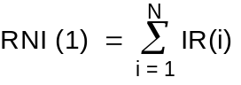
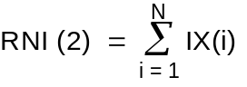

These residuals are used in case of normal operation, that is without short-circuits or isolated bars. In presence of short-circuits or of isolated bars the two residuals vary and the different cases are indicated in the module FORTRAN.

In addition to the two above mentioned residuals there are residuals giving the module of the bus bar voltage between lines and the current modules of each different branch.

#$K+!MODULE SBAR CARD G

Module subprograms

SUBROUTINE SBARI2 (IFUN,VAR,MX1,IV1,IV2,XYU,DATI,ID1,ID2, IBL1,IBL2,IER,CNXYU,TOL)
SUBROUTINE SBARC1 (IFUN,AJAC,MX5,IXYU,XYU,IPD,DATI,RNI,IBL1,IBL2)
SUBROUTINE SBARJC (IFUN,AJAC,MX5,IXYU,XYU,IPD,DATI,RNI,IBL1,IBL2)
SUBROUTINE SBAR (IFUN,IXYU,XYU,IPD,DATI,RNI)
SUBROUTINE SBARI3 (IFO,IOB,DEBL)
SUBROUTINE SBARI4 (IOB,MOD)
SUBROUTINE SBARD1 (BLOCCO,NEQUAZ,NSTATI,NUSCIT,NINGRE,SYMVAR,XYU,
IXYU,DATI,IPD,SIGNEQ,UNITEQ,COSNOR,ITOPVA,MXT)

#$K+!MODULE SBAR CARD H

Test cases

# lg_libproc_SBAR_summ
$ SBAR process module
K SBAR process module
+ lg_pag_modu:1080
! EnableButton("button_up"); ChangeButtonBinding("button_up", "JumpId(`lglibpro.hlp',`lg_libproc_main')")
# lg_libproc_SBAR_A
$ SBAR process module (A)
K SBAR process module (A)
+ lg_pag_sbar:0002
! EnableButton("button_up"); ChangeButtonBinding("button_up", "JumpId(`lglibpro.hlp',`lg_libproc_SBAR_summ')")
# lg_libproc_SBAR_B
$ SBAR process module (B)
K SBAR process module (B)
+ lg_pag_sbar:0003
! EnableButton("button_up"); ChangeButtonBinding("button_up", "JumpId(`lglibpro.hlp',`lg_libproc_SBAR_summ')")
# lg_libproc_SBAR_C
$ SBAR process module (C)
K SBAR process module (C)
+ lg_pag_sbar:0004
! EnableButton("button_up"); ChangeButtonBinding("button_up", "JumpId(`lglibpro.hlp',`lg_libproc_SBAR_summ')")
# lg_libproc_SBAR_D
$ SBAR process module (D)
K SBAR process module (D)
+ lg_pag_sbar:0005
! EnableButton("button_up"); ChangeButtonBinding("button_up", "JumpId(`lglibpro.hlp',`lg_libproc_SBAR_summ')")
# lg_libproc_SBAR_E
$ SBAR process module (E)
K SBAR process module (E)
+ lg_pag_sbar:0006
! EnableButton("button_up"); ChangeButtonBinding("button_up", "JumpId(`lglibpro.hlp',`lg_libproc_SBAR_summ')")
# lg_libproc_SBAR_F
$ SBAR process module (F)
K SBAR process module (F)
+ lg_pag_sbar:0007
! EnableButton("button_up"); ChangeButtonBinding("button_up", "JumpId(`lglibpro.hlp',`lg_libproc_SBAR_summ')")
# lg_libproc_SBAR_G
$ SBAR process module (G)
K SBAR process module (G)
+ lg_pag_sbar:0008
! EnableButton("button_up"); ChangeButtonBinding("button_up", "JumpId(`lglibpro.hlp',`lg_libproc_SBAR_summ')")
# lg_libproc_SBAR_H
$ SBAR process module (H)
K SBAR process module (H)
+ lg_pag_sbar:0009
! EnableButton("button_up"); ChangeButtonBinding("button_up", "JumpId(`lglibpro.hlp',`lg_libproc_SBAR_summ')")

